BỘ GIÁO DỤC VÀ ĐÀO TẠO
TRƯỜNG ĐẠI HỌC MỎ ĐỊA CHẤT
------------------------------------

BÁO CÁO SINH HOẠT HỌC THUẬT
CẤP BỘ MÔN

Vietnam’s import and export: The overview of achievements and the future perspectives

Người báo cáo: Nguyễn Thị Hoài Nga

Bộ môn: QTDN Mỏ

HÀ NỘI - NĂM 2024

INTRODUCTION

1. Rational
Vietnam’s import-export sector is an economic powerhouse, with total trade turnover reaching nearly $787 billion. Over the last decade, Vietnam successfully transitioned into a major global manufacturing hub, shifting from raw material exports to high-tech and value-added processing while maintaining a consistent trade surplus.
Besides of this achievement, it can be seen that a shift to high-tech goods, for example electronic goods, mobile phones, and computer components have overtaken traditional sectors (textiles, footwear, coffee) as the leading export items, heavily driven by massive Foreign Direct Investment (FDI) from companies like Samsung.
Vietnam has also a diverse market reach with over 100 countries worldwide. Vietnam exports to over 100 countries. The United States remains the largest export destination (accounting for nearly 30% of exports), followed by China, South Korea, and Japan. Successful utilization of Free Trade Agreements (FTAs) such as the EVFTA, CPTPP, and RCEP has reduced tariffs, improved supply chain integration, and reformed domestic IP and legal systems, bringing more opportunities for companies.
This report summarized the outputs of the import and export in Vietnam, and mentioned the perspectives and future outlook.

2. Vietnam’s import and export
Vietnam is occupying favorable infrastructure conditions for logistics and import/export, such as the total lengths of national road network is more than 295,000 km (and will be expanded more in 2050 with more than 9,000 km of expressways), and many busy cargo ports (Port of Ho Chi Minh City (Cat Lai Terminal), Port of Hai Phong, Port of Cai Mep-Thi Vai, Port of Da Nang, Port of Quang Ninh).
Figure 1 shows the imports and exports of Vietnam from 1995 to 2025 (estimated) in USD. In can be seen the excellent outcomes from a revenue of 13.40 bil. USD in 1995 to 786.9 bil. USD in 2024, which is 58.7 times bigger after 29 years.
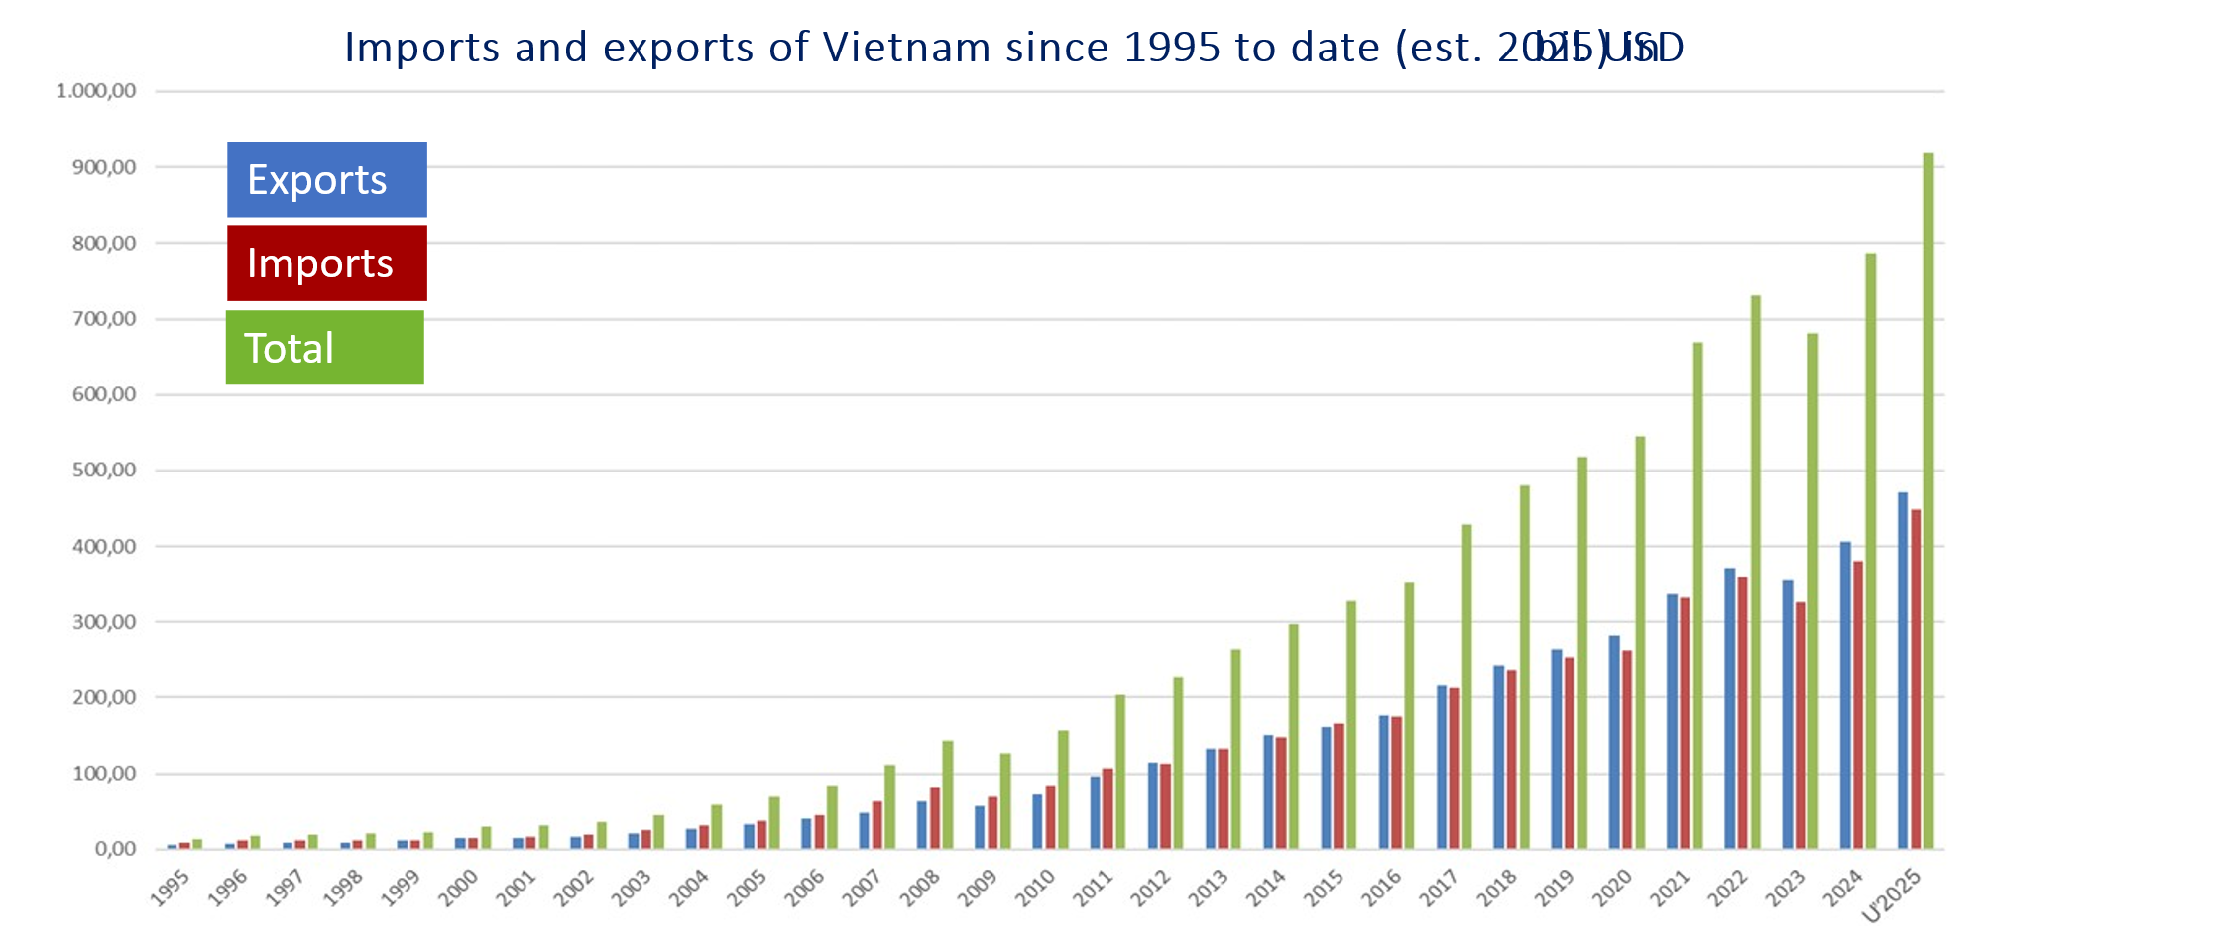
Figure 1. The imports and exports of Vietnam since 1995 to 2025 in USD
Regarding trade balance, Vietnam has gradually shifted from a trade-deficit country to a trade-surplus country. 2025 marked Vietnam’s 10th consecutive year of running a trade surplus.
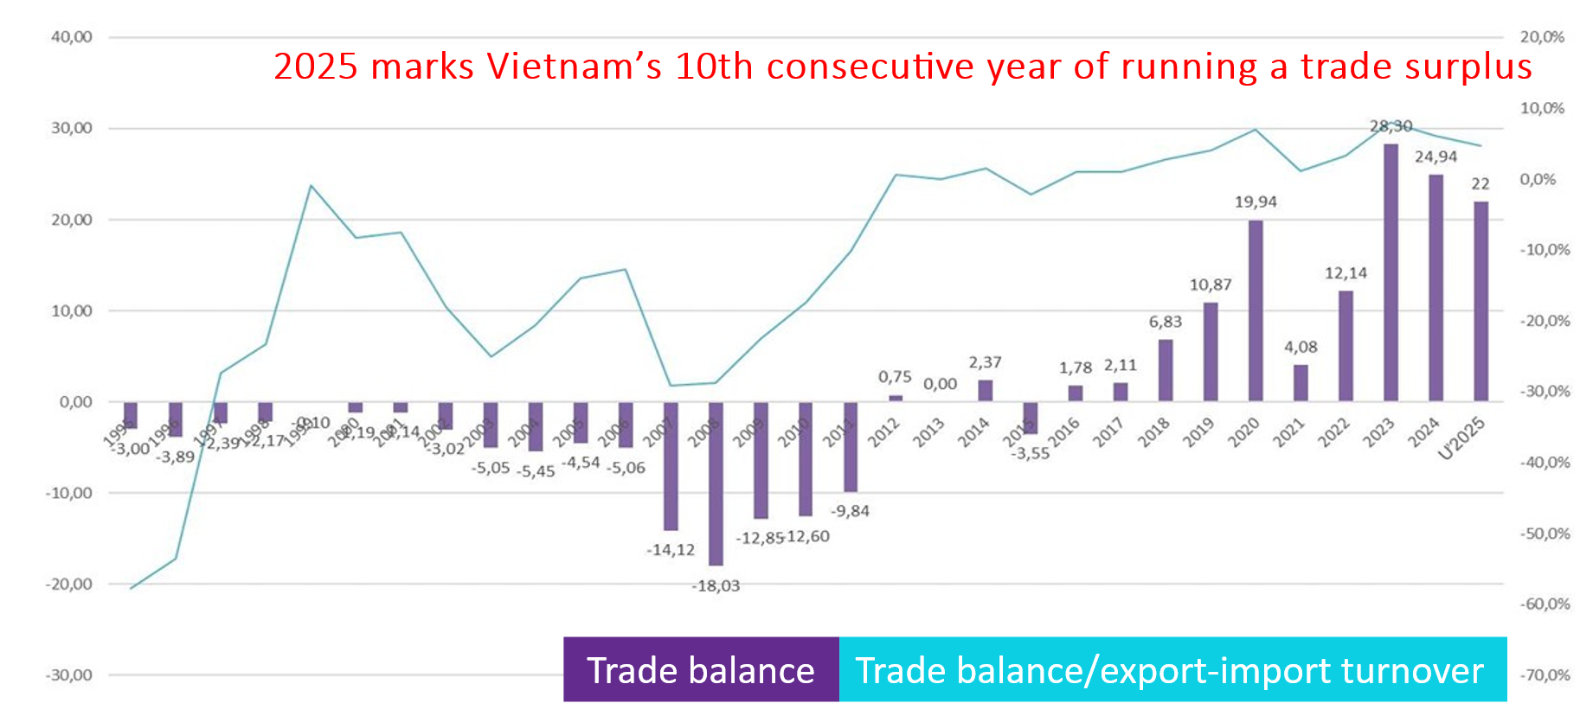
Figure 2. Trade balance of Vietnam and its ratio of export-import turnover
The top 10 exports commodities in 2025 can be listed with computers, electronic products and components (96.92 bil. USD), machinery, equipment, tools and spare parts (53.36 bil. USD), telephones and components (52.66 bil. USD), textiles and garments (35.91 bil. USD), transport vehicles and spare parts (15.18 bil. USD), wood and wood products (15.52 bil. USD), seafood (10.32 bil. USD), toys, sports equipment and parts (8.37 bil USD) and coffee (7.84 bil. USD).
The top ten exports markets of Vietnam are the United States (37%), China, European Union, South Korea, Japan, Netherlands, Hongkong (China), India, Australia and Canada. The number of markets with exports over one billion USD is increasing fast from 27 in 2013 to 37 in the first eleven month in 2025. It is worth noting that the exports online exceeded 2.4 bil. USD in 2024.
The top 10 imports commodities in 2025 are computers, electronic products and components (136.17 bil. USD), machinery, equipment, tools and spare parts (54.75 bil. USD), fabrics of all kinds (13.76 bil. USD), plastics in primary forms (11.38 bil. USD), telephones and components (10.26 bil. USD), other base metal (10.21 bil. USD), iron and steel (9.98 bil. USD), articles of plastics (9.78 bil. USD), iron and steel products (7.42 bil. USD) and chemical products (7.28 bil. USD).
The top 10 imports markets in 2025 were China (40%), South Korea, Japan, Taiwan (China), Singapore, Thailand, Malaysia, Indonesia, USA and Germany.
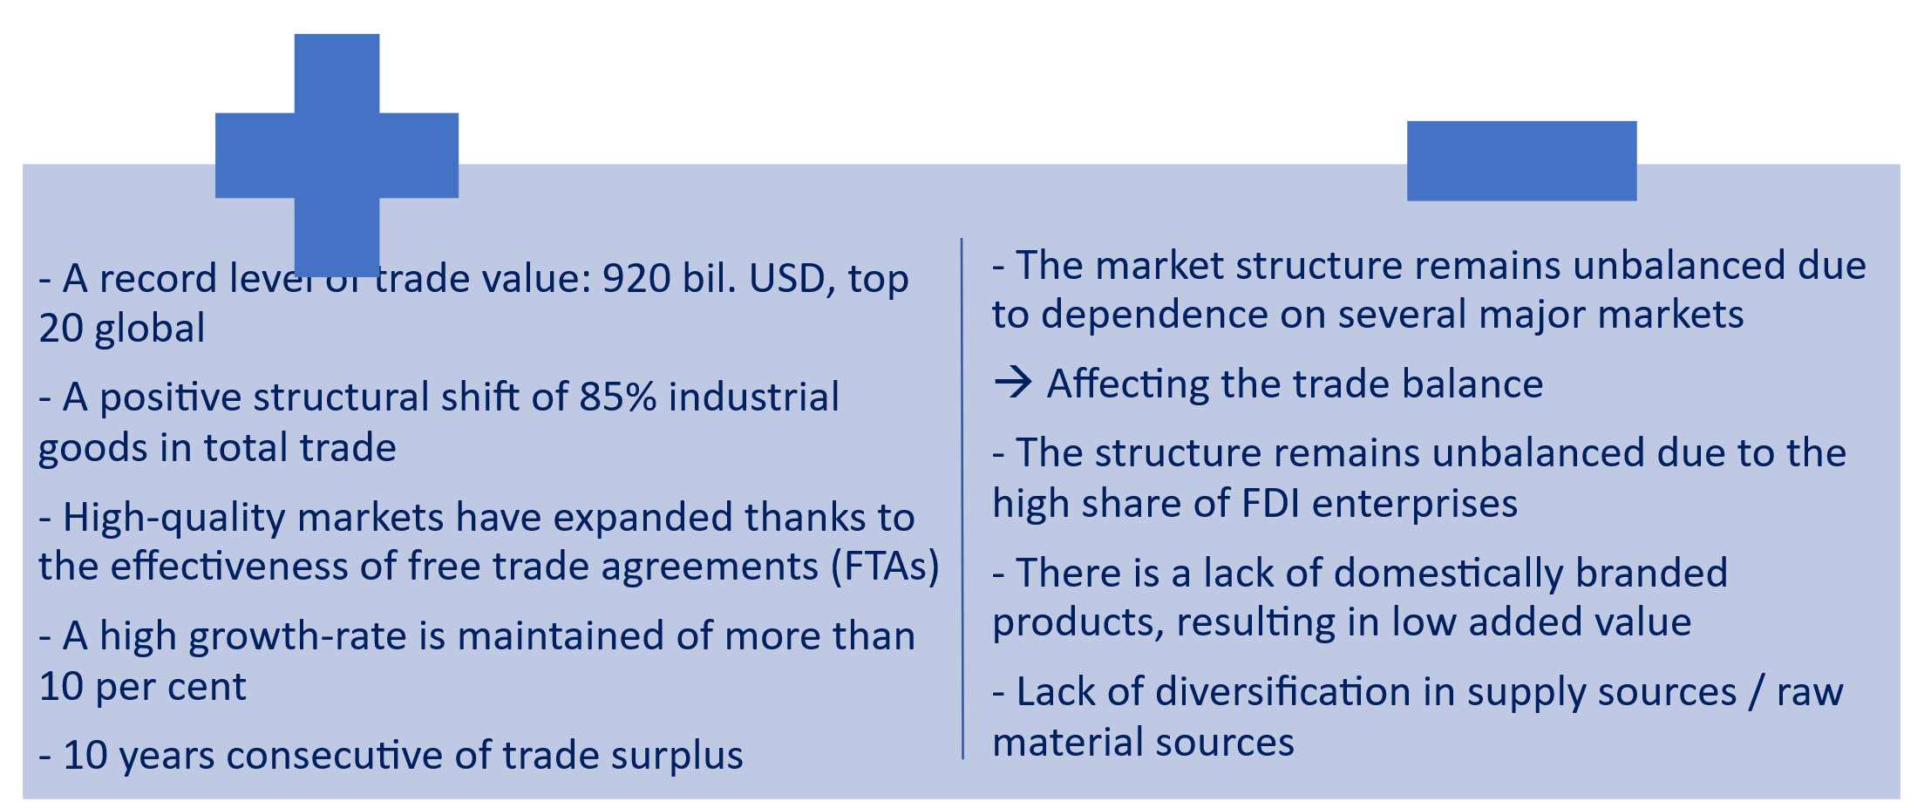
Figure 3: Achievements and limits of the Vietnam’s import and export

3. The future perspectives in import and export of Vietnam
The context of international trade is changing quickly nowadays with the volatility in the supply chain and the global supply chain relocation, leading to the de-globalization trend, which refers to regionalization instead of globalization, or increasing of protectionism.
Global trade conflicts must be one of the most critical topics that impact the import and export of Vietnam. Besides, several export sectors are at high risk of being investigated and subject to trade defense measures. The rise of trade protectionism has led to an increasing use of trade remedy measures by importing countries. By the end of June 2023, Vietnamese exports had faced 231 trade remedy cases initiated by foreign markets.
Vietnam can minimize the risks and grab the opportunities if topical issues such as green in manufacture, green in the supply chain, Net Zero, etc. are utilized to adapt with global demands.
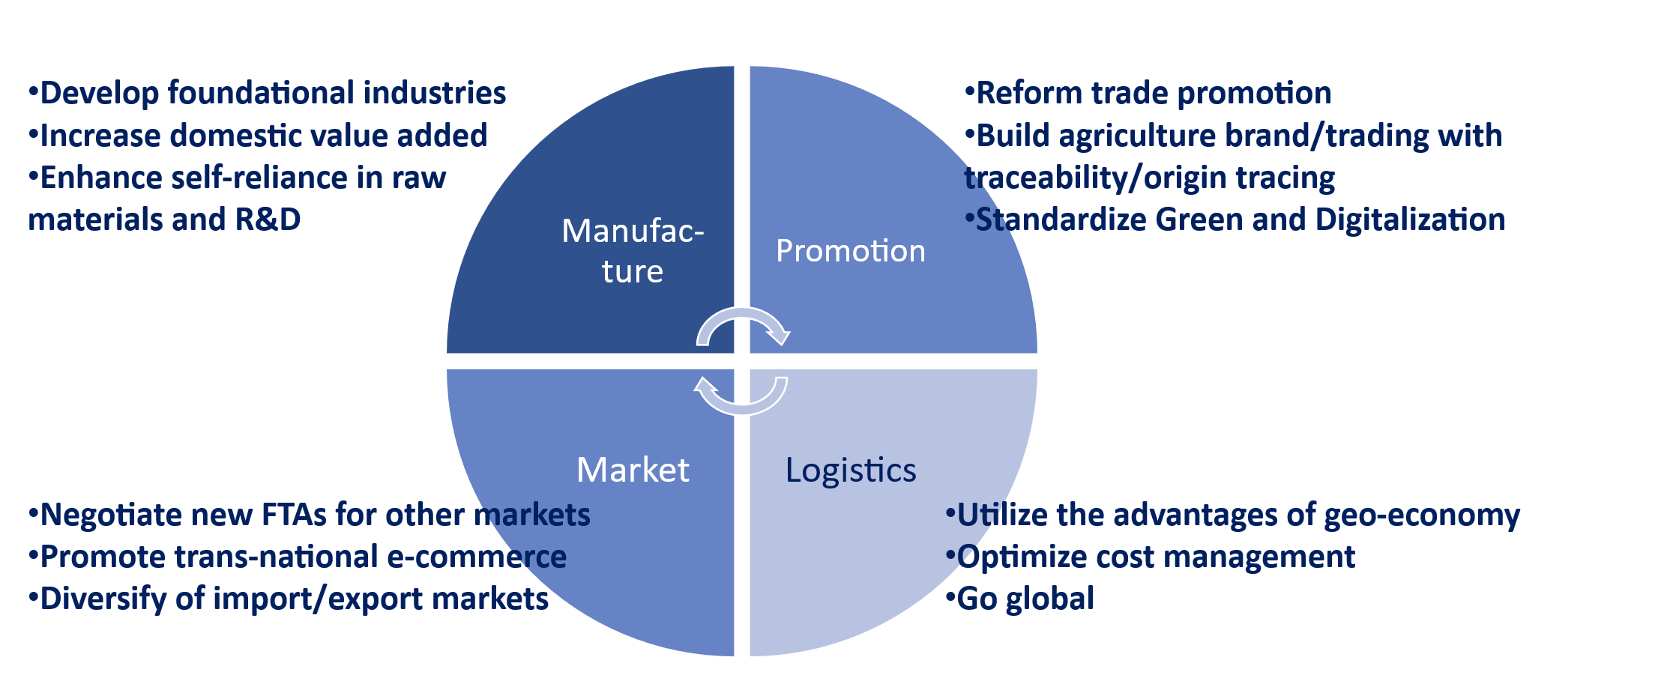
Figure 4. New engines for development of import and export in Vietnam
Value Chain Upgrading: Moving forward, Vietnam aims to deepen its domestic manufacturing capabilities. The focus is on transitioning from final assembly to producing core components and raw materials locally to capture a higher percentage of the value chain.
Green and Sustainable Trade: With global markets imposing strict ESG standards (like the EU's CBAM), the country is actively greening its industrial zones, transitioning to renewable energy, and promoting eco-friendly manufacturing processes to maintain global competitiveness.
Diversification & Risk Mitigation: Vietnam is expanding trade avenues to emerging markets (Middle East, Latin America, Africa) to avoid over-reliance on a few traditional partners.
Digital Transformation: The Ministry of Industry and Trade (MoIT) is driving the digitalization of customs procedures and supply chain logistics to further reduce administrative costs and improve cross-border efficiency.

4. Conclusion
The future perspective of Vietnam’s import and export landscape remains deeply intertwined with its overarching economic growth, solidifying international trade as the primary driver of national GDP. Over the next several decades, cross-border trade is projected to expand significantly, presenting both unprecedented opportunities and structural challenges. To sustain this momentum, the country must urgently address the growing deficits in its qualified labor force, particularly within the rapidly evolving logistics and digital e-commerce sectors, which serve as critical pillars for the internationalization of Small and Medium Enterprises (SMEs). Navigating this transition successfully requires deliberate state intervention through proactive strategic decisions and comprehensive policy frameworks that foster a competitive business environment. Ultimately, by leveraging robust partnerships with global financial and commercial institutions, Vietnam can transition from volume-driven trade to high-value, sustainable global integration, ensuring its long-term resilience in an interconnected global market.

References
- General Statistics Yearbook (2020 – 2025)
- Ministry of Industry and Trade, Annual Official reports, Vietnam Import-Export Report
- The Chi Ngo, Vietnam's Exports in the Period of 2016-2023 and Main Solutions to Promote Exports to 2030, 2024, Business and Economic Research
- Tran Thanh Hai, Vietnam imports and exports, 2024, Ministry of Industry and Trade

