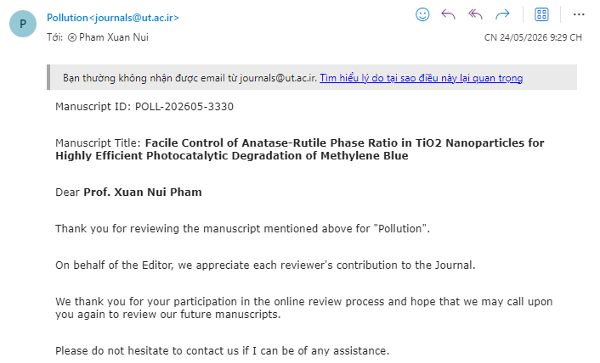
Review-3330
The novelty and scientific significance of this study have not been sufficiently demonstrated. Furthermore, the manuscript requires major revisions and additional investigations, as outlined below:
- The intensity of the UV irradiation source should be clearly determined and reported.
- The references cited are outdated and lack sufficient recent and up-to-date literature.
- The influence of pH on the treatment process should be discussed in greater detail. In addition, the surface charge properties of TiO₂ should be characterized through zeta potential or surface potential measurements.
- As observed in Fig. 1(b), the XRD diffraction peaks corresponding to the rutile phase of TiO₂ are not evident and should be clarified.
- The specific surface area and pore size distribution of the samples should be determined, as these parameters are closely related to the adsorption capacity prior to the photocatalytic degradation of methylene blue (MB).
- The intermediate products formed during MB degradation over the 3-TiO₂ (3-HNO₃) catalyst should be identified and discussed.
- The structure, morphology, and chemical bonding characteristics of the 3-TiO₂ catalyst after four reaction cycles should be further characterized to evaluate its stability and reusability.

