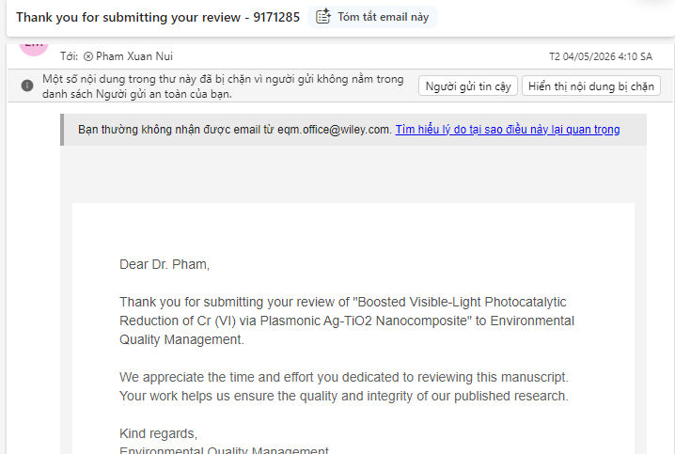
Reviewer Comments – ID 9171285
- The application of Ag–TiO₂ photocatalysts for the reduction of Cr(VI) to the less toxic Cr(III) in aqueous systems is of practical significance. However, the scientific novelty of this study appears limited, as similar catalytic systems have been extensively reported in the literature.
- The synthesis approach for the Ag–TiO₂ composite is not novel and can be considered rather conventional. Furthermore, the preparation method of TiO₂ described in the manuscript appears to correspond to a precipitation method rather than the sol–gel method claimed by the authors, indicating inconsistency in the experimental description.
- The manuscript lacks sufficient detail regarding the chemicals used and the experimental procedures. A more comprehensive description is necessary to ensure reproducibility.
- The photoluminescence (PL) spectra presented do not convincingly demonstrate reliability. Additional clarification and supporting analysis are required.
- Surface modification of TiO₂ with Ag does not appear to significantly reduce the band gap energy (Eg). Moreover, the role of surface plasmon resonance (SPR) induced by Ag nanoparticles has not been clearly elucidated.
- The manuscript lacks consistency in the use and description of irradiation conditions, particularly between UV and visible light. The authors should clearly specify the light source, wavelength range, and experimental setup, and ensure consistency throughout the manuscript.
- The language of the manuscript requires substantial revision to meet the standards of scientific and academic writing.

