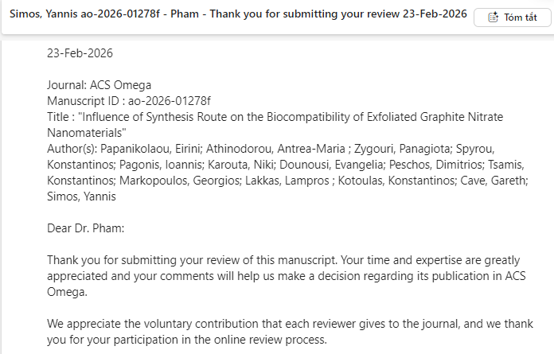
Review - 01278f
In this study, the authors describe two approaches for the preparation of exfoliated graphite nitrate: (1) a conventional chemical method and (2) a biological route aimed at producing a biocompatible material for biomedical applications. However, several concerns regarding the materials synthesis and characterization should be addressed:
- The chemicals and reagents used in the synthesis are not clearly specified. A detailed description of the precursors, their purity, concentrations, and suppliers is necessary to ensure reproducibility.
- The experimental section describing the material preparation is difficult to follow. In particular, the thermal treatment of the Graphite Nitrate@120 sample is unclear. The authors should rewrite the experimental procedure in a more systematic and transparent manner and provide a clearer explanation in the Results and Discussion section.
- The XRD patterns of bGN and cGN are not presented. Moreover, the exfoliation mechanism of graphite nitrate (GN) is not sufficiently clarified. The assignment of diffraction peaks for graphite, graphite nitrate, and graphite nitrate@120 appears inconsistent and requires careful re-evaluation.
- TEM images of nitrate-doped exfoliated graphene prepared via the biological (bGN) and chemical (cGN) methods should be presented at the same magnification to enable a direct and meaningful comparison of morphology and exfoliation degree.
- Overall, the reported results do not clearly demonstrate the influence of the synthesis method on the exfoliation efficiency and structural properties of graphite nitrate nanomaterials.
- The use of HNO₃ for the preparation of graphite nitrate raises concerns regarding the claim of a “green” exfoliation process. The authors should justify this terminology or reconsider the environmental sustainability claims associated with the method.

