Research Paper
The Potential of Using Waste Rock and Tailings from Gold Mining in Concrete Production
Engr. Eugene Salam Ayoakateng^{a,b}, Ing. Prof. Emmanuel Appiah-Kubi ^{b}
ª Department of Building Technology, Bolgatanga Technical University. Post Office Box 767, Bolgatanga, Ghana.
^{b} Akenten Appiah -Menka University of Skills Training and Entrepreneurial Development. Post Office Box 1277, Kumasi, Ghana

A R T I C L E I N F O  Article history :  Received 00 December 00  Received in revised form 00 January 00  Accepted 00 February 00  Keywords:  Gold mining waste rock  Gold mining tailings  Compressive strength  Flexual strength  Water absorption |  | A B S T R A C T  This study explores the possibility of using waste rock and tailings from gold mining as alternatives to traditional aggregates in concrete production to minimize the environmental impact of mining and improve concrete sustainability. The research examines the chemical composition, physical properties of the gold mining waste rock and tailings, mechanical properties, and water absorption of concrete incorporating (GMWRT) aggregates in six different mixtures at varying GMWRT percentages (0% to 25%). The study analysed the chemical composition of Goldmine tailings, cement, and sand using X-ray fluorescence spectrometry and assessed particle size distribution via sieve analysis. Compressive, flexural, and water absorption tests were carried out after 28 days of curing, with mean values compared to conventional concrete. Statistical analysis and graphical representations, including ANOVA, were utilised to determine significant differences in test results. The findings revealed that the primary chemical constituent of the GMWRT (SiO₂ +Al₂O₃ + Fe₂O₃) was 80.37%, which met the 70% pozzolanic material requirement by ASTM C618. The outcomes indicated that replacing traditional aggregates with GMWRT from 0 to 25% resulted in compressive strength (CS) ranging from 31.40 to 17.50 N/mm², which decreased as the proportion of the GMWRT increased. While there was a decrease in compressive strength, the values were within an acceptable range of 17 to 28 N/mm², for different applications. Flexural strength (FS) followed a similar trend as CS but exceeded the standard requirement of 3.13N/mm², indicating practical applicability. GMWRT concrete displayed improved chloride attack resistance and low water absorption rates, making it suitable for durable coastal constructions. In general, the GMWRT can partially replace fine and coarse aggregates in concrete production, with economic advantages and a green concrete solution to the disposal of mining waste rock and tailings. This study contributes to developing sustainable construction practices and efficiently utilizing mining waste materials in developing economies like Ghana.

- Introduction
In many developing countries, such as Ghana, the high cost of concrete materials like cement and aggregates remains challenging [1]. The reliance on granite rock as the primary source of coarse aggregate for concrete poses a risk of depletion and escalating cost [2; 3; 4]. Therefore, researchers are exploring more economical and environmentally friendly alternatives for concrete materials [5; 6; 7].
Gold mining tailings (GMT) are the solid waste products of ore beneficiation processes and are available in abundance, especially in countries like Ghana. Various studies have examined different types of GMT, such as molybdenum tailings, phosphate tailings, gold tailings, copper tailings, iron tailings, zinc tailings, and oil-sand tailings. These GMTs have been utilized as aggregate or supplementary cementitious materials in concrete and other construction applications [8; 9; 10]. Notably, GMTs have been found to have a significant impact on concrete properties, including compressive strength, water absorption, and durability [11; 12; 13; 14]. Incorporating GMTs in concrete can enhance its compressive strength (CS), but the recommended GMT substitution for fine aggregate should not exceed 30% to avoid decreasing CS [11]. Using GMT as supplementary cementitious materials can also decrease CS [15].
Gold mining tailings tend to increase water absorption (WA) in concrete due to their fine content and specific surface area [15; 13]. However, GMT substitution for fine aggregate can decrease WA due to a fill effect in the pores of the cement paste, as observed in concrete with 80% fine aggregate replacement [14].
Gold mining waste rock (GMWR) has also been explored as an alternative to traditional granite coarse aggregate for concrete. Studies have shown that GMWR can have a significant impact on the compressive strength of concrete [16; 17]. For example, [16] reported that the complete replacement of natural aggregates with flint aggregates from phosphate waste rocks led to substantial improvements in compressive strength and flexural strength. [17] found that the compressive strength of concrete incorporating waste rocks was close to that of the control. Furthermore, other waste materials have been explored as coarse aggregates in concrete, such as marble waste and waste ballast.
These substitutions have shown promise in enhancing the workability and mechanical properties of concrete [18; 19]. In the case of marble waste, concrete formulations with marble aggregate exhibited increased workability and compressive strength compared to traditional concrete mixes [18].
Utilizing GMT and GMWR as alternative concrete materials not only addresses cost challenges but also contributes to environmental sustainability. These materials are often dumped around mining sites, leading to environmental pollution and increased waste management costs [20; 21; 22]. Thus, incorporating GMT and GMWR into construction in developing countries can provide economic and environmental benefits to mining stakeholders.
Despite the potential of GMT and GMWR, there is limited experimental research on their use as cementitious materials for green concrete production [11]. Additionally, the diverse nature of these materials necessitates further research to understand their characteristics and potential for specific applications.
Specialized information on Ghanaian Gold mining Waste Rock Tailings (GMWRT) as a partial replacement for natural sand and granite coarse aggregates is scarce. Therefore, this study aims to evaluate the mechanical properties of concrete made with GMWRT as a partial replacement for fine aggregate and GMWRT as a partial replacement for granite coarse aggregate. The use of gold mining tailings (GMT) and gold mining waste rock (GMWR) as concrete materials provide a promising solution to decrease construction costs while promoting eco-friendly concrete production. These materials can significantly affect concrete properties, and their use addresses environmental waste challenges related to mining activities. However, further research is necessary to investigate the specific characteristics and applications of GMT and GMWR, particularly in Ghana and other developing countries. This study contributes to the development of sustainable construction practices and the efficient utilization of mining waste materials.

2. Materials and Methods
2.1 Materials
In this study, the main materials used were pit sand, granite coarse aggregate, gold mining waste rock, gold mining tailings (Fig. 1a-d), cement and water. Ordinary Portland cement (32.5R) CEM II / B-L (GHACEM) which meets the Ghana standard GS 1118:2016 [23] was used as a binder. Fine aggregates were locally available natural pit sand obtained from Offinso in the Ashanti Region, which conformed to the requirement of BS 882[24].
The fine aggregate (pit sand) used in the study was free from impurities, with sieve sizes ranging from 0- 4.75mm complying with the requirements of BS 882[24]. Coarse aggregates used in this study were crushed granites produced from a local quarry crushing plant in Ntesera in the Ashanti Region. The crushed granites were irregular and angular shapes of 20mm size complying with the requirements of BS 882[24].
GMWRT were obtained from the Shaanxi Mining Company dump site located in Tongo in the Talensi District of the Upper East Region of Ghana. For the comparative study, the tailings were utilized as a partial replacement of the fine aggregates, with sizes ranging from 0-4.75mm complying with the requirements of BS 882[24]. The waste rock was manually crushed to the required dimension and used as a partial replacement of the granite coarse aggregates according to the requirement of BS 882[24] and Saturated Surface Dry (SSD).
Portable drinkable water was obtained from AAMUSTED University’s construction/wood laboratory in Kumasi, Ghana.
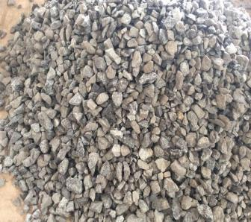
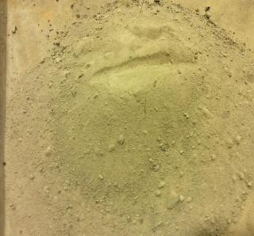
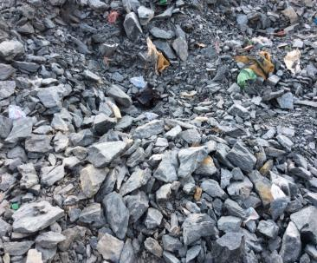
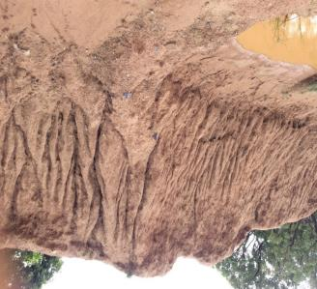
(a) Natural Pit sand
(b) Crushed Granite
(c) Gold Tailings
(d) Gold waste rock

Fig. 1- Sample of pit sand, crushed granite, goldmine tailings and waste rock from the source for the experiment
2.2 Determination of Chemical and physical property tests
The chemical composition of the goldmine waste tailings (GMWT), cement and sand were analyzed with X-ray fluorescence characterization techniques, using the Rigaku NEX CG X-ray fluoresce spectrometer equipment (Fig. 2a) at the Department of Earth Science in the University of Ghana, Legon to determine the oxide content of the tailings, Portland cement and the sand used (Table 3), mineralogical analysis of tailings (Fig. 7) as well as the presence of heavy metals in the gold waste tailings presented in Table 4.
For physical property tests, the particle size analysis (PSA) was done using a sieve analysis test process and apparatus (Fig. 2b-d). PSA apparatus were a sieve shaker, the riddle controller, and an electronic balance for batching the materials such as natural sand, granite coarse aggregates, goldmine waste rock and tailings. The particle size distribution (PSD) curves for the materials are shown in Fig. 8.
A Pycnometer Jar of 1-litre capacity (see Fig. 2e) was used to determine the specific gravity (SG) of cement, fine and granite coarse aggregates, and GMWRT. Specific gravity (SG) of recommended standards ranges from 2.5 to 2.8 for fine aggregate, and 2.6 to 2.9 for granite coarse aggregate [25].
Vicat apparatus test was conducted on the cement to determine the standard consistency test and subsequently initial and final setting time (Fig. 2f, g). 32% of water was added to the 500g of cement mix in the cement paste mix and mixed automatically for 240 seconds or 4 minutes, the results were not satisfactory. The 32% was reduced to 30%, 28% until 25% of water was successful.

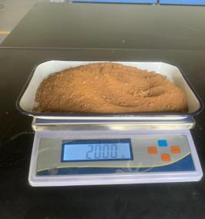
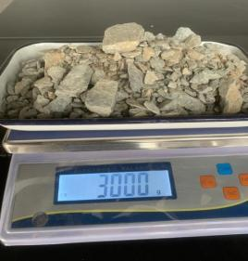
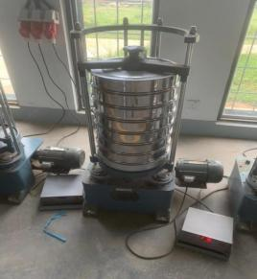
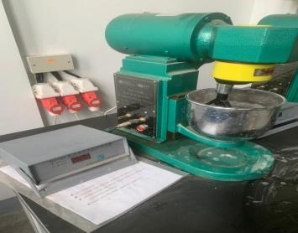
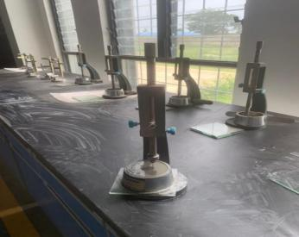
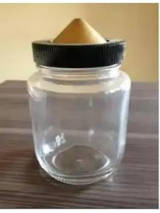
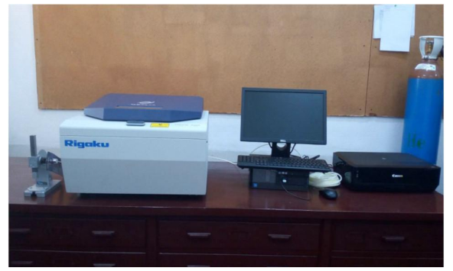
(a) Rigaku NEX CG X-ray fluoresce spectrometer
(d) Electronic balance for tailings

(c) Electronic balance for coarse rock
(b) Top-Hitting Standard Sieve Shaker and riddle controller

(e) Pycnometer Jar (1 litre),
(f) Cement Paste Mix
(g) Vicat Apparatus
Fig. 2 - Apparatus for chemical and physical property tests
2.3. Mix proportioning and designations
In this study, the mix proportioning conformed to the BS requirements method of concrete mix design [26]. Accordingly, a mix ratio proportion of 1:2:4 was adopted for the concrete work. Trial casting was made for various W/c ratios and a 7-day curing period, and the W/c ratio that resulted in the highest strength was selected for the final castings. A reference mixture (control) was designed to achieve 100% cement, natural sand and granite coarse aggregate content, with 0% GMWRT. The GMWRT concrete mixtures were prepared with waste rock and tailings content of 5, 10, 15, 20 and 25% by a constant 10 kg weight of cement for each mixture respectively. The mix proportions are listed in Table 1, and their descriptions in Table 2.

Table 1- Mix proportion for concrete materials
Mix design | Mix Ratio | Cement (kg) | Fine Aggregate (kg) | GWMT (kg) | Coarse Aggregate (kg) | GWMR (kg) | W/C
0% | 1:2:4 | 10 | 20 |  | 40 |  | 0.6
5% | 1:2:4 | 10 | 19 | 1 | 38 | 2 | 0.6
10% | 1:2:4 | 10 | 18 | 2 | 36 | 4 | 0.6
15% | 1:2:4 | 10 | 17 | 3 | 34 | 6 | 0.6
20% | 1:2:4 | 10 | 16 | 4 | 32 | 8 | 0.6
25% | 1:2:4 | 10 | 15 | 5 | 30 | 10 | 0.6

Table 2 - Mix designations
Identity | Description
C0 | concrete produced with 0% replacement of GMWRT
R5T5 | concrete produced with 5% replacement of GMWR and 5% replacement of GMRT
R10T10 | concrete produced with 10% replacement of GMWR and 10% replacement of GMRT
R15T15 | concrete produced with 15% replacement of GMWR and 15% replacement of GMRT
R20T20 | concrete produced with 20% replacement of GMWR and 20% replacement of GMRT
R25T25 | concrete produced with 25% replacement of GMWR and 25% replacement of GMRT
2.4. Sample preparation
Concrete mixing procedures for batching, mixing, and manufacturing of specimen cubes and beams were prepared following the BS EN 14488–4[27] and BS EN 12390–7[28] specification steps. Apart from the control specimen, five specimens of concrete mixtures were prepared based on the partial replacement of goldmine tailings for fine aggregate and waste rock for granite coarse aggregate. Cement, aggregates, and water were batched by weight as shown in Fig. 3 (a, b, c & d). A laboratory pan concrete mixer was used to mix the concrete conforming to BS requirements as shown in Fig. 3 (e, f, g & h).
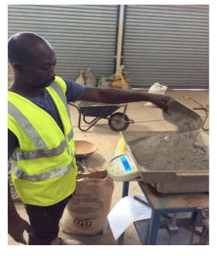
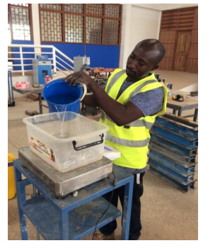
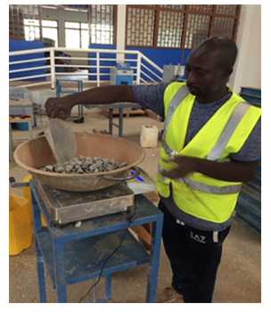
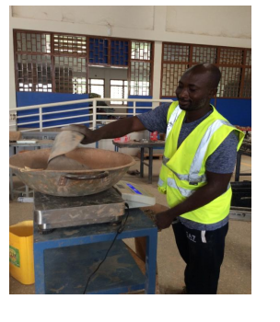
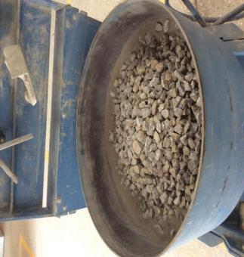
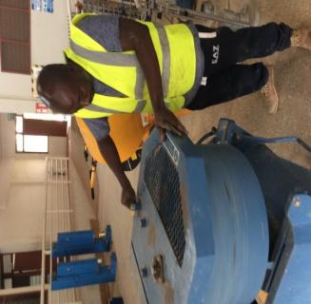
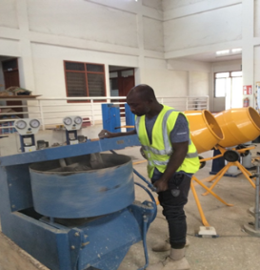
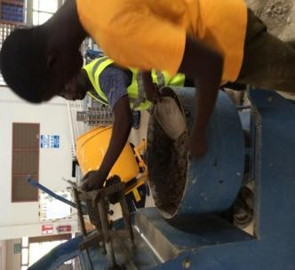
(a)
(e)
(b)
(f)
(c)
(d)
(g)
(g) (h)

Fig. 3-- Batching and Mixing material: (a) sand (b) cement (c) coarse aggregate (d) water (e) combination of material (f) mixing in the process (g) mixing of concrete (h)concrete ready for use
The cubic and beam moulds and their samples in the concrete production process are illustrated in Fig. 4 (a, b, c, d & e). 54 cubes samples were used for the mean compressive strength (CS) test and 18 cubes samples for the water absorption test. In all a total of 72 cubes samples of dimension 100$×100×100$ mm, specimens were cast, 12 specimens for each 6 mix, complying with BS EN 14488–4[27]. A total of 54 beams of dimension 100$×100×500$ mm in length, specimens were cast, six concrete beams for each 9 mix, conforming to the requirement of BS EN 12390[29] for the flexural test using the six finished mix proportions (control and GMWRT concretes).
The mean compressive strength (CS) and flexural strength (FS) of the specimens were reported for each test age of 7, 14 and 28 days. For their curing, the concrete cubes and beams specimens were removed from their moulds 24 hours after casting, and they were immersed in the clean drinkable water tank and cured to comply with the requirements of BS EN 12390[28] and ASTM C 309 [30] as shown in Fig. 4f.
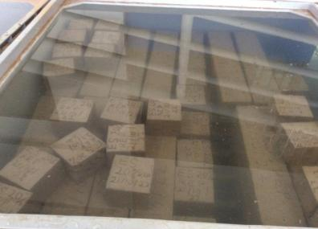
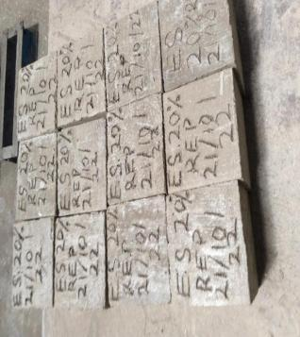
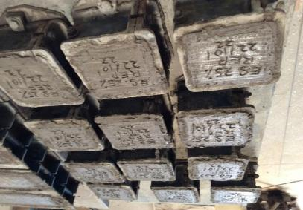
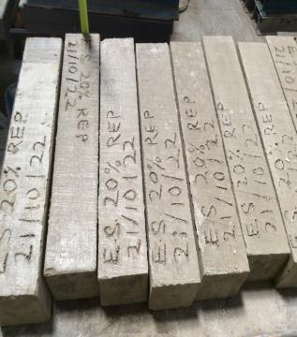
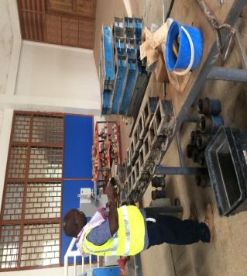
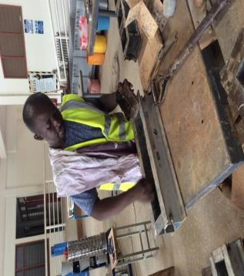
(a)
(d)
(b)
(e)
(c)
(f)

Fig. 4 - (a) BS mould 100x100x100 for (b) specimen concrete inside cube mould, (c) specimen concrete out of cube mould, (d) BS mould 100x100x500 for (e) specimen concrete beams (f) Specimen in a curing tank
2.5. Compressive Strength (CS) test
Compressive Strength tests were conducted on the hardened specimens after 7, 14, and 28 days of moist curing following the guidelines from BS EN 12390-3[31]. The Hydro Servo Computer Controlled Automatic 1000kN UTM was used to conduct the test as shown in Fig. 5 (a & b). The load on the cube was applied gradually and continuously at the rate of 140kg/cm² per minute till the specimen failed. The averages of the three specimens of 0% (control), 5%, 10%, 15%, 20% and 25% (GMWRT) each tested were recorded for CS test results displayed in Table 6.
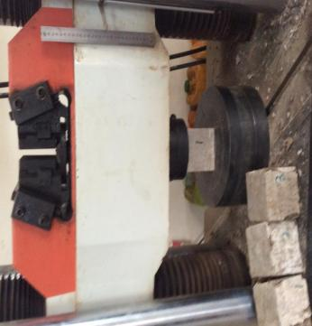
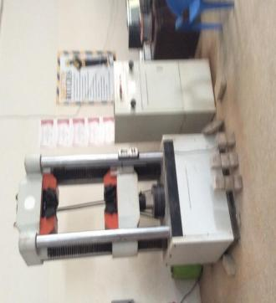
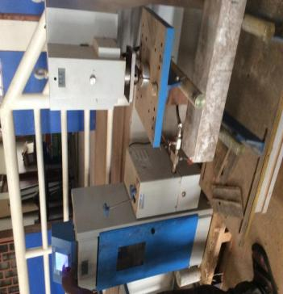
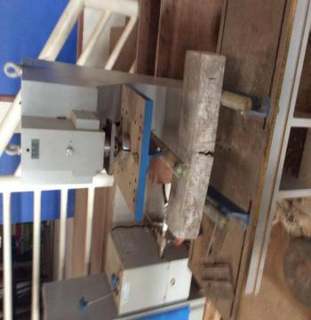
(a)
(b)
(c)
(d)

Fig. 5 - CS and FS tests (a) CS test set-up (b) CS test in progress (c) Flexural (3-point load) strength test set-up (d) FS test in progress

2.6. Flexural Strength (FS) test
The flexural strength (FS) test of the specimen concretes was conducted to determine the ability of concrete to resist bending stresses. After curing and drying the test specimens, the specimens were weighed and examined for FS following the BS EN 12390-5[29]. The ELE flexural frame testing machine with a capacity of 100kN was used to conduct the test. Each beam was loaded with a central-point load located at mid-span and on top of the beam, whilst the bottom face was supported on two supported ends as shown in Fig. 5 (c and d). The specimen was carefully aligned with the axis of the loading device. The load was gradually and continuously applied at 180 kg/cm2 per minute until the specimen failed. The flexural strength (FS) test results are presented in Table 7.
2.7. Water absorption (WA) test
A physical property test was performed to determine the concretes’ water absorption and initial rate absorption in maintaining its desired engineering properties. The process of the water absorption test is shown in Fig. 6 (a, b, c). This was done after curing for 28 days. The WA test complied with the requirement of BS 1881 – 122 [32], and a total of 18 cube specimens were utilised. Specimens underwent a water and air treatment. The samples were dried in the oven for 24 hours at an initial temperature of 0.5°C while the ambient temperature was 35°C. It was then taken out and cooled for 24 hours in a dry, airtight container. The mass of the samples after cooling was weighed as shown in Fig. 6(c) and submerged in water for 60 minutes. After 60 minutes in water, the samples were taken out, wiped with a cloth, and weighed wet. The water absorption test and the initial rate of absorption (IRA) were then analysed. The WA tests were performed following AS/NZS 4456.17 [33]. Equation (1) was used to compute the WA of each specimen, and Equation (2) was used to calculate the IRA. Each combination had three specimens tested for both WA and IRA.
$WA=\frac{100(m_{i}-m_{f})}{m_{i}}\%$ (1)
$IRA=\frac{1000\left(m_{f,60}-m_{i}\right)}{A}(kg/m^{2}/min)$ (2)
Note: Where mi is the mass of oven-dried specimen (g), mf is the mass of the specimen after 24 hours of immersion in water (g), mf,60 is the mass of the specimen after immersion of the bottom 3 mm in water for 60 seconds (g), and A is the bottom surface area of the specimen (mm2).
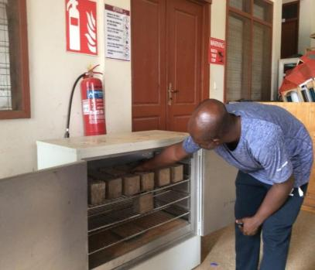
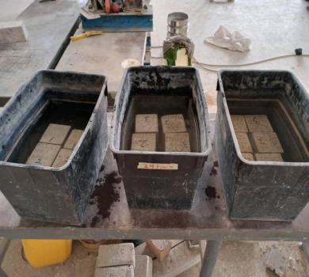
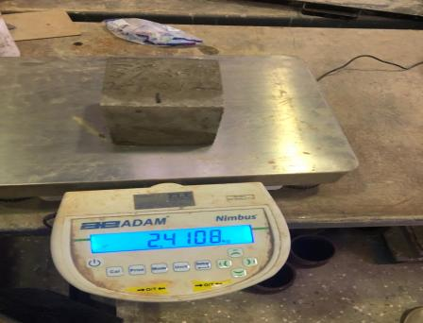
(a)
(b)
(c)

Fig.6 - (a) Oven drying samples for testing (b) Cubes submerged in water (c) Weighing of cubes after submerged in water.
2.8 Statistical Analysis
The mean values of the compressive, and flexural strengths related to the conventional concrete and, the percentage of replacement of gold mining waste rock and tailings were determined using the Statistical Package for Social Science (SPSS), version 22 software program. The data was also presented in graphical visualizations. ANOVA test was used to determine significant differences and variations between the test results.

3. Results and Discussion
3.1. Chemical Composition of GMWT, Cement and Sand
Table 3 - Chemical Composition of the gold mining waste tailings, cement, and sand
Oxide | SiO₂ | SO₃ | Fe₂O₃ | Cl | K₂O | Al₂O₃ | MnO | Na₂O | TiO₂ | MgO | ZnO | CaO | Cr2O3
^{Tailings (%)} | ^{46.36} | ^{2.99} | ^{24.81} | ^{0.03} | ^{0.71} | ^{9.2} | ^{0.06} | ^{1.20} | ^{0.41} | ^{0.62} | ^{0.13} | ^{13.2} | ^{0.23}
^{Cement (%)} | ^{30.3} | ^{3.31} | ^{5.13} | ^{0.05} | ^{1.32} | ^{11.4} | ^{0.44} | ^{0.53} | ^{0.74} | ^{2.64} | ^{0.011} | ^{43.9} | ^{0.02}
^{Sand (%)} | ^{90.12} | ^{0.05} | ^{0.68} | ^{0.03} | ^{1.30} | ^{3.91} | ^{0.03} | ^{0.05} | ^{0.83} | ^{0.13} | ⁻ | ^{0.48} | ^{0.03}
^{Pozzolanic} | SiO2 + Fe2O3 + Al2O3 = 80.37%; LoI 12.5

Heavy metal (mg/kg) | Gold tailings (wt%)
Zn | 28.5
Pb | 60
Cr | 8
Cu | 34
Cd | 0.33
Table4-Heavy metal content GMWRT
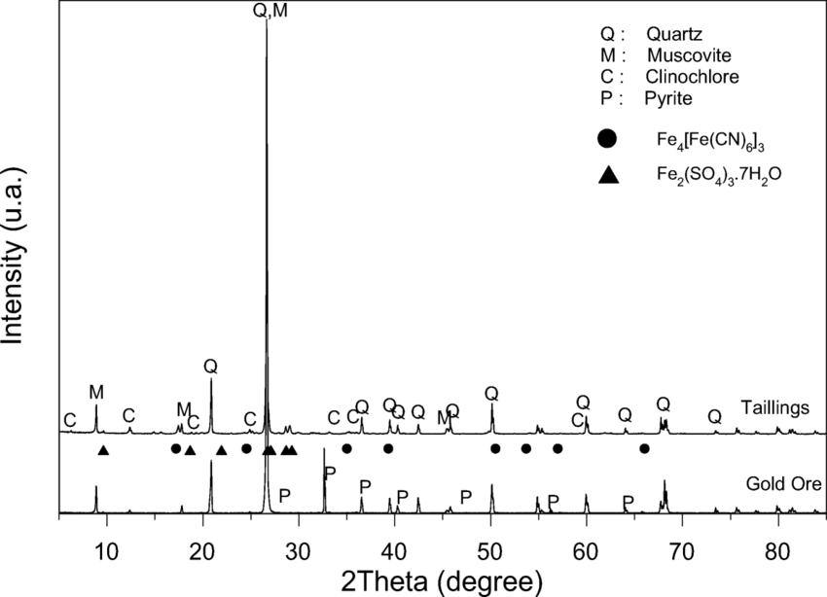
Fig. 7 - XRD analyses of the mineral content of the GMWT

The chemical composition of the GMWT shown in Table 3 indicates that SiO₂, CaO, Al₂O₃, and Fe₂O₃ constitute the major oxides in the tailings. The combined value of the major constituents of the gold mining rock tailings (SiO2 + Al2O3 + Fe2O3) is 80.37%, exceeding the ASTM C618 [34] requirement of 70% for pozzolanic materials. This indicates that GMWT has a high potential for use as a supplementary cementitious material in green concrete production. These results align with the chemical composition findings of gold tailings reported in previous studies [35; 11]. While the sum of these oxides alone does not confirm pozzolanic properties, it is a significant indicator of the material's suitability for such applications.
This clarifies that while the oxide sum is an important indicator, it is not the sole determinant of pozzolanic properties. In addition, the physical and mechanical properties of GMWT are also fulfilling the requirements of ASTM C618[34]. As shown in XRD data (Fig. 7), GMWT consists mainly of volcanic materials of amorphous structure, such as muscovite, pyrite, and quartz, with the basic composition of relatively high quartz, SiO₂, and Fe₂O₃ contents.
The main oxide content of Portland cement is CaO (43.9%) and SiO₂ (43.3%), similarly, GMWT also has CaO (14.87%) and SiO₂ (46.36%). Table 4 shows the heavy metal composition of gold tailings. The influence of these heavy metals on the fresh characteristics of concrete, as summarized in past investigations [36; 37], revealed that the presence of heavy metal ions causes delayed hydration, which can lead to a reduction in the setting time of concrete. Due to the low levels of heavy metal in the gold tailings, the aforementioned consequence was not a problem in this study.

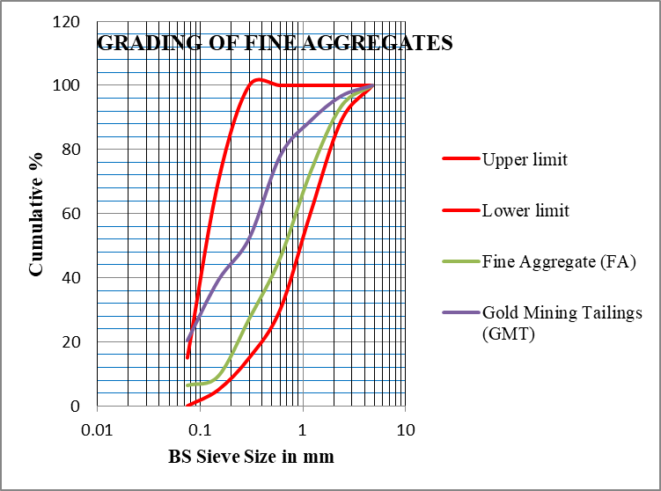
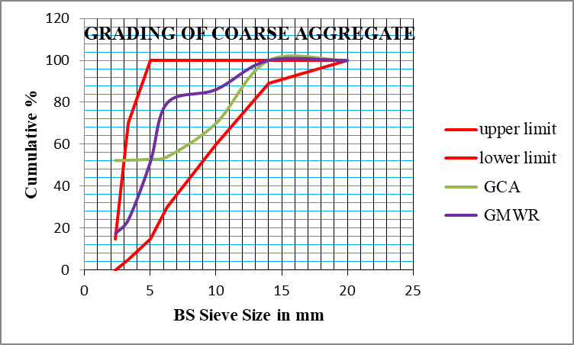
3.2. Physical properties of GMWRT

Fig. 8 - Particle size distribution (PSD) curve of concrete materials
Note: Sand as fine aggregate (FA) and goldmine tailings, gold mining waste rock (GMWR), and granite coarse aggregate (GCA)
Table 5 - Physical properties of aggregates and cement
Properties | Result
Standard consistency test | 25%
Initial setting test | 2hrs,25mins
Final setting time | 3hrs, 55mins
SG of cement | 3.10g/cc
Soundness of cement | 4mm
SG of fine aggregate | 2.45
SG of coarse aggregate | 2.72
SG of goldmine waste tailings | 2.65
SG of goldmine waste rock | 2.50
FM of fine aggregates | 3.6
FM of coarse aggregates | 5.4
FM of goldmine tailings | 2.32
FM of gold mine waste rock | 3.0
Particle Size Distribution (PSD) of the aggregates shown in Fig. 8 was revealed by the fineness Modulus (FM) of the fine aggregate, granite coarse aggregate, and goldmine waste rock and tailings in Table 5. The FM of PSD determines which zone an aggregate falls and for what construction use it could be deployed. Regarding ASTM C33/C33M [25], the study’s results on aggregates’ FM of 2.32 for tailings aggregate falls within the recommended ranges of 2.3 to 3.1, and that of the waste rock aggregate was 3.0 below the recommended range of 6.0 to 6.9.
The specific features of the internal aggregate structure and its physio-mechanical properties have a bearing on concrete strength. Consequently, metamorphic rock-quartzite coarse aggregate, like GMWR exhibits pronounced porosity which can lead to susceptibility during cube tests and potential crushing when utilized [38; 39; 40; 41]. This may have an impact on the concrete’s workability and strength [42; 43].
In terms of ASTM C33/C33M [25], the study’s results on FM of 3.6 for fine aggregate is above the recommended range, which means it is coarser sand, and that of the granite aggregate was 5.4 which is below the recommended range of 6.0 to 6.9, indicating more finer coarse aggregate. Tailings, which are generally made of fine-grained minerals, are easily workable when their fineness modulus is in Zone II as observed in this study’s results [44]. This suggests a well-graded particle size distribution, enabling fines in the tailings to fill gaps between coarser particles, enhancing cohesion and flow during mixing. Incorporating tailings as a partial replacement for fine aggregate can impact the strength of concrete. The specific characteristics of the tailings, such as mineralogy and particle shape, play a significant role in overall strength development. Proper mix design and thorough testing are essential as well as adjusting the water-to-cement ratio and using the right mix design procedures to ensure adequate strength is achieved [45]. According to [46], a greater FM for granite coarse aggregate suggests coarser particles, which might make the concrete mix harder to work with. It could be essential to add more water or chemical admixtures to maintain the desired workability. For a mix to be functional, coarse aggregates must be graded and sized properly.
Specific Gravity (SG) measures a substance’s density with the density of water, which contributes to the quality of concrete in construction. As indicated in Table 5, the SG of the fine aggregate was 2.45, and that of granite coarse aggregate was 2.72, which were both within the recommended ranges of SG of fine aggregate, 2.5 to 2.8, and SG of granite coarse aggregate, 2.6 to 2.9 ASTM C33/C33M [25], ASTM C136[47]. However, while SG of the gold mining tailings (2.54) was within the recommended range that of the waste rock (3.3) was above that of the granite coarse aggregate (2.72) and the recommended range. This may impact the density and workability of the concrete. The tailings had a comparatively high specific gravity of 2.54. They had a density comparable to other aggregates, indicating that they might be utilized in place of more traditional aggregates in concrete compositions.
Gold mine waste tailings (GMWT) have a high specific gravity (SG) because they contain heavy minerals such as pyrite and magnetite [48]. In contrast, the waste rock has a lower SG than granite coarse aggregate, leading to larger cavities within the rock mass [ASTM C188, [49]; ACI221R-14 [50]; 51; 52]. The SG of tailings in this study ranged from 2.6 to 4.4 [53]. The SG of waste rock varies significantly depending on the rock type, but an SG of 3.3, as shown in Table 5, is typical for most natural rocks. The high SG of gold tailings is due to the high concentration of SiO2 and Fe2O3. A substantial amount of water (0.6) was needed to achieve the desired consistency in the cement.
Accordingly, the standard consistency test result of 25% falls within the 25% to 35% recommended range of water in the volume needed to make a standard consistency of cement. While the final setting test result of 3 hours and 55 minutes revealed that the cement sets relatively faster, the first setting test result of 2 hours, and 25 minutes suggested that the cement had a moderate rate of setting. These characteristics had a significant role in deciding how easily the concrete could be worked during construction. Cement had an SG of 3.10, which was within the average range for Portland cement (2.8 to 3.2). This demonstrated the cement’s increased density. This can compromise its CS and workability. Cement’s soundness is a measurement of its capacity to withstand variations in volume during hydration. The cement soundness value of 0.4 cm implies it has a low chance of developing fractures or flaws [54].
3.3. Compressive Strength (CS)
Table 6 - Difference in Mean CS of control and GMWRT concrete specimens
 | Mean CS of materials (N/mm2)
Mix design | 7 days | 14 days | 28 days
Control 0% | 20.5±1.37A | 27.5±1.00A | 31.40±1.58A
Replacement 5% | 17.8±1.89AB | 22.9±0.44BC | 27.2±1.23AB
Replacement 10% | 16.3±0.88AE | 19.4±5.73AD | 24.5±0.74AC
Replacement 15% | 14.3±0.69AC | 16.6±0.87CE | 22.0±1.57AD
Replacement 20% | 11.6±0.84AD | 14.5±0.18AF | 19.7±0.89AF
Replacement 25% | 10.8±0.60AF | 15.0±0.36AG | 17.5±0.40AE
p Value | 0.000 | 0.004 | 0.000
Note: Means in the same column followed by the same letter(s) are statistically significant at (p≤0.05)

The Compressive Strength (CS) test results in Table 6 show the trend of CS for varied curing periods and percentages of GMWRT replacements in concrete production. Within the normally recommended concrete’s CS range, from 17 N/mm2 to 28 N/mm² or higher for residential and commercial structures BS EN 12390-3[31], the CS results of this study generally show that the CS values obtained from the partial substitution of GMWRT (5%, 10%, 15%, 20%, and 25%) fall within 17 N/mm² and 28 N/mm², at 28th day. Hence the use of the concrete with the waste rock and tailings from the Shaanxi gold mining firm in Tongo, Ghana is sustainable for normal construction works. Moreover, the results show that the highest CS of 31.4 N/mm² was obtained from 0% (control mix) at 28 days, which represents an increase of 13.4%, 21.97%, 29.94%, 37.26% and 44.27% over the 5%, 10%, 15%, 20% and 25% replacement of GMWRT at 28 days of 27.2N/mm², 24.50N/mm², 22.0N/mm²,19.70N/mm², and 17.50N/mm² respectively.
Furthermore, it can be observed that all the gold mining waste replacement concrete mixes recorded in this study decreased CS as the percentage of replacement increased. Furthermore, compared to the control mix, the CS of the specimens differed significantly (p = 0.000) after 7, 14, and 28 days of curing, according to statistical analysis using One-Way ANOVA. This suggests that curing time affects the CS development of concrete samples. Tukey HSD analysis revealed that, although the One-Way ANOVA indicated significant differences, not all mix designs were statistically significant compared to others (Table 6). These data imply that using GMWRT as a substitute for fine and granite coarse aggregates in concrete production might result in a decrease in CS when compared to the control group that did not use GMWRT. Generally, these findings are consistent with much experimental work that CS decreased with increasing amounts of mining tailings for different and same categories of tailings [11]. In gold tailing contexts, the inverse relationship between CS and increased amounts of gold tailing found in this study is consistent with other studies. For example, while the present study observed a reduction of up to 44.3% observed at a substitution level of 25% of GMWRT, [55] found that CS of concrete decreased with increasing percentages of GMWRT, with a reduction of up to 22% observed at a replacement level of 25%. [56] observed that the CS of concrete decreased with increasing percentages of gold tailings, with a reduction of up to 17% observed at a replacement level of 25%. [37] found concrete’s CS decline at the gold mining tailings’ 30% replacement level. [43] found that the number of total voids in concrete was significantly decreased by the fineness of the gold ore tailings and that gold mining tailings can be employed up to 20% as a replacement level in concrete production.
Similarly, [57] observed that the CS of concrete decreased with increasing percentages of gold mining waste rock and tailings, with a reduction of up to 22% observed at a replacement level of 25%. A study by [58] discovered that increasing the tailings concentration in concrete resulted in a drop in CS. Similarly, another research on the effect of iron ore tailings in concrete by [59] found that larger tailings replacement percentages reduced CS. However, it is important to note that the decrease in CS with the use of GMWRT can be mitigated by optimizing the mix proportions and curing conditions. For instance, a study by [60] investigated the effect of mix proportions and curing conditions on the CS of concrete with gold mining waste rock as a partial replacement for conventional aggregates. The study found that the use of appropriate mix proportions and curing conditions can lead to an improvement in the CS of concrete, even with the use of gold mining waste rock as a partial replacement for conventional aggregates.
These findings have two implications for the use of GMWRT in concrete manufacturing. To begin, in situations where high CS is critical, it is best to keep the proportion of GMWRT replacements as low as possible to retain sufficient strength levels. Second, further research and optimization are required to find the optimal amount of GMWRT replacements that balance both strength needs and sustainable waste material used in concrete manufacturing. Finally, to ensure good performance, the intended strength needs should be carefully considered, and the proportion of GMWRT replacement should be tuned.
3.4 Flexural Strength (FS)
Table 7 - Difference in Mean FS of control and GMWRT concrete specimens
 | Mean FS of materials (N/mm2)
Mix design | 7 days | 14 days | 28 days
Control 0% | 3.8±0.96 | 4.0±0.96 | 4.4±0.10
Replacement 5% | 3.7±0.15 | 3.8±0.21 | 4.3±0.36
Replacement 10% | 3.5±0.23 | 3.7±0.46 | 4.2±0.26
Replacement 15% | 3.3±0.13 | 3.6±0.17 | 4.0±0.56
Replacement 20% | 2.5±0.21 | 3.0±0.25 | 3.7±1.66
Replacement 25% | 2.4±0.35 | 2.7±0.03 | 3.5±0.57
p Value | 0.124 | 0.439 | 0.574
Note: p-values statistically significant at 0.05

The Flexural Strength (FS) test results in Table 7 show the trend of FS for varied curing periods and percentages of GMWRT substitution. It indicates that the control group (0% GMWRT) had the greatest mean FS after 7, 14 and 28 days of curing than all the partially replaced specimens. The results show that the highest FS value of 4.40 N/mm² was obtained from 0% (control mix) which represents an increase of 2%, 2.73%, 5.23%, 13.64%, 21.14% over the GWRT mixtures (5%, 10%, 15%, 20% & 25%) of 4.3N/mm², 4.2N/mm², 4.0N/mm², 3.7 N/mm², 3.5 N/mm² at 28days respectively. Despite these apparent differences, the one-way ANOVA test indicated that there were no statistically significant differences between the specimens at all curing times (p=0.124, p=0.439, and p=0.574 for 7, 14, and 28 days) respectively. This suggests that the FS of the specimens with GMWRT replacements were not significantly different from the control specimen.
Generally, the results imply that as the percentage of GMWRT increases, the FS tends to decrease at each curing period (7, 14, and 28 days). Thus, the FS followed a similar trend with the CS. Even though the FS decreased with an increase in the GMWRT mix proportion, there is a peak in the FS of the GMWRT (5%, 10%, 15%, 20%, and 25%) concrete that has surpassed the standard requirement value of 3.13 N/mm² according to IS 456-[61] [42]. This study’s FS results are consistent with earlier studies that utilized mining waste rocks and tailings as partial substitutes in concrete production. In this regard, [55] found that the FS of concrete decreased with increasing percentages of gold mining waste rock, with a reduction of up to 20% observed at a replacement level of 25%. Another study by [56] reported a decrease in FS of concrete with increasing percentages of gold tailings, with a reduction of up to 12% observed at a replacement level of 25%. [37] found that the FS of concrete decreased at 30% replacement level of the gold mining tailings. [43] the study revealed that there is a slight decrease in the corresponding compressive and FSs at 20% replacement. [62] showed that larger replacement percentages led to decreased FS. [63] observed that burnt bricks’ FS reduced as GMWR content increased.
These results indicate that using GMWRT as a substitute for fine and coarse aggregates in the manufacturing of concrete may have a negative impact on the FS of the finished products. These results imply that the use of GMWRT in the manufacturing of concrete must carefully consider the intended strength needs of the concrete for the given construction project. The proportion of GMWRT replacement should be kept to a minimum to ensure acceptable strength if FS is a key component in the application. The decrease in FS with the use of GMWRT can be mitigated by optimizing the mix proportions and curing conditions with admixtures. In this regard, [60] reported that appropriate mix proportions and curing conditions can lead to an improvement in the FS of concrete, even with the use of gold mining waste rock as a partial replacement for conventional aggregates.
3.6. Water Absorption (WA)

Fig. 9- Water absorption and initial rate of absorption results of GMWRT concrete
The WA of concrete contributes to the lifespan (durability) of construction structures. Concrete durability depends upon the degree of exposure, the concrete grade (or strength) and the cement content. Water absorption (WA) and initial rate of absorption (IRA) results in Fig. 9 indicate that on the 28th day WA of 5% replacement is 0.19 %, 10 % replacement had a WA of 0. 4%, 15% replacement had a WA of 0.6%, 20% replacement had a WA of 0.8%, and 25% replacement had a WA of 1.0%. Also, 5% replacement had an IRA of 0.02 kg/m²/min, 10% replacement had a 0.04 kg/m²/min, 15% replacement had a 0.06kg/m²/min, 20% replacement had a 0.08 kg/m²/min, and 25% replacement had a 0.1 kg/m²/min. From the WA and IRA trend in Fig. 11, it can be observed that WA and IRA for the 5% to 25% GMWRT-based concretes were generally higher than those of normal concrete (0%) but lower than the recommended threshold of 1.5% [64]. In coastal areas, concrete with a WA of less than 2% is deemed durable for construction projects with a fifty-year design life [64]. Therefore, it is suitable to use these materials to develop concrete for the construction industry. These findings are consistent with those of previous studies [65;18]. [18] found that fine particles from GMWRT were likely to fill micro-voids in the concrete, resulting in reduced 28-day water absorption (WA) and initial rate absorption (IRA).
4. Conclusion and summary of findings
Since there is significant diversity in the chemical compositions of tailings from different sources in different countries, even within a particular kind of tailing [11], it means more research is needed to understand the scientific nature and potential use for each specific kind of gold tailings. This experimental work was aimed at investigating the potentiality of using GMWRT generated by Shaanxi mining firm operations in Tongo in the Upper East Region of Ghana as a partial replacement of fine and coarse aggregate in concrete production. The findings of this study are summarised as follows:
- In terms of chemical composition, the GMWRT material is inert and primarily composed of SiO₂, CaO, Al₂O₃, MgO, and Fe₂O₃. The combined value of the major constituents of the gold mining tailings is SiO₂ + Al₂O₃ + Fe₂O₃ is 80.37%, which exceeds the 70% pozzolanic material requirement (ASTM C618). Therefore, the GMWT can be considered a suitable pozzolanic material for use as supplementary cementitious materials in green concrete production. The results are consistent with many previous studies [35; 11].
- The GMWT has a specific mass of 2.54g/cm³, slightly higher than sand’s 2.45 g/cm³. Importantly, the GMWT material does not require any additional treatment and can serve as a substitute for natural sand in concrete. Interestingly, there is no substantial difference in the utilization of river sand or GMT in terms of performance. Moreover, incorporating GMWRT fractions into concrete not only produces a more sustainable material but also offers potential cost savings for the mining industry involved in tailings disposal through collaborations with the concrete industry for aggregate procurement.
- Particle size distribution of fine aggregate and granite coarse were better than the gold mining tailings and waste rock aggregates respectively, though both samples were within the recommended ranges.
- For the CS, as the percentage of GMWRT replacement increased, the CS of the concrete mixtures decreased. The CS of the control mix was higher than the five GMWRT mixtures. Furthermore, compared to the control mix, the CS of the GMWRT specimens differed significantly after 7, 14, and 28 days of curing, confirming the assertion that curing time affects the CS development of concrete samples [66;67;68]. Despite this trend, the CS of the five GMWRT specimens falls within the recommended 17 N/mm² and 28 N/mm², at 28 days BS EN 12390-3 [31]. Hence, up to 25% substitution of the GMWRT from the Shaanxi gold mining firm in Tongo, Ghana can be used for concrete production for normal construction works. To ensure good performance, the intended strength needs should be carefully considered to the proportion of GMWRT replacement.
- The flexural strength decreased with increased GMWRT mix proportions at each curing time. Although the FS of the control mix was higher than the five GMWRT mixtures, there was no statistically significant difference between them after 7, 14, and 28 days of curing. The FS of the five GMWRT specimens surpassed the standard requirement value of 3.13 N/mm² according to IS 456-[61] [42]. Overall, the research highlights the superior FS achieved by utilising GMWRT as partial replacements in concrete, surpassing standard expectations. These findings support the practical application of such concrete mixtures in various construction projects with up to 25% substitution of GMWRT. To mitigate the decrease in FS using GMWRT, admixtures can be applied to the mix proportions and curing conditions to optimise the concrete’s FS.
- For water absorption (WA), concretes made with GMWRT coarse aggregate showed greater potential for durability in terms of resistance to chloride attack. Despite that WA and IRA for the 5% to 25% GMWRT-based concretes were lower than the recommended threshold of 1.5% [64], a WA of less than 2% is deemed durable for construction projects with a fifty-year design life [64] in coastal areas. Therefore, GMWRT is suitable to use to develop concretes for the construction industry in many coastal areas in Ghana.
- Overall, this study’s findings support the viability of incorporating GMWRT in concrete mixtures. These results suggest that the use of GMWRT in concrete production can contribute to the development of durable concrete suitable for the construction industry.
References
[1]- M. Sandanayake, Y. Bouras, R. Haigh, Z. Vrcelj, Current sustainable trends of using waste materials in concrete—a decade review, Sustainability 12 (22)(2020)9622.
[2]- M.A. Etim, K. Babaremu, J. Lazarus, D. Omole, Health Risk and Environmental Assessment of Cement Production in Nigeria. Atmosphere, (2021) 12,1111. doi:10.3390/atmos12091111
[3]- A. Demissew, Comparative Analysis of Selected Concrete Mix Design Methods Based on Cost-Effectiveness. Advances in Civil Engineering, (2022) 4240774doi:10.1155/2022/4240774
[4]- W. Yifru, N. Getu, D. Kifle, A. Mesfn, A. Sewunet, & M. Tamene, Effects of Corn Cob Ash as Partial Replacement of Cement for Stabilization of an Expansive Clay. Advances in Civil Engineering, 2022, Article ID 6788120, (2022) 13 pages doi:10.1155/2022/6788120
[5]- S. Ahmad, O.S. Baghabra, Al-Amoudi, S.M.S. Khan, M. Maslehuddin, Effect of silica fume inclusion on the strength, shrinkage and durability characteristics of natural pozzolan-based cement concrete, Case Stud. Constr. Mater. 17 e01255, (2022) doi:10.1016/j.cscm.2022.e01255.
[6]- M.N. Amin, W. Ahmad, K. Khan, M.M. Sayed, Mapping research knowledge on rice husk ash application in concrete: a scientometric review, Materials 15 (10) (2022) https://doi.org/10.3390/ma15103431
[7]- M. Antoun, C.A. Issa, G. Aouad, N.Gerges Sustainable masonry blocks: olive wood waste as substitute for fine aggregates, Case Stud. Constr.Mater. 15 e00590 (2021) doi:10.1016/j.cscm.2021.e00590.

[8]- Z. Fang, Wu, Y. X. Li, & Zhang, Z. Utilization of waste materials as alternatives to natural aggregates in cement and concrete: A review. Construction and Building Materials, 268, (2022) 124794.

[9]- K. Pires, J. Mendes, V. Figueiredo, F. Silva, F. Kruger, C. Vieira, Mineralogical characterization of iron ore tailings from the Quadrilatero Ferrifero, Brazil, by eletronic quantitative mineralogy. Mater Res (2022)
[10]- Y. B. Dibike, A. Shakibaeinia, I. G.Droppo, & E. Caron. Modelling the potential effects of Oil-Sands tailings pond breach on the water and sediment quality of the Lower Athabasca River. Science of the total environment 642, (2018) 1263-1281.

[11]- M. Gou, L. Zhou, & N. W. Y Then, Utilization of tailings in cement and concrete:A review. Sci Eng Compos Mater (2019) 26(1) 449–464doi:10.1515/secm-2019-0029
[12]- X.D. Lv, W.G.L. Wang, Y. Dong, J. F. Zhang, Z.Q. Xie, "A comparative study on the practical utilization of iron tailings as a complete replacement of normalaggregates in dam concrete with different gradation." Journal of Cleaner Production 211 (2019) 704-715.

[13]- A.K Saha, M.N.N. Khan, P.K Sarker. Value added utilization of by-product electric furnace ferronickel slag as construction materials: A review, Resources Conservationand Recycling 134 (2018) 10-24.

[14]- J.N. Sant’ana, S.N. Da Silva., G.C. Silva, R.A.F. J.C. Mendes, Peixoto, Technical and Environmental Feasibility of Interlocking Concrete Pavers with Iron Ore Tailings from Tailings Dams, Journal of Materials in Civil Engineering (2017) 29(9)

[15]- R. Argane, M. Benzaazoua, R. Hakkou, A. Bouamrane A comparative study on the practical use of low sulfide base-metal tailings as aggregates for rendering and masonry mortars, Journal of Cleaner Production 112 (2016) 914-925.
[16]- A.E. Machi, S. Mabroum, Y. Taha, A. Tagnit-Hamou, M. Benzaazoua. and R. Hakkou, Use of Flint from Phosphate Mine Waste Rocks as an Alternative Aggregates for Concrete. ConstructionandBuildingMaterials,271,(2021)ArticleID:121886.doi:10.1016/j.conbuildmat.2020.121886

[17]- M. Janadi, N. Al-Akhras, & K.Al-Akhras, Performance of concrete incorporating waste rocks as partial replacement of fine aggregates. Construction and Building Materials, 254, (2022) 124570.

[18]- L.K. Gupta, A.K. Vyas, Impact on mechanical properties of cement sand mortarcontaining waste granite powder. Construct. Build. (2018) Mater.191,155–164 doi:10.1016/j.conbuildmat.2018.09.203.

[19]- H.E. Yücel, M. Dutkiewicz, F.Yıldızhan, The Effect of Waste Ballast Aggregateson Mechanical and Durability Properties of Standard Concrete. Materials, 16, (2023) 2665 doi:10.3390/ma16072665

[20]- M. Edraki, T. Baumgartl, E. Manlapig, D. Bradshaw, D.M. Franks., C.J.Moran, Designing mine tailings for better environmental, social and economic outcomes: a review of alternative approaches, Journal of Cleaner Production 84 (2014) 411-420.
[21]- F. Muleya, B. Mulenga, S. Zulu, S. Nwaubani, C. Tembo, and H.Mushota, Investigating the suitability and cost-benefifit of copper tailings as partial replacement of sand in concrete in Zambia: An exploratory study. Journal of Engineering, Design and Technology ISSN(2020)1726-0531 doi:10.1108/JEDT-05-2020-0186

[22]- S.H. Yin, L.M. Wang, A.X. Wu, E. Kabwe, X. Chen., R.F. Yan, Copper recycle from sulfide tailings using combined leaching of ammonia solution and alkaline bacteria, Journal of Cleaner Production 189 (2018) 746-753.

[23]- Ghana Standards Authority, GS 1118: Building and Construction Materials - Composition, Specifications and Conformity Criteria for Common Cemments, Ghana Standards Authority (2016) Accra, 2016.

[24]- BS882, (1992). “specification for aggregate from natural sources for concrete”

[25]- American Society for Testing and Materials. (2008). ASTM C33/C33M-08: Standard specification for concrete aggregates. West Conshohocken, PA: ASTM International

[26]- British Standards Institution. (1980). BS 3148: Specification for water for making concrete. British Standards Institution

[27]- BS EN 14488-4:2005 + A1:2008:Testing sprayed concrete - Part 4: Determination of thickness. British Standards Institution

[28]- BS EN 12390-7, Testing hardened concrete. Density of hardened concrete, British Standards Institution, London, (2009)

[29]- BS EN 12390-5:2009. Testing hardened concrete -FS of test specimens.London: British Standards Institution
[30]- ASTM International. (2019). ASTM C 309-19 Standard Specification for Liquid Membrane-Forming Compounds for Curing Concrete.
[31]- British Standards Institution. (2019). BS EN 12390-3:2009. Testing hardened concrete - CS of test specimens.London: British Standards Institution.
[32]- BS 1881-122:2011 Testing concrete Part 122: Method for determination of water absorption. BSI Standards Publication
[33]- Standards Australia and Standards New Zealand. (2003). Masonry units and segmental pavers and flags - Methods of test - Determining initial rate of absorption (suction). AS/NZS 4456.17. Sydney, NSW: SAI Global Limited.

[34]- ASTM International. (2019). ASTM C618; Standard Specification for Coal Fly Ash and Raw or Calcined Natural Pozzolan for Use. ASTM International: West Conshohocken, PA, USA.
[35]- J. Balegamire, J.Kiremire, & W.Kansiime, (Utilization of gold mine tailings as a sustainable concrete aggregate. Journal of Cleaner Production, 334,2022) 133060.
[36]- F.S.Hashem, M.S. Amin, & E.E. Hekal, Stabilization of Cu (II) wastes by C3S hydrated matrix. Constr. Build. Mater. 25 (8)(2003) 3278e3282. https://doi.org/ 10.1016/j.conbuildmat.2011.03.015.
[37]- B.M.R. Reddy, K.S. Satyanarayanan, H.N. J. Reddy, N.Parthasarathi, Use of gold mine tailings in production of concrete-a feasibility study. Int. J. Earth Sci. Eng. 9 (3), (2016)197e202.
[38]- J.T. Buertey, F. Atsrim, W.S. Ofei, An Examination of the Physiomechanical Propertiesof Rock Lump and Aggregates in Three Leading Quarry Sites near Accra. Am. J. Civ.Eng. 4(6): (2016) 264-275.
[39]- M. Gambir. Concrete technology. New Delhi: McGraw Publishing Co. Ltd (2006).
[40]- T Young, S. Sam Performance of Concrete Containing Engine Oil. Kuala Lumpur (2008):Thesis Submitted to the University of Kuala Lumpur, (Department of Civil Engineering).
[41]- C. Aginam, C. Chidolue, C. Nwakire Investigating the Effects of Coarse Aggregates Types on The CS Of Concrete. Int. J. Eng. 3(4): (2013) 1140-1144.
[42]- Khan, Moiz, Suresh G Patil, and S H Vaggappa. “Preparation of Concrete Using Goldmines Waste.” 14(5): 20–25.Prod. (2017) 126946.
[43]- A.V. Preethi, S Rajendra, Navneeth, and L P Pawan Kumar “Studies on Gold Ore Tailings as Partial Replacement of Fine Aggregates in Concrete.” International Journal of Latest Technology in Engineering, Management & Applied Science VI(Iv): (2017) 30–32.
[44]- A. S. Rathor, M. Pradhan, & S. V. Deo, Assessment of Coal Mine Overburden Sand for Use in Concrete Making As Fine Aggregate. International Journal of Advanced Research in Engineering and Technology, (2020) 11(9).
[45]- C. Shi, Z. Wu, K. Lv, & L.Wu, A review on mixture design methods for self-compacting concrete. Construction and Building Materials, 84, (2015) 387-398.
[46]- B. M. Aïssoun, S. D. Hwang, & K. H. Khayat, Influence of aggregate characteristics on workability of superworkable concrete. Materials and Structures, 49, (2016). 597-609.
[47]- ASTM International. (2006). ASTM C136: Standard Test Method for Sieve Analysis of Fine and Coarse Aggregates (2498). ASTM International, West Conshohocken, PA. Retrieved from www.astm.org.

[48]- K. Dong, F.Xie, W.Wang, Y. Chang, C. Chen, X. Gu, Calcination of calcium sulphoaluminate cement using pyrite-rich cyanide tailings. Crystals 10 (11), (2020) 971.
[49]- American Society for Testing and Materials. (2003). ASTM C188: Standard test method for density of hydraulic cement. West Conshohocken, PA: ASTM International.
[50]- American Concrete Institute, ACI 221R-14: Guide for Use of Normal Weight and Heavyweight Aggregates in Concrete. Farmington Hills, MI: American Concrete Institute.
[51]- E.Hoek, Practical Rock Engineering. CRC Press 2014(2007)
[52]- D. W. Kappes, & G.Hilson, The Extractive Metallurgy of Gold. John Wiley & Sons (2018)
[53]- R. S. Dimitrova, & E. K. Yanful, Factors affecting the shear strength of mine tailings/clay mixtures with varying clay content and clay mineralogy. Engineering Geology, 125, (2012) 11-25.
[54]- A.M. Neville, and , J.J Brooks, Concrete Technology. 2nd Edition. Pearson Education Ltd., London (2010)
[55]- M.Cheyrezy, & D.Fowler, Performance of waste materials in concrete: Gold tailings and waste rocks. Journal of Materials in Civil Engineering, 24(12), (2012) 1579-1587.
[56]- A.K. Jha, P.V. Sivapullaiah, Mechanism of improvement in the strength and volume change behaviour of lime stabilized soil. Eng. Geol. 198(2015) 53–64.
[57]- S. Akçaözoğlu, & M. Tokyay, Utilization of gold tailings as an additive in Portland cement. Journal of Materials in Civil Engineering, 29(2), 04016218.Engineering, 27(7), (2017) 04014207.
[58]- D. Tavakoli, M. Hashempour, & A. Heidari, Use of waste materials in concrete: A review. Pertanika J. Sci. Technol, 26(2), (2018) 499-522
[59]- Y. Zhang, Y. J. Li, Wang, & H. Zhang, Effect of iron ore tailings on the properties of concrete. Construction and Building Materials, 186, (2018) 281-289. doi:10.1016/j.conbuildmat.2018.04.190.
[60]- M. N. Prasad, D. Sathyan, K. Mohan, & G. Reddy, Influence of mix proportion and curing (2016)

[61]- IS 456: 2000, “Plain and reinforced concrete – code of practice”
[62]- D.Wang, Y. Xue, Z. Huang, & Y.Tang, Utilization of gold tailings as an additive in Portland cement. Construction and Building Materials, 174, (2018a) 77-84.
[63]- A. Benahsina, Y. Taha, R. Bouachera, M..Elomari, & M. A. Bennouna, Manufacture and characterization of fired bricks from gold mining waste rocks. Minerals, 11(7), (2021) 695.

[64]- T. Ahmed, M. Elchalakani, H. Basarir, A. Karrech, E. Sadrossadat, & B. Yang, Development of ECO-UHPC utilizing gold mining tailings as quartz sand alternative. Cleaner Engineering and Technology, 4, (2021)100176.
[65]- W. Zhang, X. Gu, J. Qiu, J. Liu, Y. Zhao, & X. Li, Effects of iron ore tailings on the compressive strength and permeability of ultra-high performance concrete. Construction and Building Materials, 260, (2020b) 119917.
[66]- S. A. Azeez, M. N. Sulaiman, M. A. Mustapha, & A. Abdullahi, Effect of Curing Methods on the Compressive Strength of Concrete. International Journal of Civil Engineering and Technology, 11(1), (2020) 227-237
[67]- R. Kumar, V. Singh, & A. K. Yadav, The influence of specific gravity on the strength and durability of concrete. Construction and Building Materials, 224, (2019) 759-767.
[68]- H. Zhang, Z. Chen, & Y. Wang, Effect of curing time on compressive strength of composite cement concrete. Construction and Building Materials, 68, (2014) 228-235.

