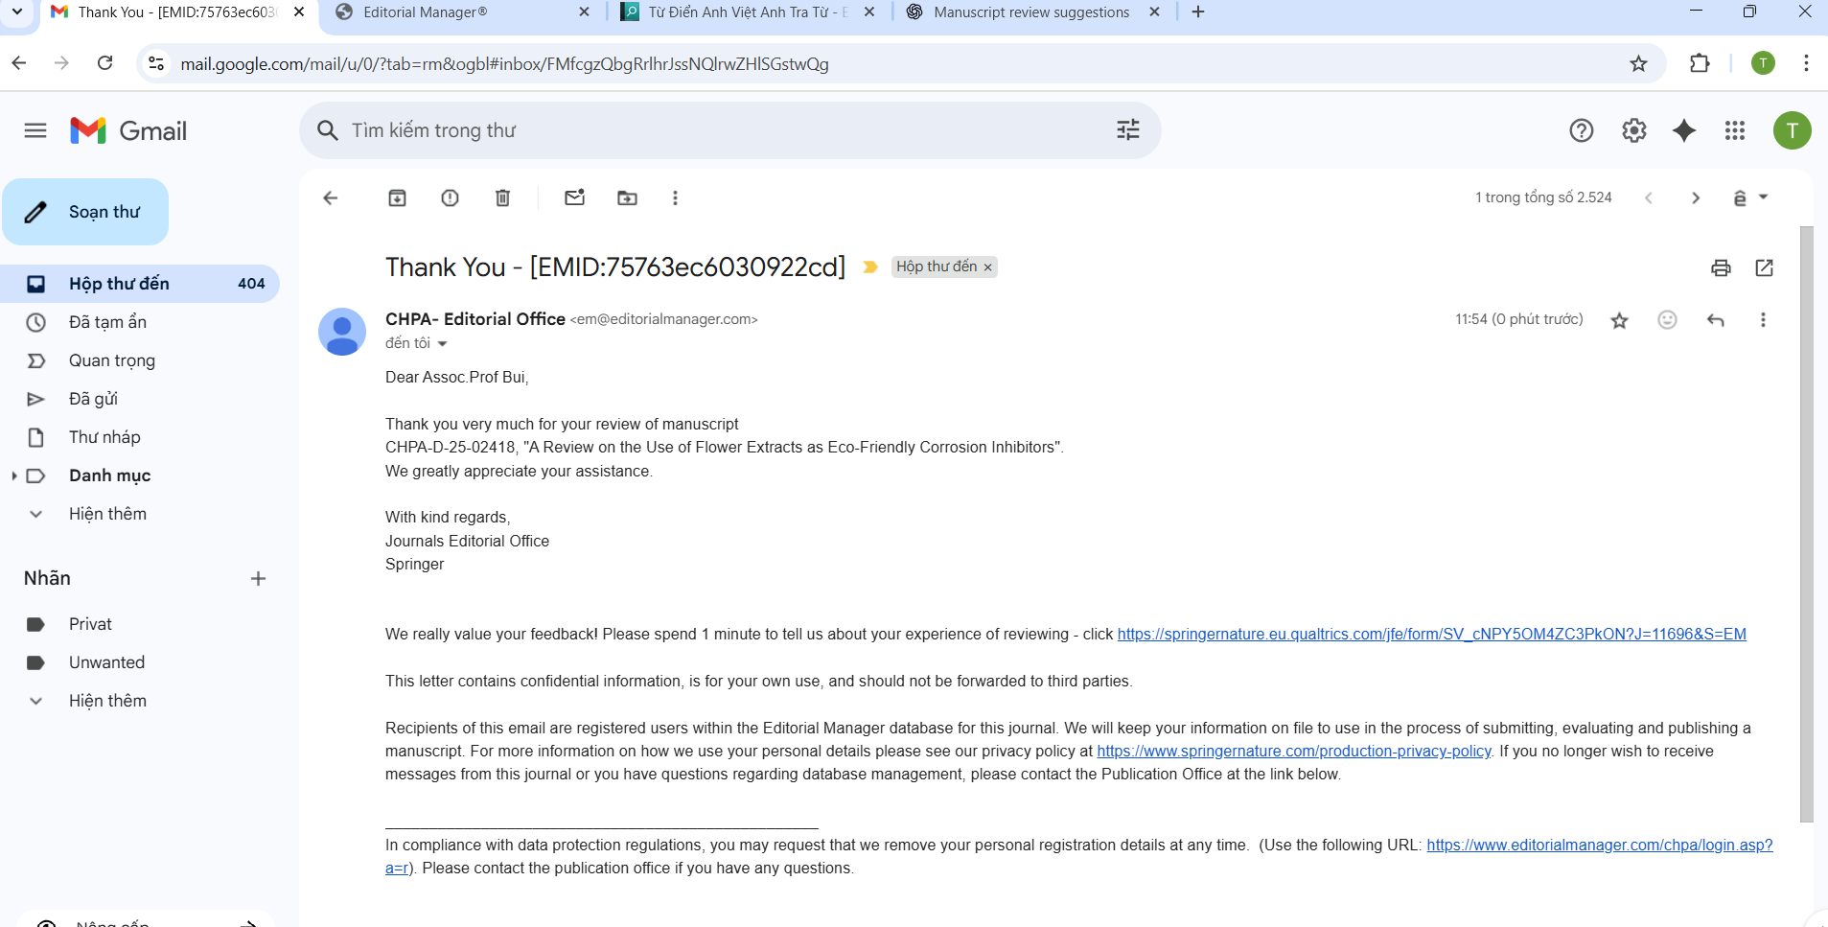Review for Manuscript CHPA-D-25-02418
Dear Editor,
The article addresses an important and timely topic: the use of active ingredients extracted from flowers to develop anti-corrosion materials. This approach is aligned with the principles of green chemistry, which is currently of global interest. The study is interesting and relevant; however, several improvements are necessary to enhance its clarity, organization, and scientific contribution.

Overall Evaluation
The manuscript has potential to make a valuable contribution to the field of green chemistry and sustainable materials. However, in its current form, the structure and depth of discussion are insufficient. Significant revisions are needed before the article can be considered for publication.

Major Comments
- Organization:
The main body should be divided into smaller, logical sections for better readability. Suggested classifications include:
  - By flower type or plant source.
  - By chemical composition of the extracted compounds.
  - By the specific materials or environments requiring corrosion protection.
- Additional Sections:
The manuscript would benefit from including:
  - Methods for extracting the anti-corrosion active ingredients.
  - Techniques for modifying or blending these active compounds.
  - A discussion of the proposed anti-corrosion mechanisms.
- Economic Analysis:
Provide an assessment of the cost associated with using flower-derived active ingredients for anti-corrosion purposes.
- Comparison with Conventional Methods:
Include a comparative analysis of the economic and technical efficiency between the bio-based solutions and traditional anti-corrosion materials.

Recommendation
Major Revision Required.
The topic is promising and relevant, but substantial restructuring and additional analysis are necessary to meet the journal's standards and enhance the manuscript's scientific impact.

Yours sincerely,
Thuy Thi Le Bui

