TRƯỜNG ĐẠI HỌC MỎ - ĐỊA CHẤT
BỘ MÔN TỰ ĐỘNG HOÁ
***************

BÁO CÁO HỌC THUẬT
Học kỳ I, năm học 2024-2025

“PEDESTRIAN TRAJECTORY ESTIMATION AND PREDICTION”

Người thực hiện: TS. Phạm Thị Thanh Loan
PGS. TS. Khổng Cao Phong
TS. Đào Hiếu

Hà Nội, 9/2024

I. Introduction
As part of the modernization of Samsung’s manufacturing plants in Vietnam, Samsung wants to implement autonomous robots capable of transporting products from one end of the plant to the other. The goal is to use robots that are safe, adaptive, programmable, and easily controllable.
The interactions between autonomous transport robots and humans are essential for successful integration at manufacturers like Samsung. These robots must be able to communicate effectively with human operators and adapt to their actions and changes in the environment. Sophisticated communication systems, such as intuitive user. interfaces and visual or audio signals, allow robots to signal their presence and coordinate their movements with those of workers. For example, when a robot approaches an area where employees are working, it can slow down or change its route to avoid collisions, thus ensuring harmonious coexistence.
Thus, the autonomous machine must be able to continuously analyze its environment in order to calculate a correct trajectory avoiding any risk of collision. The robot must therefore have a complete navigation system with its own sensor network (3 2D Lidar radars positioned at 120 degrees each on the robot) and a trajectory anticipation system in which my internship is included.
Autonomous transport robots represent a major economic challenge for modern industries. Their ability to move autonomously optimizes internal logistics, reducing labor costs and increasing operational efficiency. By automating the transport of materials and products, these robots reduce the need for human intervention in repetitive tasks, which reduces errors and improves precision. This automation contributes to a reduction in production costs and an increase in overall productivity.
Autonomous robots also enable better inventory management and reduced waiting times, which improves the fluidity of manufacturing and distribution processes. They can operate 24 hours a day, increasing production capacity without requiring breaks or periods of inactivity, which optimizes the use of resources. This research will be accompanied by a scientific method for comparing the different algorithms and techniques to make this prediction. It is important to note here that neither the detection nor the method of measuring the positions of the human (which can be called the target in accordance with the literature written on the estimation of the trajectory of an external actor) were the subject of the research.
II. The content of the research
1. Literature review
This research has a dual objective, both to do research work and to discover a research environment. Thus in such an environment, the calls for creativity, autonomy organization, discipline, critical thinking are multiple. In line with these requirements, the degree of initiative is high, even complete. So to speak, carrying out research whose specificities are known only to the researcher makes the researcher dependent on the level of initiative authorized by the employer.
Consequently, in order to allow this research to be carried out in the best possible conditions, the initiative was total. Conditioned not by the employer, the degree of initiative then depends only on the research structure, the means and physical resources.
In our case, the solutions were thus limited by the power of the robot's processor and by the unfortunately weak financial means of the laboratory. These weak means restricted the space of solutions but also questioned the possibility of carrying out research with weak means.
*) The Missions of research
The main mission is the meticulous study of the literature on the estimation and anticipation of humans in an environment unknown to the robot. This study is
supplemented by the methodical comparative analysis of several solutions. Then make proposals for implementing the method best suited to the problem by managing as much as possible the robot's already heavily used computing resources. Added to this is the integration into a young Vietnamese team that has worked very little with Europeans. Thus the component of sharing methods in skills between the two educations was very important for both parties.
2. The research methods
The methodology was based at best on a rigorous approach as close as possible to the academic research process. First of all, an intense 10/19 week session of ibliographic research with the following main keywords: Pedestrian anticipation – Tracking manoeuver target - Estimation of state vector - Bayesian filtering - Monte Carlo statistics. This was followed by Python code to implement and test the different algorithms, which lasted 6/19 weeks. This phase was accompanied by many back and forths between theory and practice to confirm the quality of the programs.
The rest of the weeks consist of welcome times, writing reports and the technical file. Which represents 3/19 weeks
3. Procedure
Once the scientific documents have been read, it is necessary to tackle the tests. For this, there were several models and filters to test. First of all, the elementary models such as the CV, CT or CA models which have been used in many papers on the subject (See the technical file which accompanies in pdf). Then for each basic model we can use a filter or not, when it comes to the filter, the Kalman filter was used for its qualities of best filter adapted to the problem of
minimizing the quadratic error. Even outside the hypotheses of the Kalman filter
(Gaussian probability densities, linear system, ...) it remains the most used filter /
estimator for this type of problem. The particle filter was also considered, but the low power of the robot's processor makes it ineffective.
Finally, the possibility of testing several filtered models at the same time was explored with the famous IMM algorithm (see details in the technical file).
So each of these algorithms was tested and compared, for this several random walks
were recorded in the room using a camera. Every 0.1s a recording using the distance
measurement algorithm was made. Then the algorithms made predictions of the next
steps from the previous ones and we could measure the gap between the prediction and the step. So at each point we predicted the next 4 to measure the prediction gap at 0.4s of time.
For each model, their predictions at 0.1s, 0.2s, 0.3s and 0.4s are compared. Some models were found to be better for very short periods of 0.1s. And others are more efficient in the longer term. Most of the time a model that performs very well in the long term performs well in the short term and the opposite has not been observed.
Once the measurements were made, we could apply the “Kernel Density Estimator” algorithm to have an estimate of the probability density function of the error. This allows us to have a visual result to compare the models. This algorithm allows us to visually remove large prediction errors. These errors were not representative of 99% of the other measurements, they were removed by the KDE algorithm. Thus the KDE algorithm eliminates these differences to visually compare the results of the algorithms. Then an algorithm was applied to compare the two curves using the integral. Finally, the curves output from the KDE will be presented here to observe the differences. Thus, the comparison results of the different models follow, note that visually we must look at the spatial distribution of the peaks, the closest to 0 on the x-axis and the highest possible they must be
4. The results
We will define the word “model” in this part as the combination of a
physical/mathematical model (CV, CA, CT) with a filter (Kalman or particle). In the following graphs, several models will be compared. For a model to be considered
better than another, the area between 0 and x (x in [0, 0.5]) must be larger than its
neighbor. For example, if we plot cos(x) and sin(x) between 0 and 1, in this logic, cos(x) will be better because its area between 0 and 0.5 is always larger than sin(x) [justification at the end of the document].
Applying this logic may seem obscure but it allows us not to assume the distribution of the error as Gaussian and therefore not to take into account only the mean and the standard deviation to compare two models
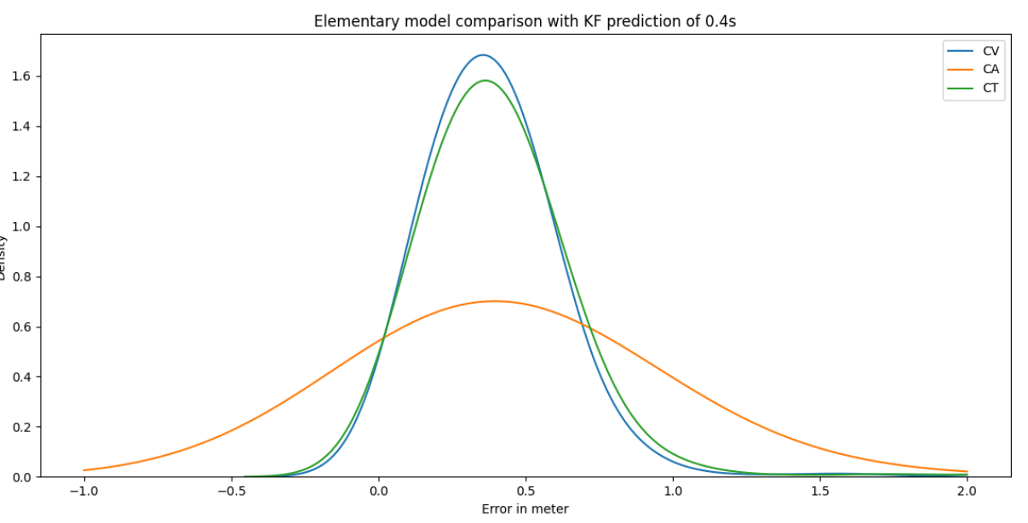
Fig. 1 Differences between base models
Here we observe the difference between the basic models (equipped with a Kalman filter with a large operating noise). We can see quite easily here that the CV model has a lower error than the other two. Indeed for any x between 0 and 0.5m, the CV probability density curve is higher than the others.
If the curve goes below 0 on the x axis, it is because the algorithm does not restrict the probability density to positive numbers. Thus the points before 0 should not be considered since they do not give additional information.
We can also notice that there are errors beyond one meter, this is because the algorithm is not optimal, it is just a question here of comparing different models.
*) Process noise influence
First we studied the difference for each of the elementary models (CV, CA, CT [See technical file]) on the prediction with different operating noises with a prediction at 0.1s. The operating noise represents for the model its confidence in the mathematical model in the absence of measurements. Thus a high operating noise will force the Kalman filter to listen more to the measurements than to its mathematical model.
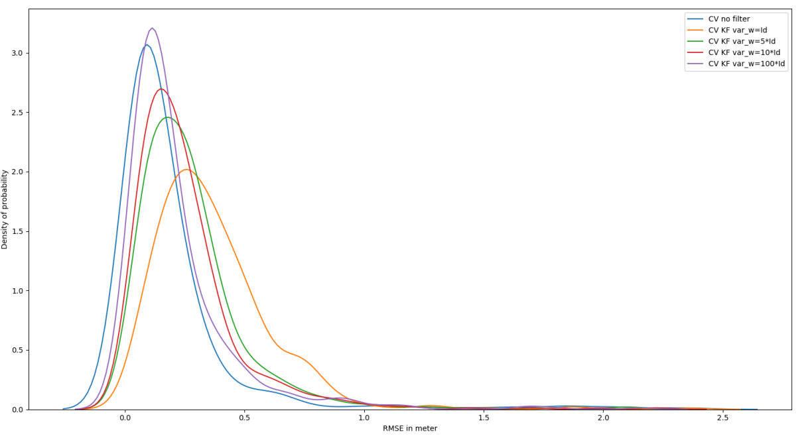
Fig2. CV model with and without Kalman filter prediction at 0.1s
As we can see, for the basic models. The performance depends a lot on the operating noise or process noise in English. Thus, for the CV model, a large operating noise is required. When we remove the Kalman filter to put no filter, this corresponds to an infinite operating noise where we believe 100% of the measurement and 0% of the model (See the technical file for more justifications).
This result is logical since we compare the prediction with the measurement. Thus, the more the model “believes” the measurement in favor of the mathematical model, the more it will predict measurements close to those recorded by the sensor. Note that these results are obtained by producing only one step and that when we predict 4 steps (or 0.4s) the Kalman filter with a process noise of 100 outperforms the model without a filter assumed with an infinite process noise for the 3 basic models. See the next part.

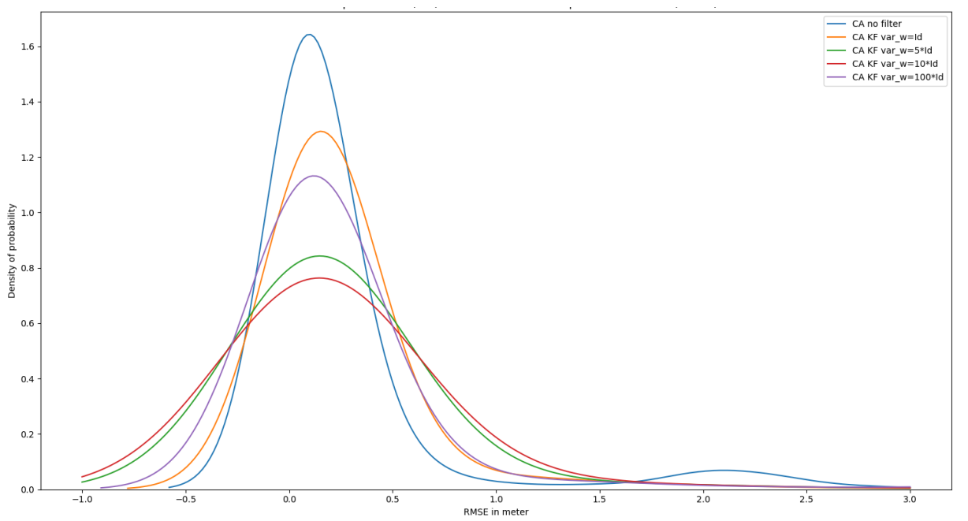
Fig3. CA model with and without Kalman filter prediction at 0.1s

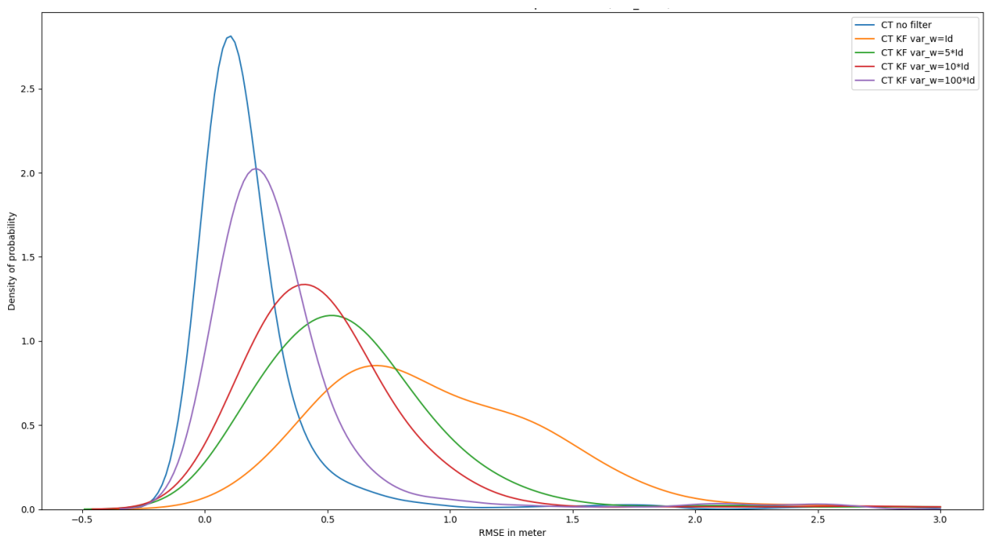
Fig4. CT model with and without Kalman filter prediction at 0.1s
*) Differences between filtered and unfiltered
Another result of the study conducted is the difference between the Kalman filter and the unfiltered mathematical model alone. Thus we can see that depending on the prediction horizon, one is more favorable than the other. (4 step ahead means prediction at 0.4s, 3 step prediction at 0.3s, …).
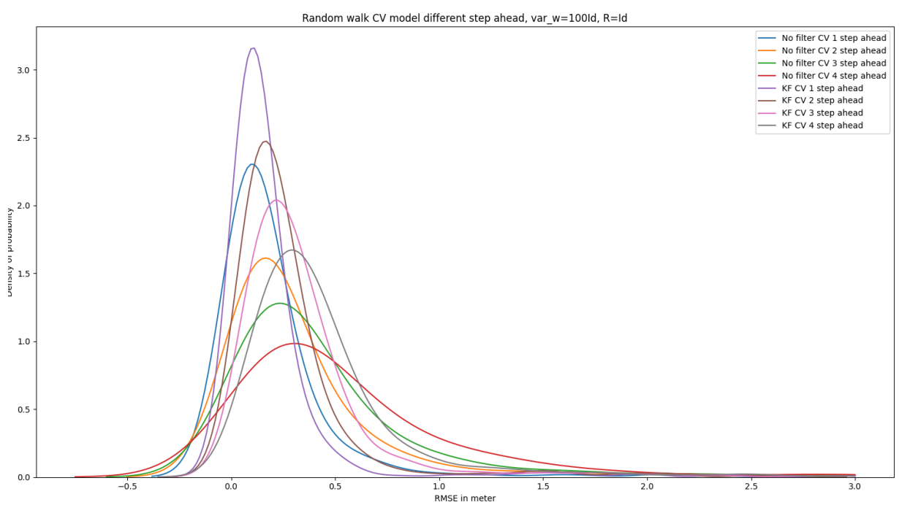
Fig5. CT model with Kalman filter
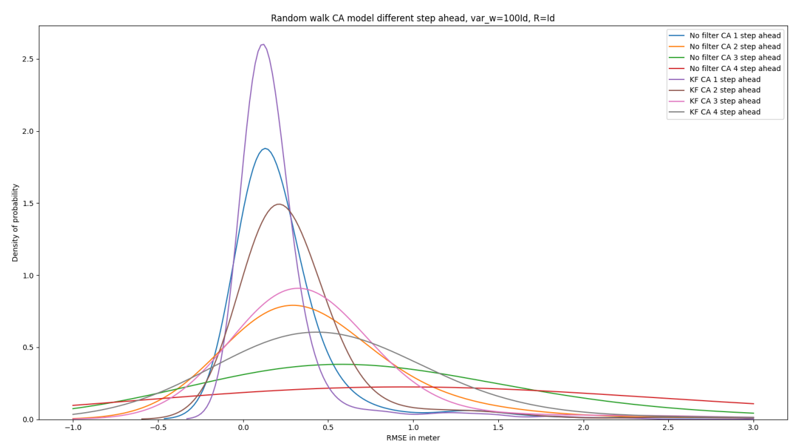
Fig6. CT model without Kalman filter

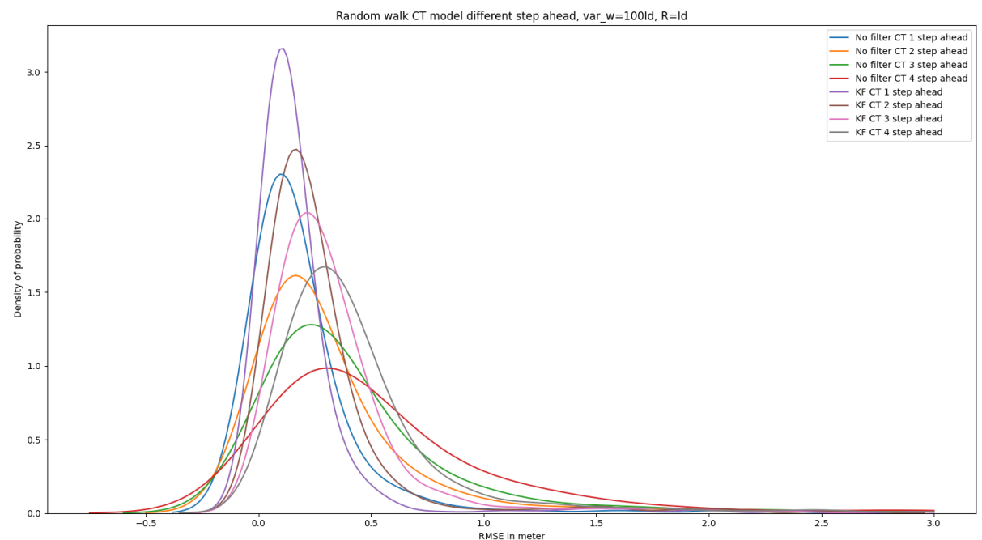
So looking at these graphs we observe that the more the prediction horizon increases, the more the Kalman filter will be interesting compared to the unfiltered mathematical model.
*) Measurement noise influence
Conversely with the operating noise, the measurement noise will give an indication to the filter to what extent it can believe that the position measurement is close to the true value. Thus a high measurement noise will force the model to believe its mathematical model (CV, CA, CT) more than the measurement.
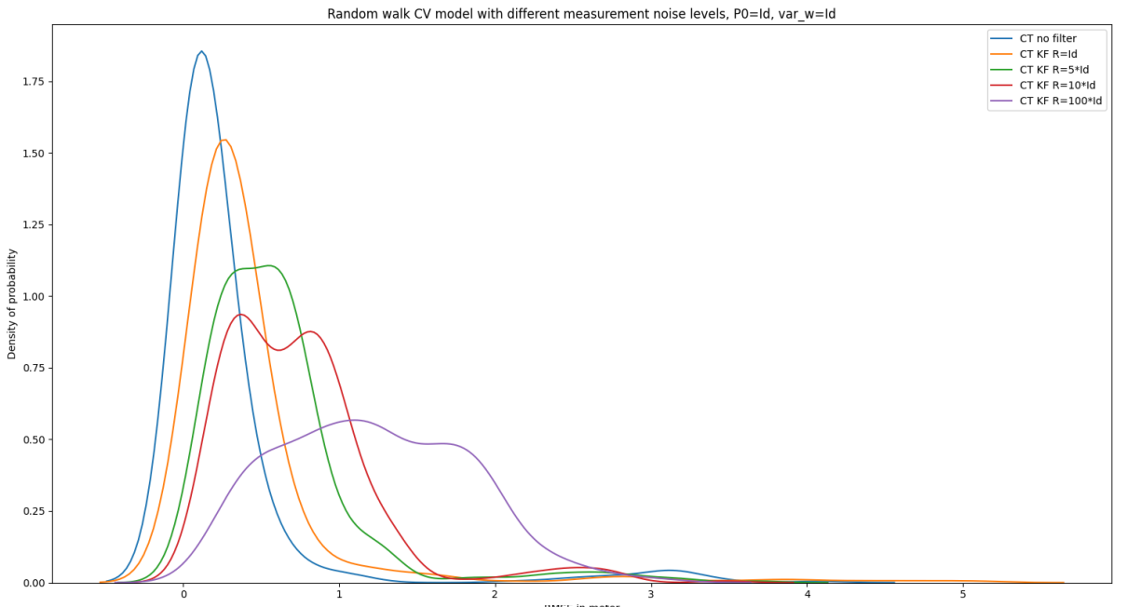
Fig7. Random walk CV model with different measurement noise level
However, for this problem we consider that the measurement is true, so we see that the more we lower our measurement noise, the more we realize that the error decreases. All the following predictions are at a horizon of 0.1s.
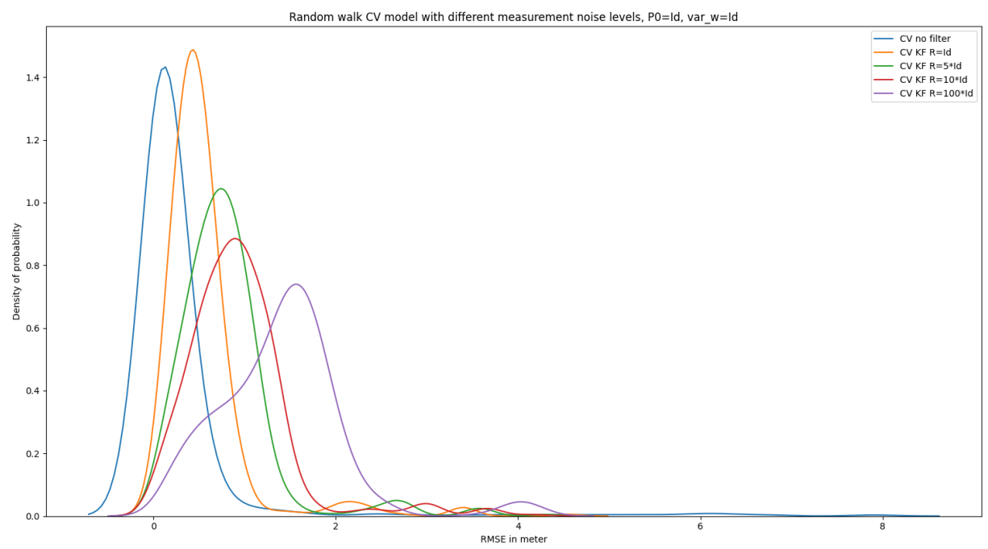
Fig8. Random walk CV model with different measurement noise level

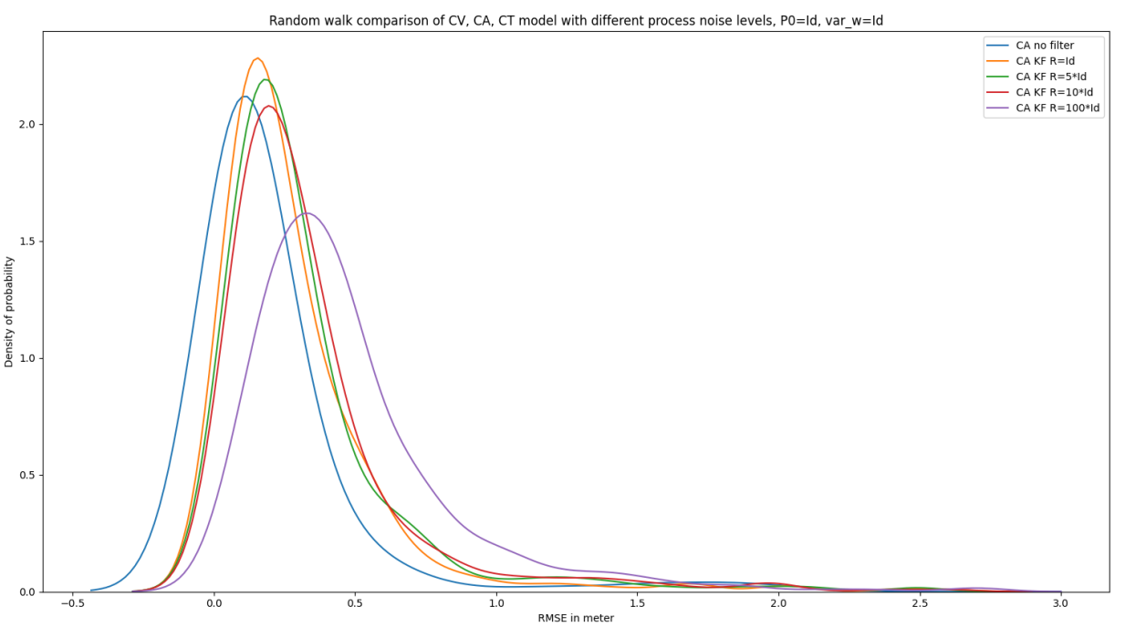
Fig9. Random walk CV model with different measurement noise level

So as explained before, measurement noise can only have a negative influence since the measurement is considered to be correct.
*) P0 matrix influence
P0 represents an initial gain for our filter. A large P0 implies a large correction of the model by a large Kalman gain. A large Kalman gain implies a large belief in the measurement.
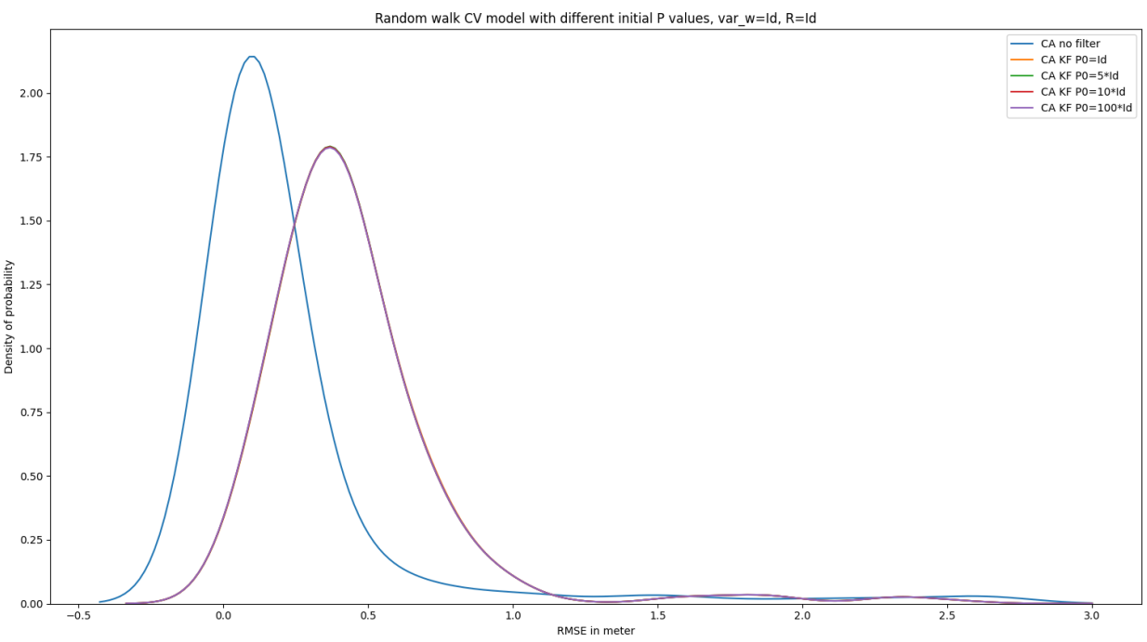
Fig10. Random walk CV model with different initial P values
As we can see on this graph, the influence of P0 seems not to exist. Indeed, all the variations of P0 seem to give the same purple curve. Note that the influence of P0 by observing the measurements only seems to concern the first points. Thus the influence of P0 is likely to increase if the number of steps observed decreases.
Thus the Kalman filter seems to work better with the CV (Constant Velocity)
mathematical model. When we put a high operating noise on it, it works better in the prediction at 0.4s than the other models. Thus, if we choose only one model to run to predict the future trajectory of the human, we will have to choose this one.
The influence of P0 and x0 only concern the first points and therefore have very little influence in our experiments.
*) Comparison AMM/IMM with standard models
Assuming that the computation time is not too degraded to allow the addition of another model, we could consider comparing the prediction at 0.4s between the best model we found previously (CV Kalman with high operating noise, called in this part CV model) with a combination of models in order to take advantage of the strengths of each. For this, many algorithms exist as indicated in the technical file but we have focused on only two, the AMM and the IMM which present an excellent compromise between computation time and precision. Note that these two algorithms have already been used several times for this type of problem.
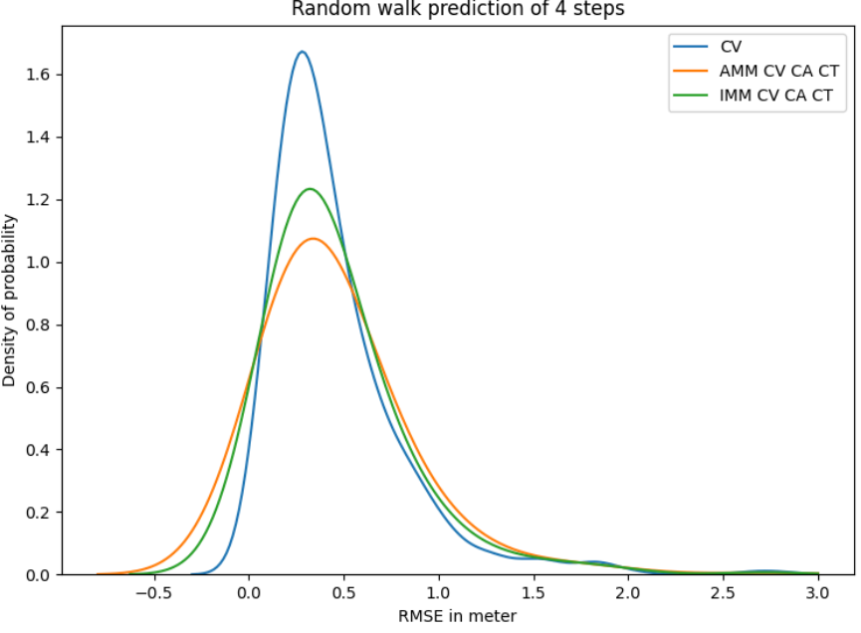
Fig11. Random walk prediction of 4 steps
First we predicted at 0.4s with the CV model and the multi models AMM and IMM containing the three elementary physical models. We can see that the multi models underperform the CV model.
Then we removed the elementary model CA and made predictions again at 0.4s. We now observe that the multi models are equivalent in terms of performance to the CV model (the curves overlap).
Then we tested with the elementary models CV and CA in comparison with the CV model. We noticed that this time the CV model gave better results. So one possible explanation is that the CA model did not work well with the other elementary models within the multi-model.

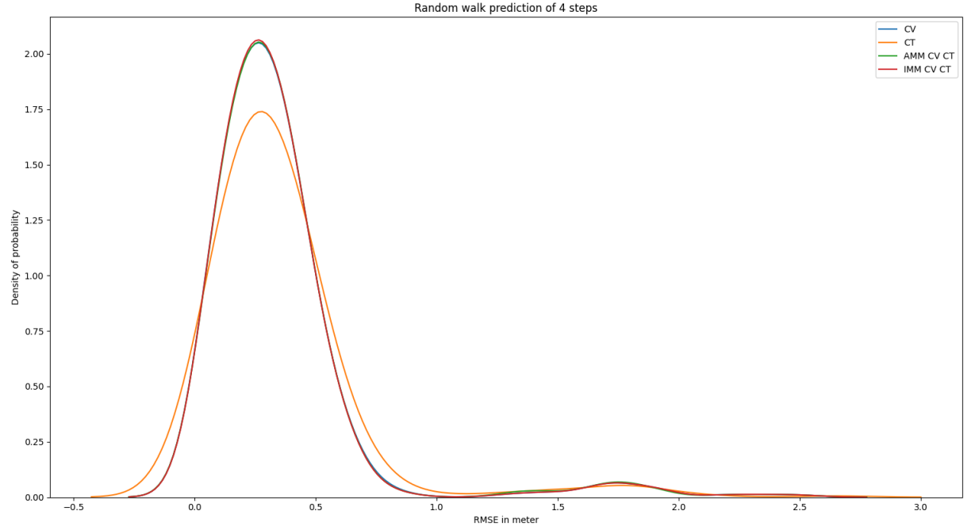
Fig12. Random walk prediction of 4 steps
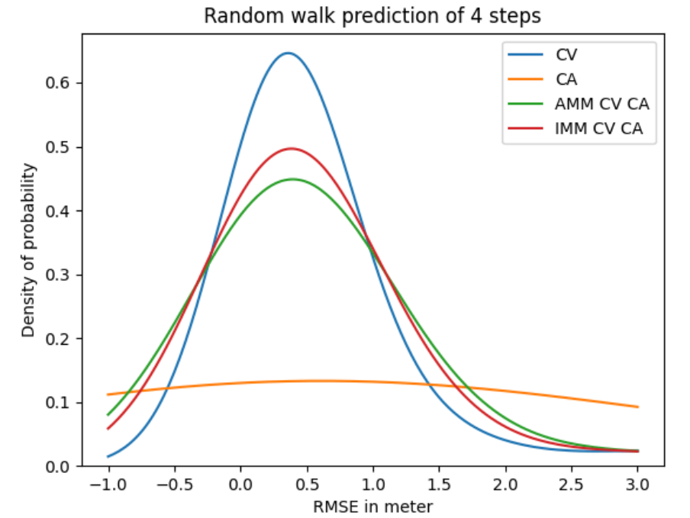
Fig13. Random walk prediction of 4 steps
To try to understand which models work best together, we can measure how the elementary models are best in terms of probability and no longer in terms of RMSE and we get the following graph. Which gives us the following graph:
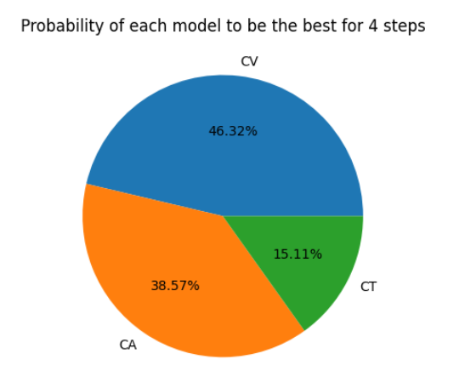
Fig13. Probabitity of each model to be the best for 4 steps
We thus note that the CA model on the prediction at 0.4s seems to be the best in 38.57% of cases, even before the elementary CT model. However, the CT model works better with the CV model than the CA model.
We then made an attempt that turned out to be unsuccessful to understand how to create a model association that gives better results than the simple CV model (with a Kalman filter), here is the idea:
One of the theories to understand if a model association could work well was to measure to what extent the IMM algorithm must change model. Indeed, multi-algorithms like the IMM calculate at each iteration which will be the best model. If the best model changes each time then our algorithm will use the wrong algorithm each time. This combined with the measurement of which algorithm is the best will perhaps allow us to know which algorithms work well together without having to test.
The problem of pedestrian anticipation comes from its agility: it can change operating mode extremely quickly. So it is possible that our multi-model will have to quickly change the model that best matches the current operating regime.
As we saw in Figure 1, the CV model performs the best and the CA model the worst.
However, the CA model is almost as often good as the CV model. So combining the two in a multi-model will make them each very busy while in general the CA model gives worse performances than the CT model for example, which will give a multi-model with poor performances.
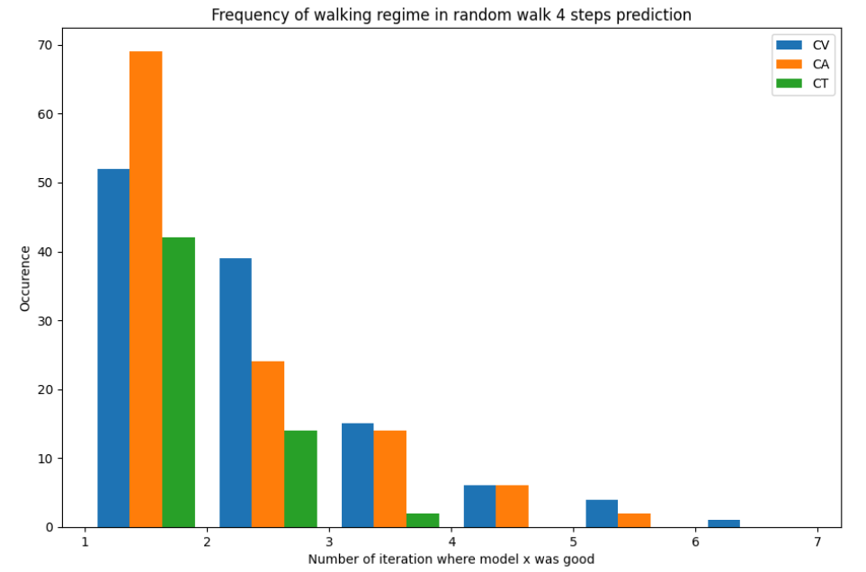
Fig14. Frequency of walking regime in random walk 4 steps
This measure is therefore the number of times (y axis) that the models were the best x times in a row (for the x axis). Thus we can read that the CV model was better only once in a row about 50 times. Or that the CT model was not the best 4 times in a row.
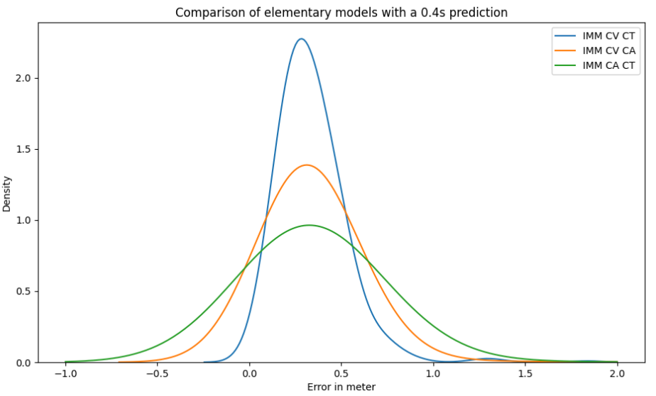
Fig15. Comparison of elementary models with a 0.4s prediction
Thus we could deduce from this graph that the CV model cannot associate with the CA model and that it could more easily with the CT model which has been confirmed.
However this graph can only be explained by the fact that the CA model gives more errors than the CV or CT model. For this, another measurement was taken.
This time using the CV model with different noise levels.
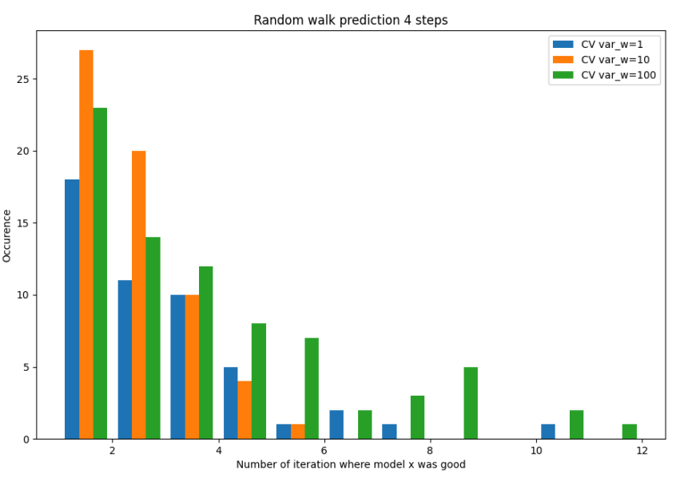
Fig16. Random walk prediction 4 steps
Here we can see that the CV model with a small operating noise (var_w=1) and the one with a large noise are the best several times in a row. Which could better characterize operating regimes. For example, the CV model with a small noise could represent the small speeds that are easily modeled with a CV model. The CV model with a large noise represents a more uncertain model that may be more related to high speeds. However when comparing the multi-models with these 3 CV models we get this:
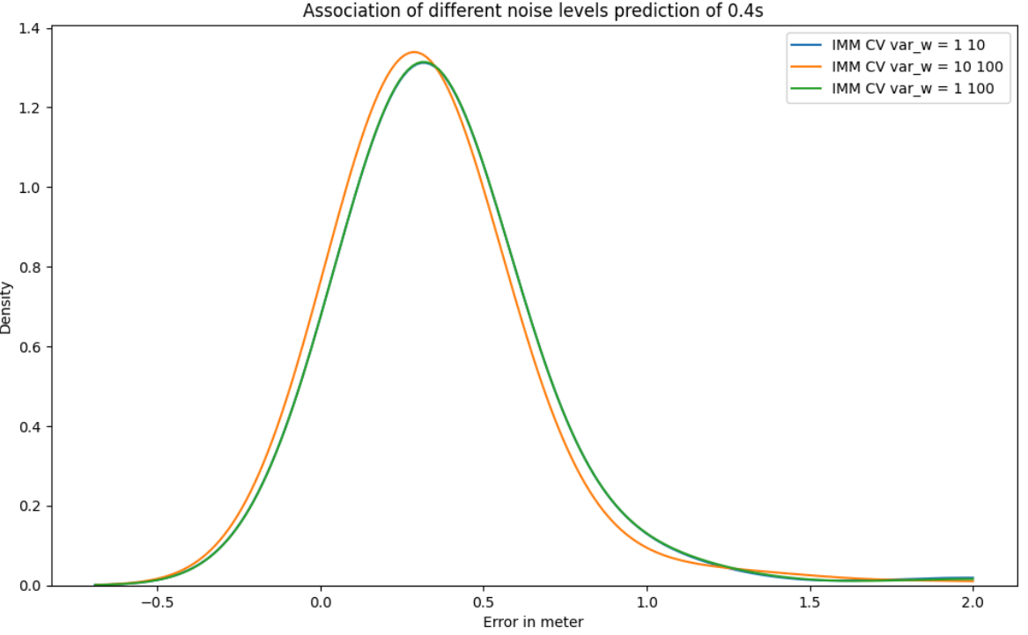
Fig17. Association of different noise levels prediction of 0.4s
So, here we can see that the multi-model that works best is the IMM (CV(var_w=10), CV(var_w=100)) and not (CV(var_w=1), CV(var_w=100)). Which tells us that the measurement of speeds by the method described above does not work well.
By combining two CV models with different operating noise powers we still managed to approach the performance of the CV model but without exceeding it. Our attempts at explanations have proven unsuccessful.
In conclusion of this results part, no model beat the simple CV model with a high operating gain. And this even by enriching this model with other models. The RMSE of the CV model is always lower than that of all the other models

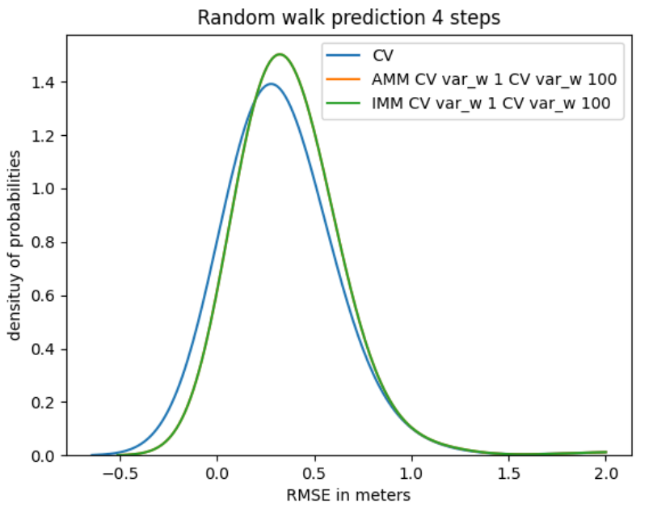
Fig18. Random walk prediction 4 steps
*) REFLEXIVE ANALYSIS
By conducting an introspective analysis on the skills required of the Centrale engineer that can be found in the skills framework found at the end of this document in the appendix, we were able to identify several points according to the themes. Here is the summary:
First of all, from the point of view of the ability to produce a bibliographic reflection on a technical subject. We think that this internship allowed us to develop in order to be able to distinguish the scientific elements and theories useful for our objective. However, we do not think that we have improved my abilities to produce a business plan or a cost and competition analysis in view of the theme of our work.
The 3rd category of skills is the ability to organize, structure a project in order to make its management clear, transparent and efficient. From this point of view, our research focuses on solitary efforts in order to reach the solution that develops other human resources than the ability to organize a group. Indeed, this study allowed us to develop the resources to organize myself on a long-term task in order to produce the best possible quality work for the time allocated.
To continue, the Centrale engineer must be able to identify his personal characteristics in order to know his own values and his ethical positioning in a team or any organization.
References:
[1] Yaakov Bar-Shalom, X Rong Li, and Thiagalingam Kirubarajan.
‘Estimation with applications to tracking and navigation: theory algorithms
and software’. John Wiley & Sons, 2004
[2] Andrey Rudenko, Luigi Palmieri, Michael Herman, et al. ‘Human
Motion Trajectory Prediction: A Survey". In: The International Journal of
Robotics Research 39.8 (July 2020), pp. 895{935. issn: 0278-3649,
1741-3176. doi: 10.1177/0278364920917446. arXiv: 1905.06113[cs].
url: http://arxiv.org/abs/1905.06113 (visited on 04/19/2024)
[3] X. Rong Li and V.P. Jilkov. ‘Survey of maneuvering targettracking .
part I: dynamic models". In: IEEE Transactions on Aerospace and
Electronic Systems 39.4 (Oct. 2003), pp. 1333{1364. issn: 0018-9251.
doi: 10.1109/TAES.2003.1261132. url ttp://ieeexplore.ieee.org/document/1261132/ (visited on 04/22/2024)
[4] X Rong Li. ‘Multiple-model estimation with variable structure. II.
Model-set adaptation". In: IEEE Transactions on Automatic Control 45.11
(2000), pp. 2047{2060.
[5] Xiao-Rong Li, Yaakov Bar-Shalom, and William Dale Blair.
‘Engineer’s guide to variable-structure multiple-model estimation for
tracking". In: Multitarget-multisensor tracking: Applications and
advances. 3 (2000), pp. 499{567

