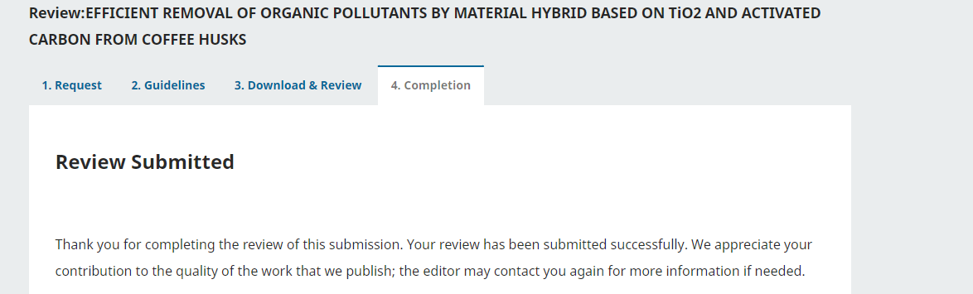
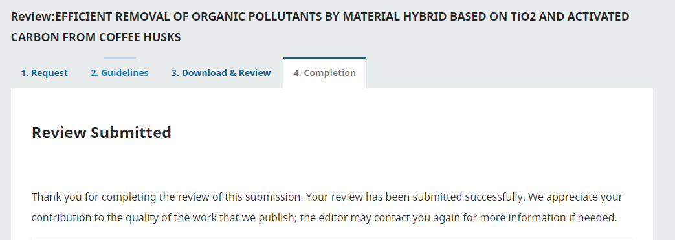
Review-TiO₂/AC
This research by authors is systematic and logical in using environmentally friendly activated carbon material to treat organic pollutants. However, research on using activated carbon as a carrier, as well as an adsorbent, which is fabricated from coffee husks, has also been previously researched. Therefore, the authors need to explain what is new in this study?
- The author needs to specify the power of the UV light source used.
- When performing the photocatalytic reaction, did the author place the reaction system in the dark to achieve adsorption equilibrium? This is necessary! Therefore, the removal efficiency given by the author is not accurate.
- To prove the TiO₂, TiO₂/AC (1:3; 1:1 and 3:1) as photocatalysts, the results of UV-Vis spectra should be supplemented.
- The XRD diffraction pattern of TiO₂ should also be included in the work.
- Photocatalyst stability experiments should be performed.

