Review
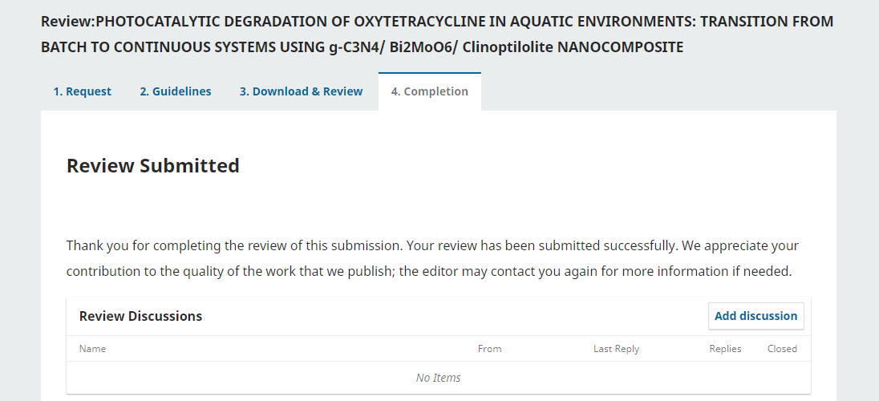
In this study, the authors used the Z-Scheme photocatalytic g-C₃N₄/Bi₂MoO₆/Clinoptilolite system to remove OTC in a continuous flow system. The research is innovative but not new. Authors need to supplement and complete before it can be published in the journal. Specifically as follows:
1) It is necessary to replace the catalyst concentration with the catalyst content.
2) Photocatalytic properties should be determined by UV-Vis DRS spectroscopy and fluorescence emission spectroscopy (PL).
3) Need to provide SEM images of individual components g-C₃N₄, Bi₂MoO₆ and Clinoptilolite to identify the interaction morphology between the composite.
4) It is necessary to demonstrate or explain the role of each component g-C₃N₄, Bi₂MoO₆ and Clinoptilolite in enhancing optical activity.
5) The author should explain more clearly why using a continuous system gives higher OTC processing efficiency.
6) Nitrogen adsorption-desorption isotherm, pore size distribution plots of each component should be shown.
7) If possible, the author should analyze the intermediate products of OTC decomposition.

