AGENDA

The first International Seminar of Intergrated Petroleum Research Group on

Carbon Sequestration

Time: 14:00 -16:00, Thursday, September 21, 2023
Venue: Room Thuan Thanh, Hanoi University of Mining and Geology, 18 Pho Vien - Duc Thang - Bac Tu Liem - Hanoi – Vietnam

TIME | CONTENT
14:00 - 14:15 | Reception
14:15 - 14:20 | Opening remarks
14:20 -14:50 | Carbon Sequestration Presentation and Q&A  Southwest Regional Partnership on Carbon Sequestration  Dr. Robert Balch, Director of the Petroleum Recovery Research Center at New Mexico Institute of Mining and Technology (NMT), USA
14:50 - 15:20 | Carbon Sequestration Presentation and Q&A  Numerical reservoir simulation of CO₂ injection and brine production - Case Studies  Dr. Tran Huu Kien, Lecturer of Hanoi University of Mining and Geology
15:20 - 15:50 | Carbon Sequestration Presentation and Q&A  Geomechanical challenges during geological CO₂ storage  Dr. Jihoon Wang, Professor of Hanyang University, Korea
15:50 - 16:00 | Closing remarks

Speakers:
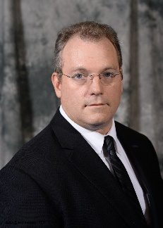 | Dr. Robert Balch is the Director of the Petroleum Recovery Research Center (PRRC) located on the campus of New Mexico Tech. At the university he also holds Adjunct Professor positions in Petroleum Engineering and Geophysics. During his 20 years at the PRRC he has been principal Investigator on a range of enhanced oil recovery projects focused on developing and applying solutions to problems at many scales using geological, geophysical, and engineering data. Dr. Balch is the Principal Investigator of the Southwest Partnerships Phase III demonstration project. During the course of his work he has published more than 45 papers, is a frequent invited has held an appointment as an Oil Conservation Commissioner for the State of New Mexico since June of 2011. Balch received his MSc in Geophysics and Ph.D. in Earth and Environmental Science from New Mexico Institute of Mining and Technology.
 | Dr. Jihoon Wang is a lecturer at Department of Earth Resources and Environmental Engineering, Hanyang University. He has experienced with a demonstrated history of working in the industry; skilled in Reservoir Engineering, Geomechanics and Reservoir Characterization; strong professional experience in shale plays in North America and offshore natural gas hydrate.  Wang received his PhD in Petroleum Engineering focusing on Wellbore Stability, Induced Fracture Geometry, Permeability Alteration and Productivity Enhancement from Texas A&M University.
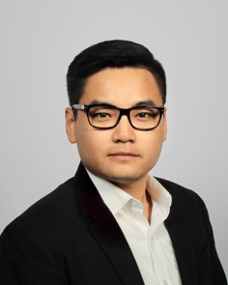 | Dr. Tran Huu Kien is a lecturer at Faculty of Petroleum and Energy, Hanoi University of Mining and Geology. During his academic journey, Dr. Tran served as a Teaching Assistant at Pennsylvania State University, supervising numerous capstone projects and driving improvements in software tutorials and technical seminars. His research experience includes database generation and structuring for machine learning models to expedite real-time decision-making in subsurface applications, for a project funded by the National Energy Technology Laboratory of the U.S. Department of Energy. Having earned a Ph.D. in Petroleum and Natural Gas Engineering from Pennsylvania State University, Dr. Tran's doctoral research specialized on "Unified Density-Based Production Data Analysis Under Multiphase Flow Conditions."

