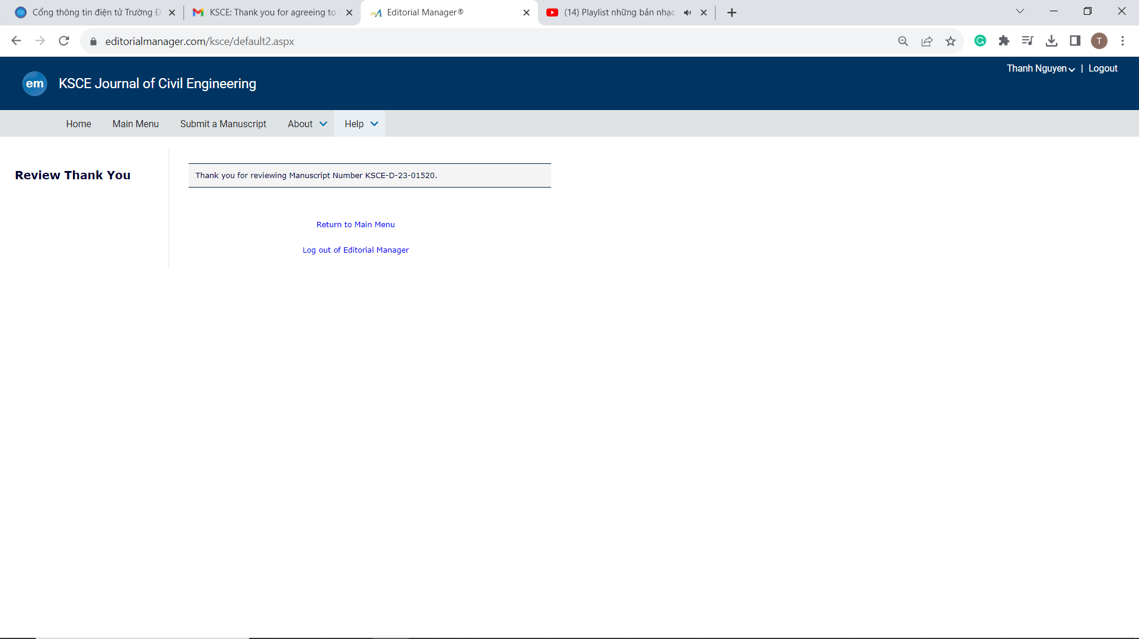

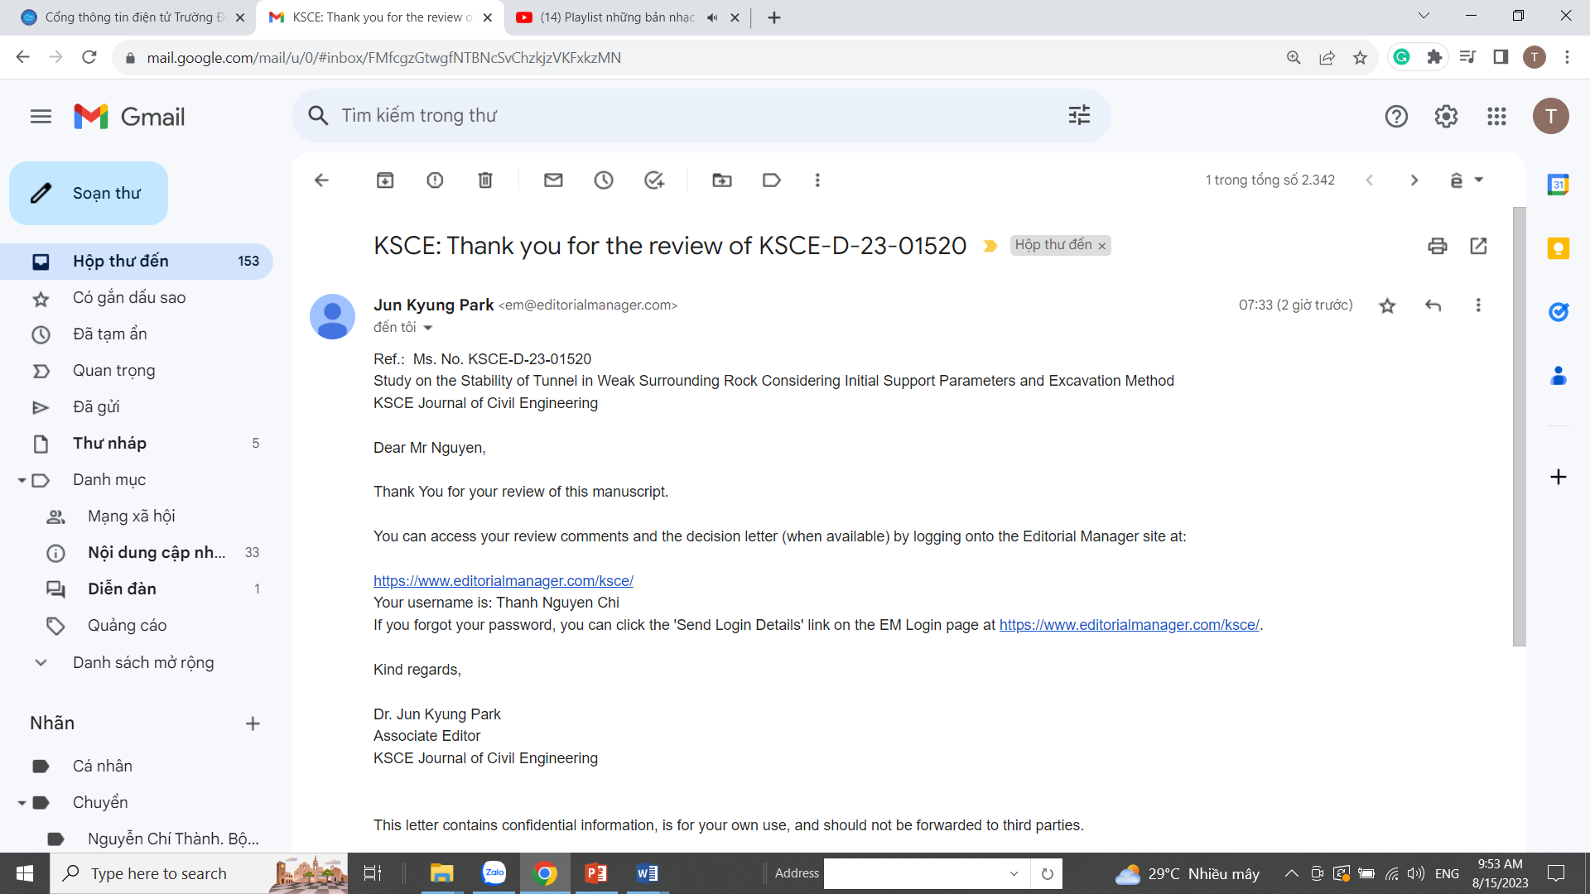

Upon reviewing the edited manuscript, the reviewer observed issues in the pre-edited content that had been rectified. The authors of the manuscript should adjust the content of the manuscript in accordance with the template required by the journal. The reviewer accepted this corrected manuscript.

