Integration of damage curves and GIS to estimate the economic exposure for flood disaster assessment in the Vu Gia -Thu Bon river basin of Vietnam.
Keywords: disaster management, flood, damage curves, GIS, Vietnam, economic exposure, Vu Gia, Thu Bon
Abstract
The flooding is a common disaster in the world. Vietnam has no exception, she has a long coastal line, monsoon rainfall seasons, tropical storms and river deltas located from the North to the South, those are favorable condition for flooding occurring. As the results, Vietnam is one of heavy affected by flood disaster. There are a number of studies and researches about flood and disaster reduction has been conducted in Vietnam but most of them use qualitative assessment in flood disaster assessment, which is provide the generic view of flood in Vietnam but difficult to estimate the economic loss by flood. The Vu Gia- Thu Bon river basin has been selected to conduct study. In this study, we focus on develop the damage curves which is presenting the damage levels based on the water depth of each type of land use present in flooding area. The damage curves have been constructed for 7 types of land use in the study area, which is selected by investigating the flooding report of authorities. This process considers the nature of land use types, living and socio- economic conditions of the study area. The economic exposure value is defined by using disaster report standards for agriculture, urban and rural residential, transportation and infrastructure. For the industrial and commercial land, we obtain the economic exposure by service prices and investment report of authorities. The damages curves combined with economic exposure by applying GIS analysis to provide the economic loss estimation. The result is validated with the disaster report which acquired from disaster management authority. The result shows the potential of using damage curves and GIS application in quantitative disaster assessment, especially with the flood. The result can be applied as the disaster assessment tool for central and local authorities in the standardization of disaster reporting and management.
Integration of damage curves and GIS to estimate the economic exposure for flood disaster assessment in the Vu Gia -Thu Bon river basin of Vietnam.
1. INTRODUCTION
According to disaster reports (Vu Minh Giang 2015), every year, Vietnam faces 10 to 12 storms and tropical depressions. Those climate extremes are direct cause of flooding, a very complex phenomenon which are common thread to people in low land in Asia.(Field et al. 2011). Flooding in particular is the most vulnerable disaster in Vietnam(Thắng et al. 2016).

In Vu Gia - Thu Bon river basin, heavy rainfall causes flood and inundation which occurs almost every year in the lower part of the basin where many big centers such as Da Nang city and Hoi A city are located. According to the statistic information, from 1997 to 2013, flood in Vu Gia Thu Bon cause 765 lots, 63 missing and 2403 injures. The total damage reached 18000 billion VND (Pham Ngoc Son, 2016). Therefore, building the flood risk maps for disaster prevention would be an important step to reduce the damage during the natural disaster occurs in Vu Gia Thu Bon basin and other river basin in Central part of Vietnam in general. We use quantitative method to estimate the damage of flood disaster by constructing the damage curves. The damage curves will be combined with water depth provided by MIKE modeling software and land economic loss potential from land use data.

2. FLOOD DISASTER RISK ASSESSMENT
The nature disaster risk combined by three factors, the Vulnerability, Exposure and Hazard(IPCC 2012). To prevent the damage of nature disaster, it needs to reduce one of those factors to be minimum. Before minimizing of those factors, the risk should be evaluated and assessed. In the disaster risk assessment, those factors can be measured by two methods, qualitative and quantitative assessments.
The first method is applied in traditional disaster risk assessment. Each factor was ranked and combined into a risk indicator which shows level of risk i.e. Very high, High, Moderate, Low. The qualitative method is widely used by disaster researches, it shows the area of risk with difference levels, it helps researcher and authorities understand the disaster and provide basis for disaster reduction management (DRM).(IPCC 2001) This method is suitable for large study area and useful for DRM by authorities.
The quantitative method for flood disaster is also applied in a number of researches. It shows the highly potential in urban area with study from (Hasanzadeh Nafari, Ngo, and Lehman 2016) , (Notaro et al. 2014), (Dias et al. 2018). It is also applied in infrastructure damage estimation from research of (Pregnolato et al. 2017), (Lugeri et al. 2006),(Naso et al. 2016). The quantitative method has it limited by available of data and data accuracy.(Mohammadi, Nazariha, and Mehrdadi 2014), (Win et al. 2018). In other hand, the quantitative method gives the disaster managers such as authorities and other stakeholder a very detailed view in damage of flood in every location in risk area. It also gives an economic loss estimation depend on flooding scenarios which are provided by numbers of researches and modelling packages. The most common method used in quantitative risk assessment is applying of the damage function or damage curve. (Eckhardt, Leiras, and Thomé 2018)
Damage curve is a correlated function between the extent of hazard and damage level. The general formula of the damage curve is: D = f (H) where H is the level of hazard and D is the level of damage.(Eckhardt et al. 2018)
For each type of hazard, and each object that can suffer damage from the hazard, this function will have appropriate parameters and structures, most of which are in the form of exponential or logarithm functions. In general, the damage curve development depends on the post – event field survey to find out the correlation between the level of hazard and the level of damage for each object in the hazard area.(FEMA 2012)
Although depth-damage functions should be applied only where real data can be collected, the extrapolation to similar areas is a common practice accepted by the literature. (Eckhardt et al. 2018)
The damage curve is mainly applied to wide-ranging hazards such as storms, floods, earthquakes or droughts. However, the vast majority of current studies mainly apply to earthquake or flood disasters. This damage function has advantages of ease of application, good integration with GIS technology, suitable for many conditions with limited data, time or resources of projects. One of the outstanding applications of the damage function is the application in HAZUS method that has been applied in dozens of different studies around the world, especially with flood in the United States.(FEMA 2018)
In this research, the damage functions are derived from HAZUS(FEMA 2012) process but correlation by using local data. This process will give more precise results than apply generic curves from the research which may not suitable with local condition and data availability.
3. STUDY AREA
Vu Gia - Thu Bon river basin is layed between Da Nang and Quang Nam provinces, it collects water from eastern side of Truong Son mountain range and flow to East Sea by several out streams in Da Nang city and Hoi An. This is the largest basin on central coastal of Vietnam, it consists 2 main streams is Vu Gia river and Thu Bon river which are flowing in complex terrain ranging from narrowed mountain to flat low land in coastal zone.

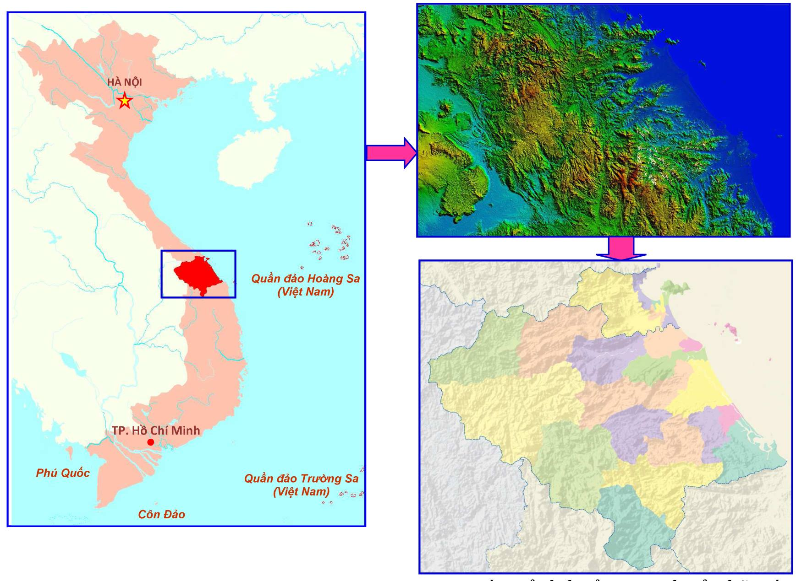
Figure 1: Vu Gia Thu Bon river basin
The river basin climate is influenced by tropical monsoon and ocean, therefore, rainfall behavior in this area is complicated. The rainfall mostly ranged from 2000 to 4000m per year with 65-80% occurred in rainfall season from September to December. This river basin faced annually 2-4 tropical storms or depression. There are 15 meteorological and hydrological stations in this area.
This river basin is the central of tourism and economic of Central Coastal of Vietnam with Da Nang city is the most livable city in Vietnam and highly industrial development in Quang Nam province. Both sectors highly affected by nature disasters as storms and flooding. Annual lost caused by flooding in Quang Nam is 6.26% GRDP. In context of global climate change, sea level rise combine with abnormal phenomenon as ENSO will cause more damage to socio-economic system in this area.
4. METHODOLOGY
4.1. Damage curves construction
The damage of flood hazard has been assessed by several method, but mainly by qualitative method which helpful for general risk assessment but difficult on economical assessment, economic loss is impossible to estimate by qualitative method. Therefore, it needs to use a quantitative method which can help to estimate the economic loss by nature hazard. In case of flooding hazard, damage curves are using to estimate the damage of land objects by flooding. The correlation between depth of water level in flood and damage level of an object is using to define the damage curves which will be using for economic loss assessment.(FEMA 2012)
The correlation between water depth and damage level can be express by following table:
Table 1: Example of correlation between water level and damage level
Type of land | Water lever (m) | Damage level
Agriculture | 0 | 0.00
Agriculture | 0.5 | 0.14
Agriculture | 1 | 0.37
Agriculture | 1.5 | 0.52
Agriculture | 2 | 0.56
Agriculture | 3 | 0.66
Agriculture | 4 | 0.83
Agriculture | 5 | 0.99
Agriculture | 6 | 1.00
The correlation is depending on type of land object or in general, type of land use. For each type of land use, the flood resistance can be used for each type of sub-category then combine to a presentative damage level:
Table 2: Example of Agriculture lands flood resistance
Type of Land use | Sub category | Flood resistance | Percentage of area
Agriculture | Paddy Rice | 1 | 50
 | Annual crop | 1 | 30
 | Seasonal fruits | 2 | 10
 | Perennial fruits | 3 | 10
4.2. Land use reclassification
The land use of River basin includes 53 types which made difficult to economic loss estimation. Therefore, this data is reclassed into 8 groups.
- Agriculture: include all type of crop, rice, fruit and grassland for livestock.
- Infrastructure: includes water supply, irrigation and drainages system, land for education, health care, power supply.
- Transportation: includes all type of transportation system and supply.
- Commercial: commercial, services, market, …
- Industrial: industrial zones, industrial supply system.
- Rural residential: include rural residential area and related
- Urban residential: include urban residential area and related.
- Other: include land use types which is unable to estimate economic loss: unused land, water surface
The number of classes is depending on the level of information can be collected from Land use map. There is no standard or references for this classification because of data limitation is difference from each projects and location. There are several classification have been considered such as HAZUS(FEMA 2012), HEC – FDA(Mohammadi et al. 2014), Albano(Albano et al. 2018)…but those classifications is unable to apply with the limitation of data in the study area.
4.3. Damage curves
The damage curves are constructed based on land use class and damage level which are received by disaster reports from river basin authorities. This process completed by using Excel regression functions.
The damage curves are applied with similar process in Hazus system(FEMA 2018).
4.4. Economic exposure by land use
The economic exposure of each land use class has been analysis based on disaster reports form Quang Nam and Da Nang which are standardized by Vietnamese Disaster Management Authority.
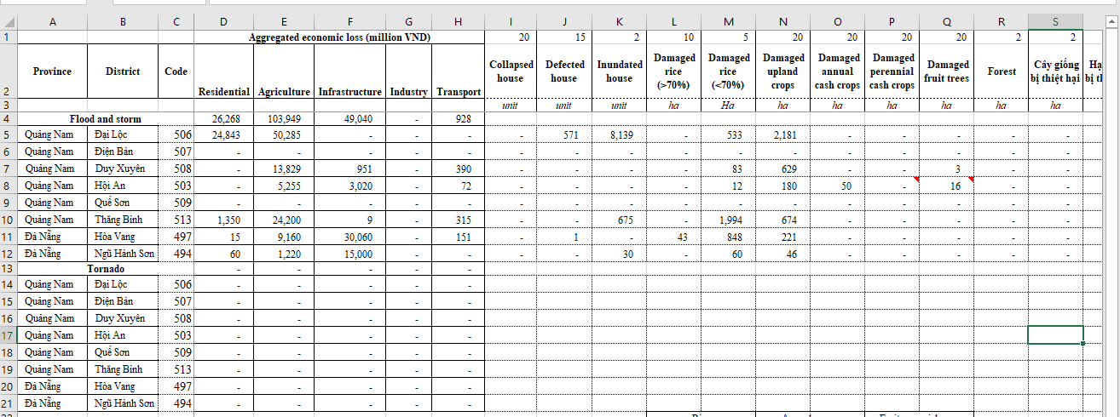
Figure 2: Example of flood disaster report from local authority.
Based on those reports, the value of each land object is estimated. For example, agriculture economic exposure value is calculated by total damaged value divided by total damage area.
4.5. Water depth modelling by Mike packages
The water depth has been modelling by MIKE packages (MIKE 21) to provide the hazard maps. The model has been calibrated with flooding data taken from 2009 flood. There are 4 scenarios have been considering for this study area and the scenario 2 with return period is 20 years has been selected to calculate the Damage and economic loss.
Table 3: Scenarios of flood modelling
Scenario | Frequency | Return period (years)
1 | 1% | 100
2 | 5% | 20
3 | 2% | 50
4 | 10% | 10
.
The scenario 2 is selected based on limitation of historical damage report. The disaster reports collected from the study area are limited from 2007, especially the detailed and structured reports are only provided from 2013 based on Regulation of disaster management. Within those reports, there are only 1 flood is categorized to 50 years return period and 3 of them are 10 to 20 years return period. Therefore, the 20 years return period has been choose to calibration and validation.
4.6. Damage level assessment by GIS analysis.
Based on the damage curves above, the land use maps and water depth maps which derived by Flood modeling processes are combined by GIS analysis. The GIS analysis has done by Raster calculation.
Damage level = f (land use, water level) Eq.1
In Equation 1, f is the damage curves with 2 parameters are landuse type and water depth level.
4.7. Economic loss assessment.
The Economic loss calculated by following equation:
Economic loss = (Damage level x Economical Exposure) x K exposure Eq.2
The K factor is derived by geographic distribution and nature of land object in land use map. Depend on type of the land use, the land object has different distribution and appearance in the maps. For example, the rural area with unstable buildings should have highest K factor in compare to urban area which have more stable and stronger constructed buildings.
4.8. Validation of economic loss estimation
The Economic loss estimation calculated for flood with frequency 20 years return has been validated with disaster reports which provided by Provincial authority.
5. RESULT AND DISCUSSION
5.1. Flood modelling
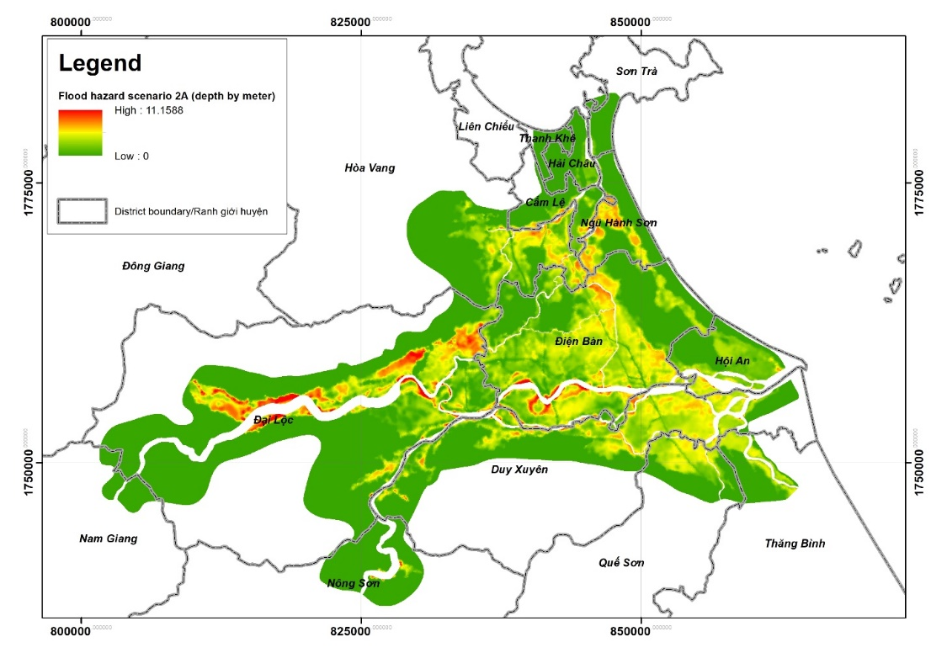
Fig2: Flood hazard modelling for frequency of 5%.
The flood modeling results shows the flooding area in Vu Gia-Thu Bon river basin mostly occurred in areas nearby river banks. From flood modelling result, there are several districts in flood area, the heavy affected is Que Son, Dien Ban, Duy Xuyen, Dai Loc and Hoi An of Quang Nam province; Ngu Hanh Son and Cam Le districts of Da Nang. The water depth varies from 0 to 11.1m but the most area is in 0-7m water depth. The higher value from 7-11.1 meters are unwanted error in few cells occurred by limitation of terrain described in the model.
5.2. Damage curves
The damage curves are constructed and present in following figure:

Figure 3: Damage curves
The damage curves show the similarity of damage level of rural and urban residential area. For the transportation, the limitation of curves rising very short, it because of nature of roads in flood. In case of Agriculture, the curves are very difficult to be defined due to lack of data and the generic curves hardly present to various types of crops in the study area.
5.3. Economic exposure
Based on the disaster reports, the land use exposure can be estimated as following table:
Table 4: Land use exposure economic estimation.
Index | Land use class | Land use exposure (VND/m² - 2017)
1 | Infrastructure | 465532
2 | Agriculture | 5895
3 | Commercial | 92400
4 | Industrial | 100000
5 | Transportation | 193614
6 | Urban Residential | 2000000
7 | Rural Residential | 368292
8 | Other | 0
The result shows the highest exposure is urban residential area which is highly subjective to be damaged in flooding disaster. The infrastructure is also getting high value, it contains values from essential infrastructures and services such as school, health care, post office, electricity, water supply… which are very important to people ling in disaster are. The lowest value comes from agriculture which are mainly valued by rice and annual crops which are cultivating in the flood plain.
5.3. Damage levels
The damage level presented by following map:
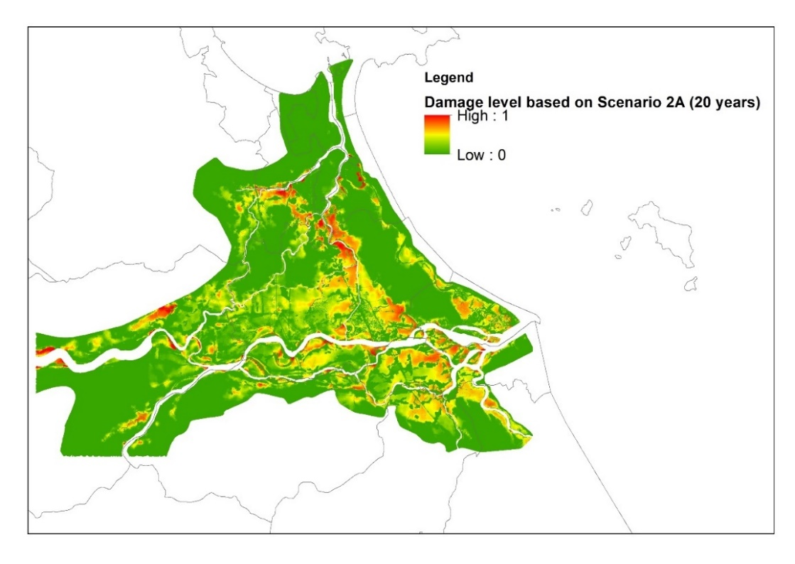
Figure 4: Damage level based on water level of scenario 2A, frequency 5% - 20 years
The damage level is derived by combining water depth layer and the land use layer by GIS analysis using damage curves. This show the highly damage occurs in Dien Ban, Que Son Duy Xuyen, Ngu Hanh Son and Hoi An. Those area get high value because those area are urban and industrial development area in the river basin. The flood will give more damage to those areas than the areas with mainly agriculture and rural area.
5.4. Economic loss assessment
Based on the damage assessment and economic loss estimation process performed by GIS analysis. The Economic loss estimation is done and the result is showed in following table:
Table 5: Economic loss estimation
Index | Land use class | D x EE | K | Economical loss estimation (Billion VND)
1 | Infrastructure | 339.91 | 0.8 | 271.9260355
2 | Agriculture | 302.67 | 0.5 | 151.3364814
3 | Other | 0.00 | 0 | 0
4 | Industrial | 83.23 | 0.3 | 24.96915014
5 | Transportation | 156.58 | 0.5 | 78.28802301
6 | Commercial | 14.36 | 0.8 | 11.48497741
7 | Rural residential | 0.90 | 1 | 0.899065376
8 | Urban residential | 10.46 | 0.3 | 3.137812197
 | Total | 908.10 |  | 542.041545
The economic loss estimation results show the very high loss in infrastructure and agriculture by flood. It shows the potential to estimate economic loss by applying GIS and damage curves. In contrast, it shows the limitation due to lack of data related to damage. The results of economic loss estimation strongly depend on how the damage curves has been constructed. The more detail and accuracy curves, the more accuracy of estimation.
5.6. Validation of results
The result of the economic loss estimation is very closed to economic loss reports which show in the following table:
Table 6: Validation and compare the estimation economic loss
Index | Land use class | Economical loss estimation (Billion VND) | Flood economic loss November 2016 (~10 years flood) | Flood economic loss September 2009 (~50 years flood)
1 | Infrastructure | 271.9260355 | 30 | 202
2 | Agriculture | 151.3364814 | 151 | 144
3 | Other | 0 | 0 | 0
4 | Industrial | 24.96915014 | 0 | 0
5 | Transportation | 78.28802301 | 62 | 143
6 | Commercial | 11.48497741 | 0 | 0
7 | Rural residential | 0.899065376 | 0.65 | 24.7
8 | Urban residential | 3.137812197 | 1.3 | 24.7
 | Total | 542.041545
The gaps between estimation and field report are acceptable in context of data limitation. If the input data is very detailed, the estimation will be very precise.
6. CONCLUSION
Based on the result of research, the damage curves are useful in flood disaster assessment. It shows the capability to estimate the economic loss quick and acceptable accuracy.
The result also gives a great credit for GIS analysis apply in disaster assessment. GIS analysis and damage curves can be combined to powerful tool in disaster management and assessment.
In the other hand, the research shows the limitation of damage is need of very detail and accuracy data to construct the reasonable curves. This is the biggest limitation in our research especially in data conditions of a developing country like Vietnam. The damage curves highly depend on Vulnerability and exposure, which are different between each river basins. It needs to adjust the damage curves based on the available data and socio-economic and nature conditions of research area.
REFERENCES
Albano, R., A. Sole, J. Adamowski, A. Perrone, and A. Inam. 2018. “Using FloodRisk GIS Freeware for Uncertainty Analysis of Direct Economic Flood Damages in Italy.” International Journal of Applied Earth Observation and Geoinformation 73(February):220–29.
Dias, Priyan, N. M. S. I. Arambepola, Kumari Weerasinghe, K. D. N. Weerasinghe, Dennis Wagenaar, Laurens M. Bouwer, and Hans Gehrels. 2018. “Development of Damage Functions for Flood Risk Assessment in the City of Colombo (Sri Lanka).” Procedia Engineering 212:332–39.
Eckhardt, Daniel, Adriana Leiras, and Antônio Márcio Tavares Thomé. 2018. “Systematic Literature Review of Methodologies for Assessing the Costs of Disasters.” International Journal of Disaster Risk Reduction 33(October 2018):398–416.
FEMA. 2012. “Multi-Hazard Loss Estimation Methodology - Flood Model - User Manual.”
FEMA. 2018. “Hazus Flood Model User Guidance.” Federal Emergency Management Agency (August):1–263.
Field, C. B., T. F. Stocker, V. R. Barros, D. Qin, K. L. Ebi, and P. M. Midgley. 2011. “IPCC Special Report on Managing the Risks of Extreme Events and Disasters to Advance Climate Change Adaptation.” AGU Fall Meeting Abstracts 1(January 2016):2.
Hasanzadeh Nafari, R., T. Ngo, and W. Lehman. 2016. “Development and Evaluation of FLFAcs- A New Flood Loss Function for Australian Commercial Structures.” International Journal of Disaster Risk Reduction 17:13–23.
IPCC. 2001. “Climate Change 2001 : Impacts, Adaptation, and Vulnerability.” Cambridge University Press 1–94.
IPCC. 2012. Glossary of Terms. In: Managing the Risks of Extreme Events and Disasters to Advance Climate Change Adaptation.
Lugeri, Nicola, Elisabetta Genovese, Carlo Lavalle, and Ad De Roo. 2006. “Flood Risk in Europe : Analysis of Exposure in 13 Countries.” Institute for Environment and Sustainability 35.
Mohammadi, S. A., M. Nazariha, and N. Mehrdadi. 2014. “Flood Damage Estimate (Quantity), Using HEC-FDA Model. Case Study: The Neka River.” Procedia Engineering 70:1173–82.
Naso, Susanna, Albert S. Chen, Giuseppe Tito Aronica, and Slobodan Djordjevi. 2016. “Flood Risk Assessment Using a Novel Exposure-Vulnerability Matrices Approach.” 15:2016.
Notaro, V., M. De Marchis, C. M. Fontanazza, G. La Loggia, V. Puleo, and G. Freni. 2014. “The Effect of Damage Functions on Urban Flood Damage Appraisal.” Procedia Engineering 70:1251–60.
Pregnolato, Maria, Alistair Ford, Sean M. Wilkinson, and Richard J. Dawson. 2017. “The Impact of Flooding on Road Transport: A Depth-Disruption Function.” Transportation Research Part D: Transport and Environment 55:67–81.
Thắng, Nguyễn Văn, Mai Văn Khiêm, Nguyễn Trọng Hiệu, Vũ Văn Thăng, Nguyễn Đăng Mậu, and Lã Thị Tuyết. 2016. “Ảnh Hưởng c ủ a Bão ở Việt Nam Thời kỳ 1961-2014.” 210–16.
Vu Minh Giang. 2015. Báo Cáo Đặc Biệt Của Việt Nam Về Quản Lý Rủi Ro Thiên Tai.
Win, Shelly, Win Win Zin, Akiyuki Kawasaki, and Zin Mar Lar Tin San. 2018. “Establishment of Flood Damage Function Models: A Case Study in the Bago River Basin, Myanmar.” International Journal of Disaster Risk Reduction 28(November 2017):688–700.

CONTACTS

Mr. Duong Anh Quan
Institution: Department of Cartography, Faculty of Geomatics and Land Administration, Hanoi University of Mining and Geology
Address: 18, Vien Street
City: Hanoi
COUNTRY: VIETNAM
Tel. +8416447769968
Email: duonganhquan@humg.edu.vn
Web site: http://humg.edu.vn
Dr. Truong Van Anh
Institution: Faculty of Hydrology and Meteorology, Hanoi University of Nature resources and Environment
Address: No 41 A Phu Dien Road
City: Hanoi
COUNTRY: VIETNAM
Tel.
Email: truongvananh.vn@gmail.com
Web site: http://en.hunre.edu.vn/hunre-en/trang-chu
Assoc.Prof. Dr. Bui Ngoc Quy
Institution: Department of Cartography, Faculty of Geomatics and Land Administration, Hanoi University of Mining and Geology
Address: 18, Vien Street
City: Hanoi
COUNTRY: VIETNAM
Tel. +84912912190
Email: buingocquy@humg.edu.vn
Web site: http://humg.edu.vn

