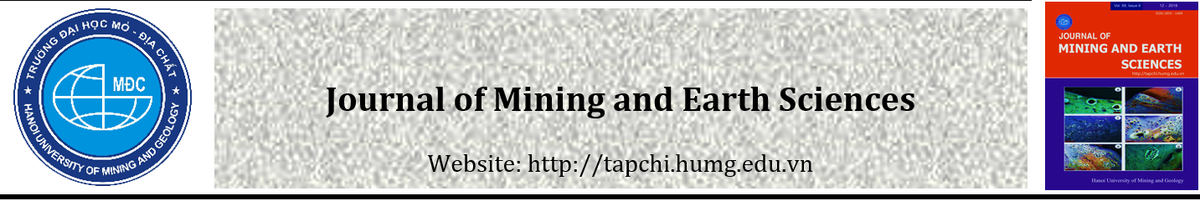
Reasonable exploitation solution for longwall in Seam L7 at East Side to ensure the stability of G9 surface works of Mong Duong coal mine

ARTICLE INFO |  | ABSTRACT
Article history:  Received  Accepted  Available online |  | When exploiting the working face located under the surface works to be protected, it may lead to potential risks that cause unsafety and effect the stability of those works. The degree of influence on the surface works depends on many factors, including the exploitation technology factor. It is always necessary to study and evaluate the impact of mining on the surface works in order to propose appropriate technical solutions and mining technology to ensure the safety during mining process. Through field study at Mong Duong coal mine, finding a reasonable mining solution for the longwall in Seam L7 at East Side is important to ensure the stability of the G9 surface works. Research methods used include numerical modeling method combined with comparative data analysis method. The authors have determined the heights of the collapse zone and fracture zone corresponding to the face advance of the longwall and the degree of influence on the surface works. These are considered as a basis for choosing a reasonable mining solution for the condition of the longwall to ensure the stability of the surface works. The above methods are applied to the condition of the longwall in Seam L7 at East Side of Mong Duong mine and finds that a reasonable exploitation for the longwall in Seam L7 with a cutting height of 2.2 m and recovering 100% of top coal (corresponding to 0.8 m). When the longwall is exploited in the strike direction to 140 m, the G9 surface works remain unaffected. When the longwall is exploited in the strike direction of 160 m onward, those works will be affected. The paper’s results are used as a basis for Mong Duong coal mine to choose a mining solution and to timely adjust the mining solution of the longwall in Seam L7, ensuring efficiency and stability for G9 surface works.  Copyright © 2020 Hanoi University of Mining and Geology. All rights reserved.
Keywords:
collapse; fracture; mining; surface; stability; roof.

1. Introduction
The G9 surface works are located in the field site of Mong Duong Coal Company, and it includes important works that need to be protected. The Seam L7 at East Side is located under the G9 surface works area. According to the initial assessment, the exploitation of the longwall in Seam L7 may affect the G9 surface works. The Seam L7 has an average thickness of 3 m, an average slope angle of 30 degrees. The choice of the exploitation solution for Seam L7 to ensure safety, resources saving and the stability of G9 surface works of Mong Duong coal mine is therefore very necessary.
Exploiting the longwall or coal seams located under surface works to be protected is a complicated problem because it involves many influencing factors (Tran Van Thanh, 2007; Li De zhong, 2011). The mining process will cause collapse and fracturing zones of the roof, and these zones will negatively affect the works on the surface (Do Manh Phong and Vu Dinh Tien, 2008; Qian Mingcao et at., 2003a, 2003b). In the world and in Vietnam, there has been many research works to ensure the safety when exploiting the coal seams under works to be protected. Typical studies are based on numerical modeling methods to calculate mine pressure (G.S.P. SINGH, U.K SINGH, 2009; Le, T. D et at., 2018), protective coal pillar (Pham DUC HUNG et at., 2020), and the recovery rate of top coal (Bui MANH TUNG et at., 2020). In the Mong Duong area, there have been a number of studies to calculate the effects of underground mining on surface works (Hung Duc Pham and Dung Tien Van Mac, 2021), and to calculate the safe mining depth for the coal seams located under rivers and streams (Chung Van Pham et at., 2021; Tran Duc Dau, Le Van Hau, 2021). Some other studies are mainly based on observational data to determine surface deformation values (Long Quoc Nguyen et at., 2019; Andrzej Kowalski et at., 2021).
It can be seen that these studies have not proposed mining solutions for the longwall, and the influence area of the mining process of each mining solution has not been determined. Therefore, in this study, the authors have proposed mining solutions for the longwall, monitoring and determining the height of the collapsed and fractured areas when the longwall is exploited in the corresponding strike direction. This is also the basis for evaluating, analyzing and choosing a reasonable mining solution for the longwall in the condition of Seam L7 of Mong Duong coal mine.
_____________________
* Corresponding author
E - mail:
DOI:

2. Data and research methods
2.1. Research method
In this study, the authors use the numerical modeling method combined with comparison and data analysis methods to choose a reasonable mining solution for the longwall in Seam L7 condition. Using UDEC software to build a numerical model that simulates the collapse of roof corresponding to face advance when exploiting the longwall. The analysis results from the numerical model will determine the total height of the collapsed and fractured zones of the roof, as well as the depth of surface subsidence.
The specific steps to implement the method are as follows:
+ Collect input data for numerical modeling simulation;
+ Build a numerical model corresponding to different mining solutions of the longwall, specifically as follows:
- Solution 1: the mining height of the longwall is 2.2m, the recovery rate of top coal is 0%;
- Solution 2: the mining height of the longwall is 2.2m, the recovery rate of top coal 100%
+ Run the numerical model, calculate the results;
+ Analyze results from the model to determine the mining influence area;
+ Compare, analyze data and choose a reasonable mining solution for the longwall.
2.2. Research site
The longwall in Seam L7 at East Side is located in the coal seams of Mong Duong coal mine, Mong Duong ward, Cam Pha city, Quang Ninh province. The longwall is bounded by coordinates X = 2328.751÷ 2329.237; Y = 455.925 ÷ 456.324. The mining area is completely under the G9 surface works of Mong Duong mine with an estimated load of about 200,000 tons. Figure 1 shows the location of the longwall in Seam L7 at East Side of Mong Duong coal mine (Mong Duong Coal Company - Department of mining technology, 2020).

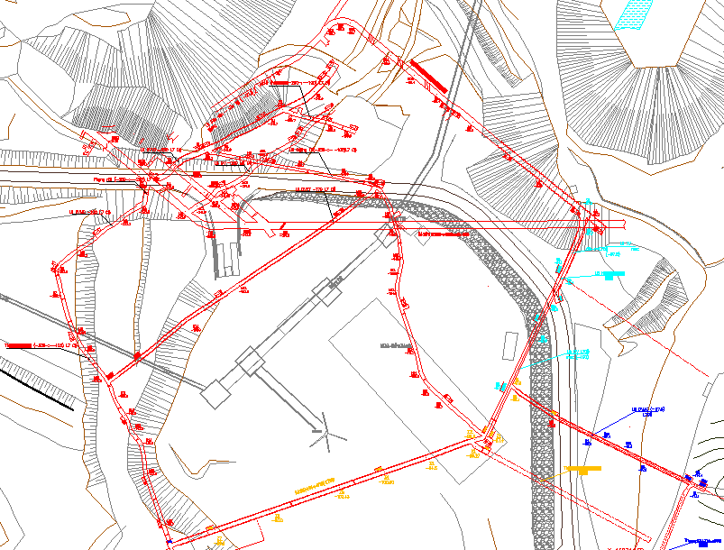
Figure 1. Location of the longwall in Seam L7 at East Side of Mong Duong coal mine

2.3. Geological conditions and mining technology of the longwall in Seam L7 at East Side
+ Geological conditions (Mong Duong Coal Company - Department of Geodesy and Mine Geology, 2019).
- Average thickness of seam: m = 3.2m
- Average slope angle: α = 30⁰
- The length of the longwall in the dip direction: 267 m;
- The length of the longwall in the strike direction: 200 m;
- Immediate roof: siltstone, average thickness of 7.3 m, easy to collapse, average hardness of 4.95;
- Main roof: sandstone and siltstone, average thickness of 30.8 m, average hardness of 12.67;
- Immediate floor: siltstone, average thickness of 7.43 m, average hardness of 4.57.
Figure 2 shows the stratigraphic column and coal seams of the cross-section E-E along line XIX of the Mong Duong coal mine (Mong Duong Coal Company - Department of Geodesy and Mine Geology, 2019). Table 1 shows the analytical results of the roof and floor rock of Seam L7 (Mong Duong Coal Company - Department of Geodesy and Mine Geology, 2019).

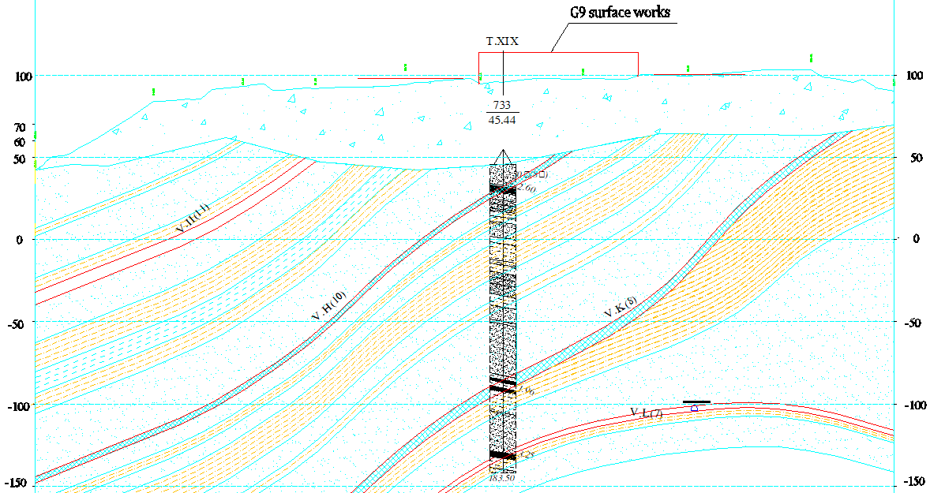
Figure 2. The stratigraphic column and coal seams of the cross-section E-E along line XIX
Table 1. Analytical results of the roof and floor rock of Seam L7
Type of rock | Rock unit | Value | Compression resistance strength σn (kG/cm²) | Tensile strength σk (kG/cm²) | Internal friction angle (degrees) | Cohesive force C | Specific weight γ (g/cm³)
Roof of Seam L7 | Sandstone | Max |  |  | 34,30' | 265
Roof of Seam L7 | Sandstone | Min |  |  | 32,05' | 219
Roof of Seam L7 | Sandstone | Medium | 898.1 | 76.33 | 33,13' | 240.67 | 2.74
Roof of Seam L7 | Siltstone | Max | 549 | 49.75 | 34,00' | 179 | 2.78
Roof of Seam L7 | Siltstone | Min | 435.6 | 58.29 | 32,12' | 93 | 3
Roof of Seam L7 | Siltstone | Medium | 495.37 | 47.22 | 33,13' | 134 | 2.84
Floor of Seam L7 | gravel stone | Max | 1877 | 187.1 | 34,05' | 575 | 2.71
Floor of Seam L7 | gravel stone | Min | 968.57 | 90.26 | 33,50' | 294 | 2.63
Floor of Seam L7 | gravel stone | Medium | 1422.79 | 138.68 | 33,55' | 434.5 | 2.67
Floor of Seam L7 | Sandstone | Max |  |  | 34,30' | 265
Floor of Seam L7 | Sandstone | Min |  |  | 32,05' | 219
Floor of Seam L7 | Sandstone | Medium | 898.1 | 76.33 | 33,13' | 240.67 | 2.74
Floor of Seam L7 | Siltstone | Max | 549 | 49.75 | 34,00' | 179 | 2.78
Floor of Seam L7 | Siltstone | Min | 435.6 | 58.29 | 32,12' | 93 | 3
Floor of Seam L7 | Siltstone | Medium | 495.37 | 47.22 | 33,13' | 134 | 2.84

+ Mining technology
In order to exploit the longwall in Seam L7 at East Side, Mong Duong mine uses mining technology by drilling and blasting, support by ZH frame, transporting coal by scraper conveyors and controlling mine pressure by caving method.
2.4. Building a numerical model
Based on the characteristics and physical and mechanical parameters of the soil and rock in the geological stratigraphic column of the E-E section (Figure 2), as well as the exploitation conditions of the longwall in Seam L7 at East Side, UDEC software is used to build a model with model height of 390 m, model width of 320 m, model length in dip direction of 267 m, average slope angle of 30 degrees, average seam thickness of 3 m, as shown in Figure 3. The mining process at the longwall is simulated according to the mining progress of the drilling and blasting technology, supported by ZH frame, with the movement speed of the model extraction is about 2 m/cycle.
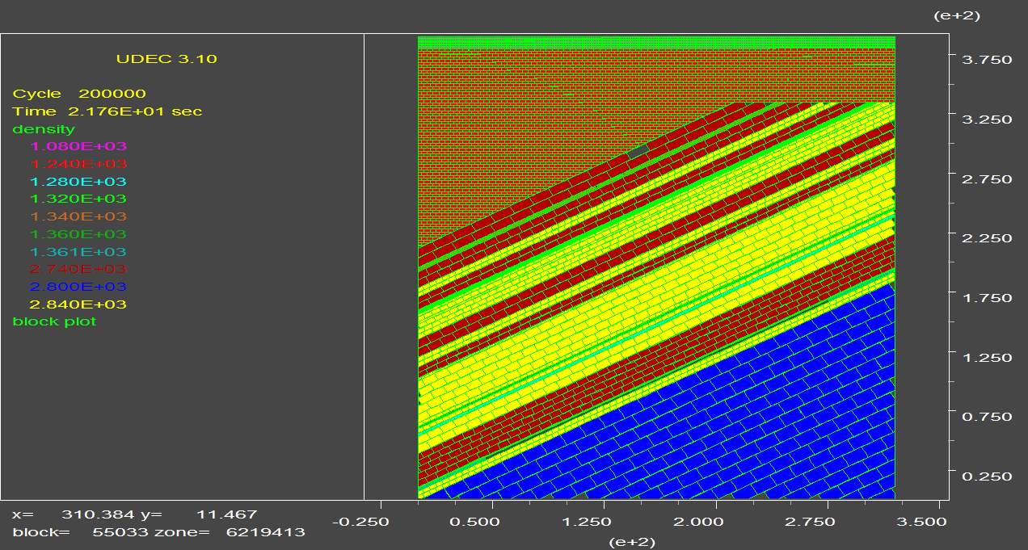
Figure 3. Simulation numerical model by the UDEC 3.10 software of the longwall in Seam L7 at East Side of Mong Duong coal mine.

3. Results and discussion

3.1. Analysis of model results

When exploiting the longwall in Seam L7along strike direction, the state of the roof is monitored with two solutions to exploit the height of the longwall at 2.2 m. That is, the recovery rate of top coal is 0% and 100%, as follows:

- Solution 1: the cutting height of the longwall is 2.2 m, the recovery rate of top coal is 0%;

- Solution 2: the cutting height of the longwall is 2.2 m, the recovery rate of top coal is 100%, corresponding to the recovery thickness of 0.8 m.

Thus, for each mining solution, when the longwall moves in the strike direction, it will observe the movement of the roof, determine the caving span of the immediate roof, the breaking span of the main roof, the height of the collapsed and fractured zones, and the degree of the crack system development in the roof of longwall. This result proves the extent of the influence of mining on the surrounding rock areas and the G9 surface works. This, thereby, serves as a basis for choosing a reasonable mining solution for the longwall in Seam L7.

+ Figure 4 shows the results of monitoring the state of the roof of the longwall in the Seam L7 when moving in the strike direction of 70 m.

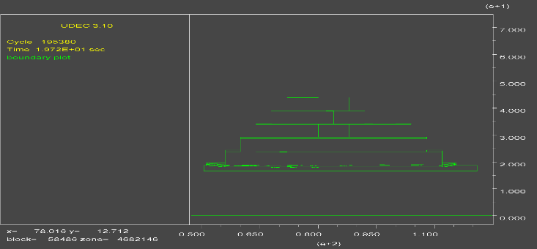  Height of collapse and fracture zones (solution 1) | 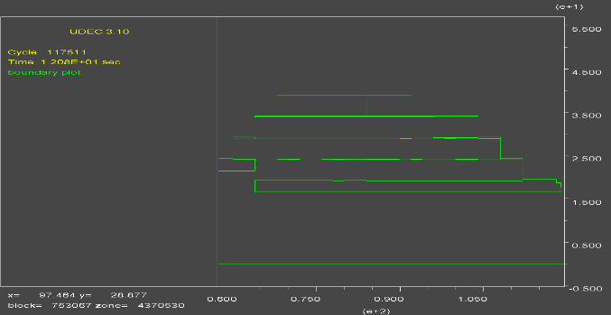  Height of collapse and fracture zones (solution 2)
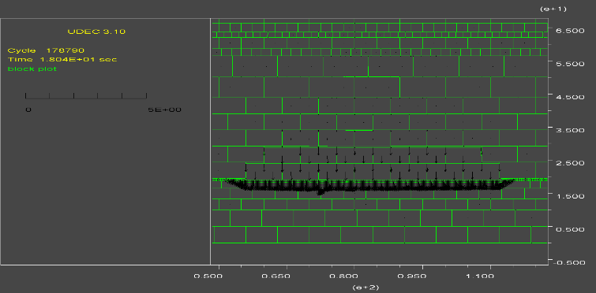  The process of moving of roof (solution 1) | 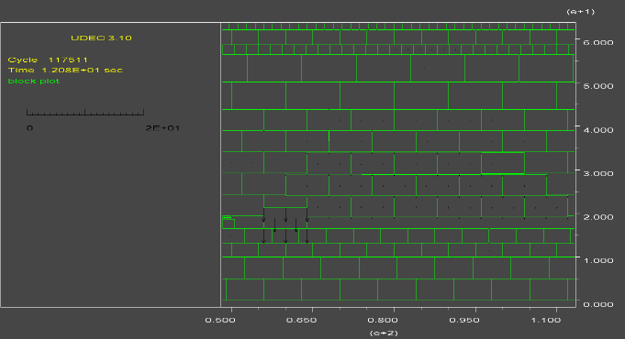  The process of moving of roof (solution 2)
Figure 4. State of the roof of the longwall in the Seam L7 at the East Side of Mong Duong mine when cutting 70 m in the strike direction

When cutting 70 m in the strike direction, through model observation, it is shown that, in the two mining solutions, the immediate roof collapses very clearly, and the cracks in the roof appeared with more density. In both mining solutions, the immediate roof is destroyed most of its thickness. The pressure in the mining area of the two solutions is similar: the value is from 4-6 MPa, the greatest in the area in front of the longwall face with a value of about 8MPa. The height of collapse and fracturing of the two mining solutions is not much different, which is about 30-40m.
+ When cuttting 100 m in the strike direction, the state of the roof of the longwall in the Seam L7 is shown in Figure 5. The numerical model observation shows that the roof pressure is similar to when cutting to 70 m. In both mining solutions, the roof behind the longwall gradually stabilized. The pressure of the roof in this area of the mining solutions is slightly changed: the value of the pressure is still from 4-6 MPa: the height of collapse and fracturing of the mining solutions do not change much, which is from 70 – 90 m. The analysis results from the model showed that the main roof was completely affected by the coal mining process at the longwall. The density of rock movement into the mining area is increasing day by day, as shown by the movement vectors of rock in Figure 5. The system of fractures continued to form and develop from the main roof area to the alluvia area near the G9 surface works of Mong Duong coal mine.

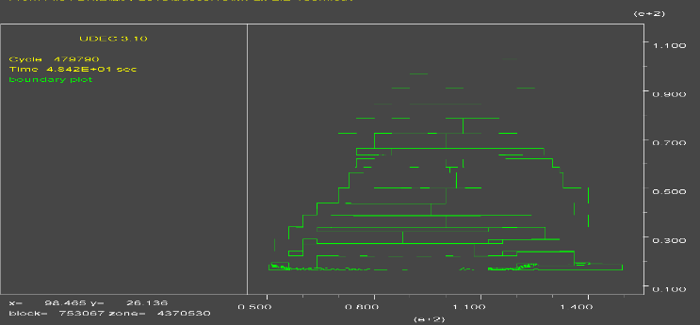  Height of collapse and fracture zones (solution 1) | 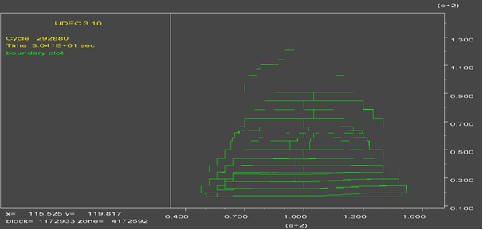  Height of collapse and fracture zones (solution 2)
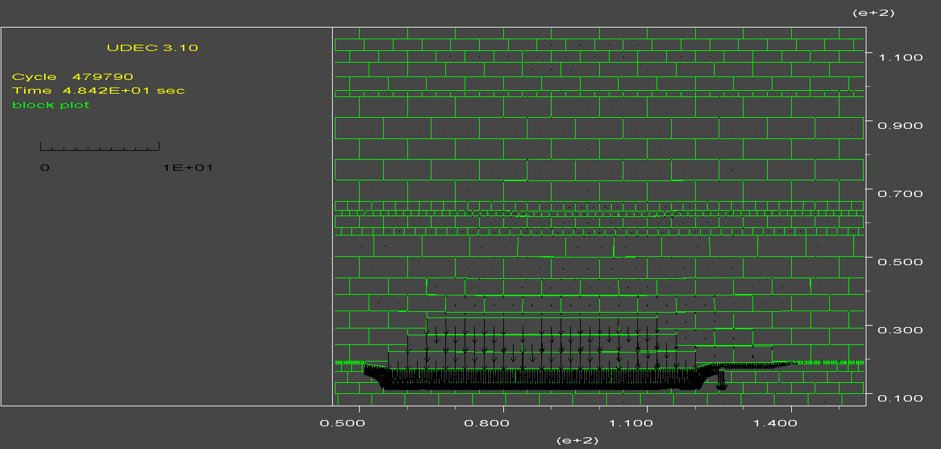  The process of moving of roof (solution 1) | 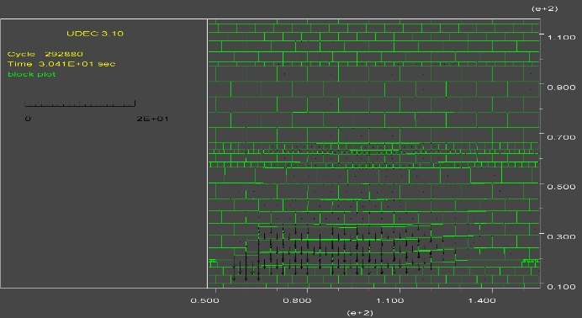  The process of moving of roof (solution 2)
Figure 5. State of the roof of the longwall in the Seam L7 at the East Side of Mong Duong mine when cutting 100 m in the strike direction

+ When cutting 140 m in the strike direction, the state of the roof of the longwall in the Seam L7 is shown in Figure 6.

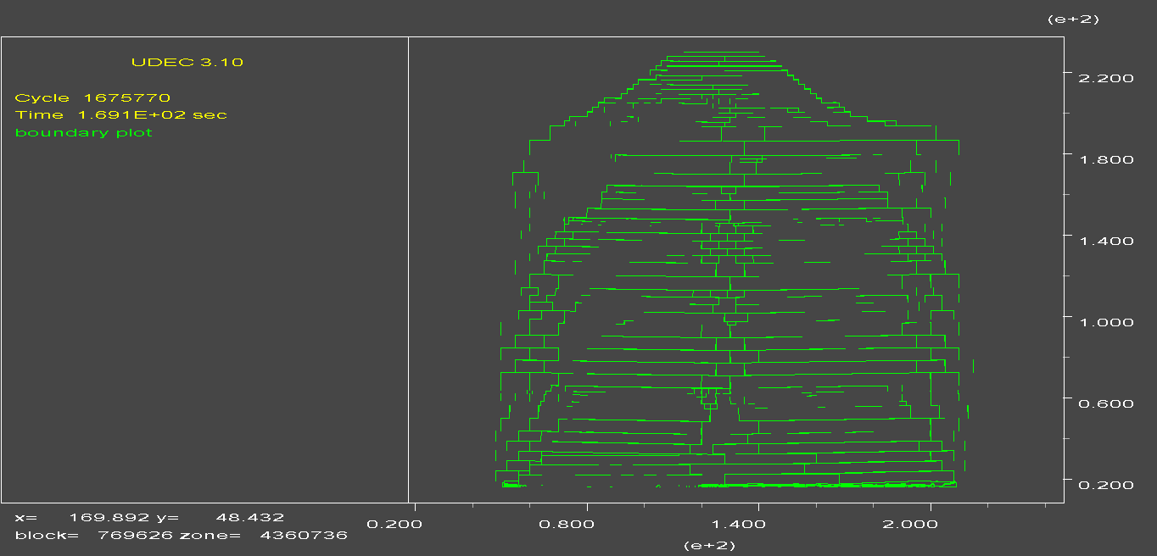Height of collapse and fracture zones (solution 1) | 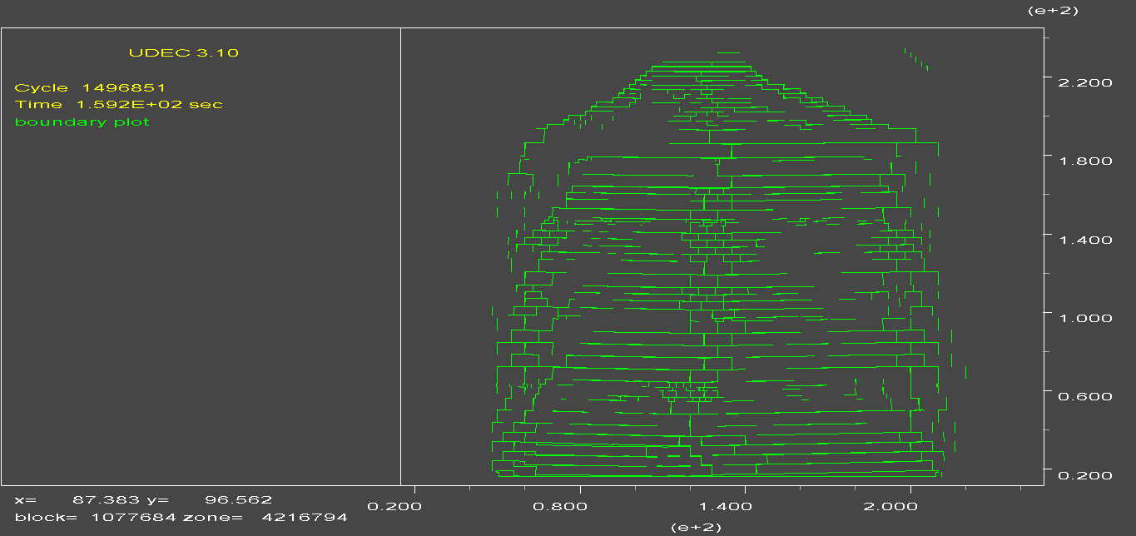  Height of collapse and fracture zones (solution 2)
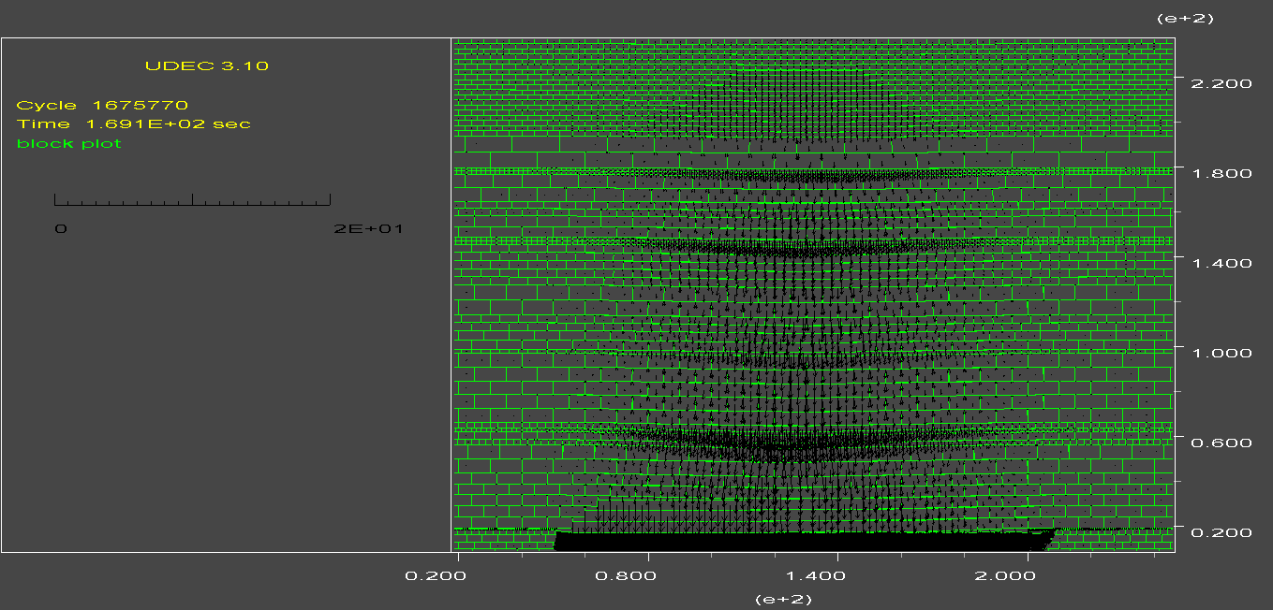The process of moving of roof (solution 1) | 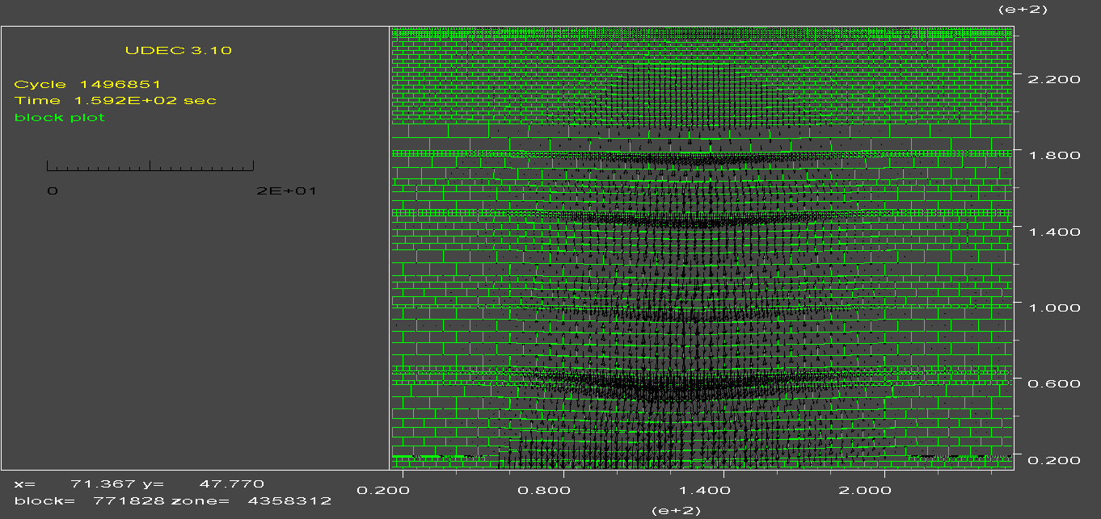The process of moving of roof (solution 2)
Figure 6. State of the roof of the longwall in the Seam L7 at the East Side of Mong Duong mine when cutting 140 m in the strike direction

The numerical model observation shows that the roof continues to form more systems of fractures, which gradually expand up to surface. At the same time, the height of collapse and fracturing zones of the two mining solutions also gradually increased, which is from 80 -100m. The density of rock movement into the mining area is increasing day by day, as shown by the movement vectors of rock in Figure 6. In the alluvia area near the G9 surface works, the density of fractures developed with a length of 0.4 - 0.6 m, which is relatively clear. Through monitoring images, the pressure in the mining area is from 4-6 MPa. Observations on the model show that the movement of roof can reach values from 0.06 to 0.1m in alluvia area near the G9 surface works.
+ As longwall cutting to 160 m and 200 m in the strike direction, the results of the model analysis show that, in the two solutions of exploiting, there is a strongly developed system of factures, which is reasonable because the longwall has been exploited for about 6 months, behind the mining area has gradually stabilized. It can be seen that, in both mining solutions, the formation and location of the fracture systems are almost the same. The total height of collapse and fracture zones of both mining solutions are from 150 - 170m. Model observations show that when the longwall falls in the strike direction of 140 m onwards, the level of subsidence develops according to the reduction progress. When the longwall is from 160 to 200 meters, the surface subsidence level reaches 0.2 -1.0m.
3.2. Analysis and selection of solutions
The monitoring in numerical models shows that the roof state of the two mining solutions is not much different. Thus, it can be concluded that the influence of underground mining on the G9 surface works in the two mining solutions is almost similar. The key is to clarify the total height of collapse and fracturing zones of the two mining solutions to serve as a basis for determining the impact of underground mining activities on the G9 surface works of Mong Duong coal mine.
From the results of model analysis for the two mining solutions as above, we have the following summary Table 2:

Table 2. Height of collapse and fracturing zones of two mining solutions 1 and 2
Solutions  1  and 2 | The length of the longwall when cutting in the strike direction (m) | The height of collapse and fracturing of the roof of the longwall in Seam L7 (m) | Surface subsidence (m)
Solutions  1  and 2 | 70 | 30 ÷40 | -
Solutions  1  and 2 | 100 | 70 ÷90 | -
Solutions  1  and 2 | 140 | 80 ÷100 | 0.06- 0.1
Solutions  1  and 2 | 160 - 200 | 150 ÷ 170 | 0.2 – 1.0

The results from Table 2 show that, when the longwall is exploited in the strike direction to 140 m, the height of the collapsed and fractured area is from 80 to 100 m, and the level of surface subsidence is from 0.06 to 0.1 m. However, when the longwall is exploited in the strike direction of 160 m onward, the total height of the collapsed and fractured area develops strongly, ranging from 150 to 170 m, and the level of surface subsidence is from 0.2 to 1.0 m. Accordingly, the G9 surface works will be affected when exploiting the longwall from 160 m onwards.

Thus, with the above results, the reasonable exploitation solution for the longwall in Seam L7 at East Side is Solution 2: exploiting with a height of 2.2 m and recovering 100% of the top coal (corresponding to 0.8 m). With this solution, the thickness of the coal seam will be fully exploited, minimizing the impact on the G9 surface works, and this therefore is a suitable solution.

4. Conclusions

The research results show that the numerical modeling method using UDEC software for simulation of the mining process in order to predict and determine the total height of collapsed and fractured areas and the influence of mining process of the longwall is reasonable and necessary. From the results of the model analysis, the authors have selected a reasonable mining solution for the longwall in Seam L7 at the East Side of Mong Duong coal mine with a cutting height of 2.2 m and 100% top coal recovery rate (corresponding to 0.8 m). This is also a solution that can exploit the entire thickness of the seam, ensuring no waste of resources. The model monitoring results show that when the longwall is exploited in strike direction up to 140 m, the surface subsidence is from 0.06 to 0.1 m. When the longwall is exploited in strike direction of from 160 to 200 m, the height of the collapsed and fractured area is from 150 to 170 m, and the surface subsidence is from 0.2 to 1.0 m. The research results of the article can be used as a basis for Mong Duong Coal Company to determine the affected area of the movement and deformation of the roof when exploiting the longwall in Seam L7. Subsequently, it is possible to evaluate the stability of the G9 surface works, and at the same time apply a comprehensive solution of engineering and technology to ensure safety during the mining process of this longwall.

Acknowledgments
This research is funded by Hanoi University of Mining and Geology, Vietnam.

Contribution of authors

References
Andrzej Kowalski, Jan Białek, Tadeusz Rutkowski, (2021). Caulking of Goafs Formed by Cave-in Mining and its Impact on Surface Subsidence in Hard Coal Mines. Arch. Min. Sci 66 (1), 85-100. DOI 10.24425/ams.2021.136694
Bui MANH TUNG, Nguyen VAN QUANG, Nguyen PHI HUNG, Vo NGOC DUNG, Do HOANG HIEP, (2020). Front Stress Distribution Under the Impact of Cutting Height to Caving Height Ratio in Extra thick Longwall Top Coal Caving Technology. Journal of the Polish Mineral Engineering Society, 123 -129. http://doi.org/10.29227/IM-2020-02-16
Chung Van Pham, Dac Manh Phung, Ha Thu Thi Le, Trong Gia Nguyen, Trung Thanh Ngo, Thang Vu Tran, (2021). Research on determining the safe miningdepth in special geological conditions of Mong Duong coal mine. Journal of Mining and Earth Sciences 62 (5), 76 – 83. DOI: 10.46326/JMES.2021.62 (5).07 (Vietnamese).
Do Manh Phong, Vu Dinh Tien, (2008). Rock pressure control. Transportation publisher. Hanoi, 140 pages (Vietnamese).
G.S.P. SINGH, U.K SINGH (2009). A numerical modeling approach for assessment of progressive caving of strata and performance of hydraulic powered support in longwall workings. Computers and Geotechnics 36, 1142–1156.
Hung Duc Pham, Dung Tien Van Mac (2021). Application of numerical modelling method for determination of underground mining’s impact on constructions in G9 coal storage at Mong Duong coal mine by using program UDEC2D. Journal of Mining and Earth Sciences 62 (6a), 18 – 27. DOI: 10.46326/JMES.2021.62(6a).03 (Vietnamese).
Le, T. D., Oh, J., Hebblewhite, B., Zhang, C. & Mitra, R, (2018). A discontinuum modelling approach for investigation of Longwall Top Coal Caving mechanisms. International Journal of Rock Mechanics and Mining Sciences 106, 84-95.
Li Dezhong, (2011). Special underground coal mining. China University of Mining and Technology Press. XuZhou, 207 pages (Chinese).
Long Quoc Nguyen, Adeel Ahmad, Cuong Xuan Cao, Canh Van Le, (2019). Designing observation lines: a case study of the G9 seam in the Mong Duong colliery. Journal of Mining and Earth Sciences 60(3), 18 - 24.
Mong Duong Coal Company - Department of mining technology, (2020). Exploitation plan of the longwall in Seam L7 at East Side of Mong Duong coal mine. Cam Pha (Vietnamese).
Mong Duong Coal Company - Department of Geodesy and Mine Geology, (2019). Report on assessment of geological conditions of Seam L7 at East Side of Mong Duong coal mine. Cam Pha (Vietnamese).
Pham DUC HUNG, Le TIEN DUNG, Nguyen VAN QUANG, (2020). Safe Exploitation Solution and Reduction of Resources Loss for the L7 Seam at the West Wing Area of the 790 Open Pit Site of the Mong Duong Coal Mine. Journal of the Polish Mineral Engineering Society, 231 -238. https://doi.org/10.29227/IM-2020-02-28
Qian Mingcao, Shi pingwu, (2003a). Mine pressure and strata control. China University of Mining and Technology Press. XuZhou, 373 pages (Chinese).
Qian Mingcao, Miao xiexing, Xu jialin, (2003b). Key layer theory of strata Control China University of Mining and Technology Press. XuZhou, 224 pages (Chinese).
Tran Duc Dau, Le Van Hau, (2021). Research on reasonable exploitation technology for coal seams under the protected objects on the surface in Quang Ninh region. Journal of Mining Industry 3, 18 -24 (Vietnamese).
Tran Van Thanh, (2007). Special underground mining methods. Transportation publisher. Hanoi, 89 pages (Vietnamese).

