Reasonable coal Pillar Width and Surrounding
Rock Control of Gob-side Entry Driving in
Inclined Short-distance Coal Seams
Fulian Heª’ ^{b}, Wenli Zhaiª’
*, Xuhui Xuª, Jiayu Songª, Liang Liª, Kai Lvª, Deqiu Wangª
ª School ofEnergy and Mining Engineering, China University of Mining and Technology (Beijing), Beijing 100083, China
^{b} Beijing Key Laboratory for Precise Mining ofIntergrown Energy and Resources, China University of Mining and Technology (Beijing), Beijing 100083, China.
Corresponding author: Wenli Zhai; Email: wlzhai8@163.com
Abstract: During gob-side entry driving under complex conditions in inclined short-distance coal seams, the roadway loses stability and deforms seriously, which affects the safety and efficiency of mine production. In this study, a reasonable coal pillar width was explored by means of on-site investigation, theoretical analysis, numerical simulation and engineering test. The following research results were obtained. (1) In selecting a reasonable coal pillar width, the influences of the position of residual coal pillars, stratum spacing, main roof breakage, roadway section in the upper coal seam should be considered, and established mechanical models of inclined gob-side roadways. (2) The stress states of coal pillars with different widths were analyzed by numerical simulation, the coal pillar width increases, the peak value of stress increases first and then decreases, according to the site geological conditions, the coal pillar width is finally determined to be 8 m, whose results are basically consistent with the theoretical calculation results. (3) A new pressure-yield support technology was proposed, and its on-site application confirmed its notable roadway control effect.
Key words: Inclined coal seams; Gob-side entry driving; Numerical simulation; Reasonable coal pillar width; Yield support
- Introduction
As the depth of coal mining rises, an increasing number of coal mining areas are faced with the technical problem of short-distance multi-seam mining (Yavuz et al.2004, Yan et al. 2015, Kuyuk et al. 2019, Palei et al. 2009). During the mining of short-distance coal seams, the gob and coal pillars left from the upper coal seams greatly affect the selection and control of the roadway location in lower coal seams (Mo et al. 2019, Shang et al.2019, Yue et al. 2021). An unreasonable roadway location in lower coal seams often causes serious roadway deformation, which seriously affects normal recovery of the working face (Islam et al. 2009, Das et al. 2018,). Therefore, gob-side entry driving in lower coal seams should not only consider factors influencing lower-coal-seam mining, but also avoid the influence of the high stress concentration of residual coal pillars in the upper coal seams, which is of great significance to the safe and efficient coal mining.

Experts have conducted extensive researches on the stress distribution characteristics of short- distance coal seams, the reasonable coal pillar width in gob-side entry driving and the surrounding rock control (Yadav et al. 2020, Murphy et al. 2021, Ram et al. 2021). Wang et al. (2020) analyzed the correlation between deformation failure of bottom coal in the gob-side entry and coal pillar width by theoretical analysis, numerical calculation, and similar simulation experiments. Peng et al. (1980) studied the mechanical behavior of coal pillar load on floor rock strata in multi-seam downward mining, and discovered that stress was highly concentrated in floor rock strata near coal pillars, and the stress concentration degree in floor rock strata was positively correlated with the distance between the surrounding rock and coal pillars. Quang et al. (2020) adopted of numerical simulation software, a reasonable design for roadway supporting pillars was determined. Ghasemi et al. (2014) applied the fuzzy logic to predict sate pillar sizing in room and pillar coal mines. Hu et al. (2012) summarized the main factors causing roadway damage in adjacent gobs and fount that roadway deformation can be effectively controlled using high-preload and dense-bolt (cable) support system. With respect to problems such as serious asymmetric deformation and support failure of gob-side roadways. He et al. (2020) proposed a hydraulic fracture technique to pre-fracture the two hard roofs and the validity of the above roof treatment was verified via field application.
Based on the engineering background of the 4602 head roadway in Hong hui Coal Mine, this study established a theoretical model for floor failure in short-distance coal seams and analyzed the floor failure range of the residual coal pillars. Besides, it established a mechanical model of inclined gob-side roadways and deduced an expression for influence range of low stress area and its influencing factors. Moreover, the stress distribution characteristics of coal pillar under different coal pillar widths in gob-side entry driving were analyzed by numerical simulation; a reasonable coal pillar width was comprehensively determined; and the yield anchor mesh cable support system was proposed. The proposed support system effectively controls the integrity of roadway surrounding rock and realizes the safety and stability of roadway support.
- Engineering background
  - Engineering profile
The 2# coal seam of the 4602 working face was mined. Some parameters of the coal seam are as follows: buried depth 354 ~ 284m, average dip angle 17°, average thickness 3.0 m, firmness coefficient f 1.8 ~ 2.2 and medium-level bedding development. The shallow and deep parts of the 4602 working face are the 4502 gob and the 4702 gob, respectively. The 4602 working face is an island face whose location is illustrated in Fig. 1. A mudstone false roof that is 1 m thick exists in the 2# coal seam roof. The immediate roof, whose thickness is unstable and averages 19 m, belongs to fine sandstone and siltstone, with gray and argillaceous cementation and developed fractures. The immediate floor, whose average thickness is 2.45 m, belongs to argillaceous siltstone with gray white

and argillaceous cementation and poor hardness, and it softens when encountering water. The lithologies of the coal seam roof and floor are shown in Fig. 2.
4603 goaf
Coal piiiar
}0"<
4602 goaf
4502
4602 working face
4602 head entry
ч4702 goaf
Stopping iine 1# coal seam
2# Coal seam
Coal pillar
Fig. 1. Spatial position diagram of working face
Histogram |  | Rock stratum | Thickness/m | Lithology description
 |  | coarse  sandstone | 16.5 | gray white, coarse-grained structure, massive structure, mainly composed of quartz
 |  | No.l coal seam | 8.8 | black, massive, with pyrite film, Semi bright briquette
 |  | siltstone | 12.0 | dark gray, dense, brittle, developed fissures
 |  | fine  sandstone | 6.0 | dark gray, dense and hard, containing a large number of
 |  | fine  sandstone |  | muscovite fragments , mixed with coal line
- V^{s} |  | mudstone | 1.0 | grayish black, argillaceous cementation, softened in case of water
 |  | No.2 coal seam | 3.0 | black, massive, with pyrite film, Semi bright briquette
 |  | pelitic  siltstone | 2.45 | dark gray, dense and hard, argillaceous cementation, with coal line
 |  | siltstone | 6.5 | dark gray, dense, brittle, developed fissures
Fig. 2. Rock stratum histogram of working face
  - Originally adopted support scheme and deformation and failure characteristics
In originally adopted gob-side entry driving, the roadway has a rectangular section with a net width of 4,000 mm and a net height of 3,000 mm. The roadway roof and sides adopt Ф 20 mm x 2,400 mm high-strength bolt support with a row spacing of 800 mm x 800 mm. The anchor cables are Ф 18.9 mm x 5,000 mm mining anchor cables; each row has 3 cables with a spacing of 1,200 mm, and the row spacing is 1,600 mm. After the above support scheme is adopted, the roadway
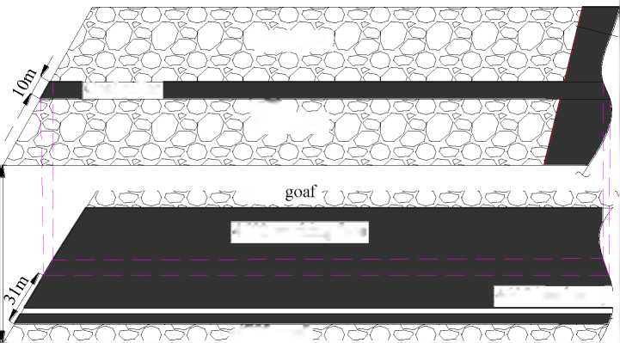

surrounding rock deforms seriously during recovery, especially the gob-side roof and sides of the roadway where the bolts move outward with the deformation of surrounding rock (Fig. 3a). At the same time, local floor heave occurs in the roadway (Fig. 3b). The recovery requires repeated side expansion and floor reshaping. If it gets too serious, grouting and re-building metal U-shaped steel shed support are needed after the repair. According to the above roadway deformation characteristics of gob-side entry driving, coal pillar width and support parameters require further optimization.
(a) (b)
Fig. 3. Deformation and failure of gob side coal roadway. (a) Deformation of roof and rip. (b) Roadway floor heave.
- Calculation of coal pillar width of gob-side entry driving
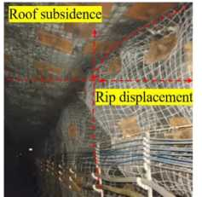
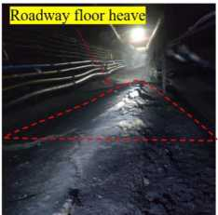
  - Study on floor failure range of residual coal pillars
Residual coal pillars exist after the 1# coal seam mining. The floor failure depth resulting from the residual coal pillars can directly tell whether the lower coal seam mining is affected. The coal pillar load acts on the floor and causes damages (Fig. 4).
O
G
A
B
C
D
Fig. 4. Floor failure model
The ED curve is logarithmic spiral, and its formula is (Xu et al. 2021):

(1)
where r is the spiral radius with O as origin at an angle of a with r₀; r₀ is the length of OE; a is the angle between r and r₀; (p_{f} is the internal friction angle of rock strata.
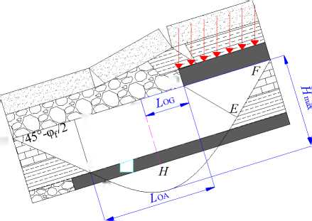
Since ZOFE = ZEOF = n/4 + v/2 ,
Г = B /2 cos (n / 4 + p_{f} /2)
where B is the width of the coal pillar acting on the floor.
When the floor reaches the maximum yield failure depth, c can be calculated by:

a = n/4+<^/2
Then the maximum floor failure depth can be expressed as:
H =
max
B cos
Vf
nVf
tan Vf
2cos
^{f}^+f
V ⁴ ² У
(2)
(3)

(4)
According to Eq. (4), the maximum floor failure depth under the influence of residual coal pillars is related to the coal pillar width and floor lithology. Based on the actual geological conditions of coal
e
and rock strata, the internal friction angle Vf is 38° and the width of coal pillars B is 10 m. They are
substituted into Eq. (4): Hmax = 27m, larger than the average distance of 19 m between the two coal seams. Therefore, the failure range of residual coal pillars in upper coal seams has a significant influence on the lower coal seam mining and the mining roadway layout.
Based on the above analysis, the 2# coal seam roadway can be arranged at the position where the residual coal pillar stress is less concentrated on the floor, which is conducive to roadway stability.
The influence range of high floor stress concentration of residual coal pillars in the 1# coal seam L_{OG}
is shown in Fig. 4,

Log = ( h + h ) tanV
(5)
where h is the thickness between the 1# and 2# coal seams, m, calculated as 19 m; h₂ is the 2#
coal seam thickness, m, calculated as 3 m; V is the propagation angle of stress influence, calculated as 25°.
Based on the calculation of ^{L}_{OG} , that is, at the 1# coal seam floor, the concentrated influence
range of coal pillars is 11 m. With reference to the calculation results, if the 2# coal roadway is arranged over 11 m away from the residual coal pillars of the 1# coal seam, the roadway will be less affected by the residual coal pillars of the 1# coal seam.
  - Study on the reasonable coal pillar width
After the recovery of the working face in the upper section, the gob-edge immediate roof collapses, and the main roof rotates. The gangue supports the rock block B of the main roof; the rock block B

and adjacent blocks squeeze each other to form a relatively stable structure. The fracture of the main roof divides the lateral abutment pressure into obvious internal stress field S1 (stress falling area) and external stress field S2 (stress rising area). The location of the main roof fracture is the boundary of the two stress fields (Fig. 5a). To provide a good stress environment for the roadway and facilitate roadway maintenance, roadways are generally arranged in the stress falling area in coal pillar width selection (Song et al. 1986).
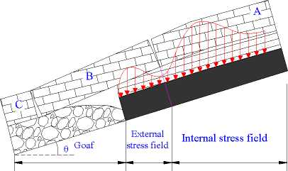
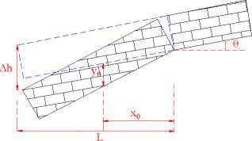
(a) (b)
Fig. 5. Mechanical model. (a) Distribution diagram of internal and external stress field. (b)Breaking structure model of main roof.
In the internal stress field, the abutment pressure x m away from the coal wall can be expressed
as:
= ^{G}_{x}y_{x}
(6)
where G_{x} is the stiffness of the coal body x m away from the coal wall, Pa; y_{x} is the deformation of the coal body x away from the coal wall, m.
As the abutment pressure develops to the deep part of the coal wall, the stiffness of the coal body gradually rises while the compression gradually decreases. It is simplified as a process of linear variation. According to the geometric relationship, then:
Ух = — (^{x}o ^{- x}) , ^{G}x = — ^{X} (7)
^{x}o ^{x}o
where — is the maximum stiffness of the coal body within the internal stress field, Pa; ^{y}_{o} is the
compression of gob-edge coal body, m; x₀ is the distribution range of the internal stress field, m.
According to Eqs. (6) and (7), the abutment pressure of the internal stress field is
—o^{y}o ^{x}o
f ° <j dx =
0 ^{v}
6
(8)
According to the theory of internal and external stress fields, the abutment pressure within the internal stress field on the coal body around the stope is equal to the self-weight of the main roof strata during the first weighting of the working face, then:

^{G}0^{y}0 ^{X}0
6
abC₀ у

(9)
where a is the inclined length of the working face, m; C₀ is the first weighting step distance of the
adjacent working face, m; b is the thickness of the main roof strata, m; у is the bulk density of the main roof rock, kN/m³. According to Fig. 5 (b), then:
Уо ₌ Ah _M - h (K_{c} -l) x₀ L L

Уо = L — - ^{h} (Kc -¹)]
^{L (11)}
where M is the mining thickness of the coal seam, m; h is the thickness of the immediate roof rock strata, m; Ah is the maximum subsidence of the key block, m; L is the span of hinged rock beams, which is nearly equal to the periodic weighting step distance of the fully mechanized caving face, m;
K_{c} is the dilatancy coefficient of the immediate roof rock.
According to the inclusion theory, the stiffness of the coal body G₀ (Zhang et al. 2016) in the
plastic state is
^{G}0
E
2 (1 + v )%
(12)
where E is the elastic modulus of the coal body, Pa; v is Poisson’s ratio; % is the influence coefficient,
which is related to the development of fractures in the coal body.
The range of the internal stress field x₀ can be obtained based on Eqs. (9)~(12):
^{X}0 =
12abC₀ y%L (l + v)
E [M - h (Kc-1)]
(13)
According to geological data from the mine and on-site measurement, a = 120m, b = 12m, C₀ = 35m , у = 27kN/ m³ , % = 0.85 , L = 16m , v = 0.3 , E = 24GPa , M = 3m , h = 7m and
K_{c} = 1.32. These values are substituted in Eq. (13) to obtain the internal field range x₀ = 12.58m.
The limit of reserved coal pillars in gob-side entry driving is to arrange roadways within the internal stress field. The 4602 head roadway is designed 4.6 m wide, and the width of coal pillars should not exceed 8 m.
A reasonable width should ensure not only the stability of the roadway surrounding rock during excavation, but also the safety and stability of the working face during recovery. Although the 4602 head roadway can be arranged in a low stress environment by reserving 3 ~ 5 m small coal pillars,

the 4602 working face belongs to an island face which is also affected by the residual coal from the 1# coal seam. Hence, the 4602 working face is likely to experience large-scale instability and damage. The internal fractures of coal pillars are developed, leading to poor stability and air leakage in the gob, unfavorable for fire prevention. Meanwhile, according to the above calculation, the roadway should also be arranged outside the influence range of coal pillar stress concentration in the upper coal seam, so the coal pillar width is preliminarily determined to be in the range of 6 ~ 8 m. Due to the limitations of theoretical model calculation, the final coal pillar width is determined by calculating the stress distribution characteristics of coal pillars with different widths through numerical simulation.
- Numerical simulation of coal pillar width of gob-side entry driving in inclined coal seams
  - Establishment of the numerical model
According to the mining relationship and the roof and floor strata conditions of the 4602 working face, a numerical calculation model that is 470 long, 200 wide and 200 m high is established (Fig. 6). The lateral displacement of the model is limited in the horizontal direction, and the bottom is fixed in the X, Y and Z directions. The lateral pressure coefficient is set as 1.2, and coal and rock mass is calculated by the Mohr-Coulumb model. The horizontal distance between the 1# coal seam residual pillars and the 2# coal seam is 31 m; the above calculated stress concentration influence range of residual pillars is 11 m and the range of the internal stress field is 8 m. Therefore, the reasonable pillar width can be further determined by simulating the stress distribution characteristics of roadway surrounding rock with pillar widths of 4 m, 6 m, 8 m, 10 m, 12 m and 14 m, respectively. The calculation process is as follows: model establishment ^ original rock stress equilibrium ^ excavation of the 1# coal ^ excavation of the 4502 and 4702 working faces in the 2# coal seam ^ excavation of the 4602 head roadway ^ calculation result analysis.
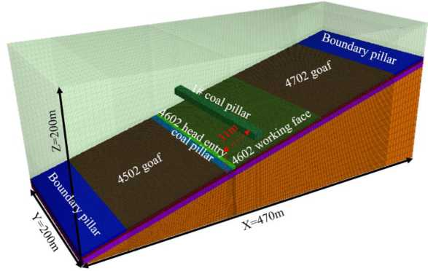
Fig. 6. Three-dimensional numerical model

4.2 Analysis on the model results
When the coal and rock mass boasts a strong bearing capacity, stress concentration is likely to
occur in a certain range. Stress is re-distributed after roadway excavation. The simulation and analysis on the stress distribution in the coal pillars is of certain guiding significance for determining the reasonable coal pillar width. The stress nephograms and distribution curves of different coal pillar widths were obtained by numerical calculation results (Fig. 7).
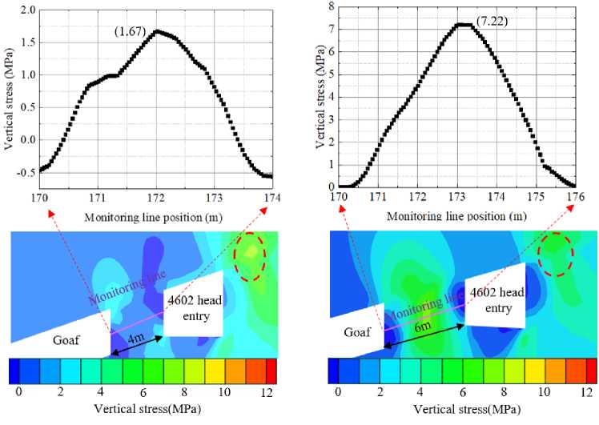
(a)
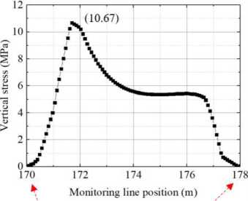
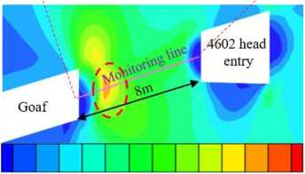
0 2 4 6 8 10 12
Vertical stress(MPa)
(b)
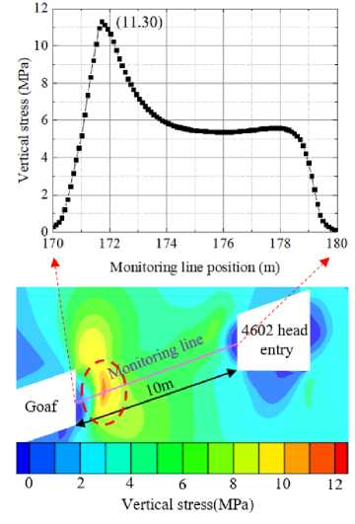
(c)
(d)

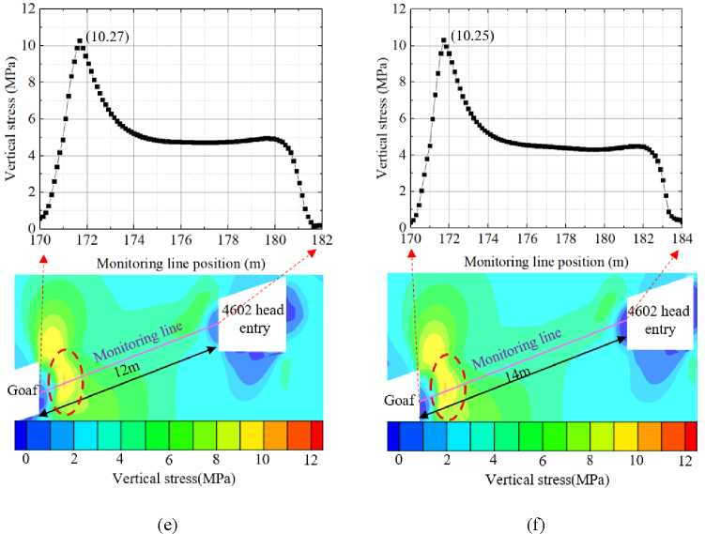
Fig. 7. Stress distribution of different coal pillar widths. (a) Stress variation of 4m coal pillar. (b) Stress variation of 6m coal pillar. (c) Stress variation of 8m coal pillar. (d) Stress variation of 10m coal pillar. (e) Stress variation of 12m coal pillar. (f) Stress variation of 14m coal pillar.
According to Fig. 7, overall, the stress distributions of different coal pillar widths show the following rules:
- At the coal pillar width of 8 ~ 14 m, the internal stress of coal pillars presents an asymmetric bimodal distribution with high stress on gob sides and low stress on roadway sides. When the width is below 6 m, the internal stress presents a single peak distribution.
- After the roadway excavation, the vertical stress is re-distributed. At a small coal pillar width, stress is concentrated on the right side of the roadway. As the width increases, the position of stress concentration gradually shifts to the gob side.
- At the widths of 4 m and 6 m, fractures develop in the coal pillars, leading to serious damage and poor bearing capacity, which fails to form stress concentration. However, as the width continuously increases to 8 m, the mechanical properties of the coal and rock mass improve; the peak value of the stress nucleus rises. When the width reaches 10 m, the maximum stress peak value is 11.30 MPa. When the width exceeds a certain value and reaches 12 m, the abutment pressure increases and surpasses the ultimate strength of the coal body. In this case, the stress in the coal pillar is relieved, and the peak value of stress nucleus decreases. The peak stress value rises first and then decreases, following the order 1.67 MPa, 7.22 MPa, 10.67 MPa, 11.30 MPa, 10.27 MPa and 10.25 MPa in turn.
- When the width of the coal pillar reaches 8 m, the coal pillar boasts an overall good bearing capacity. An increase in the width improves the integrity of the coal pillar. However, a width below 8

m corresponds to a poor integrity and difficult maintenance. Therefore, the width of 8 m can ensure the stability of coal pillars through appropriate measures and maximize the recovery of coal resources.
In summary, when the width of coal pillar is 8 m, coal pillars have an overall good bearing capacity. Meanwhile, the roadway is within the internal stress field, and can also avoid the impact of high stress caused by the residual coal pillars in the upper coal seams. Under strengthened support, the roadway can fully meet the requirements for the basic transportation, ventilation and side walking during recovery. Moreover, strengthened support can maximize the recovery of coal resources and ensure the safety and stability of roadway during recovery. As a result, it is determined that the coal pillar width of gob-side entry driving is set to 8 m through theoretical analysis and on-site actual situation.
- Determination of the 4602 head roadway support scheme
For the 4602 head roadway of gob-side entry driving, the roadway is in a high stress environment. Hence, targeted design and improvement in anchor net cable support are required. The stability of roadway surrounding rock can be controlled using yield support technology. The principle of “yield before resist, a combination of yield and resist” was adopted to control the deformation of roadway surrounding rock. “Pressure yielding” can lead to a certain plastic deformation of roadway surrounding rock by pressure-yield bolts, so that the deformation of surrounding rock can be released to a certain extent. “Pressure resisting” can resolutely resist the deformation of roadway surrounding rock by high-strength bolts. “Pressure resisting” does not mean simply improving the bolt strength. When the bolt strength increases to a certain extent, the mechanical parameter ratio of the roadway surrounding rock varies slightly. Meanwhile, when the bolt has a higher strength, its elongation is lower, failing to satisfy the deformation of the roadway surrounding rock. At this time, the performance of the pressure-yield bolts can be brought into full play.
  - Bolt support system
The parameters of the support system are as follows: Ф 20 mm x 2,600 mm high-strength anchor bolts, 150 mm x 150 mm x 10 mm high-strength trays with 260 Nm preload. The anchor bolt layout is shown in Fig. 9, and surface support is realized by prepared metal mesh. The anchor bolts are matched with pressure-yield pipes. The pressure-yield distance is 26 mm and the pressure-yield point is 120 ~ 150 kN (Fig. 8a).

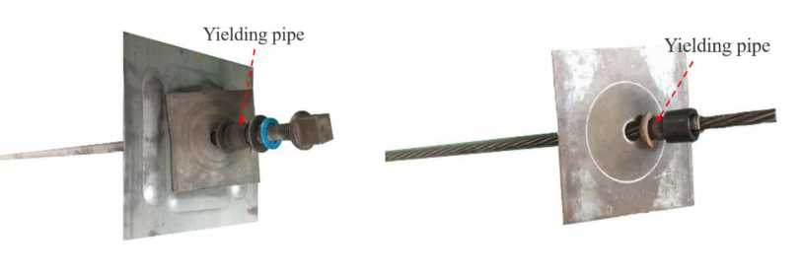
(a)
(b)
Fig. 7 Pressure-yield Supporting materials. (a) Pressure-yield anchor bolt. (b) Pressure-yield anchor a cable.
  - Auxiliary support system
The roadway roof is supported by Ф 18.89 mm x 5,000 mm mining anchor cables. The upper parts of the two sides of the roadway are both equipped with a Ф 18.89 mm x 5,000 mm anchor cable for reinforcement support. The installation preload is 100 kN, equipped with 300 x 300 x 12 mm high-strength arc trays, and the cable layout is given in Fig. 9. The anchor cables are matched with pressure-yield pipes. The pressure-yield distance is 26 mm and the pressure-yield point is 220 ~ 250 kN (Fig. 8b).
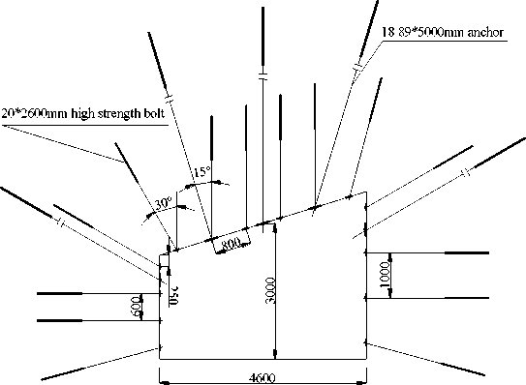
20*2600mm high strength bolt
0 0
0 0 0 0®
18.89*5000mm anchor
В 0 0 0 ■■■,0 0
"® 0 0 0 0 0
2400
0 0 0 0 0 0
■
0 0 0 0 0 0
4600
(a) (b)
Fig. 9. Support scheme. (a) Front view. (b) Top view of roof support.
- Engineering experiment
An engineering experiment of the support scheme was conducted in the 4602 head roadway with the coal pillar width being 8 m. During excavation, mine pressure observation points are arranged in the roadway to monitor the roadway support quality, hereby monitoring the reasonableness of the selected roadway support parameters. It provides a certain basis for the optimization and adjustment of roadway support scheme. Five groups of mine pressure observation points are arranged in the 4602
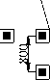

head roadway. The contents of each group mainly include roadway deformation monitoring and bolt (cable) stress monitoring. Among them, two groups were selected for analysis.
6.1 Roadway deformation data and analysis
(a) (b)
Fig. 10. The curves of roadway deformation variation with working face distance. (a)Deformation of 1# measuring station. (b)Deformation of 1# measuring station.
Based on the data recorded at the observation points of roadway surrounding rock deformation, the curves of roadway deformation variation with working face distance were drawn (Fig. 10). The roadway is basically stable when excavation advances to the observation point about 80 m away from the working face. Influenced by the gob and coal pillar concentrated stress in the 1# coal seam as well as the coal pillars in the 2# coal seam, the coal pillar sides deform seriously (up to 82 mm) while the working face sides deform relatively less (up to 65 mm). When excavation advances to the observation point 80 m away from the working face, the roof subsidence curve basically stabilizes and becomes basically linear, the maximum roof subsidence being 95 mm.
According to the roadway deformation, the deformations of the roof and two sides are well controlled. The coal pillar sides deform relatively seriously, and the deformation of the left side accounts for 56% of the deformation of the two sides.
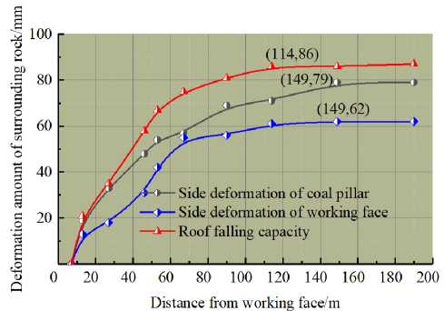
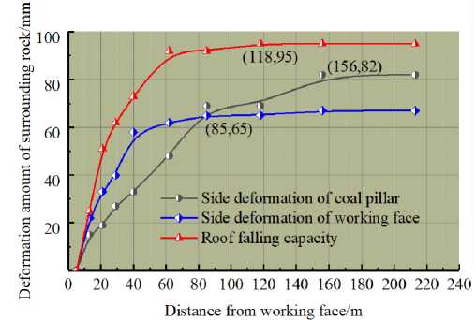
6.2 Observed data of bolt stress and analysis
Distance
(a)
60 80 100 120 140 160 180 200
Distance from head-on/m
(b)
Fig. 11. The curves of bolt stress variation with working face distance. (a)Pressure of 1# measuring station. (b)
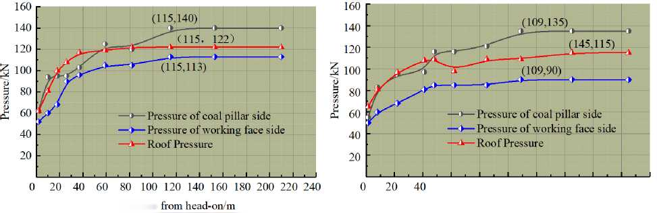
Pressure of 2# measuring station.
According to the data recorded at the two groups of bolt stress observation points, the curves of bolt stress variation with working face distance were drawn (Fig. 11). The bolt stress of the working face sides and roof increases linearly before the distance from the working face exceeds 80 m, and tends to stabilize after the distance from the working face exceeds 80 m. Influenced by coal pillars, the bolt stress of the coal pillar side is likely to cause stress concentration, which leads to high bolt stress of the coal pillar side. The maximum bolt stress is 140 kN and the maximum bolt stress of the working face side is 113 kN. The coal pillar side bolt is subject to a higher stress than the working face side bolt, and the maximum roof bolt stress is 122 kN. According to the data of anchor bolt stress, bolts are subject to a high stress. The bolt stress of the coal pillar side and the roof is close to or even exceeds the pressure-yield point of the pressure-yield pipe. The pressure-yield device plays a certain role of pressure-yield to make the anchor bolts bear the stress together and prevent the breakage of the local anchor bolt by excessive stress.
- Observed data of anchor stress and analysis
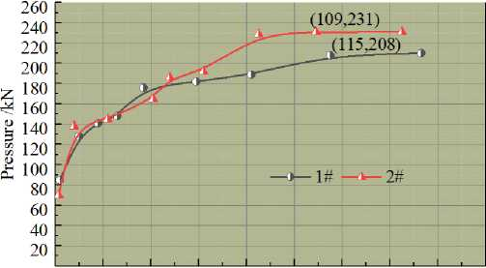
0 20 40 60 80 100 120 140 160 180
Distance from working face /m
Fig. 12. The curves of anchor cable stress variation with working face distance
According to the recorded data of two groups of anchor cable stress, the curves of anchor cable
stress variation with working face distance were drawn (Fig. 12). After the installation of anchor cables, the stress of the anchor cable basically increases linearly and tends to stabilize when the observation point is about 100 m away from the working face, the maximum stress of the anchor cable being 210 kN, smaller than the cable breaking strength of 400 kN. Cables can bear the stress together with anchor bolts and play the role of auxiliary strengthened support.
According to the above ground pressure observation and analysis, the stable support of roadway excavation along the gob in the inclined coal seam is effectively realized by the pressure anchor mesh cable support scheme. The on-site support effect is illustrated in Fig. 13.

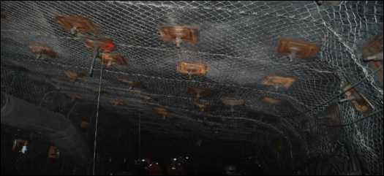
Fig. 13. Effect drawing of on-site support
- Conclusions
- A theoretical model of short-distance coal seam floor failure and a mechanical model of inclined gob-side roadway were established. The influence depth of the residual coal pillars in the upper coal seam on the floor is 27 m, the influence ranges of the stress concentration of coal pillars and the low-stress area of the inclined coal seam are 11 m and 12.6 m, respectively. With reference to the on-site production geological condition, the coal pillar width is preliminarily determined to be in the range of 6 ~ 8 m.
- Numerical simulation analysis reveals that when the width of coal pillars is smaller than 6 m, the internal stress of coal pillars is distributed in a single-peak shape, and stress is concentrated near the roadway. When the width is 8 ~ 14 m, the internal stress concentration position of coal pillars moves to the gob side, showing an asymmetric bimodal distribution of high stress on the gob side and low stress on the roadway side.
- Through numerical simulation calculation, as the coal pillar width rises, the overall peak stress increases first and then decreases. When the coal pillar width reaches 8 m, the coal pillars have an overall strong bearing capacity. When the coal pillar width continues to rise, the integrity of the coal pillars improves. However, when the width is smaller than 8 m, the coal pillars have poor integrity, causing difficulty in maintenance. Finally, the coal pillar width is determined to be 8 m, which can not only ensure the stability of coal pillars through appropriate measures, but also maximize the recovery of coal resources.
- The gob-side entry driving in inclined short-distance coal seams adopts the technology of pressure-yield anchor net cable support. The technology boasts a good overall support, realizes the safety and stability of roadway support and provides reference for mine roadway support under similar conditions.

Acknowledgments
This work was supported by the National Natural Science Foundation of China (No.51974317), and the Fundamental Research Funds for the Central Universities (2021YJSNY01).

References

Das, A.J., Mandal, P.K., Sahu, S.P., Kushwaha, A., Bhattacharjee, R and Tewari, S. (2018), “Evaluation of the Effect of Fault on the Stability of Underground Workings of Coal Mine through DEM and Statistical Analysis”, Journal of the Geological Society of India., 92(6), 732-742. https://doi.org/ 10.1016/j.ijrmms.2013.11.009.
Ghasemi, E., Ataei, M. and Shahriar, K. (2014), “An intelligent approach to predict pillar sizing in designing room and pillar coal mines”, International Journal of Rock Mechanics and Mining Sciences., 65, 86-95. https://doi.org/ 10.1016/j.ijrmms.2013.11.009.
He, F.L., Gao, S., Zhang, G.C. and Jiang, B.Y. (2020), “Ground response of a gob-side gateroad suffering mining- induced stress in an extra thick coal seam”, Geomechanics and Engineering, 22(1), 1-9. https://doi.org/ 10.12989/gae.2020.22.1.001.
Hu, B., Kang, H.P. and Lin, J. (2012), “Comparison and application of high prestress and intensive support system in close, soft and cracked roadway support”, Advanced Materials Research., 524-527, 29-35. https://doi.org/10.4028/www.scientific.net/AMR.524-527.2.
Islam, M.R. and Shinjo, R. (2009), “Mining-induced fault reactivation associated with the main conveyor belt roadway and safety of the Barapukuria coal mine in Bangladesh: constraints from BEM simulations”, International Journal of Coal Geology., 79(4), 115-130. https://doi.org/ 10.1016/j.coal.2009.06.007.
Kuyuk, A.F., Ghoreishi-Madiseh, S.A., Sasmito, A.P., and Hassani, F. (2019), “Designing a Large-Scale Lake Cooling System for an Ultra-Deep Mine: A Canadian Case Study”, Energies., 12(5), 811. https://doi.org/10.3390/en12050811.
Mo, S., Tutuk, K., Saydam, S. (2019), “Management of floor heave at Bulga Underground Operations - A case study”, International Journal of Mining Science and Technology., 29(1),73-78. https://doi.org/10.16/j.ijmst.2018.11.015.
Murphy, M.M., Ellenberger, J.L., Esterhuizen, G.S., and Miller, T. (2016), “Analysis of roof and pillar failure associated with weak floor at a limestone mine”, International Journal of Mining Science and Technology., 26(3), 471-476.https://doi.org/10.1016/j.ijmst.2016.02.016
Peng, S.S. and Chandra, U. (1980), “Getting the most from multiple seam reserves”, Coal Mining and Process., 17, 78-84.
https://doi.org/10.1016/0148-9062(81)90129-7.
Quang, P.L., Zubov, V. and Duc, T.P. (2020), “Design a reasonable width of coal pillar using a numerical model. a case study of khe cham basin, vietnam”, Vth International Innovative Mining Symposium., 174, 01043. https://doi.org/10.1051/e3sconf/202017401043.
Ram, S., Singh, A.K., Kumar, R., Kumar, A., Kumar, N., Waclawik, P, Gautam, A. and Raja, M. (2021), “Design of rock bolt-based goaf edge support for conventional depillaring with stowing”, Arabian Journal of Geosciences., 14(21), 2164. https://doi.org/ 10.1007/s12517-021-08379-3.

Shang, H.F., Ning, J.G., Hu, S.C., Yang, S. and Qiu, P.Q. (2019), “Field and numerical investigations of gateroad system failure under an irregular residual coal pillar in close-distance coal seams”, Energy Science & Engineering, 7(6), 2720-2740. https://doi.org/10.1002/ese3.455.
Song, Z.Q. (1986), Mining Pressure and Strata Control, China University of Mining and Technology Press, Xuzhou, Jiangsu, China.
Wang, K., Huang, Y.L., Gao, H.D., Zhai, W., Qiao, Y.F., Li, J.M., Ouyang, S.Y. and Li, W. (2020), “Recovery technology of bottom coal in the gob-side entry of thick coal seam based on floor heave induced by narrow coal pillar”, Energies., 13 (13), 1896-+. https://doi.org/10.3390/en13133368.
Xu, X.H., He, F.L., Li, X.B., Lv, K., He, C.X. and Li, L. (2021), “Roadway impact mechanism and optimization design under coal pillar disturbance in large mining height working face”, Journal of Mining & Safety Engineering., 38(3), 547-555+564. https://doi.org/10.13545/j.cnkijmse.2020.0320.
Yadav, A., Behera, B., Sahoo, S.K., Singh, G.S.P. and Sharma, S.K. (2020), “An Approach for Numerical Modeling of Gob Compaction Process in Longwall Mining”, Mining Metallurgy & Exploration., 37(2), 631-649. https://doi.org/ 10.1007/s42461-020-00182-0.
Yan, H., Weng, M.Y, Feng, R.M. and Li, W.K. (2015), “Layout and support design of a coal roadway in ultra-close multiple-seams”, Journal of Central South University., 22(11), 114385-4395. https://doi.org/10.1007/ s11771-015-2987-7.
Yavuz, H. (2004), “An estimation method for cover pressure re-establishment distance and pressure distribution in the goaf of longwall coal mines”, International Journal of Rock Mechanics and Mining Sciences., 41(2), 193205.
https://doi.org/10.1016/S1365-1609(03)00082-0.
Yue, X.Z., Tu, M., Li, Y.F., Zhang., J.S. and Gao, L. (2021), “Calculation of subsidiary mining stress in floor roadway under the remaining boundary pillar of close coal seam mining”, Journal of Mining & safety engineering., 38(2), 246-252+259. https://doi.org/10.13545/j.cnkijmse.2019.0501.
Zhang, G.C., He, F.L., Lai, Y.H., Song, J.W. and Xiao, P. (2016), “Reasonable width and control technique of segment coal pillar with high-intensity fully-mechanized caving mining”, Journal of China Coal Society., 41 (9) 2188-2194.
https://doi.org/10.13225/j.cnkijccs.2016.0145.
Palei, S.K. and Das, S.K. (2009), “Logistic regression model for prediction of roof fall risks in bord and pillar workings in coal mines: an approach”, Safety Science., 47(1), 88-96. https://doi.org/ 10.1016/j.ssci.2008.01.002.

