 CHEMICAL ENGINEERING TRANSACTIONS  VOL. 97, 2022 | A publication of  
The Italian Association
of Chemical Engineering
Online at www.cetjournal.it
Guest Editors: Jeng Shiun Lim, Nor Alafiza Yunus, Jiří Jaromír Klemeš
Copyright © 2022, AIDIC Servizi S.r.l.
ISBN 978-88-95608-96-9; ISSN 2283-9216

Molecular Characteristics of Fatty Acid Methyl Ester (FAME) in Waxy Crude Oil as a Flow Improver
Ameer N. Baharudin^{a,}*, Abdul R. Risal^{a,*}, Rozana Zakaria^{b}, Mazlin Idress^{c}, Farah R. Redzuanª
ª School of Chemical and Energy Engineering, Universiti Teknologi Malaysia (UTM), Malaysia
^{b} School of Civil Engineering, Universiti Teknologi Malaysia (UTM), Malaysia
^{c} Department of Petroleum Engineering, Universiti Teknologi PETRONAS, Malaysia
*ameernaqiuddin@graduate.utm.my, *abdulrahimrisal@utm.my

The deposition of wax is one of the major problems encountered in the oil and gas pipeline and its process. As a result, there is a reduction in the production rate, leading to a decrease in crude oil production. The currently implemented methods still have room for improvements in cost and the potential to prevent environmental damage. Therefore, an alternative method needs to be proposed to overcome the shortcomings of the current methods in handling waxy crude oil. One alternative is to utilize Fatty Acid Methyl Ester (FAME) as a wax inhibitor. This paper highlights the study of the changes in the rate of wax dissolution and the crystallization behavior of the wax molecules present in the crude oil by observing the changes in the interaction energy, kinetic energy, mean square displacement and radial distribution function. The changes in wax molecules’ interaction and kinetic energy are simulated using Material Studio. From the molecular dynamics simulation, the interaction energy increases from an average of 851 kcal/mol to 972 kcal/mol. Similarly, kinetic energy increases from an average of 629.585 kcal/mol to 675 kcal/mol. The mean square displacement also increases from 3.195 angstrom² to 6.007 angstrom². There is also an increase in the radial distribution function by having a higher probability of finding particles when FAME is added in the shorter radius. This research will improve cost and efficiency for the petroleum industry and the environment and contribute to innovation and bring more recognition to the palm oil and biodiesel industry.
  - Introduction
The main problem when dealing with waxy crude oil is wax deposition. Wax deposition in production tubing strings or transmission pipelines reduces the oil production rate and decreases total oil production. The wax deposition is initiated when the crude oil temperature is lower than the pour point temperature, where the paraffin content starts to solidify and then gradually deposited inside the tubing and the pipes. Severe wax deposition induces high operating costs of wax removal (White, Pierce, & Acharya, 2018). The problem needs to be solved immediately to prevent a continuous decline in the oil production rate.

One of the common approaches to removing wax deposition is using mechanical removal techniques. However, the cost needed to execute this method is too high and expensive. Furthermore, mechanical removal techniques have a high risk of formation damage (Anisuzzaman, Fong, & Madsah, 2018). In recent years, bacteria is utilized in removing wax, but the downside is that the method is time-consuming. Therefore, a conventional method with a low risk of damaging the formation and is time-effective is a potential solution. One of the elucidations is the utilisation of Fatty Acid Methyl Ester (FAME), a generic chemical term for biodiesel derived from renewable sources. A wide variety of oils and animal fats can be used to produce FAME fuel. The most commonly used oils and fats include: Used cooking oils; Animal fats/tallow; Soya Oil; Rapeseed oil; Sunflower oil; and Palm oil (Vyas, Verma, & Subrahmanyam, 2010). In this study, FAME from palm oil is used because of the massive prospective of its biodiesel process production, as Malaysia has abundant resources. This study observes the changes in the waxy crude oil before and after FAME is added and validates the implementation of FAME as a potential additive for preventing wax deposition using molecular dynamic simulations.
  - Literature Review
There are many types of methods that lead to wax deposition. Firstly, wax forms through molecular and thermal diffusion (Theyab, 2017). The diffusion between wax molecules can occur molecularly or thermally due to the interaction of molecules and the mass separation that affects the temperature gradient inside the pipeline (Liu et al., 2020). Brownian diffusion can also be applied to wax formation due to having a near-zero value in terms of solids concentration in the liquid when the wax crystals are sealed inside the solid layers (Yang, Lu, Daraboina, & Sarica, 2020). Apart from diffusion methods, the wax formation also can happen through shear dispersion, especially when the temperature is lower than the cloud point, followed by intermediate heat fluxes (Olajire, 2021). Lastly, wax deposition can also occur due to the shear stripping mechanism when the crude oil flow experiences turbulent conditions. However, the deposited wax removal rate is higher during the turbulent conditions than the laminar conditions; hence it is crucial to involve the shear stripping mechanism and its effects so that the quality of flow improvers can be improved (Wang et al., 2019).

The implementation of flow improvers has been applied for many years, having its first application completed due to decreased pressure loss during the commencement of fluid pumping into fracture-tight formations (Almond, 1989). The flow improvers work by having elastic macromolecules and macrostructures interact during turbulent flow conditions (Fink, 2016). There are many flow improvers currently used, and each brings different functions and mechanisms (Sivakumar et al., 2018). Firstly, copolymers as flow improvers are capable of retarding the wax crystal’s interaction and halting the aggregation process. However, the efficiency of copolymers depends on their content and physical and chemical properties in the solution (Sadiku-Agboola, Sadiku, Adegbola, & Biotidara, 2011). The bio-based pour-point depressants are also suitable improvers due to having both hydrophobic and hydrophilic natures present, reducing the interfacial and surface tension when dealing with fluids with different polarities (El-Sheshtawy & Khidr, 2016). Lastly, nano-hybrid pour-point depressants can also be considered one of the flow improvers capable of reducing the solidifying point of crude oil and having long-term stability compared to other surfactants’ pour-point depressants (He et al., 2016).

Fatty Acid Methyl Esters, also known as FAME, is one of the types of fatty acid esters. Recently, FAME has been considered one of the alternative energy sources, particularly biodiesel. First of all, FAME is considered because it can be produced by using transesterification with a catalyst to support the process (Vyas et al., 2010). Palm oil is chosen because of its abundance in resources since Malaysia is the second-largest palm oil-producing country with adequate free fatty acid (Nayaka, Alengaram, Jumaat, Yusoff, & Ganasan, 2019).
  - Methodology
The experiment was carried out with four steps of research methodology: step 1 - Identification of materials; step2 – sample preparation; step 3 – Molecular Dynamic Simulation; and step 4 – Making comparison. Firstly, the materials must be prepared by creating FAME using easier and faster homogeneous alkali-catalyzed transesterification. Sodium hydroxide is the catalyst for the process, and waxy Dulang crude oil is used as the testing medium. Before the molecular dynamics simulations, the gas chromatography analysis was conducted to identify the average carbon composition inside the paraffin content by separating the components inside the gas chromatographer and then the lighter components followed with the carrier gas as proposed by Bartle and Myers (2002). After the average carbon compound was determined, the simulation was done using molecular dynamic simulators, Material Studio. The simulation started with the building of the molecules present in the FAME and the paraffin content of Dulang Crude Oil. Then, the molecules were quantified by making the built molecules into amorphous stages. Lastly, the solvent-free paraffin was compared with the paraffin and FAME mixture in terms of interaction energy, dynamics, Mean Square Displacement (MSD) and Radial Distribution Function (RDF).
  - Results and Discussion
    - Gas Chromatography Results
The gas chromatography method identified the composition of each component of the sample. The gas chromatography results of waxy Dulang crude oil is as in Figure 1.
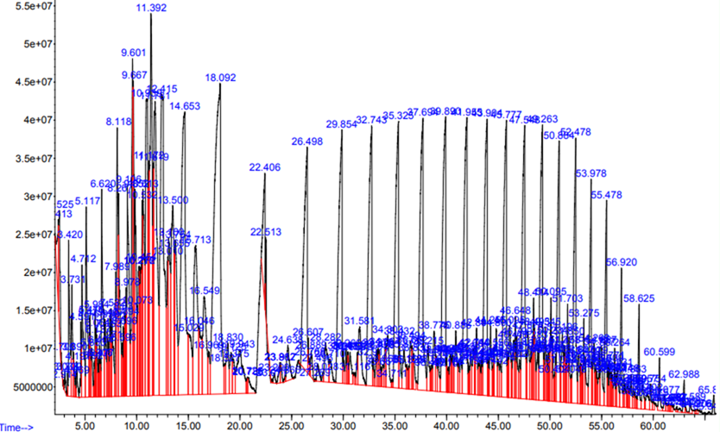
Figure 1: The results of gas chromatography to determine the average carbon composition in the paraffin content
From the recorded values as in Figure 1, the average carbon compound was calculated using Equation 1 and then benchmarked to the reported relative retention time in the literature. Table 1 shows that the average carbon composition in the paraffin content of Dulang Crude Oil is C-22. The calculation for determining the average carbon composition was generated and calculated using the weighted average method in Table 1. The average carbon composition that has been calculated will be applied later on in the molecular dynamics simulation for the building of the paraffin molecule model.
$$Average Carbon Compound = \frac{Sum of N(Abundance)}{Sum of Abundance }$$ | (1)
Table 1: Calculation of the average carbon composition in the paraffin content of Dulang Crude Oil
Retention  Time | Stoppage Time | Relative RT (Calculated) | Relative RT (Literature Review) | N-Carbon | Abundance | Ratio | N (Abundance)
62.988 | 65 | 0.969046154 | 0.96 | 34 | 0.113 | 0.361819987 | 3.842
60.599 | 65 | 0.932292308 | 0.93 | 33 | 0.118 | 0.37782972 | 3.894
58.625 | 65 | 0.901923077 | 0.91 | 32 | 0.356 | 1.139893055 | 11.392
56.92 | 65 | 0.875692308 | 0.89 | 31 | 0.48 | 1.536934456 | 14.88
55.428 | 65 | 0.852738462 | 0.86 | 30 | 0.855 | 2.7376645 | 25.65
53.978 | 65 | 0.830430769 | 0.84 | 29 | 0.935 | 2.993820243 | 27.115
52.478 | 65 | 0.807353846 | 0.81 | 28 | 1.583 | 5.068681759 | 44.324
50.884 | 65 | 0.782830769 | 0.78 | 27 | 1.465 | 4.690852038 | 39.555
49.263 | 65 | 0.757892308 | 0.75 | 26 | 1.928 | 6.173353399 | 50.128
47.548 | 65 | 0.731507692 | 0.73 | 25 | 2.058 | 6.589606481 | 51.45
45.777 | 65 | 0.704261538 | 0.70 | 24 | 2.202 | 7.050686818 | 52.848
43.904 | 65 | 0.675446154 | 0.66 | 23 | 2.134 | 6.832954436 | 49.082
41.955 | 65 | 0.645461538 | 0.63 | 22 | 2.325 | 7.444526272 | 51.15
39.89 | 65 | 0.613692308 | 0.60 | 21 | 2.345 | 7.508565208 | 49.245
37.694 | 65 | 0.579907692 | 0.57 | 20 | 2.538 | 8.126540937 | 50.76
35.325 | 65 | 0.543461538 | 0.53 | 19 | 2.286 | 7.319650347 | 43.434
32.743 | 65 | 0.503738462 | 0.49 | 18 | 2.306 | 7.383689283 | 41.508
29.854 | 65 | 0.459292308 | 0.45 | 17 | 2.357 | 7.546988569 | 40.069
26.498 | 65 | 0.407661538 | 0.40 | 16 | 2.166 | 6.935416733 | 34.656
22.406 | 65 | 0.344707692 | 0.36 | 15 | 0.681 | 2.18052576 | 10.215
Sum of Abundance |  |  |  |  |  |  | 31.231
Sum of N(Abundance) |  |  |  |  |  |  | 695.197
Average Carbon Compound |  |  |  |  |  |  | 22
    - Molecular Structure Design
After the molecular structures of FAME and Paraffin C-22 were built as per Figures 2 (a) and 2(b), the molecules were quantified by making them into amorphous stages with frames. Figures 3(a) and Figure 3(b) shows the amorphous stages of Paraffin C-22 and a mixture of Paraffin C-22 and FAME, respectively.
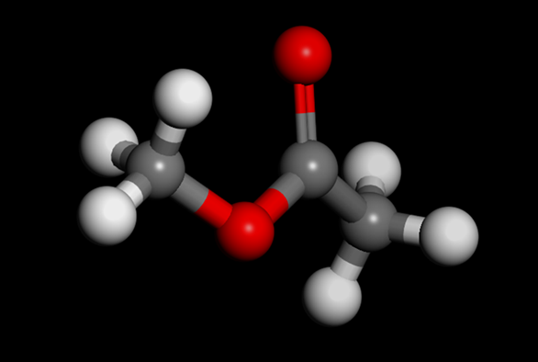  (a) | 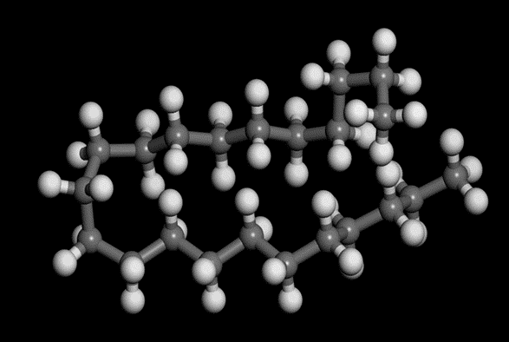  (b)
Figure 2: Molecular structure of a) Fatty Acid Methyl Ester (FAME) and b) Paraffin C-22
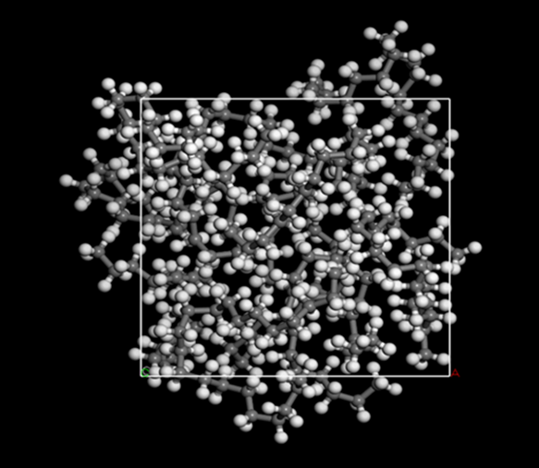  (a) | 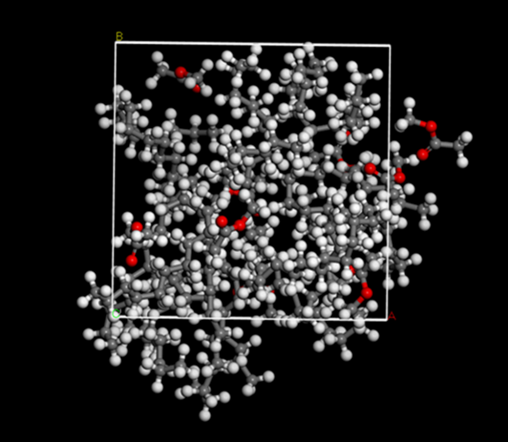  (b)
Figure 3: The amorphous stages of a) Paraffin C-22 only and b) Paraffin C-22 and FAME
    - Geometrical Optimisation
The interaction energy between molecules is calculated using Material Studio. Comparisons between the interaction energies before and after the addition of FAME are shown in Table 2 and Table 3.
Table 2: The calculated interaction energy for Paraffin C-22
Frames | Total Energy (kcal/mol) | Non-bond Energy (kcal/mol) | Van Der Waals (kcal/mol) | Electrostatic (kcal/mol)
1 | -815.701 | -335.788 | -212.399 | -116.221
2 | -868.261 | -373.161 | -222.134 | -143.858
3 | -866.739 | -368.451 | -230.756 | -130.526
4 | -858.996 | -359.993 | -214.528 | -138.296
5 | -850.199 | -345.347 | -224.996 | -113.183
6 | -853.72 | -363.643 | -218.352 | -138.122
7 | -879.728 | -386.011 | -226.292 | -152.551
8 | -821.395 | -344.198 | -208.56 | -128.47
9 | -851.513 | -378.877 | -211.112 | -160.597
Average | -851.806 | -361.719 | -218.792 | -135.758
Table 3: The calculated interaction energy for Paraffin C-22 and FAME
Frames | Total Energy (kcal/mol) | Non-bond Energy (kcal/mol) | Van Der Waals (kcal/mol) | Electrostatic (kcal/mol)
1 | -844.926 | -563.866 | -91.399 | -464.926
2 | -946.206 | -665.526 | -128.408 | -529.576
3 | -1026.367 | -681.427 | -123.768 | -550.118
4 | -924.556 | -635.074 | -102.886 | -524.647
5 | -912.877 | -643.921 | -106.278 | -530.103
6 | -1002.47 | -668.287 | -119.307 | -541.439
7 | -833.201 | -556.59 | -46.131 | -502.918
8 | -878.392 | -651.939 | -126.931 | -517.466
9 | -982.715 | -673.258 | -128.194 | -537.522
Average | -927.968 | -637.765 | -108.145 | -522.079

The negative value is due to molecule experiencing attractive forces mainly because of positive and negative charges (Kumar & Manik, 2016).The result also shows the increase in total attraction forces when FAME is added, indicating that FAME acts as a wax crystal modifier instead of a dispersant. FAME reacts and modifies the growth of wax. Despite increasing the attraction energy, the total Van Der Waals interaction energy decreases due smaller surface area between atoms, therefore, less force is needed to move the electrons.
    - Dynamic Calculation
Table 4 and 5 show the analysis and calculation of total energy, enthalpy, temperature and pressure for Paraffin C-22 before and after FAME is added.
Table 4: Total energy, enthalpy, temperature and pressure of Paraffin C-22
 | Initial | Final | Average
Total Energy (kcal/mol) | 424.951 | 425.228 | 425.521
Interaction Energy (kcal/mol) | -151.543 | -201.795 | -204.064
Kinetic Energy (kcal/mol) | 576.494 | 627.022 | 629.585
Total Enthalpy (kcal/mol) | 1219.671 | 1624.341 | 1432.801
Temperature (K) | 298 | 324.119 | 325.444
Pressure (GPA) | 1.121 | 1.692 | 1.421
Table 5: Total energy, enthalpy, temperature and pressure of Paraffin C-22 and FAME mixture
 | Initial | Final | Average
Total Energy (kcal/mol) | 153.709 | 287.459 | 283.214
Interaction Energy (kcal/mol) | -452.986 | -443.122 | -391.995
Kinetic Energy (kcal/mol) | 606.695 | 730.581 | 675.21
Total Enthalpy (kcal/mol) | 1654.178 | 1609.543 | 1466.966
Temperature (K) | 298 | 358.851 | 331.653
Pressure (GPA) | 1.882 | 1.658 | 1.485

Based on Tables 4 and 5, there is an increase in every calculated parameter, proving that the addition of FAME makes the fluidity increase and viscosity decrease, making the crude oil becomes easier to flow compared to its original condition. According to the Lennard- Jones’ theory, the negative potential energy suggests that the molecules are experiencing the attractive force, and the potential energy decreases as the molecules are attracted closer. Typically, in a liquid, the nearest neighbouring molecules of a given molecule will be at a distance close to the minimum of the pair potential. Anything that is less than infinity is considered negative. Interactions with molecules that are further away are weaker but still correspond to negative potential energies. So, for a liquid, the total potential energy for the interaction of a given molecule with its neighbours is negative.

    - Mean Square Displacement and Radial Distribution Function
Mean Square Displacement (MSD) is a method implemented to describe the random movement of particles in a specific amount of time (Masiren, Harun, Ibrahim, & Adam, 2016). From the MSD results, the distance of the particles’ movement and the situation of the particles can be determined. Table 6 shows the comparison in the mean square displacement in terms of angstrom² versus time.
Table 6: Comparison of Mean Square Displacement (MSD) between only paraffin and the paraffin and FAME mixture
 | XX | YY | ZZ | XY | XZ | YZ | Total
Paraffin C-22 | 1.104 | 1.081 | 1.010 | 0.104 | 0.100 | -0.043 | 3.195
Paraffin C-22 and FAME | 1.691 | 2.221 | 2.094 | -0.279 | 0.229 | -0.125 | 6.007

The table above shows that the values have increased in every direction when FAME is added, demonstrating that the particles inside the crude oil move even faster compared to the solvent-free paraffin. The presence of FAME lessens the Dulang Crude Oil viscosity and enhances the fluidity.

Further confirmation is applied with analysis of the Radial Distribution Function (RDF) simply to the probability of finding any particle at a certain distance from a reference particle (Dimitroulis, Raptis, & Raptis, 2015). Based on Figure 4(a) and 4(b), as distances increase, the number of peaks increases, and the peak intensity decrease. It is shown that the peaks in the paraffin and FAME mixture have a higher probability of finding particles at shorter distances compared to the solvent-free paraffin, proving that FAME acts as an effective wax crystal modifier. FAME increases the bonding between particles which are compressed and forms a lattice structure to restrict the growth of wax. If the FAME acts as a dispersant, the peaks at the further distance should have a higher probability, but that does not show in this particular case.

(a) | (b)
Figure 4: Radiation Distribution Function a) without FAME b) with FAME
  - Conclusion
This study has corroborated the implementation of FAME as a solvent to mitigate and prevent wax deposition. The results obtained from the tests and simulations confirm that FAME can act as a wax crystal modifier that reduces crude oil viscosity. From the molecular dynamic simulation, the interaction energy increased from -851.806 kcal/mol to -927.968 kcal/mol. Meanwhile, the kinetic energy increases from 629.585 kcal/mol to 675.21 kcal/mol, showing that the molecules in the crude oil become more mobile, making the fluid less viscous. The mean square displacement also increased from 3.195 angstrom² to 6.007 angstrom². As for the radial distribution function, the probability of finding a particle in the shorter radius of the reference is higher when FAME is added.In conclusion, based on the results obtained from the molecular dynamic simulation, FAME acts as a wax crystal modifier by bonding with the paraffin molecule inside the crude oil, increasing the interaction energy and the kinetic energy. The bonding of FAME and the paraffin restricts wax’s growth, lessens the crude oil viscosity, and has more fluidity. Therefore, implementing FAME as a wax inhibitor is considered valid as the results from the molecular dynamic simulation and the pour point tests show positive outcomes.
Acknowledgements
The authors hereby extend their appreciation to the Malaysia Ministry of Higher Education and Universiti Teknologi Malaysia (UTM) for financing this research under UTM Encouragement Grant (Ref: QJ130000.2651.18J65). Sincere appreciation to the authors and researcher from Universiti Teknologi Malaysia (UTM) and extended thanks to Universiti Teknologi PETRONAS (UTP) and co-authors, and everyone who has been involved directly or indirectly for assisting and supporting this study.
References

Aiyejina, A., Chakrabarti, D. P., Pilgrim, A., & Sastry, M. (2011). Wax formation in oil pipelines: A critical review. International journal of multiphase flow, 37(7), 671-694.
Almond, N. (1989). Pipeline flow improvers. Paper presented at the API Pipeline conference.
Anisuzzaman, S., Fong, Y. W., & Madsah, M. (2018). A review on various techniques and recent advances in polymeric additives to mitigate wax problems in crude oil. Journal of Advanced Research in Fluid Mechanics and Thermal Sciences, 48(1), 53-64.
Bartle, K. D., & Myers, P. (2002). History of gas chromatography. TrAC Trends in Analytical Chemistry, 21(9-10), 547-557.
Dimitroulis, C., Raptis, T., & Raptis, V. (2015). POLYANA—A tool for the calculation of molecular radial distribution functions based on Molecular Dynamics trajectories. Computer Physics Communications, 197, 220-226.
El-Sheshtawy, H., & Khidr, T. (2016). Some biosurfactants used as pour point depressant for waxy egyptian crude oil. Petroleum Science and Technology, 34(16), 1475-1482.
Fink, J. K. (2016). Guide to the practical use of chemicals in refineries and pipelines: Gulf Professional Publishing.
He, C., Ding, Y., Chen, J., Wang, F., Gao, C., Zhang, S., & Yang, M. (2016). Influence of the nano-hybrid pour point depressant on flow properties of waxy crude oil. Fuel, 167, 40-48.
Kumar, N., & Manik, G. (2016). Molecular dynamics simulations of polyvinyl acetate-perfluorooctane based anti-stain coatings. Polymer, 100, 194-205.
Liu, W., & Wang, F. (2018). p-Toluenesulfonic acid-based deep eutectic solvent as transesterification catalyst for biodiesel production. Journal of oleo science, ess18018.
Liu, Z., Li, Y., Wang, W., Song, G., Lu, Z., & Ning, Y. (2020). Wax and Wax–Hydrate Deposition Characteristics in Single-, Two-, and Three-Phase Pipelines: A Review. Energy & Fuels, 34(11), 13350-13368.
Masiren, E., Harun, N., Ibrahim, W., & Adam, F. (2016). Effect of temperature on diffusivity of monoethanolamine (MEA) on absorption process for CO2 capture. Int. J. Eng. Technol. Sci, 5(1), 43-51.
Nayaka, R. R., Alengaram, U. J., Jumaat, M. Z., Yusoff, S. B., & Ganasan, R. (2019). Performance evaluation of masonry grout containing high volume of palm oil industry by-products. Journal of Cleaner Production, 220, 1202-1214.
Olajire, A. A. (2021). Review of wax deposition in subsea oil pipeline systems and mitigation technologies in the petroleum industry. Chemical Engineering Journal Advances, 6, 100104.
Sadiku-Agboola, O., Sadiku, R. E., Adegbola, A. T., & Biotidara, O. F. (2011). Rheological properties of polymers: structure and morphology of molten polymer blends. Materials Sciences and Applications, 2, 30-41.
Sivakumar, P., Sircar, A., Deka, B., Anumegalai, A. S., Moorthi, P. S., & Yasvanthrajan, N. (2018). Flow improvers for assured flow of crude oil in midstream pipeline-A review. Journal of Petroleum Science and Engineering, 164, 24-30.
Theyab, M. A. (2017). Study of Fluid Flow Assurance in Hydrocarbon Production–Investigation Wax Mechanisms. London South Bank University.
Vyas, A. P., Verma, J. L., & Subrahmanyam, N. (2010). A review on FAME production processes. Fuel, 89(1), 1-9.
Wang, Z., Xu, Y., Zhao, Y., Li, Z., Liu, Y., & Hong, J. (2019). Role of Shearing Dispersion and Stripping in Wax Deposition in Crude Oil Pipelines. Energies, 12(22), 4325.
White, M., Pierce, K., & Acharya, T. (2018). A review of wax-formation/mitigation technologies in the petroleum industry. SPE Production & Operations, 33(03), 476-485.
Yang, J., Lu, Y., Daraboina, N., & Sarica, C. (2020). Wax deposition mechanisms: Is the current description sufficient? Fuel, 275, 117937.

