OIL ORIGIN IN PHU KHANH BASIN

The Phu Khanh Basin extends from 10º 30N to 15º30N of the coast of central Vietnam. It is bounded to the west by the narrow Da Nang shelf, separated from the Quang Ngai Graben to the north by the Da Nang shear zone, and from the Cuu Long Basin to the south by the Tuy Hoa shear zone. The sediment basin is located in the deep-water zone in offshore Vietnam and drilled wells is limited in deep trough. Oil was discovered in block 124, is evidence to confirm oil and gas potential of Phu Khanh basin.

This paper gives strong evidences about oil origin to confirm hydrocarbon generation potentialin the region.

Keyword: petroleum system, oil and gas generation potential, hydrocarbon(HC), oil origin, exploration.
- Introduce

The Phu Khanh Basin is one of Vietnams large offshore Cenozoic basins located along the western and southern margins the East Vietnam Sea (South China Sea). That is located at latitudes from 10º30N to 15º30N, 109⁰ đến 112⁰ 30E at longitudes, offshore central Vietnam with approximately 200,000km² of area [Nguyen Anh Duc, 2012]. The water depth is less than 100 m in the western near shore areas increasing to more than 3000 m towards the deep-water basin to the east. Until now, some wells were drilled mainly on shallow water and absolutely absent in deep water area. In 2009, oil was discovered in carbonate reservoirs of block 124, is evidence to confirm oil and gas potential of Phu Khanh basin.

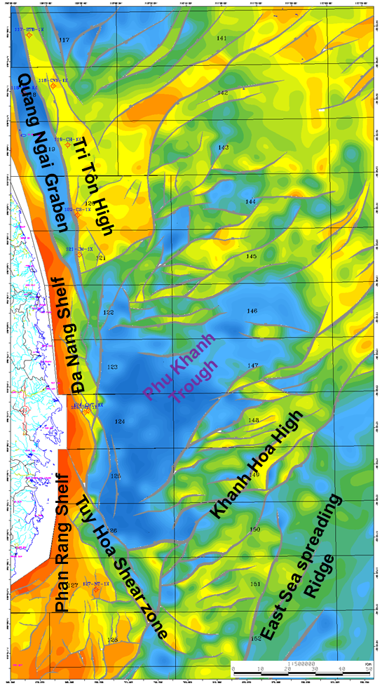

Figure 1: Location of study area [Nguyen Manh Hung, 2011]
- Geological setting
- Data set and methodology
- HC properies in PhuKhanh

II.1 Soure rock quality

Total geochemical samples were collected mainly in Miocene sediments due to the limitation of wellpenetration. Because of absent Oligocene sediments at drilled wells in shallow area of Phu Khanh, hence, it can use geochemical analyzed results in adjacent wells to extrapolate to the study area (blocks in south part of Song Hong basin). Oligocene samples were collected mainly from wells in block 118, 119 which are from fair to good source rock (TOC>0.5%wt; S2>2mg/g). Figure 2b show that source rock mainly contains kerogen type 2 and 3, were distributed in mature zone (Tmax values exceed 430ºC). These are significant contribution to oil generation potential in the area.
Most samples of lower Miocene fine grain sediments have good organic matter with TOC contents ranging from 0.5 to 1.6 %wt, most likely values are around 1%wt, hydrogen index values (HI) are less than 400mgHC/gTOC, typical for kerogen type 3. Most samples are distributed in immature zone (Tmax values less than 425ºC) except samples from block 121 fall into mature zone (Tmax >440ºC) (Figure 2b).
Shale samples of middle Miocene are from poor to fair in organic matter (OM) richness with average TOC content of 0.7%wt; HI values are less than 300mgHC/gTOC, contain mainly kerogen type 3 (Figure2a). However, the source rock is immature (Tmax<435 ºC).
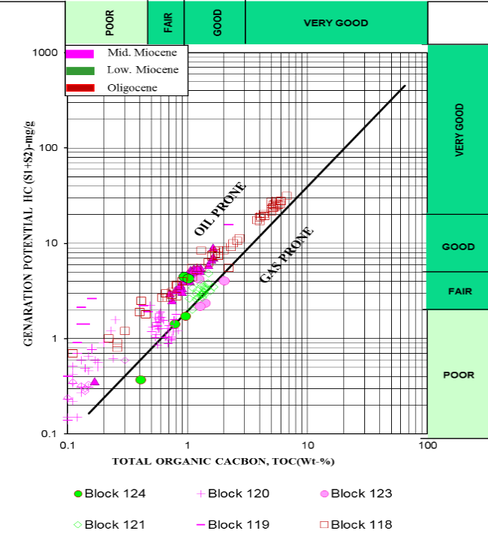 | 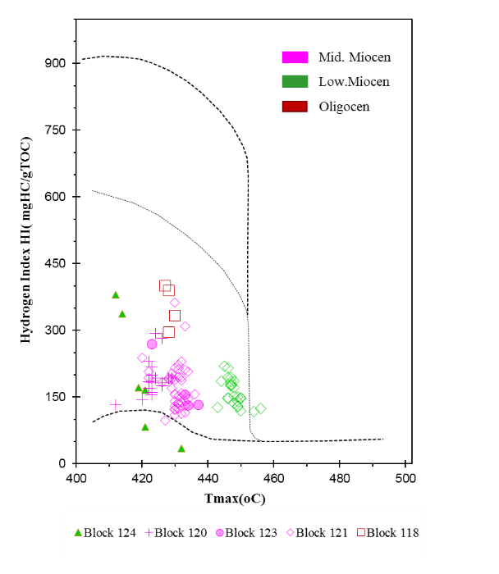
Figure 2a. Diagram %TOC & (S1+S2), Tertiary sediments in Phu Khanh | Figure 2b. Diagram HI & Tmax, Tertiary sediments in Phu Khanh

Based on gas chromatography(GC) analyses data of saturated HC C15+ was collected from rock samples were reserved in dysoxia to anoxia condition in study area (ratios of Pris/Phy<3) (Figure 3a). On Figure 3b, higher distribution of C₂₉ than C₂₈, C₂₇ sterane suggests that abundant distribution of high plant source rock mixed estuarine material to HC.
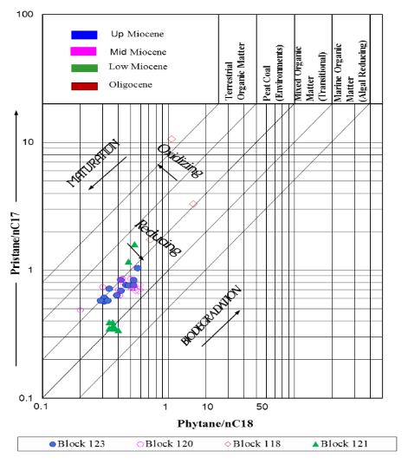
Figure 3a. Pris/nC₁₇ vs Phy/nC₁₈ Diagram, extracted samples in Phu Khanh | Figure 3b. Ternary Diagram of C27-28-29 Sterane, oil and rock samples in Phu Khanh

II.2 Oil properties in Phu Khanh
Crude oil was discovered in block 124 carbonate Miocene reservoir. Based on properties and geochemical analyzed results of the oils show the typical character for sweet, medium oil (low sulfur content: 0,2%wt<1%; APIº gravity value of 36,5) [Plains exploration & Production company, 2009].
According to saturated C₁₅₊ GC analyzed result, bimodal distribution from C₁₁-C₃₅, domination of C₁₅-C₁₉ and C₂₅-C₂₇ represent for oil was generated from source rock contain terrestrial organic matter. The extended hopane range (C₃₁-C₃₅) of most of the samples distributes in the decreasing trend with the increase of carbon number which suggests the oils were generated from source rock that deposited under oxidation condition (Figure 4a)
Distribution of C₂₉ hopane<C₃₀ hopane (in the hopane distribution pattern-m/z 191). These characteristics indicate that they are waxy oils generated from non-marine source rock (Figure 4b). C₃₀ gamacerance was absent that uninfluenced by marine environment. The C₃₀ Steranes can be found in organic matter(OM) from both lacustrine and marine environments, but only the existence of C₃₀-4α-methyl steranes (4α-methyl-24-ethylcholestanes) is typical for lacustrine sediments [Kenneth E. Peter; Clifford C. Walters, and J. Michael Moldowan, 2005]. As the result, it was revealed that 4α -methyl Steranes exist minor in the m/z 217 and m/z 231 fragments (Figure 5a, b), which support for algal organic matter input is limited for this liquid.
Further, the higher distribution of C₂₉ sterane than C₂₇, C₂₈ suggests that oil from block 124 is related to source rock containing mainly terrestrial high plant input with moderate to high thermal mature level (ratio of T_{s}/(T_{s}+T_{m}) =0.6) (equal value of vitrinite reflectance 0.8% Ro) [K.E. Peter, J.M Moldowan, 2005]. So, oil origin can be predicted from from Oligocene source rock in deep trough in Phu Khanh basin. This evidence is showed in Figure 6. Base on simulated results about sediments burial history as well as HC generation potential at section AB at present time [Nguyen Huu Trung, 2012] [Nguyen Thi Tuyet Lan, 2012] show Oligocene source rock is dry gas phase (vitrinite reflectance, %Ro>2) except east adjacent areas of basin where source rocks are oil and condensate phase. Lower Miocene oil saturation reaches medium level and appears vertical and lateral migration hydrocarbon to upper part by fault.
 |  | 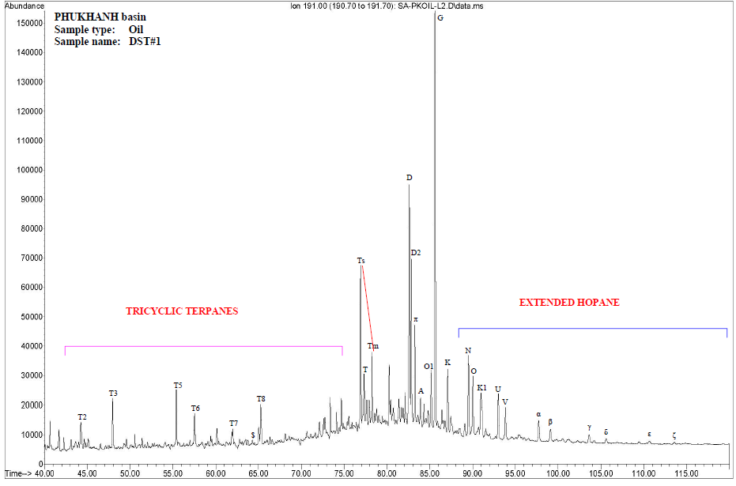
Figure 4a. C15+ hydrocarbon distribution, oil sample in Phu Khanh basin |  | Figure 4b. Hopane distribution (m/z 191), oil sample in Phu Khanh
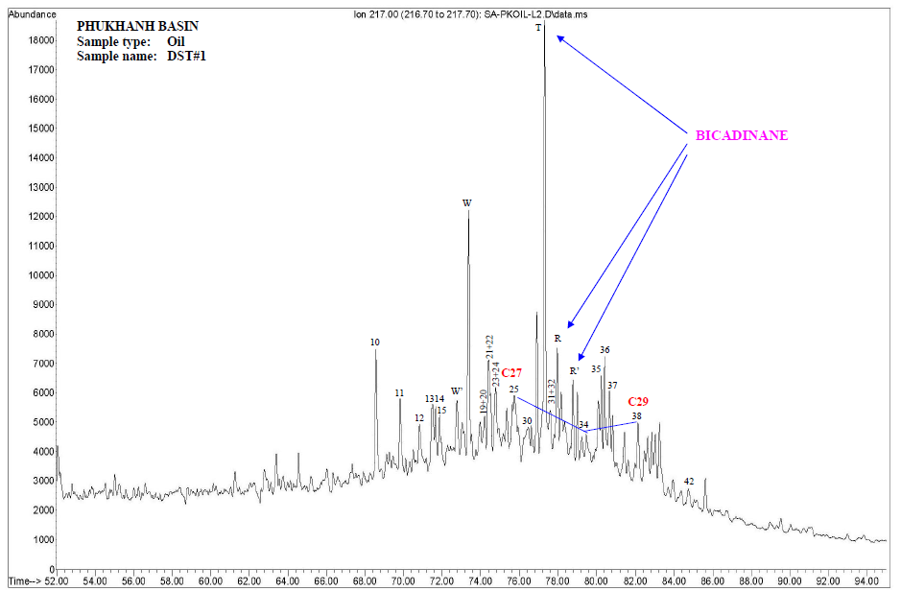 |  |  | 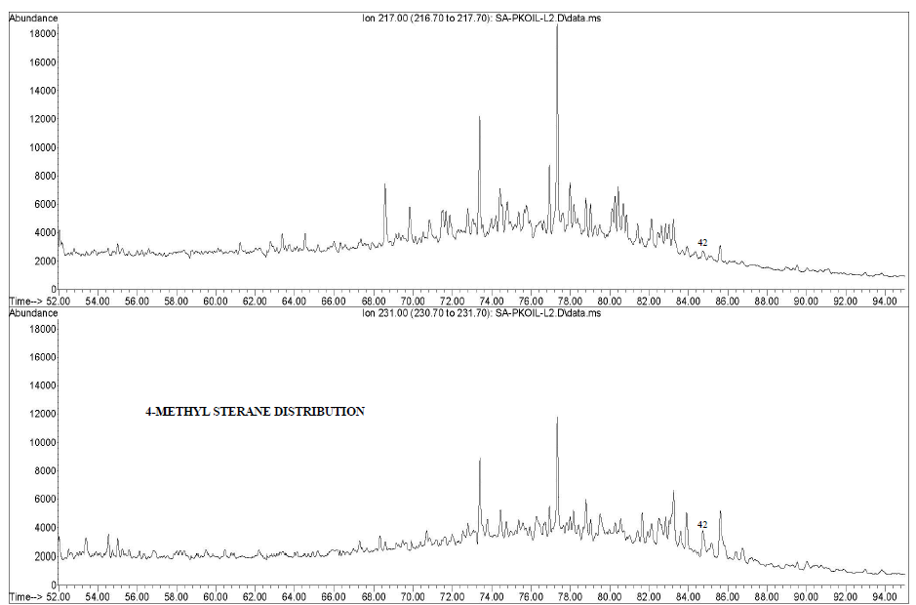
Figure 5a. Sterane distribution (m/z 217), oil in Phu Khanh |  |  | Figure 5b. Distribution of 4α-methyl-24-ethylcholestanes (m/z 231) (peak 42)
Figure 6a. Simulated Result for Line AB  Color: Oil Saturation, Contour: Vitrinite reflectance, Arrow: Oil Flow | Figure 6b. Simulated Result for Line AB  Color: Gas Saturation, Contour: Vitrinite reflectance, Arrow: Gas Flow
- Conclusion
- Existing in working of non- marine source rocks. High maturity source rocks can be reaches in deep trough in Phu Khanh basin
- Oil reaches medium to high maturity level
- Maturity oil in Phu Khanh can be generated from source rocks in basin central, especially to Oligocene generated hydrocarcbon were cracking into light weight of molecules for movable migration along faults to upper reservoirs to HC accumulation.
References
- Nguyen Manh Hung, 2011. “The study on geological structure and petroleum potential in Phu Khanh basin base on update data of new drilled wells by December in 2009”.
- Plains exploration & Production company, August 2009. “124CMT-1X petroleum characterization of MDT oil, MDT water and mud samples, block 124”.
- Kenneth E. Peter; Clifford C. Walters, and J. Michael Moldowan, 2005. “Biomarker and isotopes in petroleum Exploration and Earth history”.
- Nguyen Huu Trung, 2012. “Modeling of petroleum generation in Phu Khanh Basin by Sigma-2D software”.
- Nguyen Thi Tuyet Lan, 2012. “The study of geochemical characteristics in Phu Khanh basin”
- Nguyen Anh Duc, 2012. “Đánh giá tiềm năng dầu khí trên vùng biển và thềm lục địa Việt nam” thuộc “Đề án tổng thể về điều tra cơ bản và quản lý tài nguyên môi trường biển đến năm 2010, tầm nhìn đến năm 2020”
- Okui, A., Yokoyama, Y. and Yokoi, K., 1998 “Higher-plant Biomarkers in Oils from Southeast Asia, Res. Org. Geochem., 13, 5-12.

