Reservoir characterization of Deltaic environment: A case study from a Lower Miocene sand reservoir, X field, Cuu Long Basin
.pvn.vn
Summary
Sandstones deposited in deltaic and coastal environments cover a wide range of sediment facies and geometries and constitute the majority of the producing hydrocarbon reservoirs in siliciclastic basins. In a delta, three dimensional geometries of sands are known to be complex and highly dependent on following factors: rivers, waves or tides affecting the delta based on the relative importance of their hydrodynamic processes. Therefore, it is necessary to have a good understanding whether the delta was fluvial, wave or tide dominated for accurate prediction of reservoir property and sand body geometries to optimize geological models. In the study area, the Lower Miocene sand reservoir was deposited in a deltaic environment with minor marine influence resulted from integration of seismic attributes and well data including core, high resolution biostratigraphy and well log data. The delta is characterized by mouth bar deposits formed during regressive phase and backfilled distributary channel deposits formed during transgressive phase. Its distributaries were filled with ﬁning upward sands accompanied by relatively minor marine reworking and becomes increasingly marine upward.
Key words: Delta, mouth bar, backfilled distributary channel
1. Introduction
The X field is located in North West, Cuu Long basin offshore Southern Vietnam (figure 1). In this field, the fractured basement should be considered initially as the primary reservoir. Additional hydrocarbon has also been found and produced from the Lower Miocene and the Oligocene. The target oil bearing sand is the main reservoir in Lower Miocene. Gross sand thickness ranges from 10-16m. Core analysis results show excellent reservoir quality with very high porosity (27.6-28.1% in Avg.) and permeability (2.2-3.0 Darcy in Avg.). The objective of this paper is to integrate depositional environment from well data, seismic attributes, then predict the distribution of the sand body and evaluate characterization of the oil bearing sand reservoir.
2. Geological setting
2. Database and methodology
Datasets used for this study include 350 km² of 3D seismic data with 30Hz of dominant frequency and three exploration wells with enough main log curves, core and biostratigraphy data are available in the two wells. The evaluation of reservoir characterization for the target sand reservoir was based on the available 3D seismic data and well data including core, high resolution biostratigraphy and well log data in the study area. This evaluation is mainly based on results of core analysis calibrated with high resolution biostratigraphy data and well log patterns to identify the depositional environment. This was then integrated with seismic attributes to predict distribution of the sand body in order to evaluate the reservoir characterization and depositional environment of the target sand.
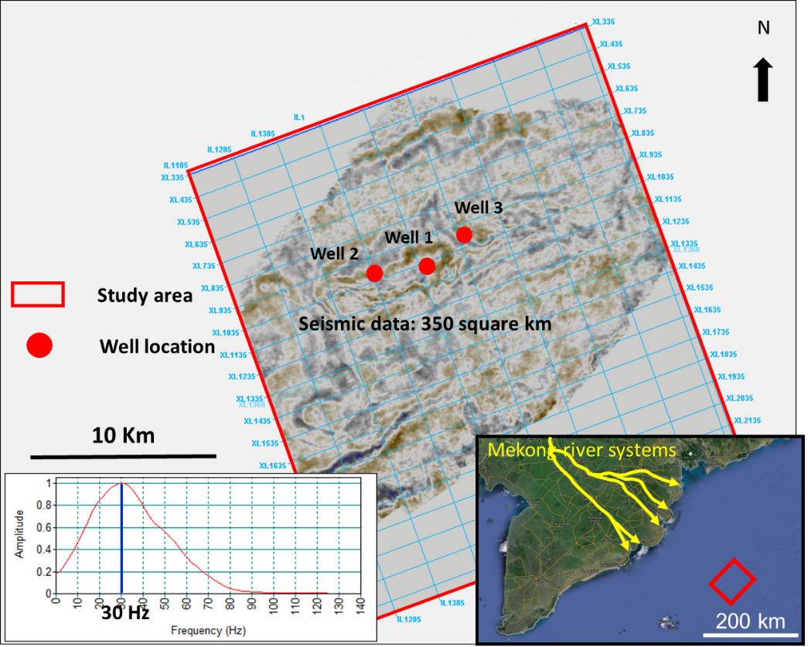
Figure 1. Location and data base of the study area

3. Interpretation and discussion

3.1 Depositional environment from well data

3.1.1 Core, biostratigraphy and well log data analysis

It is difficult to identify depositional environment with sole wireline data. This is because some different depositional environments can also have the same log patterns. In the study area, the well 3 and well 2 have both core and biostratigraphy data that are key data for interpreting depositional environment from well data. Therefore, these two wells were selected to identify depositional environments before interpreting those from the well 1 which then was correlated to interpretation results of the well 2 and well 3.

Well 3 analyses (Target interval: 1763.1– 1776mMD)
In the target interval, the results of core analyses indicated a thin layer of sands (10 cm) having coarser grain size compared to that of the other sands, overlies the erosional surface (figure 2b). In addition, the interpretation of biostratigraphy data illustrated that the target interval was deposited in alluvial/coastal plain environment. Combination with the biostratigraphy information, the thin bed of sands having coarser grain size was most likely a thin lag deposit occurring at the base of channels. The underlying erosional surface was interpreted as a channel base in this case. Although sands in the target interval are largely massive and structureless (figure 4), the presence of the lag deposit and channel base is important indications for interpretation of depositional environment in this well. Therefore, 4m thickness of the coarsening upward succession below the channel base was interpreted as mouth bar deposits (figure 6). The fining upward succession above the erosional surface is associated with laminated silty clay upward from top of the target sand (figure 5b). This shows a decrease of energy upward. Furthermore, based on the results of biostratigraphy analyses, the environment changes from alluvial/coastal plain to freshwater lagoon/brackish influence with minor marine influence that was recorded by marine microplankton (Foraminifera test lining, Dinocysts) (VPI Labs, 2001), which illustrates a more marine influence upward. As a result, the fining upward succession (from core) or blocky to fining upward succession (from well log patterns-figure 6) was interpreted as backfilled distributary channel deposits formed during transgressive phase. It is difficult to observe the evidence of marine influence in core due to its relatively minor marine influence. Hence, the interpretation for the blocky to fining upward succession was mainly based on the results of high resolution biostratigraphy analyses.

Well 2 analysis (target interval: 1890.3 – 1909.5mMD)

An erosional surface was observed in this well at 1899.45m (figure 2a), which was top of a coarsening upward succession and base of a fining upward succession (figure 6) The coarsening upward succession below the erosional surface shows an increase of energy upward. The biostratigraphy data suggested that the target sand was deposited in a low energy, freshwater to brackish lagoonal setting. However, as some different depositional environments can also have the same features, the interpretation of well 2 was correlated with the interpretations of the adjacent well 3. In both these wells, the coarsening upward succession accounted for the same thickness of sands with 4m in each well. In addition, this succession in well 2 was overlaid by an erosional surface. Hence, it was interpreted that the coarsening upward succession having parallel laminated sands (figure 3) represents mouth bar deposits, and the erosional surface was interpreted as a channel base. The fining upward succession above the erosional surface/channel base combined with parallel laminated silty clay observed in core (figure 5a) indicates a decrease of energy upward. Furthermore, the results of Palynological analyses suggested that the target interval probably was deposited in freshwater to brackish lagoonal setting (freshwater lagoon and brackish influence). Going upward, Microfauna and Palynological analyses show an increase of marine influence (mainly brackish lagoonal setting and minor connection to marine environment). The minor marine influence was recorded by shallow marine calcareous benthonic foraminifera (Lagenasp) (VPI Labs, 2001). These illustrated that the fining upward succession represents a deepening or more marine upward succession. This was interpreted as backfilled distributary channel deposits formed during transgressive phase. The thickness of backfilled channel deposits in well 2 and well 3 is almost the same with 7m and 8.5m respectively. Similarity in well 3, it is difficult to observe the evidence of marine influence in core in this well due to its relatively minor marine influence. Thus, the interpretated fining upward succession was mainly based on the results of high resolution biostratigraphy analyses.

Well 1 analysis (Target interval: 1744.8 – 1756.1mMD)
The interpretation results of well 1 was only based on the well log patterns due to lack of core and biostratigraphy data in this well, which was correlated with the interpretation result of the adjacent well 2 and well 3 in the study area. Based on the well log patterns, well 1 is characterized by coarsening upward, blocky to fining upward successions (figure 7). The interpretation of this well was correlated with the adjacent well 2 and well 3. The coarsening succession is probably a mouth bar deposit formed during regressive phase and the blocky to fining upward succession is probably a backfilled distributary channel deposit formed during transgressive phase.
Generally, as the key data used for identifying the depositional environment including core and biostratigraphy data are absent in well 1, it is difficult to interpret the depositional environment with sole wireline data. Both backfilled distributary sandstones and fluvial point bar deposits have fine upwards. The distinction of those is important because the linear, shoreline-perpendicular backfilled distributary sandstones have a very different geometry to a point bar complex. Moreover, presence of backfilled channel sandstones can improve reservoir connectivity relative to purely fluvial systems when the backfilled sandstones are adjacent to multiple point bar complexes (Lambiase, 2016). Therefore, the interpretation of the well 1 becomes more logical when it was correlated to the well 2 and well 3 in the study area.
In conclusion, a delta with minor marine influence characterized by mouth bar and backfilled distributary channel deposits in the target interval were used to integrate with seismic attributes. The 12m thick target interval is divided into a 4m thick mouth bar deposit separated by a channel base with an overlying 8m thick backfilled channel deposit. In fact, during transgressive phase, if marine influence (tides and/or waves) is strong enough, a river mouth or a delta can become an estuary. However, the presence of ……in this study area indicates a relatively minor marine influence.
3.1.2. Sedimentary processes
To begin with, the sedimentary process began with a regressive phase, which was represented by a progradational coarsening upward succession (shallowing upward). Mouth bar deposits were formed at this period. Then this process continued to record a fall of the water depth (lowstand). This resulted in channels incising into the exposed area to form channel bases. The bypassed sediments of the channels were not deposited and were transported further. A channel base or an erosional surface is evidence of a sequence boundary. However, it is obvious that the erosional surface is not considered as a sequence boundary in this case. The reason is that changes of facies below and above this surface are gradual from mouth bar to backfilled channel deposits, which witnessed local changes of the water depth and are not of regional significance. The next step recorded a transgressive phase indicated by blocky to fining upward successions that shows deepening or more marine upward successions based on minor marine reworking. As a result, aggradational to retrogradational successions illustrated deepening or more marine upward successions. This presented a transgressive phase resulting in backfilled distributary channel deposits. In conclusion, the sedimentary processes of the target sand experienced two phases of changes in water depth. The first period witnessed a regressive phase, which formed mouth bar deposits. Going upward, increasing water depth or more marine upward presented a transgressive phase resulting in backfilled distributary channel deposits. Mouth bar and backfilled channel deposits were separated by channel bases representing a lowstand (figure 6).
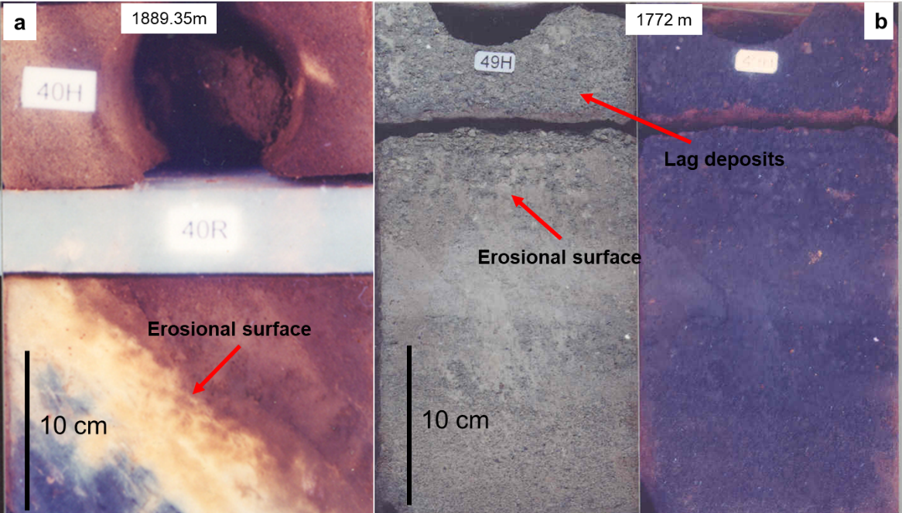
Figure 2. Erosional surfaces/channel bases and lag deposits, a. The channel base in well 2, b. The channel base and lag deposits in well 3
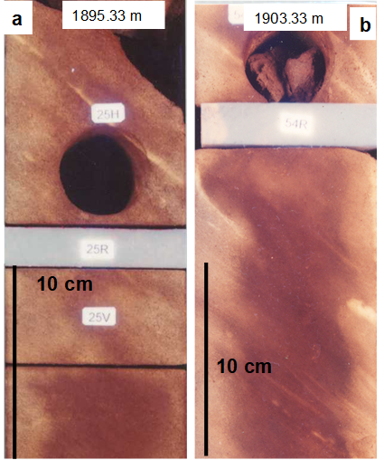
Figure 3. Parallel laminated sands in well 2, a. Parallel laminated sands above the erosional surface, b. Parallel laminated sands below the erosional surface.
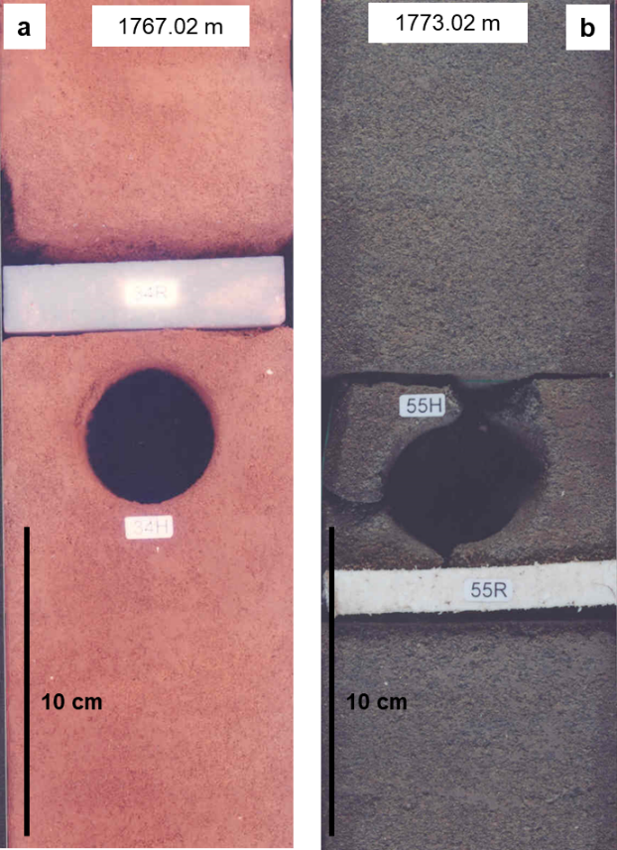
Figure 4. Massive sands in well 3, a. Massive sands above the erosional surface, b. Massive sands below the erosional surface
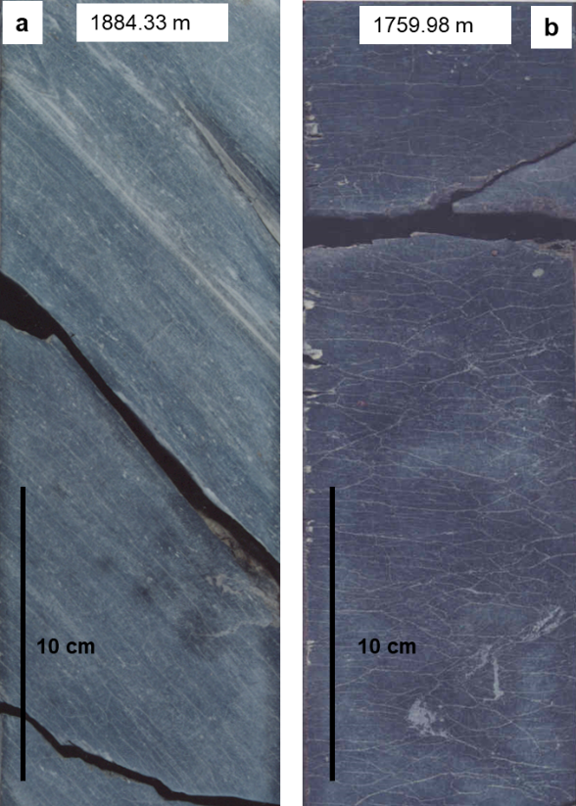
Figure 5. Parallel laminated and laminated silty clay in well 2 and well 3, a. Parallel laminated silty clay in well 2, b. Laminated silty clay in well 3. The parallel laminated and laminated silty clay indicate a low energy environment.
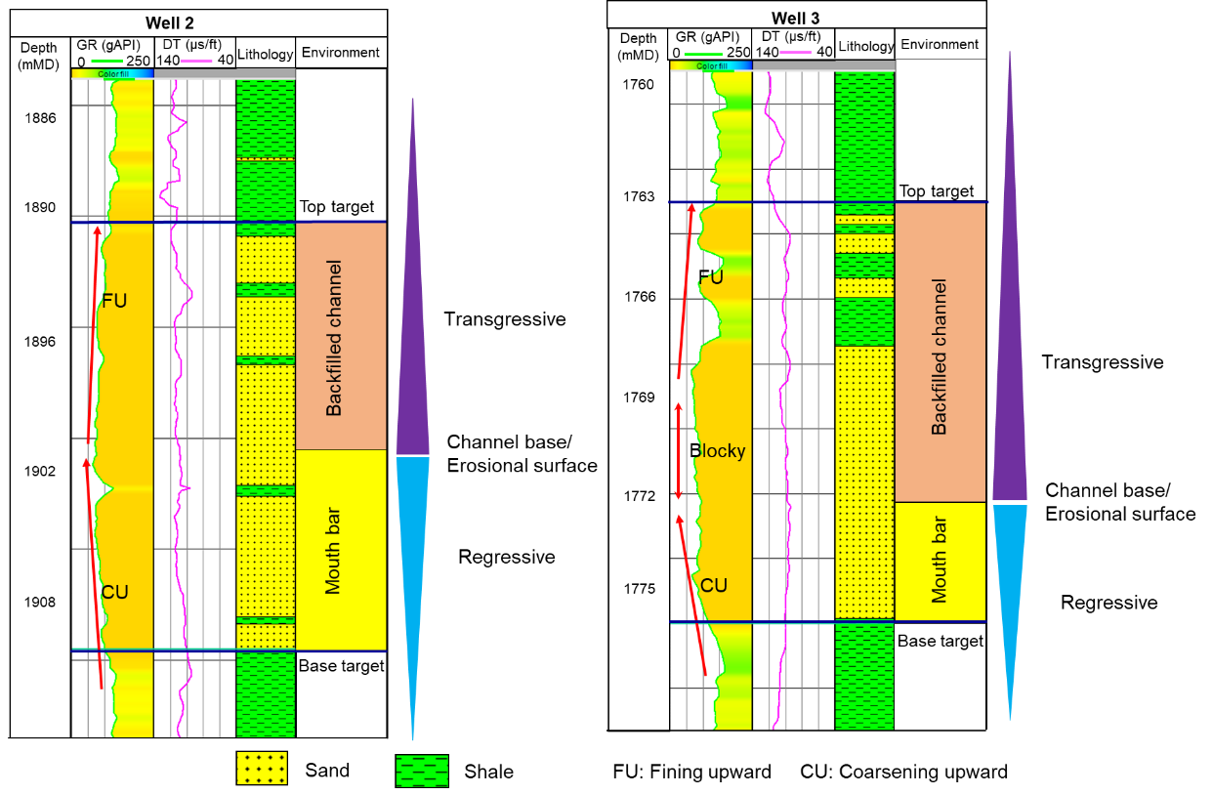
Figure 6. Depositional environment of well 2 and well 3
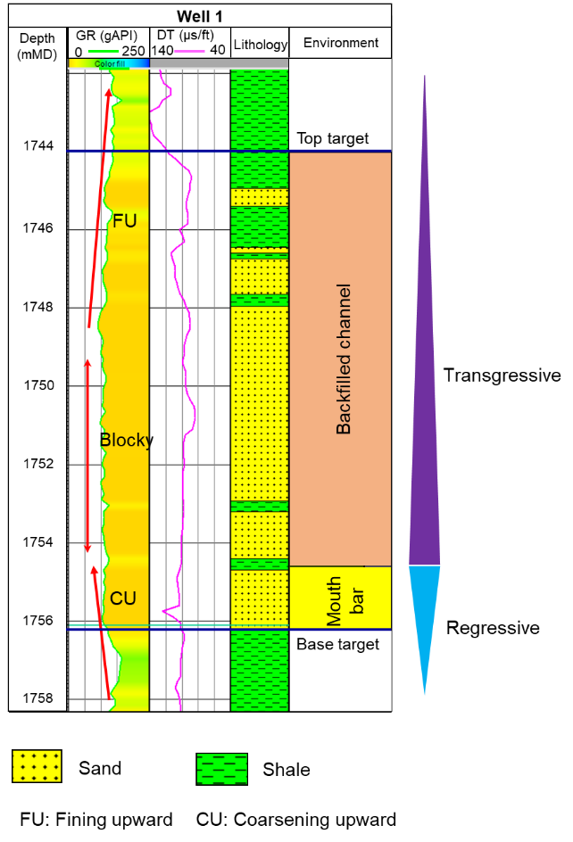

Figure 7. Depositional environment of well 1
3.2. Seismic attribute analysis and integration with depositional environment from well data
The application of running multi-attribute volumes was effective on improving the seismic images in the study area. Firstly, a relative acoustic impedance was generated from the original volume. Secondly, the relative acoustic impedance was used as an input of running a similarity attribute. Finally, RMS surface attribute was applied on the similarity volume generated from the relative acoustic impedance volume to predict distribution of the target sand. The RMS attribute was run using a 15ms time window below top the target sand being equivalent to 12m (in average) of the target sand. The RMS attribute was generated from the similarity volume which was generated from relative acoustic impedance volume. This application of running multi-attribute volumes was successful in improving the seismic images (Satinder Chopra and Kurt J.Marfurt, 2007). The red dash line in figure 8 illustrates anomalies of high similarity of the relative acoustic impedance in the sand interval. Once this was combined with the supporting well information including core, biostratigraphy and well log data, high similarity of the relative acoustic impedance most likely related to sand reservoirs characterized by coarsening upward, blocky to fining upward succession, which is interpreted as the deltaic environment. In addition, as the distance between well 1 and well 2 is approximately 2.5km and between well 1 and well 3 is approximately 2.8km (figure 8). These distances are quite far for a width of the interpreted thin backfilled channel deposits (8m) and mouth bar deposits (4m). Hence, it is predicted that the sand in the three wells could be different sand bodies, which could result from channel avulsion leading to lopes switching, and the seismic attribute result probably from stacks of backfilled distributary channel deposits and mouth bar deposits.

In this study area, it is difficult to identify whether the delta was fluvial, wave or tide dominated based on core and well log patterns. This is because the sedimentary structures showed mainly massive and structureless. However, the analysis results of high resolution of biostratigraphy data indicated that the delta was deposited in a low energy setting with minor marine influence. Therefore, although there is no evidence of fluvial influence on the delta, it is predicted that in a low energy setting and minor marine influence, the delta is prone to fluvial dominated delta. In addition, the delta shape resulted from the seismic attribute illustrated that this delta could be slightly affected by tides (figure 8). In conclusion, the delta is fluvial dominated delta and minor tide influence. As a result, geometries of backfilled distributary channel deposits are mainly perpendicular to the shoreline, and geometries of mouth bar deposits depends on influence levels of tides on the delta. However, with just 4m thickness of the mouth bar deposits and minor tide influence, it is estimated that they are approximately the same width with theirs backfilled distributary channel deposits.
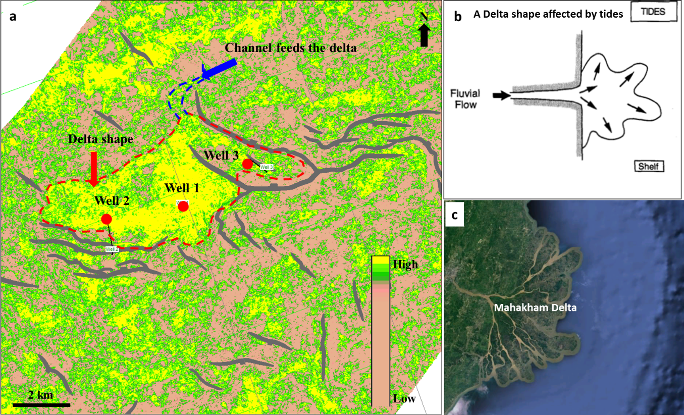
Figure 8. A delta shape. a. High similarity of the relative acoustic impedance at the well locations, which shows a deltaic shape. This shape indicated that the delta could be slightly affected by tides. b. schematic of a delta shape affected by tides. c. Mahakham delta

NOTE:

Provide a seismic section cross cut the feeder the delta

Provide a seismic section showing the erosional surface

4. Conclusions
Integration of sedimentary processes based on the well data including core, biostratigraphy and wireline data with the seismic attributes indicates that the depositional environment of the target sand is a deltaic environment with minor marine influence. The facies of this reservoir are divided into two main facies which were separated by channel bases representing a lowstand. Below the channel base is mouth bar deposits formed during a regressive phase and above the channel base is backfilled distributary channel deposits formed during a transgressive phase. The thickness of the mouth bar deposits and backfilled channel deposits is 4m and 8m in average respectively

References
Galloway, W.E., 1975. Process framework for describing the morphologic and stratigraphic evolution of the deltaic depositional systems: in M.L. Broussard, ed., Deltas, Models for Exploration: Houston, Houston Geological Society, p. 87-98.
Lambiase, Joseph J., Ridha S. Ridha S. Riadi, Nadia Nirsal, SalahuddinHusein, 2016. Transgressive successions of the Mahakam delta province, Indonesia: Geological society of London, special publications.
Satinder Chopra, Kurt J.Marfurt, 2007. Seismic attributes for prospect identification and reservoir characterization: SEG geophysical Developments series; No 11, Chapter 3, 5, 6, 7, 8.
Satinder Chopra, John P. Castagna2 and Yong Xu, 2009b. When thin is in – relative acoustic impedance helps: CSPG CSEG CWLS convention, Calgary, Alberta, Canada.
VPI, Labs, 2001. High resolution biostratigraphy of the well 2.
VPI, Labs, 2001. High resolution Biostratigraphy of the well 3.

