Assess the management status of rural solid waste in nam dinh province

Abstract
The management, collection and treatment of solid waste in rural area is of great significance in order to ensure the reduction of domestic solid waste generate to the environment and sustainable development. Nam Dinh is a province in the Red River Delta and has a lot population so that generated a large amount of domestic solid waste. By the collecting documents method, survey, sampling and community consultation, the study has determined that the total amount of rural solid waste generated in this province is 660 tons/day with an average generation factor of 0.31 ÷ 0.35 kg/person.day and the collection rate reaches 87 % (about 575 tons/day). The amount of domestic solid waste generated mainly from families, public places such as schools, offices, commercial centers... The organic in the solid waste is high, about 60% of total solid waste. The solid waste is not separated at the source. It is treated by burning in the incinerator and burying in the landfill. Currently, 47.1 % solid waste (about 112,968 tons/year) is treated by landfilling. Beside that, 10.0% domestic solid waste in this province is burned in the incinerator (equal to 24,000 tons/year). In the areas where the collection conditions are limited, local people self-treatment solid waste at the households by burning, burying or composting with 42.9 %. Nowaday, in this province, one of the well – known private companies, Tan Thien Phu has been manufacturing incinerators with the LOSHIHO brand having treatment capacity up to 1,000 tons/day. Combustion methods can be used at the sanitation landfill to reduce the volume wastes bring to burial sites and limit the pollution of soil, water and air. Therefore, to achieve a sustainable development in this province, the improvement of solid waste management is necessary which includes the solution from separation, collection, storage and treatment of solid waste.
Keywords: management, collection, treatment, domestic solid waste, rural

- Introduction
Nam Dinh is located in the South of the Red River Delta, including 9 districts and 1 city. The acreage of this area is about 1.668 km². In particular, the rate of people living in rural areas is high, about 72.9 % population. Besides that the agricultural and living activities lead to the amount of solid waste generated is increasing. Actuality, the management, collection and treatment of rural solid waste has a lot difficult. The management is overlapping between the organizations, the assignment of the responsibility is not clear. The solid waste is still fresh and decomposition (Anh, H.L.,2018).
If solid waste is not collected, it will be the cause of environmental pollution. Besides that the technology to treat solid waste is not guaranteed, people’s awareness is low, a lot of solid waste is not collected, discharge into the environment at the riverside, lakeside, field, and vacant land… (Chi, Đ.K, 2018). So that it makes the polluted environment and loses the beauty of landscape. Therefore, the management of domestic solid waste in the rural of this area should be attention and control by agencies, organizations who have to give out the suitable solutions to prevent the pollution environment.
- Methodology
  - Collecting and editing data
The author has collected information and the data about the status of solid waste management in this study area. Beside that, the research also collects information about the collection and treatment methods for the domestic solid waste. The information was collected from organization such as People's Committee of communes, districts, New Rural Office and Deparment of Natural Resources and Environment of Nam Dinh province. It is the good basis to assess overview so that give out the sustainable methods to manage the solid waste for this study area.
  - Field survey
The field survey method is very important to helps the research have an overview of the actual situation of generation, collection and treatment of rural solid waste in the study area. This research carried out the surveys on socio – economic characteristics, sampling, determination of rural domestic solid waste components, habits and methods to collect and treat the solid waste. Some methods is gave out such as:
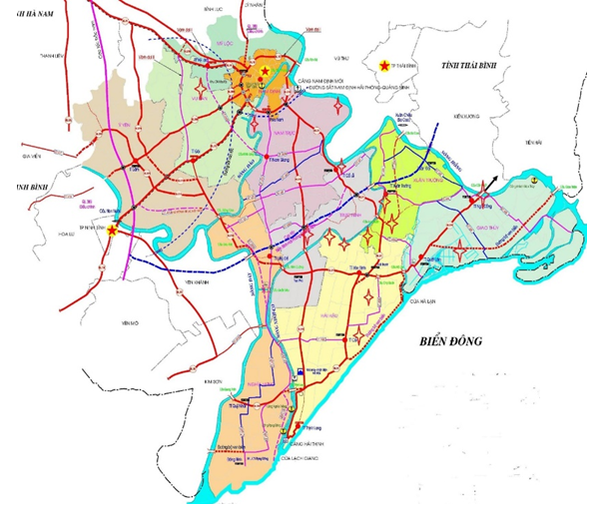
Location to sampling
Survey route

Figue 1. Map of survey location
- Sampling:
The solid waste sampling was carried out at the landfill of the districs in this province such as: Tan Thinh (Nam Truc distric), Bach Long (Giao Thuy distric), Xuan Kien (Xuan Truong distric)… to assessment the components, humidity and mass…
- Community consultation
Using the questionnaire consists of open-ended and closed - ended questions to interviewed about the current management of solid waste in rural area. Waste sources, components, volumes and technologies are being implemented in local waste treatment today. The author interviewed the commune official in charge of environment (20 questionnaires), workers who work in the collection teams, incinerators and the landfilling (15 questionnaires) and the households that discharged the soild waste into the environment (60 questionnaires).
- Results and discussion
3.1. The status of rural domestic solid waste management
According to the results of the investigation, survey and community consultation tasks showed that solid waste in the rural areas generated from households, markets, offices, shops, and public places... The total amount of solid waste generated in Nam Dinh province is 660 tons/day with an average generation factor of 0.31 ÷ 0.35 kg/person.day. Almost amount of these solid wastes were not classified at the source. Biodegradable waste and nonbiodegradable waste mixed together. This matter had to make the recycling and reuse of waste were more difficult and treatment efficiency was a very low. The main composition of solid waste is leftover food, plastic bags, cans, leaves, rubber, leather, textile and a little hazardous waste like electronic appliances, broken light bulbs, and batteries,… The solid waste has high organic content, about 60 %. The analysis result of the component of solid waste is shown in Figure 2.
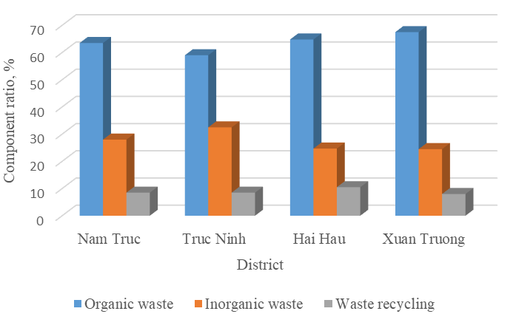
Figure 2. The component of solid waste in Nam Dinh province
By the surveying result in 60 households, the domestic waste from households is put into the rubbish bins. Only 5 households have no bins in the house, accounting for 8.3%. Solid waste collection in rural areas has also been focused in recent years, especially in the period of new rural construction and development. Summary of surveying and community consultation results at 60 households about the domestic solid waste management is shown in Table 1.
Table 1. Methods of collection and treatment of domestic solid waste in the household
The method of treatment | The number of households is implemented | The rate (%)
Collected by environmental companies | 55/60 | 91.7
Garbage collection | 60/60 | 100
Reuse as food for animal | 37/60 | 61.7
Discharge directly into the environment | 5/60 | 8.3
Other methods (combustion, composting...) | 10/60 | 16.7
In Nam dinh province, there are 2,921/3,076 villages and 203/204 communes and towns had collected solid waste (Deparment of Natural Resources and Environment of Nam Dinh province, 2018). However the wastes that are generated from different sources are mixed and collected together. The total amount of solid waste collected is estimated at 575 tons per day (about 87%). (Source: People’s Committee of Nam Dinh province, 2018). Equipment for collection and transportation of daily-life solid waste include: 342 garbage handcarts (with a volume about 0.5 ÷ 1 m³), 19 garbage trucks (with volume from 6 ÷ 10 m³). The rest of the environmental sanitation groups in communes and towns are mainly used the improved handcarts, agricultural vehicles and hand trucks. At present, the local authority has assigned the Women's Union, Farmer Association and Cooperative to take responsibility and implement collect the domestic solid waste in the rural. The solid waste from rural of this area will be transferred and treated after collection.
The result of the survey shown that having a lot of methods and technologies to treat domestic solid waste. The open landfills have decreased now and changed into the sanitary landfill or burning and incineration. Until now, there were 193 communes and towns having the solid waste treatment plants, 106 communes of which used the sanitary landfill and 88 used the incinerators. Besides, 26 communes and towns have both sanitary landfills and incinerators such as in Nam Thanh, Nam Hong and Nam Thai commune, Nam Truc district. The domestic waste of communes which do not have waste treatment plants will be collected and sent to the other waste treatment plants of other districts. Furthermore, the solid waste treatment plant is being built in this area such as Loc Hoa which is the concentrated solid waste treatment. So using these methods to treat solid waste help to reduce risk and environmental pollution.
The statistics values also show the amount of solid waste treated by each method as follows: by landfill method is 112,968 tons/year (47.1%), the burning method is 24,000 tons/year (10%) and self-treatment in households is 103,093 tons/year. Figure 3: The ratio of domestic solid waste treated by each method.
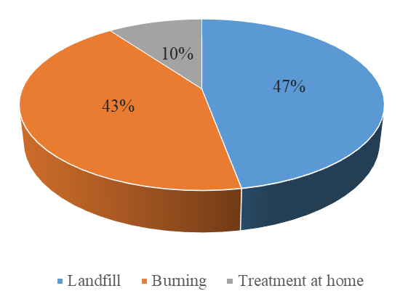
Figure 3. The ratio of domestic solid waste in Nam Dinh province was treated by each method
With 85 landfills and 87 solid waste incinerators available to date, none of the waste treatment facilities use composting technology to treat solid waste. Some of the reasons are that the amount of organic matter in the waste is not high, waste has not been classified at source. Waste was not collected and transported to treatment facilities immediately usually 2 times/week. Therefore, when solid waste was transported to the treatment plant, the organic waste was decomposed partially. This made the classification was more difficult, the quality was degraded and had not enough ability to apply biological composting methods.
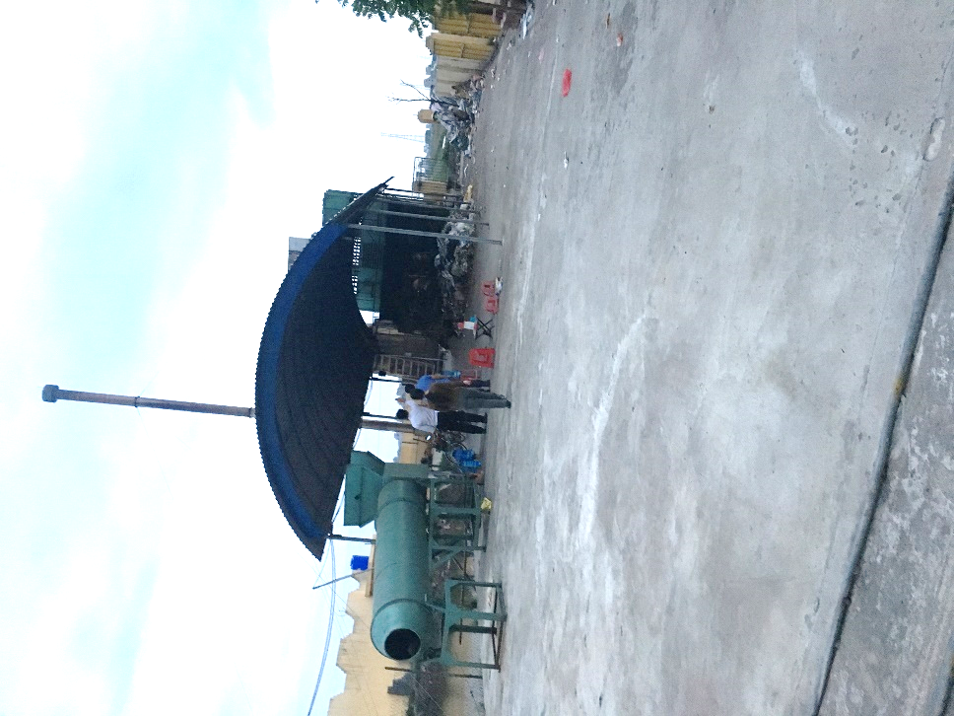
Figure 4. The incinerator with emission treatment system by absorb in the sanitary landfill in Xuan Ninh commune, Xuan Truong district
The incineration on site and burned in a landfill have meaning is to increase the treatment capabilities of the landfill, reduce pollution of land, water and air. However, when using the burning method, it is necessary to check and evaluate the technological process, equipment, and technical requirements during operation to minimize the risk of secondary pollution. Survey and evaluation results showed that the incinerators in the study area having capacity was smaller than 5 tons/day and even less than 1 ton/day. The exhaust gas treatment system of the incinerator is not up to standard. Some equipment was old or damaged which can lead to the risk of secondary pollution (Lam, N.V, 2019). Therefore, the management of incinerators has many difficulties and inefficiencies. However, in recent years, the large incinerators have been designed including exhaust treatment systems. For example, in this province, Tan Thien Phu Company is one of the well – known private company that has researched and produced LOSHIHO models of incinerators with a capacity of 350 to 1,000 tons/day. So that it helps to manage domestic solid waste in Nam Dinh province effectively and reduce the risk of environmental pollution.
In addition, for those communes with difficult conditions to collect, transport and treat solid waste, the use of treatment models at home is appropriate. In this model, people often treat waste by burning, composting in the garden or using as food for livestock. With the composting method, households build underground storage tanks or use specialized plastic containers to compost organic waste. The local government has supported some funding or biological products for the composting process. The percentage of waste treated by this method was up to 42.9 % and has been accepted by the local people.
3.2. Proposing solutions
- Replacing old equipment and increasing collection frequency to meet the amount of generated solid waste;
- Researching and developing treatment technology to reduce the amount of solid waste to be buried and increasing the rate of recycling and reuse of solid waste;
- Reducing and stop the construction of small-capacity incinerators that do not meet environmental standards. Renovating and upgrading the exhaust treatment system of old incinerators that do not meet QCVN 61-MT: 2016 / BTNMT - Standard of Technical Regulation National about the domestic solid waste incinerator;
- Continuing to implement and expand the model of solid waste classification at home and synchronize the collection, transportation, and treatment of solid waste in the studying area. Constructing large-scale concentrated solid waste treatment plants with modern technology to treat thoroughly and to minimize environmental pollution. The proposed treatment process for rural solid waste in Figure 5.
- Educating to raise people's awareness and encouraging community participation in solid waste management (Tuan, N.Q., 2017). Developing and carrying out more communication programs in solid waste management

Solid waste
Gathering
Classification
Ash
Waste can burn
Chimney
Sanitary landfill
Waste can’t burn
Emissiontreatment system
Incinerator
Can, metal, plastic, rubber, paper, etc
Brick
Recycle

Figure 5. Process of rural domestic waste treatment in the concentrated solid waste treatment plant
- Conclusion
In the study area, the collection, transport, and treatment of rural daily-life solid waste have been facing many difficulties with many following reasons: solid waste is not classified at source; inappropriate solid waste treatment technology; limited human resources; People's awareness is not high... Need to continue to build and expand the model classify solid waste at the source and to use incinerators meet to Vietnamesse's standard with the greater capacity and suitable with the amount of waste generated in the region. In addition, Nam Dinh province continues to build concentrated solid waste treatment plants and use treatment models at households in areas having difficult conditions to collect and transport waste. Need more education programs to raise people's awareness about solid waste management and to reach the consensus of the whole community in the province.
Reference
Anh, H.L., Tra, M.T.M., Loan and N.T.B. (2018) “The actual situation of generation, collection and treatment solid waste in Vietnam”, Journal of Environment, Vol 10.
Chi, D.K. (2018) ‘Report the result of Subject “Situation of solid waste management in rural areas, towns, districts and communes and procedure of collection and transportation solid waste that is suitable for the living conditions of Vietnam’, The Association for Nature and Environment Protection Vietnam.
Lam, N.V., Hoa, N.M., Huy, P.K., Thuy, T.T.T. (2019): Early classify of domestic solid waste at the source in the rural areas on a large scale, Journal of Environment, Vol 10.
Tuan, N.Q. (2017) “Solution of sustainable rural solid waste treatment”, Journal of environment, Vol 9.
Deparment of Natural Resources and Environment of Nam Dinh province (2018). The situation of implementing environmental protection models in Nam dinh province.
People’s Committee of Nam Dinh province (2018). Report No. 166/ BC-UBND dated July 13, 2018 about the situation of solid waste treatment in rural area and implementation the environmental criteria in new rural construction.

