
Temporal-spatial variation of surface water affected by apatite mining activity in Lao Cai, Viet Nam

ARTICLE INFO |  | ABSTRACT
Article history:  Received 15th Feb 2020  Accepted 16th Mar 2020  Available online 29th Apr 2020 |  | Apatite ore mining and processing is one of the main mineral activities of Lao Cai province. According to the annual environmental monitoring results, most of the rivers and streams flowing through apatite mining and processing areas such as: O, Ngoi Dum, Ngoi Duong, Dong Ho and Coc streams are all polluted by content of COD, BOD₅, TSS, NO₂⁻, NH₄⁺, NO₃⁻. The concentration of parameters as COD, BOD₅, NO₃⁻, NO₂⁻, NH₄⁺ tends to increase over the years. Streams near the mining areas such as Ngoi Duong, Dong Ho, Chu O, Coc streams were mainly polluted by COD, BOD5, TSS, NO₃⁻. Streams in the ore processing area at Tang Loong such as Trat, Cam Duong, Khe Chom streams... were mainly polluted by NH₄⁺, NO₂⁻ and some heavy metals like as Cu, Fe. The results of cluster analysis showed that basically the quality of stream water in the ore mining and processing area is divided into 4 groups: heavy pollution, medium pollution, light pollution and no pollution. In particular, heavy polluted streams flow through apatite mining areas such as Ngoi Duong, Ngoi Dum and Chu O. The results of PCA show changes in the distribution of environmental quality parameters in major components by years. The parameters related to changes in surface water quality are COD, BOD₅¸ NO₃⁻, NO₂⁻, TSS, Cu and NH₄⁺. The source of pollution is related to domestic wastewater at apatite mining and processing areas.  Keywords: Apatit, CPA, CA, parameters, surface water quality  Copyright © 2020 Hanoi University of Mining and Geology. All rights reserved.
Keywords:
Please provide 5 keywords separated with comma.
_____________________
*Corresponding author.
E-mail address: author@gmail.com
https://doi.org/10.25074/xyz

1. Introduction

Activities of apatite’s exploiting and processing have been carried out since 1993 on an area stretching from Bat Xat district, Lao Cai city to Bao Thang district, with a scale of over 200 km². According to the environmental monitoring results of the Lao Cai Environmental Monitoring Center from 2015 up to now (Environmental Monitoring Center of Lao Cai, 2018), the process of apatite exploiting and processing has been causing environmental pollution at the areas, and surrounding areas. Specifically, a large proportion of analyzing parameters of COD, BOD₅, NO₂⁻ ... in rivers and streams such as O, Ngoi Dum, Ngoi Duong, Dong Ho stream, Coc ... exceeded the permitted standards many times. The assessment of change in surface water quality at the areas according to time and space helped operators to have appropriate production plans and agencies’ environmental management, and then take management and technology measures. Currently, there were many projects applying multivariate statistics in evaluating water quality fluctuations. Nguyen Hai Au et al, 2017 used PCA to assess the quality of groundwater in Tan Thanh and Ba Ria areas, Vung Tau (Nguyen Hai Au, 2017), Thi Thu Huyen Le et.al, 2017 used PCA and CA to assess pollution of Tay Ninh river under nitrification inhibition (Thi Thu Huyen, 2017).
2. Materials and methods
2.1. Sampling area
Figure 1 drawed location of apatite ore mining sites extending from Bat Xat district - Lao Cai city to a part of Bao Thang district. At present, there are 31 apatite ore mining fields, of which 17 ores have been exploited and 14 ores have been planned until 2020; and three processing plants include Tang Looong recruiting factory, Cam Duong sorting factory and Bac Nhac Son sorting factory.
This study is carried out on the basis of periodic environmental monitoring data at the apatite ores of Lao Cai Environmental Monitoring Center from 2015 to 2018. The annual sampling sites at 10 streams flowing through apatite mining and processing area were Ngoi Duong, Dong Ho, Chu O, Ngoi Dum, Coc, Bac Nhac Son (BNS), Cam Duong, Khe Chom and Trat.

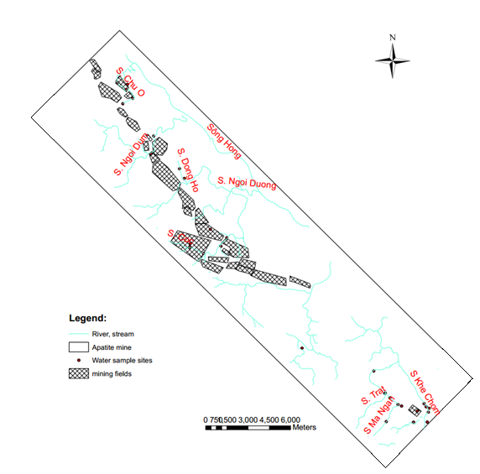
Figure.1. Location of apatite ore exploitation and processing area, Lao Cai province

2.2. Methods

2.2.1. Principal components analysis (PCA):

PCA is one of the methods in the multivariate statistical analysis method group. PCA is used to identify patterns in data, their similarities and differences by reducing the number of dimensions and complexity in the data matrix of the independent variables. In PCA, a data set containing correlated variables will be transformed to a new data set containing new orthogonal, uncorrelated variables called principal components (Olsen RL, 2012). In the field of water quality, PCA can be used to detect the correlation between water quality parameters and to determine pollution sources (point and nonpoint pollution). By dividing the data set into different periods, the PCA can also be used to investigate the temporal variations of the water quality and find out the most important pollution sources for each period. The PCA technique starts with extracting the eigenvalues (EVs) and eigenvectors of the correlation matrix (covariance matrix) of the standardized independent variables. An eigenvalue gives a measure of the significance of principal components. The eigenvectors multiplied by the square root of the eigenvalues produce a matrix of principal component loadings (PCs), which represent the importance of each original variable to a particular component. For each component, the number of original variables is equal to the number of principal component loadings. Principal components with the highest eigenvalues are the most significant, and eigenvalues of 1.0 or greater are considered significant (Wang Y, 2013). In this study, only components with eigenvalues higher than 1.0 are retained for evaluation. In this study, the authors used to SPSS statistics software to analyze PCA.

2.2.2. Cluster analysis (CA):

CA is a multivariate analysis method to classify data with similar characteristics into groups or clusters. Cluster analysis is done by two ways: analysis of hierarchical agglomerative and division. In this study, the authors is used to by analysis of hierarchical agglomerative. Clustering can be based on the linkage method or the sum of squared or variance deviations (error sums of squares in variance method), also known as "Ward’s method" or center distance method (centroid). The Ward’s method does not use cluster distances as the factor determining joining clusters. Instead, the total error sum of squares within cluster is calculated to decide the next two clusters merged at each step of the algorithm. In this research, the hierarchical agglomerative clustering using Ward’s method is performed, whereby the similarity between the two objects is calculated by Euclidean distance squared. In this study, cluster analysis method is used to group rivers and streams in the mining area based on water quality characteristics by SPSS software.
3. Results and discussion
3.1. Concentration of the water quality parameters
the analysis values such as: the range, mean, and standard deviation of 12 parameters consist of pH, DO, COD, BOD₅, TSS, NH₄⁺, NO₂⁻, NO₃⁻, coliform, Cu, Pb and Fe are shown in Table 1 and the trend characteristic in Fig. 2. Specifically, the number sample changes observing year including:: 26 samples (2015), 26 samples (2016) and 25 samples (2018).
The monitoring results from 2015 to 2018 showed that the components of pH and DO at the streams were relatively stable, with little fluctuation. The remaining indicators including COD, BOD_{5,} TSS, NO₂⁻, NH₄⁺, NO₃⁻, coliform and heavy metals fluctuate strongly over the years. Furthermore the concentration of components tended to increase from 2015 to 2018, especially the components of COD, BOD₅ and nitrogen. Streams near the mining areas such as Ngoi Duong, Dong Ho, Chu O, Coc were mainly polluted by COD, BOD₅, TSS, NO₃⁻. Streams in the ore processing Tang Loong such as Trat, Cam Duong, Khe Chom ... were mainly polluted by NH₄⁺, NO₂⁻ and some heavy metals like as Cu, Fe.
The apatite ore flotation process mainly used acids HCl, H₂SO₄. The waste water from this process is treated and reused. Therefore, almost of them a little impact on surface water systems.

Table 1. Range, mean, and standard deviation (SD) of water quality parameters at 10 streams from 2015 to 2018
Parameters | Streams | Ngoi Duong | Dong Ho | Chu O | Ngoi Dum | Coc | Ngoi Bo | BNS | Cam Duong | Khe Chom | Trat
pH | Range | 6.7-8.1 | 7.1-7.9 | 6.7-7.6 | 7.2-7.9 | 6.7-7.8 | 7.3 | 7.4-7.8 | 7.2-7.9 | 6.8-11.08 | 7.8-8.3
pH | Mean | 7.27 | 7.42 | 7.23 | 7.60 | 7.10 | 7.30 | 7.53 | 7.47 | 8.48 | 8.00
pH | SD | 0.58 | 0.31 | 0.40 | 0.36 | 0.61 | 0.00 | 0.23 | 0.38 | 1.43 | 0.26
DO | Range | 6.2-7.1 | 6-7.5 | 5.7-7.4 | 6.1-8.8 | 6.2-6.7 | 6.2-6.4 | 6.1-6.4 | 5.9-6.5 | 5.5-8.1 | 6.1-7.3
DO | Mean | 6.52 | 6.68 | 6.60 | 7.17 | 6.43 | 6.27 | 6.27 | 6.17 | 6.73 | 6.60
DO | SD | 0.32 | 0.58 | 0.65 | 1.44 | 0.25 | 0.12 | 0.15 | 0.31 | 0.97 | 0.62
COD | Range | 14.8-137.8 | 9.32-165.7 | 10.2-130.8 | 26-95.9 | 3.6-52.3 | 15.6-130.8 | 8.28-69.8 | 3.6-27.4 | 6.16-119.8 | 13.7-40.3
COD | Mean | 57.4 | 41.6 | 46.8 | 52.9 | 28.2 | 56.5 | 46.9 | 17.4 | 32.8 | 26.2
COD | SD | 47.9 | 61.0 | 43.6 | 37.6 | 24.4 | 64.5 | 33.7 | 12.3 | 29.1 | 13.4
BOD₅ | Range | 6.3-45 | 5.2-52.8 | 3.8-41.6 | 5.7-37.2 | 3-18.8 | 6-61.4 | 3.6-23.6 | 3-13.4 | 3.6-47.6 | 7.38-17.4
BOD₅ | Mean | 19.80 | 15.16 | 15.96 | 19.43 | 8.89 | 25.93 | 13.30 | 6.75 | 11.87 | 11.57
BOD₅ | SD | 13.98 | 18.70 | 13.87 | 16.13 | 8.63 | 30.79 | 10.01 | 5.77 | 11.94 | 5.21
TSS | Range | 27-1350 | 39-76.5 | 35-81 | 34-60 | 29.5-200 | 21-41 | 15-40 | 19-1900 | 17-44 | 19-33
TSS | Mean | 328.06 | 49.53 | 54.00 | 43.33 | 87.83 | 28.50 | 26.83 | 648.00 | 27.67 | 24.67
TSS | SD | 478.34 | 13.82 | 15.50 | 14.47 | 97.17 | 10.90 | 12.55 | 1084.27 | 8.51 | 7.37
Pb | Range | 0.001-0.035 | 0.01-0.036 | 0.001-0.002 | 0.001-0.029 | 0.002-0.018 | 0.001-0.005 | 0.003-0.005 | 0.001-0.005 | 0.001-0.021 | 0.001-0.004
Pb | Mean | 0.009 | 0.009 | 0.001 | 0.010 | 0.012 | 0.003 | 0.004 | 0.002 | 0.008 | 0.002
Pb | SD | 0.01 | 0.01 | 0.00 | 0.02 | 0.01 | 0.00 | 0.00 | 0.00 | 0.01 | 0.00
Cu | Range | 0.01-0.89 | 0.01-0.034 | 0.01-0.051 | 0.01-0.018 | 0.007-0.032 | 0.021-0.034 | 0.01-0.022 | 0.01-0.031 | 0.008-0.044 | 0.01-0.017
Cu | Mean | 0.17 | 0.02 | 0.02 | 0.01 | 0.02 | 0.03 | 0.01 | 0.02 | 0.03 | 0.01
Cu | SD | 0.32 | 0.01 | 0.02 | 0.00 | 0.01 | 0.01 | 0.01 | 0.01 | 0.01 | 0.00
Fe | Range | 0.078-0.57 | 0.29-2.473 | 0.238-0.614 | 0.085-1.984 | 0.029-0.258 | 0.08-0.53 | 0.08-0.42 | 0.154-0.43 | 0.39-5.4 | 0.062-0.79
Fe | Mean | 0.22 | 0.77 | 0.45 | 0.77 | 0.11 | 0.30 | 0.22 | 0.34 | 2.01 | 0.39
Fe | SD | 0.16 | 0.84 | 0.15 | 1.05 | 0.13 | 0.22 | 0.18 | 0.16 | 1.52 | 0.37
NH₄⁺ | Range | 0.16-3.37 | 0.17-1.16 | 0.08-1.29 | 0.38-0.79 | 0.38-0.88 | 0.35-1.66 | 0.14-0.60 | 0.28-3.42 | 0.57-7.45 | 0.255-0.72
NH₄⁺ | Mean | 1.05 | 0.46 | 0.56 | 0.52 | 0.62 | 0.93 | 0.44 | 1.34 | 2.25 | 0.44
NH₄⁺ | SD | 1.26 | 0.36 | 0.42 | 0.23 | 0.25 | 0.67 | 0.26 | 1.80 | 2.04 | 0.25
NO₂⁻ | Range | 0.01-0.34 | 0.027-0.15 | 0.011-0.25 | 0.02-0.98 | 0.01-0.05 | 0.01-0.24 | 0.003-0.016 | 0.023-0.04 | 0.07-0.87 | 0.003-0.03
NO₂⁻ | Mean | 0.07 | 0.09 | 0.12 | 0.34 | 0.03 | 0.10 | 0.01 | 0.03 | 0.40 | 0.01
NO₂⁻ | SD | 0.10 | 0.06 | 0.11 | 0.55 | 0.02 | 0.13 | 0.01 | 0.01 | 0.22 | 0.02
NO₃⁻ | Range | 0.85-42.9 | 0.43-85.5 | 0.32-61.9 | 7.32-173.8 | 3.72-132.4 | 0.45-1.89 | 3.0-62.7 | 0.45-23.4 | 0.07-2.49 | 0.26-0.6
NO₃⁻ | Mean | 18.65 | 49.40 | 32.07 | 76.47 | 62.07 | 1.18 | 34.38 | 8.25 | 0.95 | 0.40
NO₃⁻ | SD | 18.32 | 36.97 | 30.86 | 86.79 | 65.17 | 0.72 | 29.98 | 13.16 | 0.72 | 0.19
Coliform | Range | 500-3800 | 700-3200 | 600-1100 | 200-9800 | 200-4200 | 1000-1800 | 500-1300 | 600-800 | 100-1200 | 300-600
Coliform | Mean | 1544.4 | 1266.7 | 833.3 | 3500.0 | 1566.7 | 1366.8 | 900.0 | 700.0 | 574.2 | 433.3
Coliform | SD | 1115.92 | 962.64 | 175.12 | 5458.02 | 2281.08 | 404.15 | 400.00 | 100.00 | 390.1 | 152.7

3.2. Temporal-spatial variation of the water quality parameters
The spatial variations of the water quality parameters were evaluated through CA and PCA.
Based on the results of analyzing the composition of surface water samples at streams flowing through the apatite mining and processing area, the WQI is calculated and using cluster analysis method (ward’s method) to assess the similarity in quality between streams. Streams with similar surface water properties are placed in the same cluster.

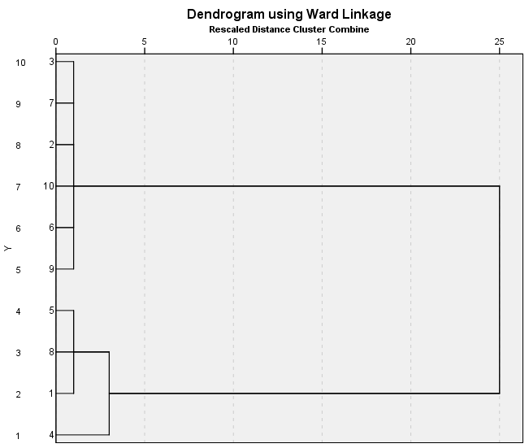  Cluster III  Cluster II  Cluster I  (a) | 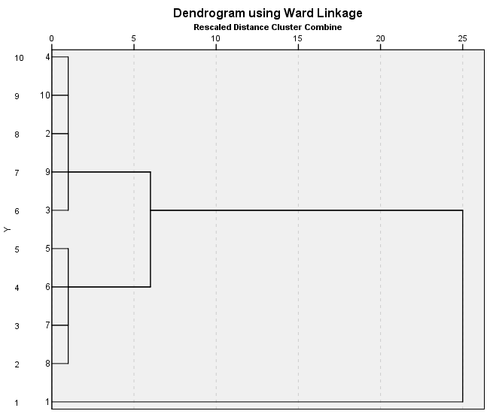  Cluster IV  Cluster I  Cluster III  (b)
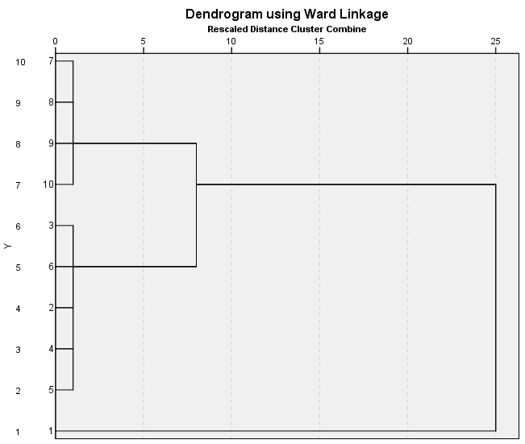  Cluster IV  Cluster III  Cluster I  (c) | Legend:
  1. Ngoi Duong Stream | a. 2015  b. 2016  c. 2018
  2. Dong Ho Stream | a. 2015  b. 2016  c. 2018
  3. Chu O Stream | a. 2015  b. 2016  c. 2018
  4. Ngoi Dum Stream | a. 2015  b. 2016  c. 2018
  5. Coc Stream | a. 2015  b. 2016  c. 2018
  6. Ngoi Bo Stream | a. 2015  b. 2016  c. 2018
  7. BNS Stream | a. 2015  b. 2016  c. 2018
  8. Cam Duong Stream | a. 2015  b. 2016  c. 2018
  9. Khe Chom Stream | a. 2015  b. 2016  c. 2018
  10. Trat Stream | a. 2015  b. 2016  c. 2018
Figure 2. The result of CA analysis by Ward linkage method

From Figure 2, basically, the quality of spring water in apatite ore exploitation and processing area is divided into 4 clusters: Cluster I (heavy pollution), Cluster II (medium pollution), Clusters III (pollution light) and Cluster IV (no pollution).

- Year 2015:

+ Cluster I: Heavy polluted water includes Ngoi Duong (1), Cam Duong (8) and Coc (5). Streams are heavily polluted by high organic matter as COD, BOD₅ and nutrients as NH₄⁺, NO₃⁻, NO₂⁻. WQI values range from 14.53 to 18.63.

+ Cluster II: Medium pollution is Ngoi Du stream (4). Spring water is polluted mainly by TSS, Fe, NO₃⁻ and coliform components. WQI value is 43.51.

+ Cluster III: Lightly polluted surface water including Dong Ho streams (2), O stream (3), Ngoi Bo (6), Khe Chom (9) and Trat stream (10). WQI values of streams range from 66.25 to 75.46.

- Year 2016:

+ Cluster I: Heavy polluted water includes Ngoi Duong stream (1), WQI value is 18.62, pollution parameters are suspended solids TSS and NO3-.

+ Cluster III includes Dong Ho stream (2), Chu O (3), Ngoi Dum (4), Khe Chom (9) and Trat stream (10), AQI values range from 63.75 to 74.82. The surface water are polluted by BOD5 and NO3-.

+ Cluster IV includes Coc stream (5), Ngoi Bo (6), Bac Nhac Son (7), Cam Duong (8), WQI index ranges from 83.35 to 90.74, parameters causing major pollution is NO3-.

- Year 2018

+ Cluster I: Heavy polluted water includes Ngoi Duong stream (1), WQI price is 14.45, the main pollution parameters are COD, BOD5 and TSS.

+ Cluster III includes Dong Ho stream (2), Chu O (3), Ngoi Dum (4), S. Coc (5) and Ngoi Bo stream (6). The group with WQI index ranges from 60.28 to 64.57. Water is polluted mainly by organic ingredients and nitrogen.

+ Cluster IV includes S. BNS (7), S. Cam Duong (8), S. Khe Chom (9) and S. Trat (10). WQI values range from 73.77 to 85.49.

From the above analysis results, the surface water quality in apatite mining and processing areas has changed over the years. Specifically, the number of streams with high and medium polluted water tends to decrease. Some areas such as Coc stream or streams near Cam Duong factory area have better water quality due to reduced suspended solids content of TSS and NO₃⁻.

The role of parameters in surface water environment is assessed through the principle component analysis method (PCA) by SPSS software. Besides, PCA analysis also aims to identify the source of pollution.

The PCA was performed on the normalized dataset (12 variables) for 10 streams. The size of the input data matrix [variables × measurements] were [12 × 26] (2015, 2016) and [12 × 25] (2018). To examine the suitability of the data set for PCA, Kaiser–Meyer– Olkin (KMO) and Bartlett’s tests were performed. KMO is a measure of sampling adequacy that indicates the proportion of variance which is common variance, which might be caused by underlying factors (Parinet B, 2014). In this study, the KMO values are 0.54, 0.54 and 0.58 and that PCA is possible. Bartlett’s test of sphericity indicates whether the correlation matrix is an identity matrix, which would indicate that variables are unrelated (Shrestha S, 2007). The significance level after Bartlett which is 0 in this study (less than 0.05) indicates that there are significant relationships among variables. The aim of PCA is to find correlations between the original variables and PCs and to define the pollution sources which affect the water quality of springs. The PCs are constrained between −1 and +1. High negative and positive loadings mean that the variables are important for the defined pollution source and conversely. Liu et al, (2003) classified the component loadings as “strong”, “moderate”, and “weak” corresponding to absolute loading values of >0.75, 0.75–0.5, and 0.50–0.30, respectively (Liu C-W, 2013). For the water quality dataset used in this study, four PCs were extracted using PCA. In Table 2, the percentages of loadings for all variables in the principal components as well as eigenvalues, total, and cumulative variance are shown. Eigenvalues measure the significance of the PCs; the higher eigenvalues and the more significant eigenvectors are the loadings. The sum of all eigenvalues equals the sum of the variances of the original variables. Only the first eigenvalue was significantly greater than 1.0. Among the four eigenvalues, the first principal component (PC1) has the highest value and is the most important PC. The analysis result of PCA is showed at talbe 2 and visualized the two main components PC1 and PC2 (figure.3).

Table 2. Loadings of the variables on the first four principal components after varimax rotation for the data set measured from 2015 to 2018 of the surpace water at apatite mining
Parameters | 2015 |  |  |  | 2016 |  |  |  | 2018
Parameters | PC1 | PC2 | PC3 | PC4 | PC1 | PC2 | PC3 | PC4 | PC1 | PC2 | PC3 | PC4
COD | 0.943 |  |  |  |  | 0.886 |  |  | 0.963
BOD₅ | 0.971 |  |  |  |  | 0.826 |  |  | 0.923
NO₃⁻ |  |  | 0.808 |  | -0.546 |  |  |  | 0.679
NO₂⁻ |  | 0.774 |  |  | 0.796 |  |  |  | 0.665
Fe |  | 0.814 |  |  | 0.865 |  |  |  |  | 0.855
Pb |  |  |  |  |  |  |  | -0.553 |  | 0.77
Cu | 0.954 |  |  |  |  |  |  |  |  | 0.75
pH |  | 0.85 |  |  |  |  | -0.79 |  |  |  | 0.925
DO |  |  | 0.797 |  |  |  | 0.68 |  |  |  | 0.774
Coliform |  |  | 0.598 |  |  |  |  | 0.824 |  |  | -0.574
NH₄⁺ |  |  |  |  | 0.807 |  |  |  |  |  |  | 0.762
TSS |  |  |  | 0.956 |  |  | 0.692 |  |  |  |  | -0.635
Eigenvalues | 4.169 | 2.331 | 1.885 | 1.186 | 3.393 | 2.268 | 1.579 | 1.109 | 3.760 | 2.322 | 1.677 | 1.215
% of Variance | 34.739 | 19.426 | 15.705 | 9.885 | 28.274 | 18.901 | 13.159 | 9.245 | 31.334 | 19.353 | 13.977 | 10.126
Cumulative % | 34.739 | 54.165 | 69.869 | 79.754 | 28.274 | 47.174 | 60.334 | 69.579 | 31.334 | 50.687 | 64.663 | 74.789

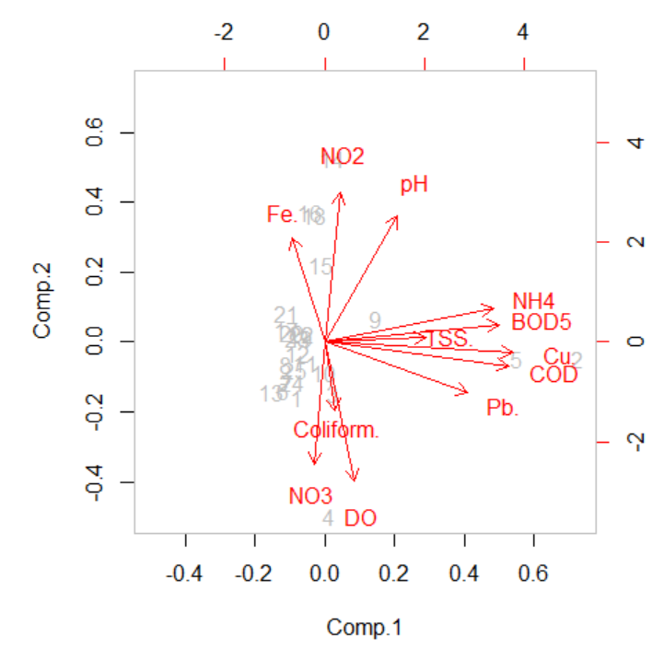  (a) | 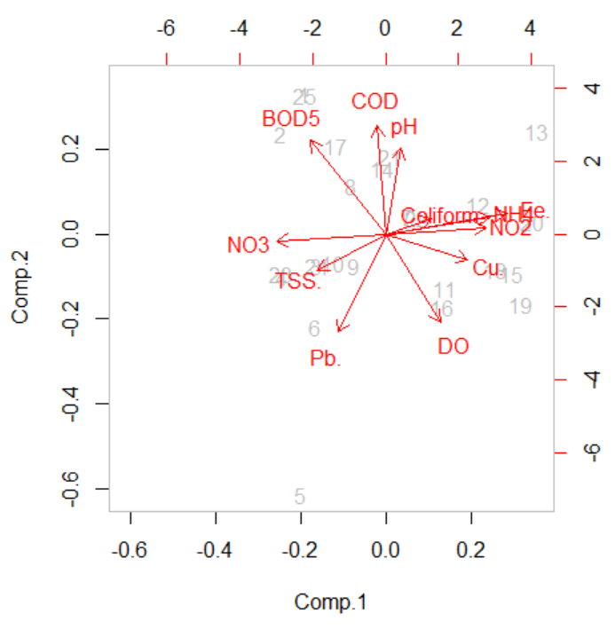  (b)
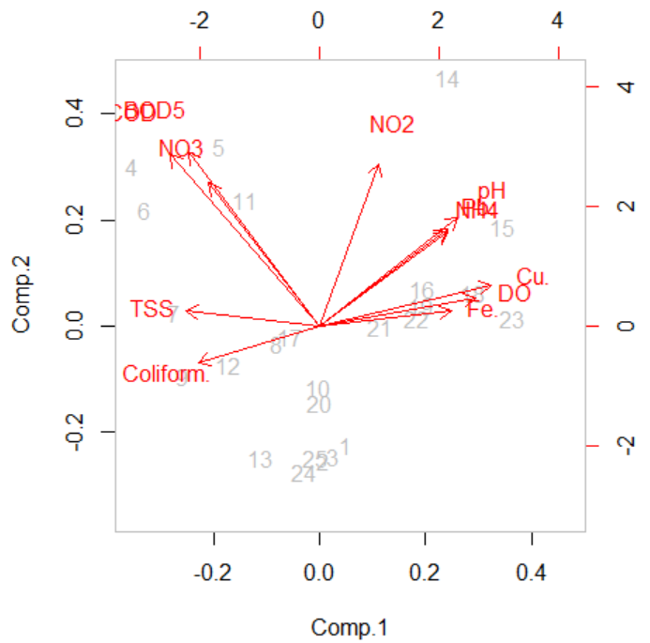  (c) | Legend:  a. 2015  b. 2016  c. 2018

Figure.3. Biplot for PC1 and PC2 showing the loadings and mean normalized scores of each stream based on the data set measured from 2015 to 2018

The parameters that reflect surface water-quality changes in the main mining areas are COD, BOD₅¸ NO₃⁻, NO₂⁻, TSS, Cu and NH₄⁺. The analysis results of PCA show changes in the distribution of environmental quality parameters in major components through years. Accordingly, in 2015, the parameters (COD, BOD₅, Cu) had the greatest explanation meaning (34.739% of the total variance) related to surface water quality. Organic composition (COD, BOD₅) was partly due to the domestic wastewater source in the ore mining and processing area; a part of the organic component was provided by erosion and soil leaching. In 2016 the nitrogen components (NO₃⁻, NO₂⁻, NH₄⁺, Fe) were valid to explain 28,274% of the total variance. Nutrient composition (NO₃, NO₂-, NH₄⁺) was explained in relation to domestic wastewater from apatite extraction and processing area.

In 2018, the main component had a high explanatory value including COD, BOD₅, NO₃⁻, NO₂⁻ with 31,334% of the total variance. It said that the trend of organic and nutrient pollution from wastewater increases, because the number of workers in apatite mining and processing area increased rapidly. Specifically, according to the periodic report on mining activities of Lao Cai province, separately for apatite exploitation and processing from 2015 to 2018, the number of workers increased from 3000 to 5371 workers. Besides, surface water in some streams is also affected by heavy metal components such as Fe, Pb, Cu, mainly Cu and Fe. However, the cause of pollution is not due to apatite mining and processing activities, but is the release toxic waste from the soil layer into the surface where the flow passes.

Figure 3 shows the visualization of the two main components PC1 and PC2. The greater the parameters get the length of the vector, the more close it correlates with the main component, and the more significant it explans the information. Thus, the COD and BOD₅ parameters are closely correlated with the main components PC1 and PC2, followed by heavy metal parameters (Fe, Cu, Pb) and parameters NO₃⁻, NO₂⁻, NH₄⁺. Figure 3 also shows that in 2015 water samples collected from streams are more similar in quality than in 2016 and 2018, expressed by the dispersion of the sampling points.

4. Conclusion

In this study, different multivariate statistical techniques were successfully applied to assess spatial variation in water quality. And the method is used to determine the main sources/factors responsible for water quality variations. Monitoring results showed that the streams are polluted by COD, BOD₅, NO₃⁻, NO₂⁻, NH₄⁺ and TSS. The concentration of parameters as COD, BOD₅, NO₃⁻, NO₂⁻, NH₄⁺ tended to increase over the years. Streams near the mining areas such as Ngoi Duong, Dong Ho, Chu O, Coc springs were mainly polluted by COD, BOD₅, TSS, NO₃⁻. Streams in the ore processing area at Tang Loong such as Trat, Cam Duong, Khe Chom streams ... were mainly polluted by NH₄⁺, NO₂⁻ and some heavy metals like as Cu, Fe. The results of cluster analysis showed that basically the quality of spring water in the ore mining and processing area is divided into 4 groups: heavy pollution, medium pollution, light pollution and no pollution. In particular, heavy polluted streams flow through apatite mining areas such as Ngoi Duong, Ngoi Dum and Chu O. The results of PCA show changes in the distribution of environmental quality parameters in major components by years. The parameters related to changes in surface water quality are COD, BOD₅¸ NO₃-, NO₂-, TSS, Cu and NH₄⁺. The source of pollution is related to domestic wastewater at apatite mining and processing areas.

REFERENCES

1. Environmental Monitoring Center of Lao Cai, 2018. Annual environmental monitoring reports 2015, 2016, 2018, apatite mine Lao Cai.

2. Nguyen Hai Au, Phan Thi Khanh Ngan, Hoang Thi Thanh Thuy, Phan Nguyen Hong Ngoc, 2017. Application of multivariate statistical analysis in the assessment of groundwater quality of Tan Thanh district, Ba Ria – Vung Tau province. Science & Technology development, vol 20, no.m2-2017.

3. Thi Thu Huyen Le, Stephanie Zeunert, Malte Lorenz, Günter Meon (2017). Multivariate statistical assessment of a polluted river under nitrification inhibition in the tropics. Environ Sci Pollut Res DOI 10.1007/s11356-017-8989-2.

4.Olsen RL, Chappell RW, Loftis JC (2012) Water quality sample collection, data treatment and results presentation for principal components analysis-literature review and Illinois River watershed case study. Water Res 46(9):3110–3122. doi:10.1016/j.watres.2012.03.028.

5. Wang Y, Wang P, Bai Y, Tian Z, Li J, Shao X, Mustavich LF, Li B-L (2013) Assessment of surface water quality via multivariate statistical techniques: a case study of the Songhua River Harbin region, China. J Hydro Environ Res 7(1):30–40. doi:10.1016/j.jher.2012. 10.003.

6. Parinet B, Lhote A, Legube B (2004) Principal component analysis: an appropriate tool for water quality evaluation and management-application to a tropical lake system. Ecol Model 178(3–4):295–311. doi:10.1016/j.ecolmodel.2004.03.007.

7. Shrestha S, Kazama F (2007) Assessment of surface water quality using multivariate statistical techniques: a case study of the Fuji river basin, Japan. Environ Model Softw 22(4):464–475. doi:10.1016/j.envsoft.2006.02.001.

8. Liu C-W, Lin K-H, Kuo Y-M (2003) Application of factor analysis in the assessment of groundwater quality in a blackfoot disease area in Taiwan. Sci Total Environ 313(1–3):77–89. doi:10.1016/S0048-9697(02)00683-6.

