SEPERATING POWER LINE USING LIDAR POINT ELEVATION AND INTENSITY

Nguyen Thi Huu Phuong
Faculty of Information Technology
Hanoi University of Mining and Geology
Hanoi, Vietnam
nguyenthihuuphuong@humg.edu.vn
Nguyen Minh Thang
General Department of Geology and Minerals
Ministry of Natural Resources and Environment
Hanoi, Vietnam
minhthang.mdc@gmail.com

Abstract: Currently, the power line and grid safety corridor are still issues of concern to the electricity industry. Every year, there are still many tragic accidents when violating the electricity grid safety corridor. In addition, unidentified objects and foreign bodies are also one of the hazards that can affect power lines and leave serious consequences. The problem is that it is necessary to separate the safety corridor of the power grid, power lines and the surrounding area so that warnings can be made quickly and promptly. To solve this problem, it is necessary to have a set of data that is collected quickly, processing data quickly and accurately. This paper deals with the use of LiDAR point cloud data in power line segregation and safety corridors. With the experimental results performed, the accuracy of the problem of separating the safety corridor of the power line, power lines and adjacent areas with an accuracy of over 90% is a reliable proof for the suitability of the LiDAR dataset, data processing technology with research problem.

Keywords: LIDAR, point cloud data, power line classification, intensity, point elevation, TIN

Introduction
LiDAR is an active remote sensing technology that is applied in many industries and fields today such as geodesy - cartography, construction, archeology, military, .... With outstanding advantages compared to other technologies Other remote sensing such as aviation, satellite, LiDAR is increasingly asserting its position.
With a laser scanner mounted on a carrier such as an aircraft, car, mobile device, etc. LiDAR can collect data about the measurement area in a short time, regardless of the weather, without Depending on time, LiDAR helps to create a complete data set of objects on the Earth's surface, space objects, etc. A data set is a collection of points that includes information about coordinates. of object (X, Y), height (Z), intensity, color, number of reflected laser, ... are saved in file with .las format.
Outstanding features LiDAR is always interested by many scientists in applied problems when this is extremely valuable information about objects in the research area. The features obtained from the reflected rays of LiDA will be used to separate points in a point cloud containing hundreds of millions of points. This process often includes many complex steps from noise removal, clustering, accurate classification of points into classes. Then, the features will be used for comparison and analysis to give accurate classification results. Features of LiDAR data points are often used in classification problems such as level, height, order of reflected rays, value of reflected intensity, colour, ....
From this data set, we can apply noise removal and classification algorithms to classify into specialized classes, each class containing points belonging to a feature type such as ground class, vegetation (trees), buildings, roads, power lines, etc. Each applied algorithm can use different features of the points to perform the cluster classification. point clouds into different classs depending on the application problem.
The recorded LiDAR intensity is the reflected intensity of the laser beam. In Geo-MMS LiDAR systems, the reflectance value is expressed as an integer between 1-256. With different objects will give different reflectance values. A low reflectance value indicates low reflectivity while a high number indicates high reflectance. The intensity of the reflected laser beam can be affected by the angle of incidence (scanning angle), range, surface composition, roughness and humidity [1]. This is important information to distinguish different objects based on their different intensity values.
With the problem of automatic classification of power lines using LiDAR data is a problem of interest. However, with complex areas, many tall trees or in urban areas, many high-rise buildings, separation of power lines will be difficult. Therefore, selecting suitable features for the problem of separating power lines from surrounding objects needs to be posed and solved to improve the accuracy of the power line classification.
From that, it can be seen that using the LiDAR point reflection intensity feature can help better identify objects in the power line classification problem.
Use of LiDAR data in power line classification has been shown in studies. As in the article[2], TerraScan is used to automatically classify point clouds into different classes such as ground, vegetation, power poles, buildings, ... and the classification method. semi-automatically for classifying vegetation into electric lines. The problem that the authors encountered was the difficulty of separating plants and electricity. In addition, street objects are difficult to perceive accurately.
Using geometric multi-scale feature and neighborhood, the authors [3] performed the power line classification with 98% accuracy. Although the accuracy of power line classification is high for the data set and study area, the authors point out that further research is needed in the future to test the generality of the method across other locations.
In paper [4], the authors proposes a point cloud classification model based on group normalization to increase the accuracy of classification. This model performs clustering and normalization of point cloud features. First perform grouping of features by their channel, then compute statistical indices and perform normalization. In addition, one-dimensional convolutional classs are used to replace fully connected classs to reduce model parameters and maintain model performance to reduce computation time. In the author's testing, PointNet++ was used to pre-train on ModelNet40 and then refine on the point cloud data of the transmissions. The results show that the authors have only extracted power lines, safe corridors and unidentified neighborhoods.
The article [5] also uses point feature and performs spatial segmentation to identify power lines in complex areas. The test results have been evaluated and confirmed by the author group. However, in the study, only the height feature of the point is used to separate the power line. The accuracy of the method may be affected if there are many tall trees of similar height such as power lines in the area. With the study [6], the authors performed image generation from different measured values ​​of the data on the selected areas and performed the clustering algorithm with each group and performed the classification by each class. cluster based. With the test data set, the authors have shown that clustering the point cloud before performing the classification will reduce the calculation time and false positives.
In the article [7], the authors use RF algorithm (Random Forest) and multi-scale cluster to perform power line classification. The authors have shown that it is necessary to distribute the features of points in the point cloud to perform the classification problem in different rules. When performing the classification problem, the higher the size of the feature set, the more redundant information and the greater the optimization required to reduce the size. To ensure the best efficiency of the classification problem, it is necessary to choose the features that are suitable for the problem.
In the article[8] a statistical-based algorithm for data analysis was developed to segment the point object from the ground point. Then the Hough transform is used to distinguish power lines from other objects (i.e. vegetation). The authors took advantage of magnitude LIDAR and attempted to classify point ground and zero ground by statistical analysis of the deviation and kurtosis of the magnitude data. The authors tested the experimental area and showed that, when using intensity data, the results are more accurate than elevation data. The paper [9] determined the points of a power line by finding points relative to its neighbors based on altitude.Then, the Hough Transform (HT) will search for the power line points in the set of neighboring points. This allows individual wiring points to be identified. Finally, wire points located on the same power line are grouped, their geometrical features are analyzed, and the quantitative characteristics of the surroundings are calculated. The authors have shown that, not only the height characteristic, but also the intensity value and total reflected rays are one of the things that help the algorithm to be used more accurately.
With research [10] using machine learning techniques combined with features of LiDAR point data such as altitude, intensity degree, RGB color, number of reflected rays to perform separation of high voltage lines with surrounding objects such as tall buildings, tall trees. With the results obtained from their research, the authors determined that using machine learning techniques to detect high voltage power lines not only provides accurate results but also is computationally less expensive. It is more computationally expensive than other techniques that rely on calculating and adjusting geometric constraints and LiDAR point features.
With the study of the authors in [11] present a pseudo-algorithm for power line extraction, modeling and analysis of potential hazards from grid safety corridor violations with LiDAR point cloud data. The first algorithm is used to extract power line candidate points from non-planar points based on linear analysis of point characteristics such as degree generation, elevation, strength. String model series are used to model and identify areas with dense power line points. The power line safety corridor is determined horizontally based on the distance between the points and the power lines. The individual tree points located in the power line corridor are divided into 3 zones: clearance, buffer zone and safe zone. From these classs, the author's team has come up with a safe area for the grid safety corridor.
Through the above studies, the authors focus on the problem of classification of power lines, safety corridors and neighborhoods. The authors use the characteristic of reflection intensity to separate power lines, safety corridors of power grids and other objects in order to support timely warning and prevention of possible damage.

proposed method
Measures to separate power lines and corridors are carried out according to the following steps:
(1) Noise removing
(2) Remove ground point
(3) Separation of power lines using elevation and intensity characteristics
(4) Classification of tree and other objects
(5) Determination of grid corridor
The detailed steps are shown in Figure 1.

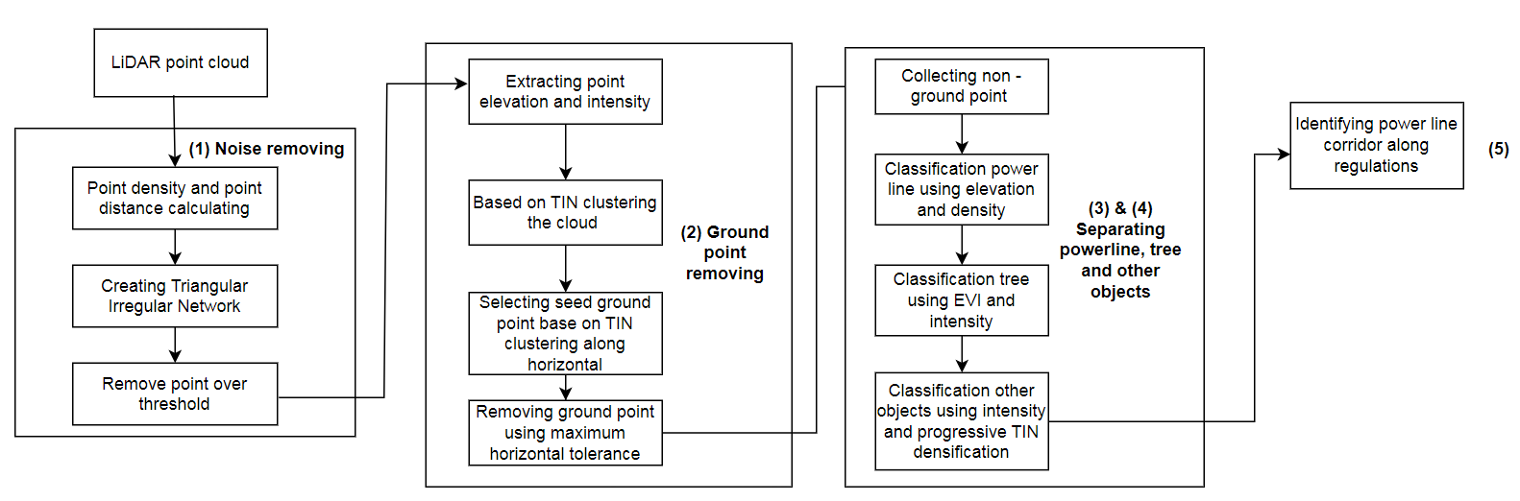
- Figure of proposed method

Creating TIN and noise removing
The authors will calculate the density and nominal distance NPS of the point to build an irregular triangle model (TIN - Triangle Irregular Network) to perform clustering and remove noise points. This is a model that helps to represent a surface from points with discrete spatial distribution. We can represent the surface in terms of adjacent triangles that do not overlap [7]. In each triangle, the surface is represented by a plane. Triangles are created from a set of points called key points. This key point can be a point at any position in the set of points. The more precisely the key point is selected, the more accurate the surface model will be. These points are well located when there is a large variation in surface geometry, for example, at the top of a mountain, at the bottom of a valley or at the edges (upper and lower) of cliffs [5]. TIN has a vector data structure, TIN performs contiguous, non-overlapping geospatial partitioning. The vertex of each triangle in the TIN model is a sample data point with coordinates (x,y,z) [8] [17].
From raw point cloud, choosing samples point base on
From the point cloud, select sample points based on calculating the nominal distance (NPS) for the points according to formula (1):
$NPS= \frac{1}{\sqrt{S^{2}}}(MAX(∆p_{ik})$ (1)
In which, S is the area of ​​the measurement area, $(∆p_{ik}$ - the distance between two points (choose the largest distance). With, the distance between two points is calculated:
${∆p}_{ik}=\frac{1}{PD}$ (2)
With, PD is point density of LiDAR point cloud.
Then sort the points by their elevation value and NPS in descending order. The selected sample points are those with the lowest and highest elevations and their NPS distances being the lowest.
Make a triangle from the selected sample set satisfying the condition (1) The smallest angle in each triangle needs to be maximized; (2) There is not any point of the triangle inside the circumcircle of any triangle in the grid; (3) Points lying on the Euclidean plane [12] [18]. At the surface interpolation step, each face of the triangle will characterize the geometry of that surface area [13]. Therefore, for each triangle in TIN, every point on its face (including the three vertices of the triangle) is always represented through a plane. Therefore, the equation of the triangle face in TIN is expressed [13]:
$Z\left(x,y\right)= b_{0}+b_{1}x+ b_{2}y$ (3)
With b₀, b₁, b₂are the coefficients.
Since then, points that do not belong to a triangular plane in the TIN will be considered noise and discarded.

Removing ground point
The ground point is classified through a horizontal clustering problem using the generated TIN.
The vertex set of the TIN model is denoted by $v_{e,1}…v_{e,n}$
where v is the vertex set of triangle [14], e represents the set of sides of the triangle TIN. We will traverse each triangle horizontally, which helps us to detect discontinuous edges between horizontal vertices. Based on the browsing process, we perform weighting for the vertices and estimate the probability between these horizontal vertices. The Euclidean distance will be calculated between two points according to the formula:
$D=\sqrt{\left|{(v_{e}-v_{e+1})}^{2}+{(v_{e+1}-v_{e+2})}^{2}\right|}$ (4)
Elevation and horizontal tolerancespositions will be selected according to the maximum value, points below this maximum threshold will be assigned to ground points and removed from the point group used for wire point classification. and its safe corridors.

Separating powerline
In LiDAR data, non-ground points in areas with a complex distribution of terrain often account for a large proportion of the point cloud. This distribution of points is often irregular, mixed between objects and difficult to recognize.
For power lines, the authors use altitude and reflectance information for identification. Usually the points on the power line will have the same height and the same intensity of reflection. However, with areas with a lot of vegetation or high-rise buildings, the points of tall trees and high-rise buildings will often be mistaken for the group of power line points. Therefore, in order to correctly and accurately identify power line points, it is necessary to devise an appropriate method to avoid fault classification.
To increase the accuracy of the problem of classifying power lines and objects in and out of its safe corridor, it is very important to determine the type and size of the neighborhood within the power line. Neighborhoods can be determined by a number of methods such as equivalence partitioning, classifier experience, etc. The size of the neighborhood also needs to be considered, if the area is small, it is difficult to properly identify and all kinds of objects, if this neighborhood is too large, then a large number of points in the vicinity need measures. for separation and identification.
Power line points will be detected as follows:
(1). Eliminate points with altitude below the threshold according to regulations on power lines in Vietnam in the group of non-ground
(2). Triangular neighborhood partition TIN has been created for the point cloud according to the maximum sample distance
(3). Select candidate power line points according to the formula:
$P_{pw}=\{Δ_{i},h_{j}-h_{p}≈0,h_{j}+T<h_{p}\}$ (5)
With, $P_{pw}$is the candidate power line point
$Δ_{i}$ is the distance between the candidate point to the TIN triangle vertices of the neighborhood to which it belongs. $Δ_{i}$ is calculated according to the following formula:
$$D_{iv}=\sqrt{{(X_{v}-X_{p})}^{2}+{(Y_{v}-Y_{p})}^{2}+ {(Z_{v}-Z_{p})}^{2}}$$
With${(X}_{v}$, $Y_{v}$, $Z_{v}$) are the coordinates of the three vertices of the triangle TIN, ${(X}_{p}$, $Y_{p}$, $Z_{p}$) coordinates of candidate point p.
$h_{j}-h_{p}$is the height difference between the candidate point and its neighbor in the partition
$h_{j}+T<h_{p}$difference in height of candidate point with neighboring points according to horizontal distribution.
If the values ​​in formula (5) satisfy the convergence condition, the candidate score will be selected
(4). Use the magnitude value and the interval covariance matrix c to identify the power line based on the candidate points found. We can assume that, with the same material, the power line points will have the same or nearly similar intensity values. And the distribution of points will be horizontal when we consider in the point cloud. The power line will be modeled according to the points satisfying the following conditions after considering its horizontal direction:
$$\left\{\begin{aligned}I_{i}/I_{p}≈1 \\ \frac{λ_{1}-λ_{2}}{λ_{1}}<δ \\ \left\lceil \tan^{-1}\left({\frac{y_{p}}{x}}_{p}\right)-θ\right\rceil >ρ[15]\end{aligned}\right.$$
Wirh$I_{i}/I_{p}$deviation of the reflected intensity of the neighboring point from the point of the power line.
$λ_{1}$, $λ_{2}$is the eigenvector of the distance covariance matrix of the points in the candidate set$P_{pw}$ và Cov($P_{pw})=\frac{1}{k}\sum_{i∈P_{pw}}{(D_{i}-D_{p})}{(D_{i}-D_{p})}^{T}$
$\left\lceil \tan^{-1}\left({\frac{y_{p}}{x}}_{p}\right)-θ\right\rceil$is the angular property of the line point. θ is the angle of the power line direction relative to the x axis.
$ρ$is the threshhold of the power line.

Trees and other objects classification
Among the objects that are at risk of causing hazards to the electrical safety corridor, tall trees and tall buildings are always threats to the safety of power lines. Therefore, identifying these objects is always important to ensure the safety of the grid corridor.
Regulations on the distance from the power line to the corridor are different for each country. However, we can generalize the rule to distinguish points from power line corridors that if the horizontal distance d between another object point and the nearest power line point satisfies the condition d <$d_{H}$, it is taken as a point. power line corridor [16].
To classify the points of trees and tall buildings, the authors use vegetation index, reflectance intensity, peak elevation and distribution by shape.
Using the plant identification accuracy improvement index to label points of the Vegetation class according to the formula:
$\left\{\begin{aligned}EVI= \frac{G*(NIR-R)}{(NIR+C_{1}*R- C_{2}*B+L)} \\ I ≈ T \\ h_{v}> H\end{aligned}\right.$ (7)
In which, G = 2.5, C1 = 6, C2 = 7, L = 1, NIR is near-infrared wave, R, B are red and blue channels in combination (R, G, B). Taking the threshold to determine the points as high vegetation with EVI in the range 0 to 1, k combined with the reflectivity index and satisfying altitude according to the given threshold will be high vegetation points. Non-vegetated spots will have EVI values ​​less than 0 and do not satisfy the threshold for altitude and reflectance.
For points that are high-rise buildings, the authors use intensity values ​​and cubic distribution to determine.

experiments and results

Expriment dataset description
The data set is used to test the proposed method used in the surveyed topic in Hanoi. The point cloud data consists of 2,716,323 points obtained from the ALS (Airborne Laser Scanning) system, the point density is 13.2pt/m². The maximum number of reflected rays is 5, with the properties of the point cloud shown in Table 1, the raw point cloud shown in Figure 2.
Feature of LiDAR point cloud used in article
No | Feature | Value | Comment
1 | Z (m) | 103,5 – 835,66 | Point elevation
2 | Intensity | 0 – 255 | Point intensity
3 | Point density | 13,2 pt/m²
4 | Area square | 45,2 km²

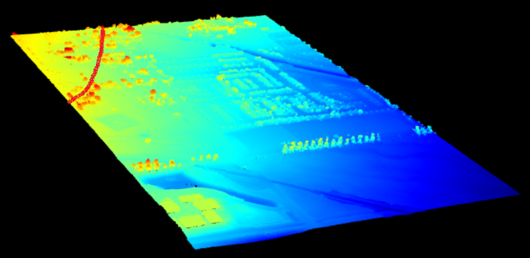
- The raw point cloud of area

Experiment result
Raw point cloud data is extracted altitude information and reflectance intensity values ​​as input for the classification problem.
Using the method of removing much according to the proposed method, we have the number of points that are considered as noise accounting for 10.2% of the total number of points of the point cloud. The distribution of infection spots in the point cloud is shown in table II below:
Distribution of noise points in the point cloud
Total of point | Noising point | Collection point
2.716.323 | 277.065 | 2.439.258
100% | 10,20% | 89,8%

Perform ground point removal from the point cloud. The ratio of ground points in the point cloud is shown in table 3, the DEM of the surface is shown in figure 3.
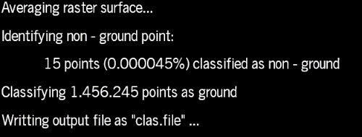
- Ground point classification result
Number of ground point
Total of point | Ground point | Non – ground point
2.439.258 | 588.837 | 1.850.421
100% | 24,14% | 75,86%

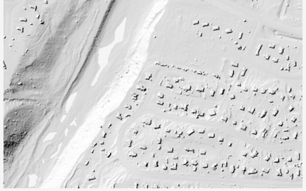
- DEM with resolution 0,75m
The results of the separation of power lines, vegetation, buildings and other objects are shown in Table 4, the power line model is shown in Figure 5, vegetation and buildings are shown in Fig. 6.
Number of power line, tree and building points
 | 1-  Unclassified | 9 – Power line point | 5 – Tree | 6 - Building
Points | 224.164 | 512.489 | 510.623 | 603.145

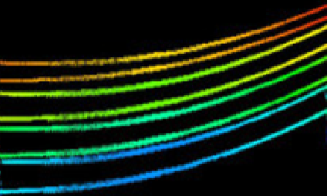

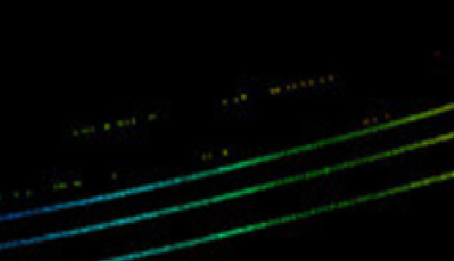
- Power line classification
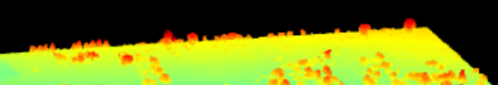
- Tree in area
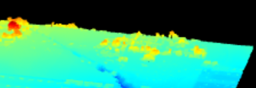
- Building in area
From the results of classification of power lines, trees and buildings, the authors have determined the safe corridor according to current regulations of Vietnam and shown in Figure 8.
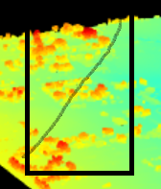
- Power line safety corridor

Accuracy
To evaluate the accuracy of the algorithm, the authors use the measures: Precision, Recall and F1 of the real math EM - D with the improved EM algorithm used in the author's research in the document[14]. These measurements will be calculated based on the ground point class.
Calculate the Precision, Recall, F1 measures using the confusion matrix with the confusion matrix table shown in the table V.
- Table V. Confusion matrix table
True  Prediction | Positive | Negative
Positive | TP – True Positive | FP – False Positive
Negative | FP – False Positive | TN – True Nagative

Based on the error matrix, the measures are calculated according to the formula:
$$Precision= \frac{TP}{TP+FP}$$
$$Recall= \frac{TP}{TP+FN}$$
$$F1=2x\frac{Precision x Recall}{Precision+Recall}= \frac{2 x TP}{2 x TP+FP+FN}$$
In there,
- TP - True Positive, points in class C_{i} are classified into correct class C_{i}
- TN - True Nagative, points in class B_{i} are classified into the correct class Bi
- FP - False Positive, points in class Ci were mistakenly classified into class B_{i}
- FN - False Nagative, point in class B_{i} was mistakenly classified into class C_{i}
The reference dataset is generated from China's LiVOX software, the layers are classified with the software including: ground, power lines, tall trees and tall buildings. The results of the evaluation are shown in Table 6.
- Measurement results of classification results according to the proposed method

 | Precision | Recal | F1
Proposed method | 93,56% | 92,50% | 0,93
Hough transform and grid vertical | 90,30% | 90,60% | 0,90

Based on the experimental results of the proposed method, which shows positive results, the method to improve the accuracy of power line separation meets the requirements of the power line separation problem. its safe passage.
Thereby, it can be seen that using LiDAR data and the proposed method in the problem has advantages and meets the requirements of the problem. With the obtained results, the classification of power lines and safety corridors is performed automatically, helping to reduce errors due to confusion. From there, appropriate management measures can be taken to ensure the grid safety corridor.

conclusion
LiDAR data are very valuable datasets when collected from survey areas. From this data set, we can use it for many different application problems with the studied and applied algorithms.
With the problem of separation of power lines and grid safety corridors, LiDAR data completely meets the requirements of accuracy, completeness and relevance of the data set. Through the studies that have been shown and the usability of LiDAR data in the power line separation problem, it can be seen that this is a suitable and valuable data set for the power line classification problem.
Through the test with the data set measured in Hanoi, the classification results are accurate and meet the requirements of the problem of classification of power lines and electrical safety corridors. Thus, the proposed method to improve the quality of the classification problem is completely suitable and is performed automatically..

Acknowledgment
The research is sponsored by the project of projectHanoi University of Mining and Geology T22-03.

References
- AEVEX Aerospace, “LIDAR INTENSITY: WHAT IS IT AND WHAT ARE IT’S APPLICATIONS?,” 2023. [Online] Available: https://geodetics.com/lidar-intensity-applications/#:~:text=LiDAR%20intensity%20is%20recorded%20as,object%20reflecting%20the%20laser%20beam.
- Dragana POPOVIC, Vladimir PAJIC, Dusan JOVANOVIC, Filip SABO, Jovana RADOVIC, “Semi-Automatic Classification of Power Lines by Using Airborne Lidar,” Helsinki, Finland, 2017.
- Yanjun Wang, Qi Chen, Lin Liu, Dunyong Zheng, Chaokui Li, Kai Li, “Supervised Classification of Power Lines from Airborne LiDAR Data in Urban Areas,” Remote Sensing, p. 771, 2017
- Zhimin Yin, Shichao Ji, Xuyong Zhang, Jianhua Dai, Weiyong Yu, Song Wu, “Classification Model of Point Cloud Along Transmission Line Based on Group Normalization,” Frontiers in Energy Research, p. 10, 2022.
- Yong He, Limeng Dong, Fanrong Zeng, Chengxi Dong, Jianan Yao, “Power Lines Extraction Using UVA LiDAR Point Clouds in Complex Terrains and Geological Structures,” IOP Conference Series: Earth and Environmental Science, pp. 1-7, 2021.
- Sebasstian Ortega, Agustin Trujillo, Jose Miguel Santana, JoseFabio Suarez, “AN IMAGE-BASED METHOD TO CLASSIFY POWER LINES IN LIDAR POINT,” trong TMCE, Las Palmas de Gran Canaria, Spain, 2018
- Qingyun Tang, Letan Zhang, Guiwen Lan, Xiaoyong Shi, Xinghui Duanmu, Kan Chen, “A Classification Method of Point Clouds of Transmission Line Corridor Based on Improved Random Forest and Multi-Scale Features,” Sensors Basel, Vol. 23, Issue 3, 2023.
- Danesh Shokri, Heidar Rastiveis, Seyed Mohammad Sheikholeslami, Reza Shah Hosseini, Jonathan Li , “Fast extraction of power lines from mobile LiDAR point clouds based on,” Earth Observation and Geomatics Engineering, Vol 5, Issues 2, pp. 63-73, 2021.
- Chasco-Hernández Daniel1, , Sanz-Delgado José Antonio, García-Morales Víctor, Álvarez-Mozos Jesús1. (2020). Automatic detection of high-voltage power lines in LiDAR surveys using data mining techniques. Unavarra.
- Firmansyah, R. Scribd.Read Triangulated Irregular Network
- Jean Romain Roussel, Alexis Achim, David Auty. (2021). Classification of high-voltage power line structures in low density ALS data acquired over broad non-urban areas. PeerJ Comput Sci
- Lingli Zhu, Juha Hyyppa. (2014). Fully-Automated Power Line Extraction from Airborne Laser Scanning Point Clouds in Forest Areas. Remote Sensing, 11267 - 11282.
- Miguel Yerno, Jorger Martinez, Oscar G.Lorenzo, et al. (2019). AUTOMATIC DETECTION AND CHARACTERISATION OF POWER LINES AND THEIR SURROUNDINGS USING LIDAR DATA. The International Archives of the Photogrammetry, Remote Sensing and Spatial Information Sciences. Enschede, Netherlands
- Na Chen, Nanmeng Wang, Yi he, Xiang Dng, Jian Kong. (2022). An improvement progressive triangular irregular network densification filtering algorithm for airborne LiDAR data. Earth Science, Vol 10
- University Consortium for Geographic information science. (2023). Triangular Irregular Network Models. GIS and T body of Knowledge: https://gistbok.ucgis.org/bok-topics/triangular-irregular-network-tin-models
- Yanjun Wang, Qi Chen, Lin Liu, Kai Li. (2019). A Hierarchical unsupervised method for power line classification from airborne LiDAR data. International Journal of Digital Earth, 1406-1422
- Yuee Liu, Zhengrong Li, Ross Hayward, Rodney Walker, Hang Jin. (2009). Classification of Airborne LIDAR Intensity Data Using Statistical Analysis and Hough Transform with Application to Power Line Corridors. Digital Image Computing : Techniques and Applications Conference (DICTA 2009). Melbourne.
- Zhenwei Shi, Yi Lin, Hui Li. (2020). Extraction of urban power lines and potential hazard analysis from mobile laser scanning point clouds. International Journal of Remote Sensing, Volume 41, Issue 9.

