Amplitude anomalies in the central Song Hong basin

Anh Ngoc Le^{1*}, Ngan Thi Bui¹, Oanh Thi Tran², Hang Thu Thi Nguyen¹, Hiep Quoc Le¹
¹ Hanoi University of Mining and Geology
² PetroVietnam University

ABSTRACT
Gas hydrates are found in many sedimentary basins, on the sub-oceanic sediments in the Polar Regions (shallow water) and in continental slope sediments (deep water), where suitable pressure and temperature conditions make them stable. Bottom simulating reflection (BSR) is known as a direct hydrocarbon indicator and also the base of the gas hydrate stability zone (GHSZ). This study, for the first time, investigates the occurrence of amplitude anomalies which are inferred to the occurrence of gas hydrate in the central Song Hong basin based on 2D seismic data. The study used 4 seismic lines located in the center of the Song Hong basin, covering an area of c. 3900 km². The BSR has been detected in the area of 150 km², below the seafloor, parallel the seafloor, and reserved seafloor polarity. The BSR is associated with the shale diapir and it tends to cross the shale diapir indicating the shale diapir is in the passive phase and the BSR has been formed after the latest phase of diapirism. The existence of the BSR refers to the gas hydrate potential. Once the gas hydrate has been confirmed by well, it will open a new direction for unconventional hydrocarbon exploration in the Song Hong basin.

Từ khóa: Gas hydrate, 2D seismic, Bottom simulating reflection, Song Hong basin.
- Introduction
The bottom simulating reflector (BSR) is a seismic reflector that cross-cuts the primary sedimentary strata and forms as a result of a geological process that occurs after the deposition of sediment (Berndt et al., 2004). Gas hydrate-related BSR is formed at the transition from hydrate-bearing sediment to sediment containing a few percent of free gas below. Thus, it marks the base of the gas hydrate stability zone (GHSZ). The occurrence of gas hydrate is controlled by the temperate and pressure. Generally, gas hydrate is stable at high pressure and low temperature (less than 25ºC). The BSR or base of the GHSZ may change its depth with time if the stability conditions are not constant. It may shift up or down to re-establish the stability condition. This will follow the phase diagram of gas hydrate stability (Holbrook et al., 1996; Hovland et al., 1997; Berndt et al., 2004).
Song Hong basin is located within 105º30’- 110º30’E longitude and 14º30’- 21º00’N latitude, covering approximately 220,000 km² of surface area; in Vietnamese territory, it occupies 126,000 km², 4000 km² of which belongs to the onshore Hanoi trough and the shallow marine littoral area. The basin is pull-apart type, extending from the Hanoi trough to the Gulf of Bac Bo and the Central coastlines (Fig. 1) with Tertiary (Paleogene to Quaternary) sediment thickness exceeding 14 km. Mesozoic - Paleozoic basement is exposed along the western and eastern flanks of the basin (Nguyen Hiep, 2019).
The study area is located in the central part of the Song Hong basin. The central basin area extends from blocks 107 - 108 to blocks 114 - 115 with water depths ranging from 20 to 90 m. This region's structure is extremely complicated, particularly in the Hue-Da Nang sub-basin. The basement gently dips towards the depocenter where the thickness of the Tertiary section exceeds 14 km. Structures range from drape-over (overlapping the basement) in the West to shale diapirs in the basin center (Nguyen Hiep, 2019). Song Hong basin has been proven for an active petroleum system by many gas fields discovered in late Miocene-Early Pliocene sand.
Gas hydrate-related BSR has been documented in some basins in the southern part of Vietnam (Nguyen Hiep, 2019). However, it has not been documented in the Song Hong basin. Because most gas hydrate study is based on several seismic lines or only based on the temperature and pressure condition (gas hydrate phase) to predict the occurrence of the gas hydrate-related BSR. In this study, for the first time, we are going to investigate the existence of the amplitude anomalies/BSR in the Song Hong basin, using the 2D seismic data.
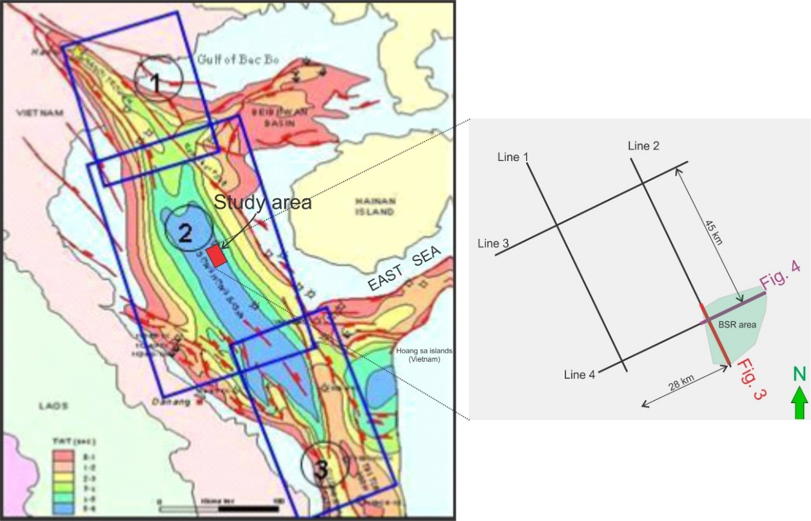
Figure 1. Schematic map of three geological provinces: (1) Northwest area, (2) Central basin area, (3) South area. The study area is located in the central part covering an area of 3900 km², bounded by 4 seismic lines named from line 1 to line 4.
- Dataset and methodology
This study uses 2D seismic lines located in the center of the Song Hong basin. The seismic data has high quality covering an area of c. 3900 km², located c. 130 km offshore (Fig. 1). The study interval is in the Pleistocene sequence which is c. 300 ms below the seafloor. The interpretation has been carried out based on the concept of Berndt et al. (2004). The gas hydrate-related BSR can be recognized on seismic based on several criteria: (i) the gas hydrate-related BSR shows a clear phase reversal compared with the seafloor due to the free gas beneath gas hydrates, (ii) gas hydrate-related BSR is characterized by an increase of depth below seafloor with greater water depth, which is controlled by the gas hydrate stability conditions, (iii) the gas hydrates are generally not stable above 25ºC, (iv) gas hydrate-related BSR does not develop within glacigenic debris flow deposits or very fine-grained sediments. In this study, we are going to apply this concept to investigate the occurrence of gas hydrate-related BSR.

Figure 2. Sketch demonstrating the changes in acoustic impedance and their causes. The temperature bar is schematic and indicates typical temperatures for the processes described in the text (Berndt et al., 2004).
- Results and Discussion
Amplitude anomalies have been observed in seismic lines 2 and 4 (Fig. 3 & 4), at the far end of these lines to the southeast. The BSR is cross the shale diapir. It is about 14 km long and ~120 ms TWT (~102 m with a velocity of 1700 m/s) below the seafloor, covering an area of c. 150 km² (Fig. 1). This amplitude anomaly is considered a gas hydrate-related BSR based on the criteria mentioned by Berndt et al. (2004).
The reflection is characterized as a strong, negative amplitude reflector (Fig. 3 & 4). The amplitude is strengthened at the shale diapir area. Criteria for interpreting the gas hydrate-related BSR as below:
(i) The observed amplitude anomalies are sub-parallel to the seafloor which is the first criteria of the BSR (Fig. 3). The study area is not located on the slope thus it is impossible to see the increasing BSR depth with the greater water depth which is a result of the gas hydrate stability conditions.
(ii) The amplitude anomalies are reversal seafloor polarity (Fig. 3 & 4). The apparent polarity of the BSR is negative meanwhile the seafloor is positive.
(iii) The amplitude anomalies cross-cut the primary strata (Fig. 3 & 4). Cross-cutting can easily be detected in the high-angle slope. This data has a relatively flat seabed but we still can see the cross-cutting strata of the amplitude anomalies (Fig. 3 & 4).

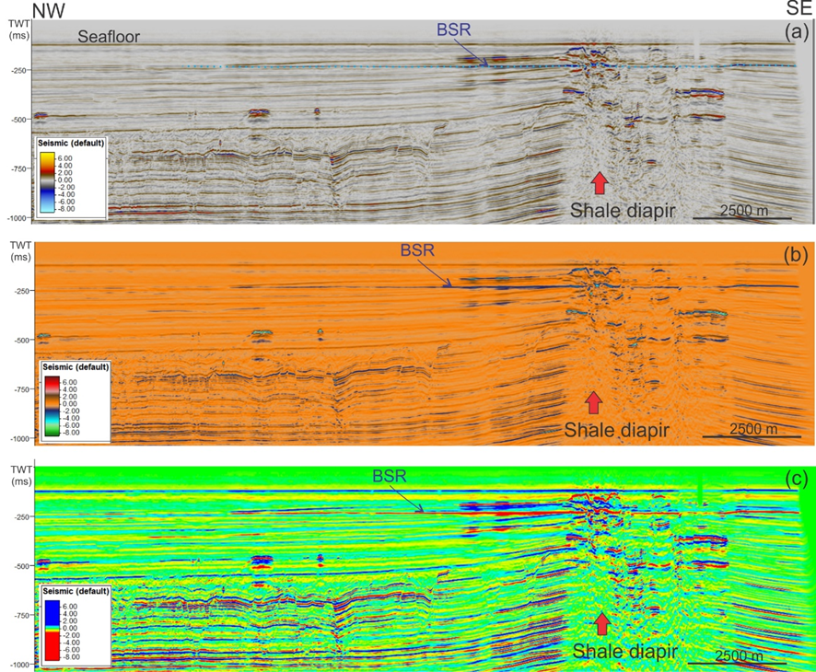
Figure 3. Seismic section line 2 with the occurrence of the BSR has been displayed in different color bars: (a) seismic default, (b) coarser extraction, (c) dip. The BSR has a strong negative amplitude near and over the shale diapir (see figure 1 for the line location).

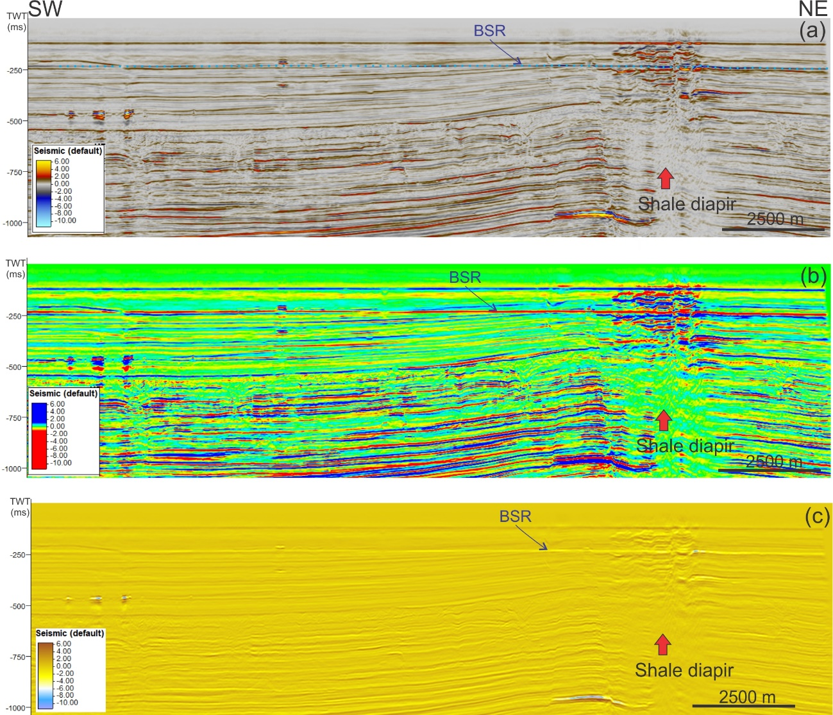
Figure 4. Seismic section line 4 with the occurrence of the BSR has been displayed in different color bars: (a) seismic default, (b) dip, and (c) structural lows. The BSR has a strong negative amplitude near and over the shale diapir (see figure 1 for the location).
In the gas hydrate stability zone, it is often documented as a blanking zone caused by the presence of gas hydrate which will reduce the acoustic impendence contrast between layers. In this area, the interval above the BSR is rather low amplitude to transparency away from the shale diapir, suggesting the increasing gas hydrate content in sediment away from the shale diapir.
However, the amplitude of the BSR tends to be stronger around the diapir. This may cause by the existence of a small amount of free gas beneath the gas hydrate stability zone, thus, creating a strong acoustic impendent contrast. The hydrate concentration typically varies from 7% to 20% with the highest concentrations near the base of GHSZ (Korenaga et al., 1997). Free gas will result in the enhanced reflections below the BSR (also known as ‘gas brightening’) as their amplitudes are higher than those caused by lithology variations. A small concentration of free gas (~1%) will cause a significant reduction in acoustic velocity (Vp). The high concentration of gas hydrate and or free gas will create a high velocity contrast above and below BSR, thus strengthening the BSR.
The BSR associated with the shale diapir and it tends to cross the shale diapir which is rather different from the model of Milkov and Sassen (2002) (Fig. 5). According to these authors, the BSR tends to move up or disappear in the area of shale diapir as heat flux moving upward. Here we still observed the occurrence of the BSR across the shale diapir. This suggests the active phase of the shale diapir happened a long time ago and the BSR has been formed after the latest phase of diapirism. Another observation of the high amplitude reflections in the ‘blanking zone’ (Fig. 3 & 4). According to Milkov and Sassen (2002) (Fig. 5), this can be called the stratigraphic accumulation of gas hydrate formed by the relatively permeable sediment thus higher concentration of gas hydrate and creating strong amplitude reflections.
Gas in the gas hydrate or free gas zone may have been supplied from both in-situ (Biotherm gas) and ex-situ (thermogenic gas). Most of the studies indicated the in-situ source of gas (99%). The Song Hong basin has proven the occurrence of an active petroleum system and many gas field has been discovered in Miocene, and Pliocene sequence, thus, it is possible to expect thermogenic gas has possibly been generated and charged the shallow sediment. Below the Pliocene sequence, a deep fluid migration network is observed including a large number of channels that are connected laterally and vertically, and vertical fluid migration pipes terminating at the Pliocene-Pleistocene level (Le, 2021). Therefore the origin of free gas may also be thermogenic gas.
The observation of the BSR in the Song Hong basin brings great gas hydrate potential for this area. However, the existence of the gas hydrate needs to be confirmed by well data. The future demand for gas will increase globally. The gas hydrate study in the Song Hong basin needs to get more attention from scientists as well as the oil and gas industry to be ready for future gas hydrate exploration and production.

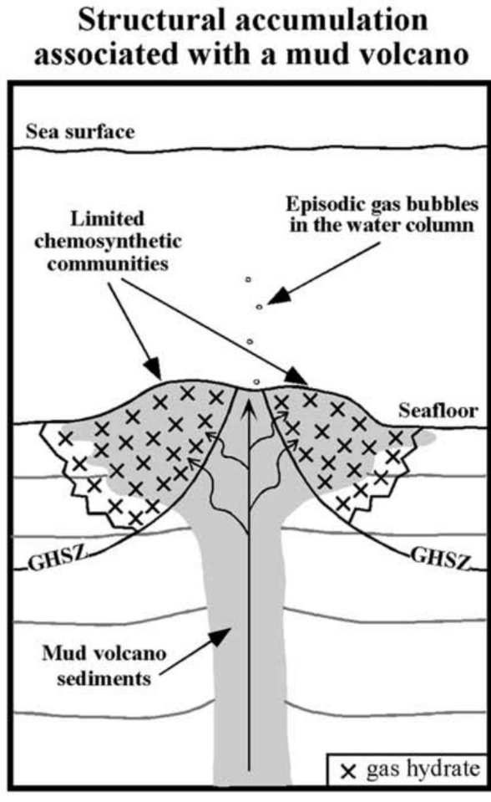 | 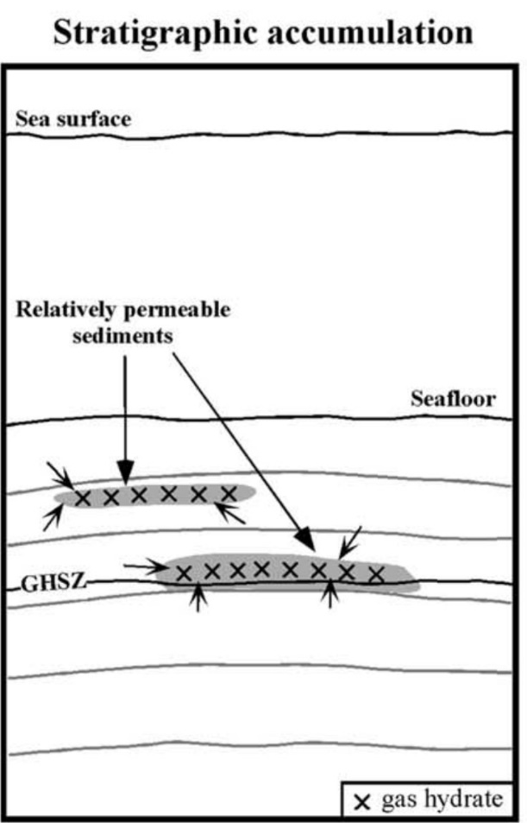
Figure 5. Two types of gas hydrate accumulation. Arrows show fluid migration (Milkov and Sassen, 2002).
- Conclusions
We infer that gas hydrate–related BSR has been observed in the central part of the Song Hong basin, recording in an area of c. 150 km², which represents the base of the gas hydrate stability zone. This is the first time gas hydrate has been mapped in the Song Hong basin. The BSR is identified in the seismic lines 2 and 4 with a length of c. 14 km. The BSR has a strong, negative amplitude reflector. The BSR associated with the shale diapir and its tendency to cross the shale diapir suggests the active phase of the shale diapir happened a long time ago and the BSR has been formed after the latest phase of diapirism. The occurrence of gas hydrate-related BSR suggests the existence of gas hydrate in sediment offshore Vietnam indicating that a vast quantity of methane is present in this area. This gas hydrate may present a future unconventional energy resource, but drilling will be required to confirm the existence of gas hydrate as well as the amount of gas hydrate accurately.
Acknowledgments:
We would like to thank Schlumberger for the software provided. We would like to thank our colleagues for their valuable discussions. We also would like to express our gratitude to the reviewers for their very useful and constructive comments on this paper.
References
Berndt, C., Bünz, S., Clayton, T., Mienert, J., & Saunders, M. (2004). Seismic character of bottom simulating reflectors: examples from the mid-Norwegian margin. Marine and petroleum geology, 21(6), 723-733.
Hovland, M., Gallagher, J.W., Clennell, M.B., Lekvam, K., 1997. Gas hydrate and free gas volumes in marine sediments: example from the Niger Delta front. Mar. Pet. Geol. 14, 245e255.
Holbrook,W.S., Hoskins, H.,Wood,W.T., Stephen, R.A., Lizarralde, D., 1996. Methane hydrate and free gas on the Blake Ridge from vertical seismic profiling. Science 273, 1840e1843.
Korenaga, J., Holbrook, W. S., Singh, S. C. & Minshull, T. A. (1997) Natural gas hydrates on the southeast US margin: Constraints from full waveform and travel time inversions of wide-angle seismic data. Journal of Geophysical Research, 102 (15), 345–415.
Le, A. N. (2021). Seismic Characteristics of Mud Diapir in the Central of Song Hong Basin, offshore Vietnam. The Iraqi Geological Journal, 1-10.
Milkov, A. V., & Sassen, R. (2002). Economic geology of offshore gas hydrate accumulations and provinces. Marine and Petroleum geology, 19(1), 1-11.
Nguyễn, H. (2019). The petroleum geology and resources of Vietnam. Science and Technology Publisher, p549.
TÓM TẮT
Anh Ngoc Le^{1*}, Ngan Thi Bui¹, Oanh Thi Tran², Hang Thu Thi Nguyen¹, Hiep Quoc Le¹
¹ Hanoi University of Mining and Geology
² PetroVietnam University
Gas hydrate đã được phát hiện ở rất nhiểu bể trầm tích, tại khu vực Bắc Cực (nước nông) hoặc tại các thềm lục địa (nước sâu), là nơi có điều kiện nhiệt độ và áp suất thích hợp để gas hydrate ổn định. Mặt mô phỏng đáy biển (BSR) được biết đến như một dấu hiêu trực tiếp nhận diện sự có mặt của gas hydrate và xác định đáy của đới gas hydrate ổn định (GHSZ). Nghiên cứu này lần đầu tiên đã nghiên cứu và xác định sự tồn tại của dị thường biên độ phản xạ địa chấn và được minh giải là mặt mô phỏng đáy biển BSR dựa trên tài lệu địa chấn 2D. Nghiên cứu sử dụng 4 tuyến địa chấn thuộc khu vực trung tâm bể trầm tích Sông Hồng với diện tích nghiên cứu là 3900 km². BSR đã được minh giải có diện tích 150 km², bên dưới đáy biển, song song với đáy biển và đảo cực so với đáy biển. BSR xuất hiện cùng với sét diaper và có xu hướng cắt qua khối diaper chứng tỏ diaper đang trong giai đoạn thụ động, không hoạt động và BSR được hình thành sau pha hoạt động cuối cùng của sét diaper. Sự tồn tại của BSR chỉ ra tiềm năng về gas hydrate tại khu vực nghiên cứu. Khi sự tồn tại của gas hydrate được xác minh bởi giếng khoan, nó sẽ mở ra một hướng tìm kiếm thăm dò mới về tài nguyên phi truyền thống tại khu vực bể trầm tích Sông Hồng.
Keywords: Gas hydrate, Địa chấn 2D, Mặt mô phỏng đáy biển, Bể trầm tích Sông Hồng.

