STUDY OF THE ACCURACY OF UAV SURVEY TECHNOLOGY FOR TOPOLOGY MAPPING ON DISCREPANCY TERRAIN CONDITIONS

Quang Khanh Nguyen¹, Anh The Hoang^{2,3*}, Thi Phuong Thao Ngo¹

¹HaNoi University of Mining and Geology
18 Pho Vien, Duc Thang, Bac Tu Liem, Ha Noi, Vietnam
Email: nguyenquangkhanh@humg.edu.vn; ngothiphuongthao@humg.edu.vn
²School of Agriculture and Natural Resource, Vinh University
182 Le Duan, Vinh, Nghe An, Vietnam
*Corresponding author Email: anhthe.dhv@gmail.com
³Department of Geophysics, School of Geodesy and Geomatics, Wuhan University
Wuhan, HuBei, China

ABTRACT

The create topographic map of hilly and mountainous area has long been a difficult problem for manufacturers in terms of both measurement methods and accuracy requirements. Traditional technologies such as total station method, aerial photography or RTK-GPS ... all have their own advantages and disadvantages. Currently, Unmanned Aerial Vehicles - UAV technology is being applied a lot in the field of mapping and is increasingly improving to have better results in production. But how much accuracy it has with comparing traditional survey methods in the discrepancy of terrain conditions? So, we have checked its in the 500ha hilly areas in Vietnam. Those areas have much different elevation (200m), hiking trails, build-up area, slope and flat area. The topographic map was conducted using UAV technology (with Phantom 4 RTK unmanned aircraft) had done the comparison with the checking points generated by RTK-GPS in term of accuracy. The result shows that the map produced by UAV technology matched with the topographic map do by RTK-GPS. Therefore, it can be concluded that the UAV technology can be considered as an alternative technique for production the topographic map.
Keywords: Unmanned Aerial Vehicles, UAV mapping, UAV, topographic map

1. INTRODUCTION

The topographic map play an important role in our daily life, it has been used in many fields such as urban planning, civil engineering, transportation, irrigation, ... The Independent Expert Advisory Group (2014) on a Data Revolution for Sustainable Development emphasized on the need for highquality and usable data, as “data are the lifeblood of decision-making”, and topographic maps is one of the accepted data. Therefore, the establishment of topographic maps is always is interested in researchs by many organizations and individuals.
In creating the topographic map, the measurement in hilly and mountainous areas with many Discrepancy Terrain Conditions has been a difficult problem of both measurement methods and accuracy requirements for a long time. We can use the following technologies to create topographic map of hilly and mountainous areas: total station, RTK – GPS (Real Time Kinematic Global Position System), airborne LiDAR. In the above technologies, the total station technology and GNSS technology holds the highest accuracy level. With the total station technology, the measurement uncertainty is depends on the distance between points and other factors, but can get as low as in mm-level (Engberg 2015) and with the the RTK-GPS technology, precision can reach a level of some millimetres in post- processing, depending on the way the computation is done and the quality of the GNSS receiver (Royal Observatory of Belgium GNSS Research Group 2017). However, those technologies are very
laborious, time costing, and economically expensive. Airborne LiDAR technology allows to draw large areas with the accuracy required but the cost of implementing this technology is quite high, affecting the cost of the product. Therefore, finding solutions to create topology map of hilly and mountainous areas to ensure accuracy and economic savings is a problem that opens to scientists.
One of the emerging technologies being applied recently is Unmanned Aerial Vehicles (UAVs), which are being proved to be a good method to create topographic map. Unmanned aerial vehicles were initially used for military purposes, however, because of it's advantages, nowadays UAV is applied in different fields, especially in civil and scientific research activities. For example, surveying and cadastral applications (Cramer et al. 2013; Barnes et al. 2014), coastal management (Delacourt et al. 2009), disaster response and monitoring (Molina et al. 2012; Boccardo et al. 2015), damage mapping (Vetrivel et al. 2015), forest and agriculture and geological investigations (Saari et al. 2011)... However, in UAV technology, with each flying device, each flight setting and different image processing software will give us different accuracy levels. And each discrepancy terrain (hills, plains, coastal, slope ...) will need to apply a different flight procedure, image processing method to produce consistent results. Each study will provide a new perspective on the application of flying equipment in topographic mapping. Therefore, we conduct to research the application of unmanned aerial vehicle (UAV) data to create topographic map of hilly area.
In this study, we propose the process of measuring mapping at mountainous areas using UAV technology and on the basis of applying Phantom 4 RTK unmanned aircraft data to create topographic map of the tea plantation hills of Phutho province of Vietnam.

2. RESEARCH APPROACH

2.1 Study Area

The study area is a tea growing area in Thanhson district, Phutho province, Vietnam (Figure 1a). The total study area is about 500 hectares. This is an area with high hill-mountain terrain, with alternating population (Figure 1b). The highest point in the study area has an altitude of 250 meters, the lowest point has an altitude of 70 meters. Because of the characteristics of the landform in this area including the large study area, high mountainous terrain, build-up, slope area and tea plantations, the researchers will take a long time and get a lot of difficulties in using the total station method to create topographic maps. Therefore, in this study, we will use the UAV method to create topographic maps and check the accuracy by RTK-GPS at some discrepancy terrain conditions.
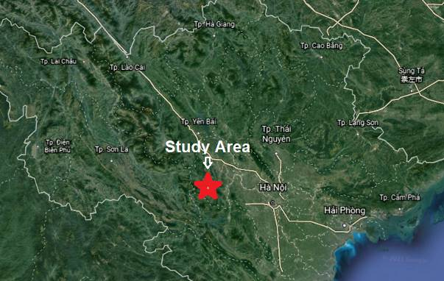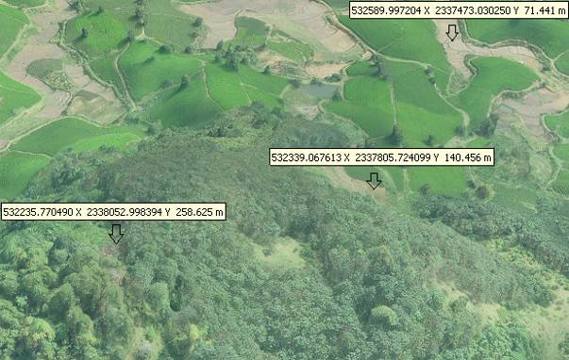
Figure 1. a) The study area in PhuTho, Vietnam. b) The terrain conditions in the study area
2.2 Methodology

In this study, the research methodology is done as showing in Figure 2. After choosing the Area for Topology mapping, we established the Ground Control Points (GCPs). The GCP is using for setting the Base Station for RTK UAV flying (translation the coordinates to the central images coordinates shooting on UAV) and for the Rover RTK GPS to measure the detail ground map. The topographic map was conducted by two methods (UAV Mapping and GPS Mapping). Finally, some tools will be used for analyzing the accuracy on the discrepancy terrain conditions. And the last phase is conclusion.
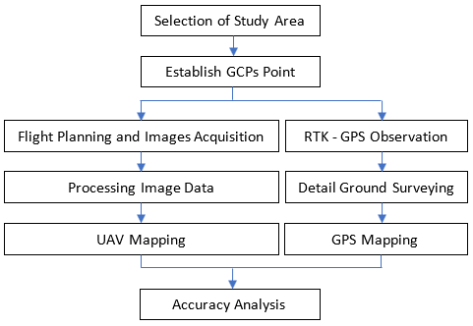
Figure 2. Research methodolody framework

2.3 UAV mapping

2.3.1 Equipment
Unmanned aerial vehicles (UAV) has been known such as aircraft itself which is intended to be operated without a pilot-on-board, remotely or autonomously controlled by on-board computers.
Based on its structure and type of taking-off and landing operation, UAVs are divided into 2 main types: fixed-wing and rotary-wing. Each type has its own advantages and disadvantages, and when measuring in mountainous areas, they often used an airplane with rotary-wing. One of the most important details to consider on the specs of its camera, including its resolution and focal length. Different camera models will provide different resolution qualities, resulting in variety of the spatial resolution of the UAV (also called the ground sampling distance - GSD). Phantom 4 RTK type of rotary-wing aircraft with four powerful rotors is equipped with the positioning system GNSS and RTK receiver to achieve position accuracy of up to cm level. Phantom 4 RTK uses a camera with CMOS sensor of 1”, resolution of 20 Mps, focal length f2.8 - f11, lens field 84⁰, can recognize objects 2.74 cm at flight height 100m (https://www.dji.com/phantom-4-rtk ).
The general structure of the UAV system includes four main parts: The aircraft; The digital camera; The ground control station; The image processing station. In this research, we was used Phantom 4 RTK, the UAV mapping production of DJI, to do the UAV mapping (Figure 3).

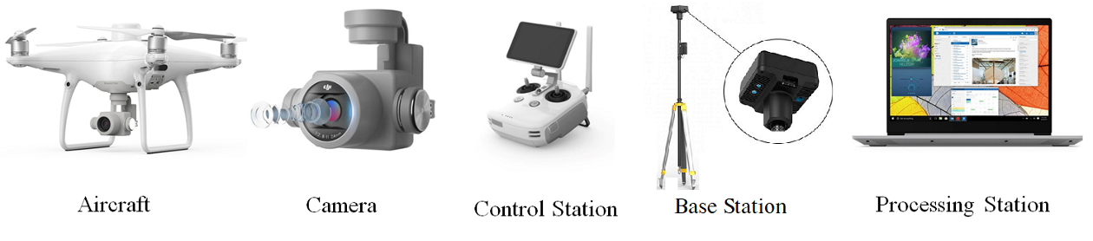
Figure 3. Phantom 4 RTK unmanned aerial vehicles (UAV) system

2.3.2. Ground Control Point (GCP)
The use of Ground Control Points is an important element that could have a substantial impact on the accuracy of the DSM model. GCPs are elements which present in the field or artificial targets points (These points have known coordinates) and can be clearly recognized in the photo sequence acquired by UAV. The number of GCPs depend on the required final accuracy of the position of the DSM and the quality of the UAV positioning system. The coordinate of GCPs is acquired using GNSS or total stations.
In this study, we conducted field reconnaissance to select safe areas to place the GCPs. The number of GCPs is 03 point (namely GCP1, GCP2 and GCP3), evenly distributed over the study area. We use artificial marker, marked with highly reflective material, the geometry and the center is perfectly defined, and it can be correctly measured with high accuracy. We also set up 2 checking points (namely Check Pt1 and Check Pt2) to determine the accuracy of image model (Figure 4).
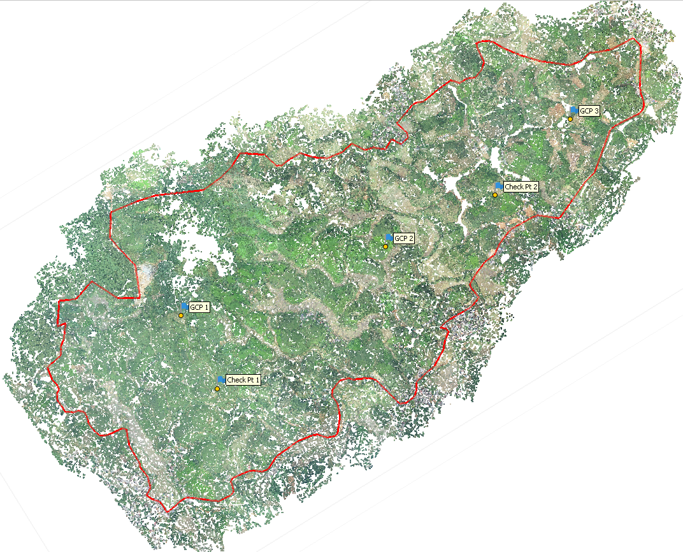
Figure 4. The position of GCPs and Checking point on the site

2.3.3 Flight planning and Image acquisition
One of the most crucial activities that should be considered for every aerial surveying project using UAVs, the first obligatory part is flight planning. When planning a flight, some important parameters need to be considered, such as: flying height, ground sample distance (GSD), camera information, UAV's batteries duration, maximum distance from the ground control station, availability and distribution of GCPs... Flight planning uses the software that comes with the aircraft.
To shoot the images of all the study areas cover 500 hectares, the flight planning has set up in three flight sections by the Control Station of the Phantom 4 RTK. The altitude for data acquisition of RGB images using UAV was 180 meter to get the image with size 5472x3648 pixels. Each flight, the Base Station was put at the GCP, the coordinate of GCP was input to the Base Station to transmit to the Aircraft (Figure 5). The result of the flight process, we had 641 images with means error of position center image coordinate was 0.018 meter.
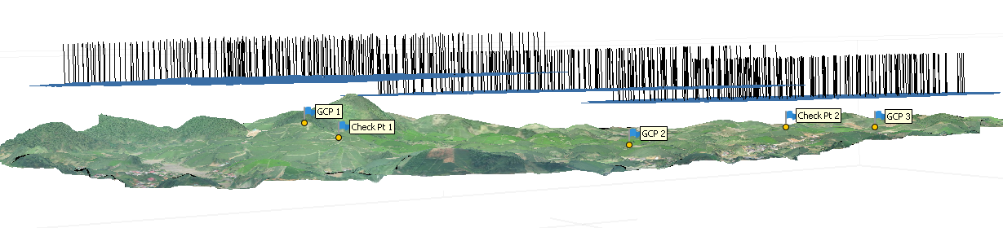
Figure 5. Image acquisition from three flights

2.3.4 Data Processing and Map Editorial
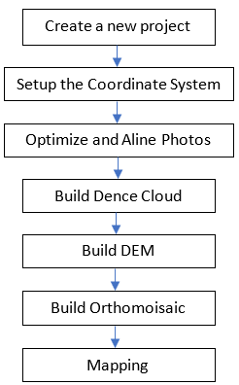
Figure 6. Flow chart for Mapping by Agisoft Metashape Professional software
Image data processing is done by software. With an iterative procedure, this software is able to reconstruct firstly a sparse point clouds and then a dense one that is generally preferred in case of terrain/surface reconstruction. After, the dense point cloud could be interpolated, simplified, classified, and finally textured for photo-realistic visualization (Nex and Remondino 2015). All the data obtained from UAV observation were processed using Agisoft Metashape Professional 1.5.2.
Agisoft Metashape Professional software was used to mosaic the imagery and align it with georeferenced points using Structure from Motion (SfM) algorithms. For each set of images, Agisoft Metashape Professional software automatically aligns the images and builds point cloud models of the surface. Agisoft allows to generate and to visualize a dense point cloud model based on the estimated camera positions to combine into a single dense point cloud. The whole process flow of mosaicking RGB imagery is summarized as in Figure 6. The result of the mosaicking process is presented as in Figure 7a, Figure 7b.
Figure 7a shows the orthophoto image produced by the mosaicking process. The orthophoto is an aerial photograph or image geometrically corrected ("orthorectified") so that the scale of the map is uniform for the whole study area. The orthophoto image provides the information about the ground resolution of 7.8 cm per pixel for the study area.
Figure 7b shows the digital elevation model obtained from the mosaicking process. The digital elevation model provides information about the terrain surface of the study area with vertical resolution of 30 cm per pixel.
The topographic map was created by Civil 3D 2019 software, the Orthophoto Image was insetted to the drawing and using the drawing tools of Civil 3D to draw the hiking trails, vegetation area, build-up area of the topology map. The elevation of the topology map was created by Global Mapper V21.1.0 that is including the detail elevation points and the contour lines with 2m interval (Figure 7c).

2.4 GPS Mapping

The topographic map will be completed with the addition of measuring points at
difficult locations by using RTK-GPS surveying technology. The GPS equipment was used is Stonex 980A (integrated GNSS receiver tracks all satellite signals GPS, GLONASS, BEIDOU, GALILEO, QZSS and IRNSS). The data getting from RTK GPS surveying technique was imported to the AutoCAD 2019 to edit the topographic map.
(b)
(a)
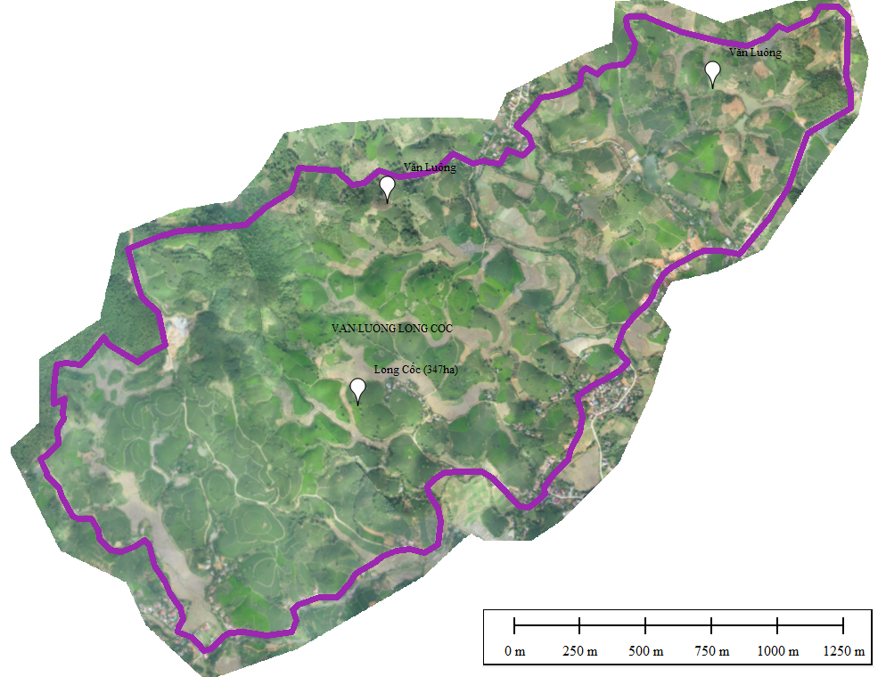 | 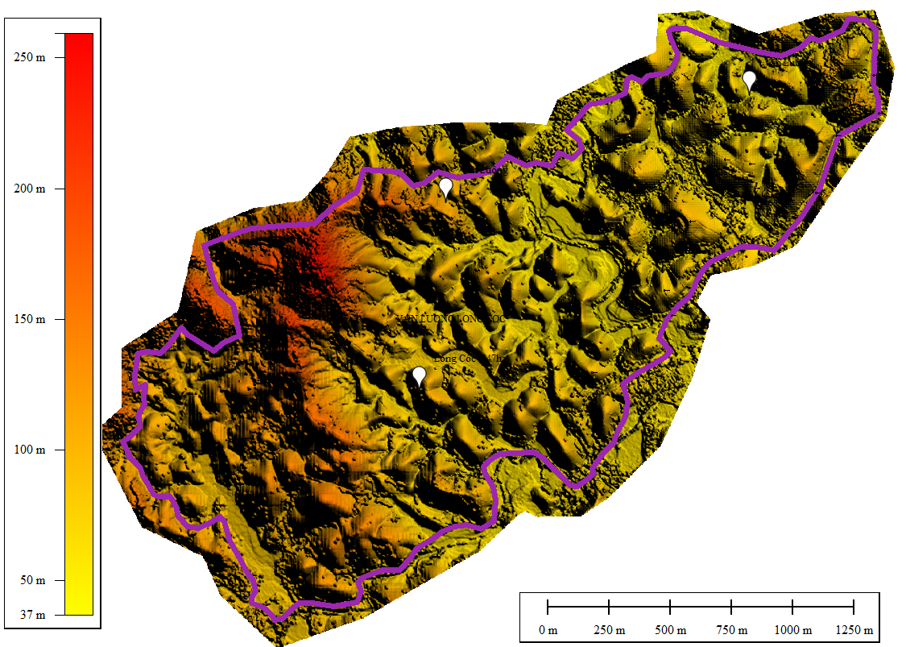 | 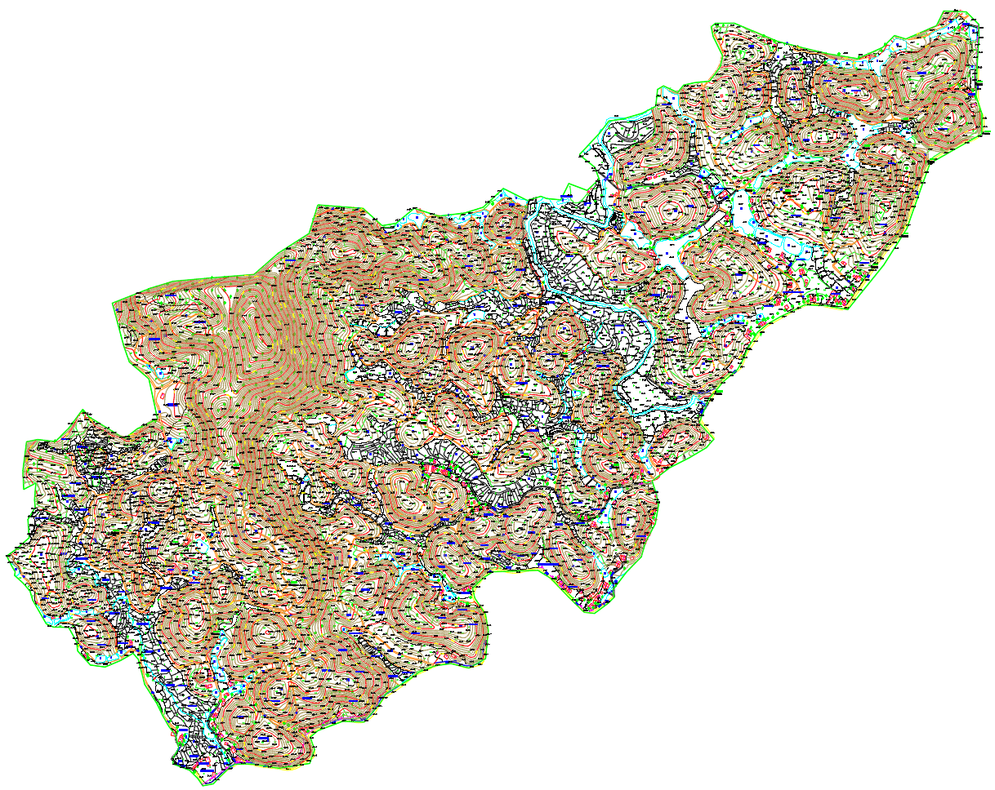  (c)

Figure 7. Data processing results
a. Orthophoto, b. Digital elevation model, c. Topographic map

3. ANALYSIS AND RESULTS

We selected areas with different topography to test (Figure 8). Quantitative analysis is about the numerical quantity that can be done by calculating or computation of the data. Quantitative assessment was carried out by calculating root mean square error (RMSE).

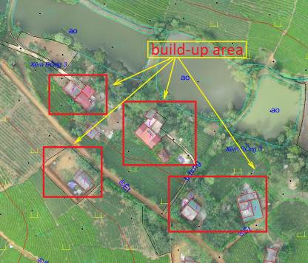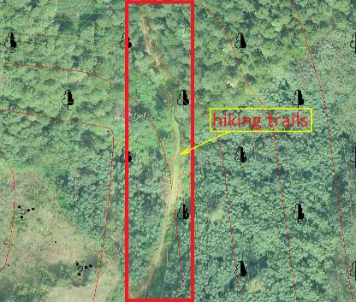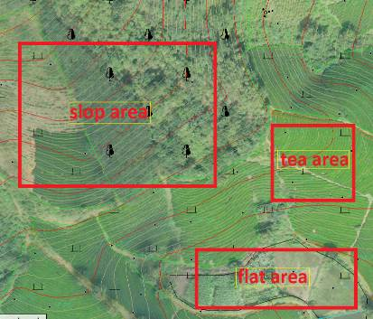
Figure 8. The areas of discrepancy terrain conditions for assessment the accuracy
The distance difference between UAV and RTK-GPS and RMSE are calculated by Eq. (1) and Eq. (2) as follows:
(1)
(2)
The elevation difference between UAV and RTK-GPS are calculated by Eq. (3) and Eq. (4) as follows:
(3)
(4)
Where X, Y are horizontal coordinates and Z is elevation (obtained by UAV method and RTK-GPS method), and are the mean values, n is number of samples.

Table 1a: Comparison of coordinates (X-Y) obtained from UAV and RTK-GPS
POINT | UAV Coordinate |  | RTK-GPS Coordinate |  | Discrepancy Distance  (meter) | Remark
POINT | (meter) |  | (meter) |  | Discrepancy Distance  (meter) | Remark
POINT | X (North) | Y (East) | X (North) | Y (East) | Discrepancy Distance  (meter) | Remark
1 | 2338441.558 | 533700.584 | 2338441.473 | 533700.522 | 0.105 | House corner
2 | 2338472.092 | 533712.736 | 2338472.061 | 533712.643 | 0.098 | -
3 | 2338468.009 | 533685.729 | 2338467.909 | 533685.671 | 0.115 | -
4 | 2338500.807 | 533672.156 | 2338500.758 | 533672.122 | 0.060 | -
5 | 2338507.844 | 533660.680 | 2338507.770 | 533660.654 | 0.078 | -
6 | 2338408.781 | 533739.059 | 2338408.754 | 533739.006 | 0.059 | -
7 | 2337599.136 | 532856.763 | 2337599.110 | 532856.696 | 0.072 | -
8 | 2337617.996 | 532796.688 | 2337617.903 | 532796.649 | 0.101 | -
9 | 2337599.152 | 532856.785 | 2337599.110 | 532856.696 | 0.098 | -
10 | 2337506.914 | 532924.791 | 2337506.840 | 532924.722 | 0.101 | -
11 | 2337487.165 | 532980.816 | 2337487.164 | 532980.807 | 0.009 | -
12 | 2337387.179 | 532030.621 | 2337387.099 | 532030.547 | 0.109 | -
13 | 2337279.669 | 531987.997 | 2337279.631 | 531987.961 | 0.052 | -
14 | 2336926.255 | 532109.837 | 2336926.189 | 532109.759 | 0.102 | -
15 | 2336898.437 | 532158.347 | 2336898.373 | 532158.301 | 0.079 | -
16 | 2336828.387 | 532127.298 | 2336828.380 | 532127.221 | 0.077 | -
17 | 2336761.658 | 532148.779 | 2336761.654 | 532148.715 | 0.064 | -
18 | 2336696.192 | 532101.494 | 2336696.100 | 532101.412 | 0.124 | -
19 | 2336675.493 | 532170.268 | 2336675.444 | 532170.242 | 0.055 | Wall conrer
20 | 2337167.304 | 533289.643 | 2337167.294 | 533289.621 | 0.024 | -
21 | 2337250.685 | 533198.467 | 2337250.675 | 533198.443 | 0.026 | -
22 | 2337543.886 | 533439.580 | 2337543.837 | 533439.510 | 0.086 | -
23 | 2338315.287 | 533859.101 | 2338315.276 | 533859.056 | 0.046 | -
24 | 2338474.912 | 533749.926 | 2338474.850 | 533749.916 | 0.063 | -
25 | 2338822.250 | 534484.946 | 2338822.231 | 534484.846 | 0.102 | -

Table 1b: Comparison of elevation (Z) obtained from UAV and RTK-GPS
POINT | X (North) | Y (East) | UAV Elevation | RTK-GPS Elevation | Discrepancy Elevation  (meter) | Remark
POINT | X (North) | Y (East) | (meter) | (meter) | Discrepancy Elevation  (meter) | Remark
1 | 2337304.910 | 532435.991 | 124.705 | 124.793 | 0.088 | Slope area
2 | 2337459.278 | 532355.327 | 107.068 | 107.194 | 0.126 | -
3 | 2337751.750 | 532232.373 | 148.675 | 148.551 | -0.124 | -
4 | 2337864.776 | 532313.287 | 166.951 | 166.905 | -0.046 | -
5 | 2337829.189 | 532357.063 | 152.044 | 152.037 | -0.007 | -
6 | 2337896.391 | 532457.572 | 114.040 | 114.229 | 0.189 | -
7 | 2338062.956 | 532395.893 | 145.524 | 145.825 | 0.301 | -
8 | 2338083.991 | 532247.060 | 239.935 | 240.363 | 0.428 | -

9 | 2338216.721 | 532744.552 | 91.219 | 91.066 | -0.153 | -
10 | 2338176.195 | 532463.735 | 106.080 | 106.206 | 0.126 | Hiking Trails
11 | 2338157.308 | 532590.399 | 86.080 | 85.821 | -0.259 | -
12 | 2338342.568 | 532907.376 | 90.097 | 89.944 | -0.153 | -
13 | 2337497.764 | 531851.680 | 126.638 | 126.539 | -0.099 | -
14 | 2337917.371 | 532613.255 | 78.863 | 78.811 | -0.052 | Flat area
15 | 2337841.585 | 532809.495 | 66.870 | 66.857 | -0.013 | -
16 | 2337791.051 | 533105.523 | 61.583 | 61.619 | 0.036 | -
17 | 2337812.129 | 533155.164 | 60.447 | 60.482 | 0.035 | -
18 | 2337740.277 | 533207.286 | 61.716 | 61.691 | -0.025 | -
19 | 2337863.410 | 533449.668 | 58.812 | 58.914 | 0.102 | -
20 | 2337853.591 | 533492.215 | 59.647 | 59.713 | 0.066 | -
21 | 2338679.953 | 534262.824 | 56.468 | 56.303 | -0.165 | -
22 | 2338679.953 | 534223.839 | 56.809 | 56.818 | 0.009 | -
23 | 2338674.365 | 534189.398 | 56.763 | 56.694 | -0.069 | -
24 | 2338721.826 | 534116.990 | 55.703 | 55.791 | 0.088 | -
25 | 2338747.239 | 534024.581 | 55.568 | 55.724 | 0.156 | -

Table 2: Comparison of coordinates (X-Y-Z) obtained from UAV and RTK-GPS.
Comparison obtained from UAV and RTK-GPS | Discrepancy of Coordination | Discrepancy of Elevation
Comparison obtained from UAV and RTK-GPS | Build – up | Slope area | Hiking trails | Flat area
Average | 0.076 | 0.089 | -0.096 | 0.014
Max of Discrepancy | 0.124 | 0.428 | 0.126 | 0.156
Min of Discrepancy | 0.009 | -0.153 | -0.259 | -0.165
Root Mean Square Error | 0.030 | 0.020 | 0.169 | 0.064

The RMSE value determined the accuracy of coordinates and elevation of each point using different observation methods. The table 1a shows the comparison of coordinate for the checking points between UAV and RTK-GPS Survey, the checking points were chosen are build – up points like the corner house and wall corner. Here, we also show the exact location with elevation information for both UAV and RTK of elevation checking points in the same X-Y coordinates were taken within the open space area of the study area, showing in the table 1b. Equation (2) and equation (4) is used to determine the root means square error (Table 2).

4. CONCLUSION

This study presents an analysis of topographic map using UAV technology and RTK conducted in Phutho province of Vietnam. The accuracy of topographic map generated by Unmanned Aerial Vehicle (UAV) Imager compares to ground survey using Real Time Kinematic (RTK) which indicates the accuracy for X-Y coordinate is 0.076m ± 0.030m and Z coordinate is 0.096 m ± 0.169m. This is good accuracy for a 1/2000 scale map. However with different type of UAV specifications, the accuracy value might get slightly different. Moreover, UAV technology allows to build maps in difficult terrain such as mountain area in this study in a very easy way, without spending too much time. In addition, the results of this study also show that using UAV technology to build topographic maps has a lower cost than
classical technologies. And the number of people participating in the survey work also needs less, just 2 to 3 people can carry out the task of controlling the aircraft to take survey photos. Therefore, it can be concluded that the UAV technology can be considered as an alternative technique to classical techniques in creating topographic map.

REFERENCES

Barnes, G., Volkmann, W., Kelm. KM., 2014. Drones for peace : Part 1 of 2 design and testing of a UAV-based cadastral surveying and mapping methodology in Albania. In: World bank conference on land and poverty, Washington DC, USA, 24–27 March 2014.
Boccardo, P., Chiabrando, F., Dutto, F., Tonolo, F. G., Lingua, A. M., 2015. UAV deployment exercise for mapping purposes: evaluation of emergency response applications. Sensors 15(7):15717–15737
Cramer, M., Bovet, S., Gültlinger, M., Honkavaara, E., McGill, A., Rijsdijk, M., Tabor, M., Tournadre, V., 2013. On the use of RPAS in national mapping —The EUROSDR point of view. ISPRS – International archives of the photogrammetry, remote sensing and spatial information sciences, XL-1/W2, 93–99.
Delacourt, C., Allemand, P., Jaud, M., Grandjean, P., Deschamps, A., Ammann, J., Cuq, V., Suanez, S., 2009. DRELIO: an unmanned helicopter for imaging coastal areas. Journal of Coastal Research, 56 (SI), 1489–1493.
Engberg, L.E., 2015. HMK-Geodesi: Terrester detaljmätning. Lantmäteriet.
https://www.dji.com/phantom-4-rtk
Independent Expert Advisory Group on a Data Revolution for Sustainable Development, 2014. A world that counts: mobilizing the data revolution for sustainable development. [Accessed: 2021-07-20].
Molina, P., Calaf, M. E. P., Colomina, I., et al., 2012. Drones to the rescue! unmanned aerial search missions based on thermal imaging and reliable navigation. Inside GNSS, 7, 36–47.
Nex, F., Remondino, F., 2014. UAV for 3D mapping applications: a review, Appl. Geomatics, 6, 1–15
Royal Observatory of Belgium GNSS Research Group. Who we are. http://gnss.be/who.php. [Accessed: 2021-07-20].
Saari, H., Antila, T., Holmlund, C., Makynen, J., Ojala, K., Toivanen, H., Pellikka, I.,Tuominen, S., Pesonen, L., Heikkila, J., 2011. Unmanned aerial vehicle (UAV) operated spectral camera system for forest and agriculture applications. In: Proceedings of SPIE, 8174.
Vetrivel, A., Gerke, M., Kerle, M., Vosselman, G., 2015. Identification of damage in buildings based on gaps in 3D point clouds from very high resolution oblique airborne images. ISPRS journal of photogrammetry and remote sensing, 105, 61–78.

