

Numerical analysis of the tunnel uplift behavior subjected to seismic loading

Tan Manh Do ^{1,2,*} , Anh Ngoc Do ¹, Hung Trong Vo ¹
¹ Faculty of Civil Engineering, Hanoi University of Mining and Geology, Vietnam
² Lulea University of Technology, Lulea, Sweden

ARTICLE INFO |  | ABSTRACT
Article history:  Received 08th Aug. 2021  Accepted 28th Nov. 2021  Available online 31st July 2022 |  | Seismic loading has always been a major concern for any engineering structures, and thereby, underground facilities (e.g., tunnels) are not exceptional. It is due to the seismically induced uplift and instability of tunnels caused by the large deformation of liquefiable soils. Therefore, the tunnel uplift behaviors subjected to seismic loading are always taken into account in any designing stages of tunnels. The main purpose of this study was to investigate the uplift behavior of a tunnel buried in liquefiable and non-liquefiable soils under seismic loading. The finite-element method was used to perform seismic and liquefaction potential analyses of the soils surrounding the tunnel. In this study, PM4sand, an advanced constitutive model for dynamic soil-structure interactions with earthquake-induced soil liquefaction, was adopted in all finite-element models. The uplift displacement and excess pore pressure of liquefiable soils were used to investigate under a typical earthquake. The effects of the non-liquefiable soil thickness on the tunnel uplift displacement and excess pore water pressure build-up under seismic loading were also investigated. As a result, during the earthquake, liquefaction was triggered in most parts of the sand layer but not in the clay layer. In addition, the tunnel uplift displacement was triggered due to the relative motion and interaction at both sides of the tunnel. Eventually, significant effects of the thickness of the non-liquefiable soil layer (sand layer) on the build-up of excess pore water pressure and hence the tunnel uplift displacement were discovered in this study, i.e., the smaller the thickness of the non-liquefiable, the higher the uplift displacement and the excess pore water pressure build-up.  Copyright © 2022 Hanoi University of Mining and Geology. All rights reserved.
Keywords:
Excess pore pressure,
Liquefiable soils,
Numerical analysis,
Seismic loading,
Tunnel uplift.

1. Introduction
_____________________
*Corresponding author
E - mail: domanhtan@khoaxaydung.edu.vn
DOI: 10.46326/JMES.2022.63(3a).02
One of the major concerns for tunnels buried in liquefiable soil is the uplift susceptibility under seismic loading. It is due to the fact that excess pore pressure in a saturated soil layer is generally built-up during earthquakes, which could lead to a decrease in effective stress and soil liquefaction. Large deformation of liquefiable soils may cause the uplift and instability of tunnels. Thereby, the tunnel uplift behaviors subjected to seismic loading are always taken into account in any designing stages of tunnels. During the past decade, behaviors of tunnels under dynamic conditions have been addressed in many studies by both numerical analyses (Azadi and Hosseini 2010; Hu et al. 2018; Lin et al. 2017; Liu and Song 2006; Sun et al. 2008; Unutmaz 2016; Zheng et al. 2021) and physical model tests (Adalier et al. 2003; Chou et al. 2011; Saeedzadeh and Hataf 2011; Tobita et al. 2011). Among these, Azadi and Hosseini (2010) performed a numerical study on tunnel uplift effects caused by soil liquefaction. In their study, a finite difference software, FLAC 2D, was used to evaluate the pore pressure changes during earthquakes with several considered parameters, e.g., tunnel diameters, buried depths, and soil strengths. In the study by Lin et al. (2017), the two-dimensional (2D) dynamic response of horizontally aligned, cylindrical twin tunnels subjected to vertically incident seismic waves was simulated by a finite/infinite element approach. Their study focused on the effects of inter-tunnel spacing on the maximum and minimum principal stresses and the peak horizontal acceleration. Zheng et al. (2021) presented the uplift behavior and the effect of interaction between twin tunnels in liquefied soil using a finite difference program. In-depth analyses on the excess pore pressure and the uplift displacement of twin tunnels were implemented and then compared with those of a single tunnel. Their study showed that the generation of excess pore pressure and the liquefaction of soil surrounding the tunnels were prerequisites for the uplift. In addition, the uplift behaviors of tunnels were affected by the interaction between twin tunnels. Sun et al. (2008) performed the tunnel final lining system during the design earthquake. Their simulation results were in line with findings from centrifuge experiments carried out by Chou et al. (2011), simulating the same tunnel condition. The physical model tests showed a large amount of sand displacing toward the invert of the uplifted tunnel. The uplift was observed to be affected by both the input earthquake shaking intensity and the generation of excess pore pressure. However, the abovementioned studies simulated idealized conditions of tunnels, i.e., tunnels buried in a single liquefiable soil layer. It should be noted that tunnels are surrounded by multi-layers of both liquefiable and non-liquefiable soils. Indeed, the tunnel uplift behaviour under seismic loading is different from the presence of non-liquefiable soil.
This study focuses on the uplift behavior of a tunnel buried in both liquefiable and non-liquefiable soils under seismic loading. The finite-element method was used to perform a seismic analysis and liquefaction of the soils surrounding the tunnel. An advanced constitutive model was adopted in the finite-element model for in-depth analyses of the uplift displacement and excess pore pressure of surrounding soils.

2. Numerical modelling

2.1. General description
An idealized tunnel with an external diameter of 5 m was simulated using a finite element software Plaxis 2D. Note that the plane strain condition is commonly adopted in simulations of tunnels as it is a long straight section. A full model was 120 m wide and 40 m high, as shown in Figure 1. The model comprised three soil types: bed rock (foundation), clay (non-liquefiable soil), and sand (liquefiable soil). Figure 1 shows the thickness H = 5 m of the non-liquefiable soil layer above the tunnel. In this current work, four case studies corresponding to four thicknesses of 15 m, 10 m, 5 m, and 0 m were used to investigate the effects of the non-liquefiable soil thicknesses on excess pore water pressure and then the tunnel uplift displacement. The tunnel position was fixed and the thicknesses of the liquefiable soil layer were then 5 m, 10 m, 15 m, and 20 m for H = 15 m, H = 10 m, H = 5 m, and H = 0 m, respectively. The phreatic line was assumed to be located at the ground surface (worst-case scenario). During the construction, soil clusters inside the tunnel were set to dry condition. In addition to the dewatering of the tunnel, other construction stages, e.g., excavation of the soil, and installation of tunnel lining, were also simulated in all models. The finite element mesh of a numerical model is shown in Figure 2. A massive number of elements were generated in the areas of interest, providing the finer mesh near the tunnel. This is due to the fact that these areas would be affected by large strains during the stage of construction. The coarser mesh was then generated at the far-field areas to minimize computation time. In addition, the maximum element sizes of all models were chosen considering the maximum frequency of the input motion spectrum and the wavelength of the propagating wave. As for the mechanical boundary conditions, the model was assumed to be fully fixed at its bottom. The horizontal displacements were assumed to be zero along the lateral edges (i.e., both left and right vertical boundaries). As for the dynamic boundary conditions, the free-field boundary was applied for the lateral edges, and a compliant base was applied for the bottom. The Kobe 1995 accelerogram was used as input ground motion (i.e., both vertical and horizontal motions in Figure 3). The input signals were scaled at peaks of horizontal and vertical accelerations of 0.55g and 0.2g, respectively. A Rayleigh damping ratio of 0.005 is adopted to control numerical noise. The earthquake was assumed to be measured at the outcrop of a rock formation and was modeled by imposing a prescribed displacement at the bottom of the model (Boulanger and Ziotopoulou 2015).

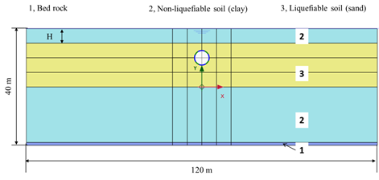
Figure 1. Selected geometry of tunnel and surrounding soil layers (H=5 m).
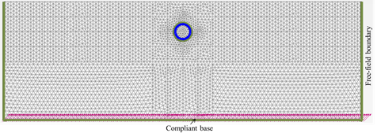
Figure 2. Finite element mesh of a numerical model.
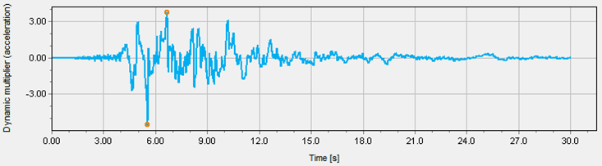
(a)
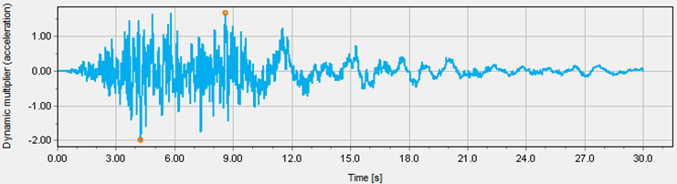
(b)
Figure 3. Time history of earthquake signals: (a) horizontal motion and (b) vertical motion.

2.2. General description
In this study, the non-liquefiable soil (clay layers) was modeled using the Hardening soil small strain model (HS small), whereas the bedrock layer was modeled as the linear elastic (LE) material of drained type behavior. The sand plasticity constitutive model (PM4Sand) was used to simulate the liquefiable soil (sand layer). The PM4Sand has successfully simulated the material behavior of liquefiable soils in dynamic or cyclic loadings, including the pore pressure generation, liquefaction, and post-liquefaction phenomena. The PM4Sand model is the elasto-plastic, bounding surface plasticity, and model critical state compatible (Boulanger and Ziotopoulou 2015). It was originally proposed from the Dafalias-Manzari model (Dafalias Yannis and Manzari Majid 2004; F. Dafalias and T. Manzari 1997) with the extensive development by Boulanger and Ziotopoulou (2015). There are various inherent advantages of using the PM4Sand model for the evaluation of dynamic properties of sand (e.g., proper stress-strain and pore pressure build-up simulations, acceptable approximation of empirical correlations used in practice, including the post-liquefaction settlements, precise simulation of the accumulation of shear strain and strength modulus reduction curves, easy forecast of a number of uniform cycles to cause initial liquefaction) (Vilhar et al. 2018). The PM4Sand has been used in many previous studies to analyze dynamic soil-structure interactions with earthquake-induced soil liquefaction (Boulanger et al. 2018; Boulanger and Montgomery 2016; Vilhar et al. 2018; Zheng et al. 2021). In this study, input parameter values of clay and bedrock were adopted from a previous study by Vilhar et al. (2018). Input parameter values of the PM4Sand model were evaluated and calibrated based on the apparent relative density (D_{r}) of sand, which is presented in detail in the report on the PM4sand model by Boulanger and Ziotopoulou (2015). All input parameter values used in the numerical analyses are tabulated in Table 1. The continuous lining was characterized by the normal stiffness EA = 1.4x107 kN/m, the flexural rigidity EI = 1.4x105 kNm²/m, weight w = 8.4 kN/m/m, lining thickness t = 0.35 m, and the Poisson’ ratio ν = 0.15 (Brinkgreve et al. 2011).
Table 1. Parameter values of used in the numerical analyses.

Parameter | Bed rock | Clay | Sand | Unit
Constitutive model | LE | HS small | PM4 sand | -
Saturated unit weight | 22 | 21 | 18 | kN/m³
Unsaturated unit weight | 22 | 19 | 14 | kN/m³
Young’s modulus | 8×10⁶ | - | - | kN/m²
Poisson’s ratio | 0.2 | 0.2 | 0.3 | -
Cohesion | - | 26 | - | kN/m²
Friction angle | - | 35 | 33 | degrees
Secant stiffness in standard drained triaxial test | - | 9000 | - | kN/m²
Tangent stiffness for primary oedometer loading | - | 9000 | - | kN/m²
Unloading - reloading stiffness | - | 27000 | - | kN/m²
Power for stress-level dependency of stiffness | - | 1 | - | -
Shear modulus at very small strains | - | 60000 | - | kN/m²
Shear strain at which  G_{s} = 0.722 G₀ | - | 0.0007 | -
Failure ratio | - | 0.9 | - | -
Reference stress | - | 100 | 100 | kN/m²
Over-consolidation ratio | - | - |  | -
Relative density | - | - | 55 | %
Shear modulus coefficient | - | - | 677 | -
Contraction rate | - | - | 0.4 | -
Parameter controlling the peak stress ratio | - | - | 0.5 | -
Parameter controlling dilatancy | - | - | 0.1 | -
Maximum void ratio | - | - | 0.60 | -
Minimum void ratio | - | - | 0.31 | -

3. Results and discussion

3.1. Soil liquefaction due to seismic loading
The potential of liquefaction can be expressed in terms of the excess pore pressure ratio, r_{u}, which is defined as a ratio between the excess pore water pressure and the initial vertical effective stress (Eq. 1). The excess pore water pressure ratio (r_{u}) is one of the most important parameters for liquefaction potential analysis. As r_{u} reaches nearly 1.0, the final pore pressure (u_{f}) can be calculated as initial effective stress plus initial pore water pressure. Thus, the final effective stress is then determined as zero, so-called zero effective stress or initial liquefaction.
$$r_{u} = \frac{∆_{pw}}{σ_{ν0}^{'} } = \frac{σ_{ν0}^{'}-σ_{ν}^{'}}{σ_{ν0}^{'}} = 1-\frac{σ_{ν}^{'}}{σ_{ν0}^{'}}$$ | $$(1)$$
Where $∆_{pw}$ is excess pore water pressure; $σ_{ν}^{'}$ is vertical effective stress and $σ_{ν0}^{'}$ is initial vertical effective stress at the beginning of the dynamic calculation.
Figure 4 shows the excess pore pressure ratio at the end of the earthquake (non-liquefiable soil thickness H = 10 m). The excess pore pressure ratio, r_{u}, which is attained in a soil element, is used to evaluate the liquefaction potential of the soil layers around the tunnel. As can be observed, most of the liquefiable soil layer (sand) liquefied during the earthquake (i.e., r_{u} reached 1.0), whereas the rest (i.e., non-liquefiable soil layers) had low r_{u}, i.e., no liquefaction.
Additional insight into the liquefaction potential analysis can be attained by looking into r_{u} of typical points B and D, as shown in Figure 5. Point B (at the middle of the clay layer) is represented for non-liquefiable soil, and point D (at the middle of the sand layer) is represented for liquefiable soil. As can be seen, the increase in r_{u} at point B was relatively insignificant during the earthquake (30 s). However, r_{u} at point D accumulated rapidly up to 1.0 (liquefaction) after about 7 s and remained high until the end of the earthquake.

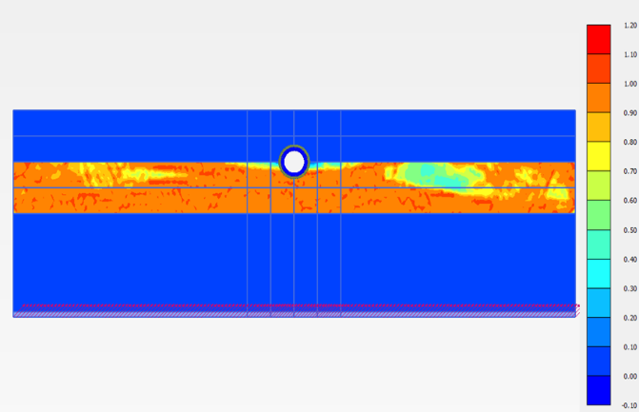
Figure 4. Excess pore pressure ratio (r_{u}) of soil layers at the end of the earthquake (Case study H=10 m).
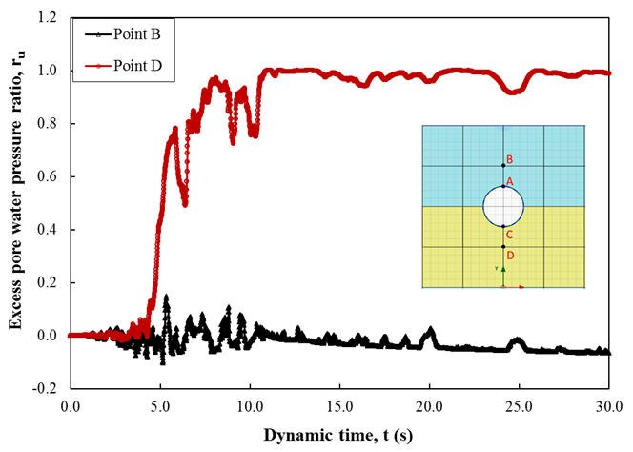
Figure 5. Excess pore pressure ratio at points B and D during the earthquake
(Case study H=10 m).

3.2. Tunnel uplift displacement due to seismic loading
It is well-known that the uplift behavior of a tunnel involves the liquefaction-induced large deformation of surrounding soils. Figure 6 illustrates the spatial deformation plot produced from the numerical analysis (Case study H = 10). It can be seen in relative motion and interaction zones at both sides of the tunnel, which induces uplift of the tunnel. In addition, the development of excess pore water pressure during the earthquake of the liquefiable soil layer beneath the tunnel would exert a force causing the tunnel to uplift. A similar observation can also be found in the previous studies on tunnel uplift behavior (Chian et al. 2014; Zheng et al. 2021).
Take Point A (crown of the tunnel) and Point C (invert of the tunnel) as examples: the movement of the tunnel was insignificant at the beginning of the earthquake (before 5 s), followed by a large movement until the end of the earthquake. Both settlement and uplift behaviors can be observed in this period, probably due to the earthquake input motions (both vertical and horizontal motions). The final uplift displacement of the tunnel was found to be 0.078 m at the end of the earthquake. In addition, it is expected to observe the most likely same displacement at Point A (crown of the tunnel) and Point C (invert of the tunnel), as shown in Figure 7.

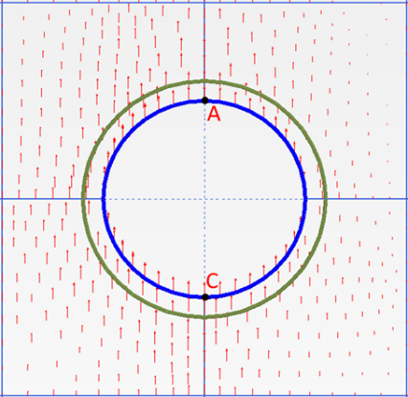
Figure 6. Spatial deformation plot produced from the numerical analysis at the end of the earthquake (Case study H=10 m).

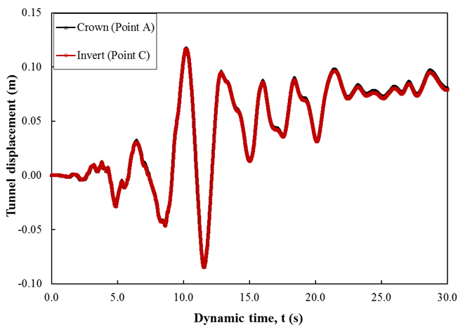
Figure 7. Tunnel uplift displacement vs time histories during the earthquake (Case study H=10 m).

3.3. Effects of the non-liquefiable soil thickness on the tunnel uplift displacement and excess pore water pressure
Figure 8 shows the effects of the non-liquefiable soil thickness on excess pore water pressure development during the earthquake (typical point right beneath the invert of the tunnel). As shown, the build-up of excess pore water pressure was dependent on the non-liquefiable soil thickness H. In particular, when the tunnel was entirely buried in clay (i.e., H = 15 m), the increase in r_{u} was relatively insignificant during the earthquake (30 s). The insignificant excess pore water pressure of soil beneath the invert of the tunnel might lead to an insignificant uplift displacement of the tunnel, as shown in Figure 9. However, r_{u} accumulated rapidly up to about 0.5, 0.64, 0.6 as H = 10 m, H = 5 m, and H = 0 m, respectively, at the ends of the earthquake. The uplift displacement became larger as the thickness of the non-liquefiable soil was smaller. In this sense, the thickness of the non-liquefiable soil H played an important role in the stability of the tunnel. However, this finding is promising for the case studies in this research as the tunnel diameter and the position of the tunnel are fixed.

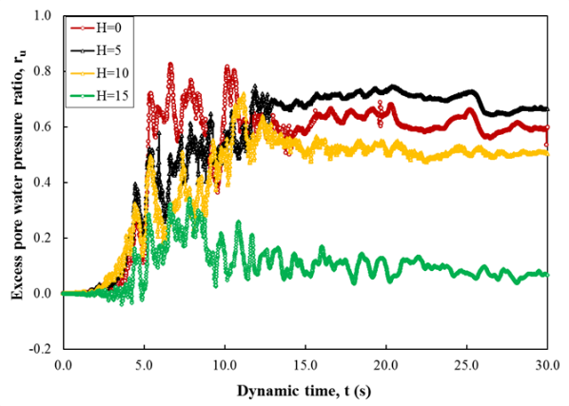
Figure 8. Effects of the non-liquefiable soil thickness on excess pore water pressure.
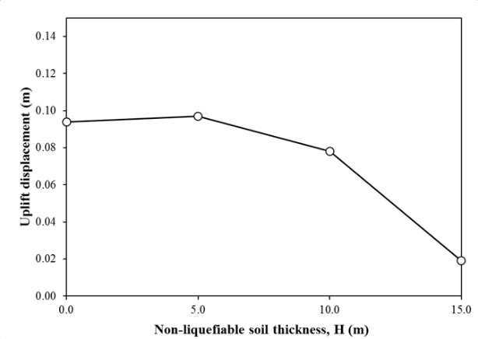
Figure 9. Effects of the non-liquefiable soil thickness on the tunnel uplift displacement.

4. Conclusions
In this study, a numerical analysis of the tunnel uplift behavior subjected to seismic loading was conducted. A finite-element software was used to simulate the tunnel buried in liquefiable and non-liquefiable soils under seismic loading. PM4sand, an advanced constitutive model for dynamic soil-structure interactions with earthquake-induced soil liquefaction, was adopted in the finite-element models. Based on the results of this study, the following conclusions can be drawn:
• Liquefaction happened at the most part of the liquefiable soil layer (sand) during the earthquake (i.e., r_{u} reached 1.0), not in the non-liquefiable soil layers (clay layers).
• The tunnel uplift displacement was triggered due to the relative motion and interaction at both sides of the tunnel. It also involved the development of excess pore water pressure beneath the invert of the tunnel.
• The thickness of the non-liquefiable soil layer significantly affected the tunnel uplift displacement and the build-up of excess pore water pressure. The uplift displacement and the excess pore water pressure build-up became larger as the thickness of the non-liquefiable soil was smaller.
• This numerical study provided an in-depth analysis of the tunnel uplift displacement and the excess pore water pressure build-up of surrounding soils under seismic loading. It is believed that the finite element method could be used to study how a tunnel should be built in order to reduce the risk of an earthquake.

Acknowledgments
This study was supported by Hanoi University of Mining and Geology, Vietnam, and Lulea University of Technology, Sweden.

Contribution of authors
Conceptualization: Tan Manh Do, Anh Ngoc Do, Hung Trong Vo; Methodology: Tan Manh Do, Anh Ngoc Do; Software: Tan Manh Do, Anh Ngoc Do; Validation: Tan Manh Do, Anh Ngoc Do; Writing-original draft preparation: Tan Manh Do; Writing-review and editing: Tan Manh Do, Anh Ngoc Do, Hung Trong Vo; Supervision: Anh Ngoc Do, Hung Trong Vo; All authors have read and agreed to the published version of the manuscript.

References
Adalier, K., Abdoun, T., Dobry, R., Phillips, R., Yang, D., and Naesgaard, E. (2003). "Centrifuge modelling for seismic retrofit design of an immersed tube tunnel." International Journal of Physical Modelling in Geotechnics, 3(2), 23-35.
Azadi, M., and Hosseini, S. M. M. (2010). "The uplifting behavior of shallow tunnels within the liquefiable soils under cyclic loadings." Tunnelling and Underground Space Technology, 25(2), 158-167.
Boulanger, R., and Ziotopoulou, K. (2015). "PM4Sand (Version 3): A sand plasticity model for earthquake engineering applications." Center for Geotechnical Modeling Report No. UCD/CGM-15/01, Department of Civil and Environmental Engineering, University of California, Davis, Calif.
Boulanger, R. W., Khosravi, M., Khosravi, A., and Wilson, D. W. (2018). "Remediation of liquefaction effects for an embankment using soil-cement walls: Centrifuge and numerical modeling." Soil Dynamics and Earthquake Engineering, 114, 38-50.
Boulanger, R. W., and Montgomery, J. (2016). "Nonlinear deformation analyses of an embankment dam on a spatially variable liquefiable deposit." Soil Dynamics and Earthquake Engineering, 91, 222-233.
Boulanger, R. W., and Ziotopoulou, K. (2015). "A Sand Plasticity Model for Earthquake Engineering Applications."
Brinkgreve, R., Swolfs, W., Engin, E., Waterman, D., Chesaru, A., Bonnier, P., and Galavi, V. (2018). "PLAXIS 2D Reference manual." Delft University of Technology and PLAXIS bv The Netherlands.
Chian, S. C., Tokimatsu, K., and Madabhushi, S. P. G. (2014). "Soil liquefaction-induced uplift of underground structures: Physical and numerical modeling." Journal of Geotechnical and Geoenvironmental Engineering, 140(10), 04014057.
Chou, J., Kutter, B., Travasarou, T., and Chacko, J. (2011). "Centrifuge modeling of seismically induced uplift for the BART transbay tube." Journal of Geotechnical and Geoenvironmental Engineering, 137(8), 754-765.
Dafalias Yannis, F., and Manzari Majid, T. (2004). "Simple Plasticity Sand Model Accounting for Fabric Change Effects." Journal of Engineering Mechanics, 130(6), 622-634.
F. Dafalias, Y., and T. Manzari, M. (1997). A Critical State Two-Surface Plasticity Model for Sands.
Hu, J., Chen, Q., and Liu, H. (2018). "Relationship between earthquake-induced uplift of rectangular underground structures and the excess pore water pressure ratio in saturated sandy soils." Tunnelling and Underground Space Technology, 79, 35-51.
Lin, S.-Y., Hung, H.-H., Yang, J. P., and Yang, Y. (2017). "Seismic analysis of twin tunnels by a finite/infinite element approach." International Journal of Geomechanics, 17(9), 04017060.
Liu, H., and Song, E. (2006). "Working mechanism of cutoff walls in reducing uplift of large underground structures induced by soil liquefaction." Computers and Geotechnics, 33(4-5), 209-221.
Saeedzadeh, R., and Hataf, N. (2011). "Uplift response of buried pipelines in saturated sand deposit under earthquake loading." Soil Dynamics and Earthquake Engineering, 31(10), 1378-1384.
Sun, Y., Klein, S., Caulfield, J., Romero, V., and Wong, J. (2008). "Seismic analyses of the Bay Tunnel." Geotechnical Earthquake Engineering and Soil Dynamics IV, 1-11.
Tobita, T., Kang, G.-C., and Iai, S. (2011). "Centrifuge modeling on manhole uplift in a liquefied trench." Soils and foundations, 51(6), 1091-1102.
Unutmaz, B. (2016). "Liquefaction potential of soils around circular double tunnels." Bulletin of Earthquake Engineering, 14(2), 391-411.
Vilhar, G., Laera, A., Foria, F., Gupta, A., and Brinkgreve, R. B. (2018). "Implementation, Validation, and Application of PM4Sand Model in PLAXIS." Geotechnical Earthquake Engineering and Soil Dynamics V: Numerical Modeling and Soil Structure Interaction, American Society of Civil Engineers Reston, VA, 200-211.
Vilhar, G., Laera, A., Foria, F., Gupta, A., and Brinkgreve Ronald, B. J. (2018). "Implementation, Validation, and Application of PM4Sand Model in PLAXIS." Geotechnical Earthquake Engineering and Soil Dynamics
Zheng, G., Yang, P., Zhou, H., Zhang, W., Zhang, T., and Ma, S. (2021). "Numerical Modeling of the Seismically Induced Uplift Behavior of Twin Tunnels." International Journal of Geomechanics, 21(1), 04020240.

