

Study on the stability of rock mass around large underground cavern based on numerical analysis: A case study in the Cai Mep project

Kien Van Dang *, Anh Ngoc Do, Thai Ngoc Do
Faculty of Civil Engineering, Hanoi University of Mining and Geology, Vietnam

ARTICLE INFO |  | ABSTRACT
Article history:  Received 08th Aug. 2021  Accepted 28th Nov. 2021  Available online 31st July 2022 |  | Geotechnical problems are complicated to the extent and cannot be expected in other areas since non-uniformities of existing discontinuous, pores in materials and various properties of the components. At present, it is extremely difficult to develop a program for tunnel analysis that considers all complicated factors. However, tunnel analysis has made remarkable growth over the past several years due to the development of numerical analysis methods and computer development, given the situation that it was difficult to solve the formula of elasticity, viscoelasticity, and plasticity for the dynamic feature of the ground when the constituent laws, yielding conditions of ground materials, geometrical shape and boundary conditions of the structure were simulated in the past. Actual problems have been successfully analyzed in addition to simple analysis and more reasonable design and construction management materials have been obtained. The stability of rock mass around an underground large cavern is the key to the construction of large-scale underground projects which have to divide into different parts stages. Rock bolt and shotcrete are important means to ensure the stability of the underground cavern. The objective of the paper is to evaluate the stability of a large cavern in the Cai Mep project in Ba Ria- Vung Tau by numerical simulation method. The results from numerical simulations show that the stability of rock support of the cavern is in fair agreement with the original design calculation. The maximum displacement of rock mass around caverns, maximum compressive stress and tensile stress in shotcrete, and the maximum axial force of rock bolt obtained by Rocscience -RS2- Phase2 software are the main parameters in the stability assessment.  Copyright © 2022 Hanoi University of Mining and Geology. All rights reserved.
Keywords:
Cai Mep,
Large Cavern,
Numerical analysis,
Stability,
Surrounding Rock.

_____________________
*Corresponding author
E - mail: dangvankien@humg.edu.vn
DOI: 10.46326/JMES.2022.63(3a).02

1. Introduction
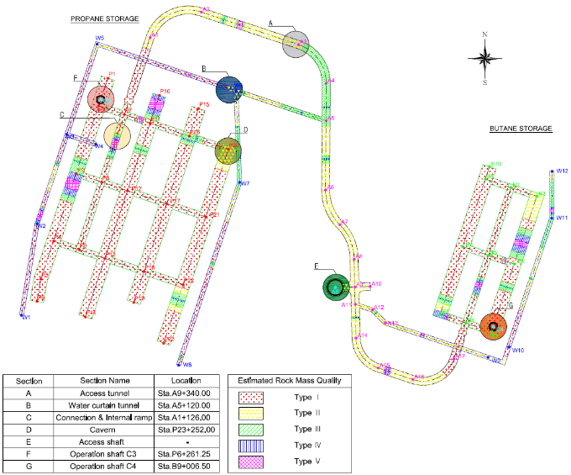
The Cai Mep project - Cai Mep LPG Cavern Project is located in Ba Ria-Vung Tau province, Viet Nam. The project is an underground storage facility. Tunnels of underground storage facilities in this project are broadly categorized into the shaft, storage gallery, water curtain tunnel, connection tunnel, internal ramps, and access tunnel with starting up the gallery to construct them. To carry out the functions of each facility harmoniously, it is necessary to secure a suitable space for each function and to select a section favorable in terms of construction stability, economical efficiency, and structural stability. In this report, we will consider these factors to determine the most efficient cross-section (Hyosung VINA Chemicals Co., Ltd, 2019).
Figure 1. Cai Mep LPG Cavern Project layout (Report on technical design of underground storage Cai Mep-LPG-CV-GR-U-0002, Hyosung VINA Chemicals Co.,Ltd).
As main tunnels for storing propane and butane, typical sections were determined according to the storage capacity plan. The sections of the project can be classified into 7 types of usage and dimension: access shaft, operation shaft C3, operation shaft C4, access tunnel, connection tunnel & internal ramp, and cavern (see Figure 1).
The Q classification proposed by Barton et al. in 1974 was chosen in the evaluation of the classification and support pattern report (Hoek, E., Diederichs, M.S. 2006). Q-system was constituted by the plenty of data that was collected from tunnels in Norway and other countries (Vo, T. H., 2005). Parameters of rock support around tunnels are determined from the values of Q-system and (Span or Height)/(Excavation Support Ratio, ESR), (Equivalent Dimension, De), respectively (Table 1). (Palmstrom A., Broch E., 2006) conducted elaborately a survey about Q-system and showed that the Q-system worked best within a certain range of parameters. This range was illustrated by a rectangular in Figure 2. Outside this area, supplementary methods, evaluations, and calculations should be applied (reproduced from Palmstrom A., Broch E., 2006).
The Cavern surface of this project is located at STA.P23+252.00 and the proposed tunnel support types are Type-2 for the cavern. The tunnel is located in grade II bedrock and the maximum height of soil on the tunnel is 98.0m. The purpose of this analysis is to review the feasibility of the above tunnel support types for cavern with the previous excavation done by civil works.
The shape and size of the cavern are shown in Figure 3. The soil & rock properties in this project are presented in Table 2. The depth of the cavern is 98.0 m in the bedrock of grade II (The total thickness of the upper soil layers is 54.6 m).
Parameters of shotcrete and pattern of rock bolts for cavern are presented in Table 3. The physical properties of reinforcement materials are presented in Table 4. The applied allowable stress of shotcrete and rock bolt is shown in Table 5 and Table 6.

Table 1. The Q classification proposed by Barton et al. (1974).
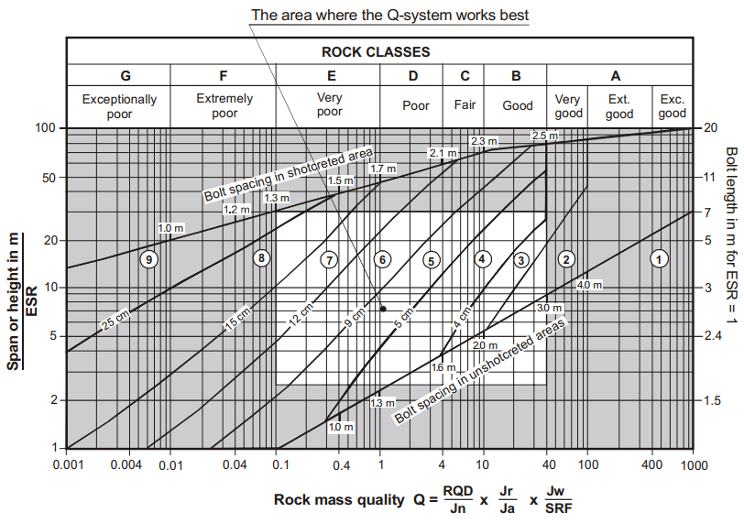
Figure 2. Application of Q-system for rock support. Outside this area, supplementary methods/evaluations/calculations should be applied (reproduced from Palmstrom and Broch, 2006)
Rock classes | I | II | III | IV | V
Q | Q > 40 | 40 ≥ Q >10 | 10 ≥ Q >4 | 4 ≥ Q >1 | 1 ≥ Q >0,1
Rock quality | Very Good | Good | Fair | Poor | Very poor
Table 2. Soil & Rock Properties.

Type | Unit Weight, (kN/m²) | Cohesion, (kPa) | Internal Friction Angle, (⁰) | Deformation Modulus, (MPa) | Poisson’s Ratio | Remarks
Grade Ⅰ | 26.6 | 9000 | 54.8 | 41000 | 0.25 | -
Grade Ⅱ | 26.5 | 7100 | 52.6 | 31300 | 0.25 | -
Grade Ⅲ | 26.4 | 5100 | 49.4 | 16100 | 0.25 | -
Grade Ⅳ | 26.1 | 3700 | 44.5 | 8300 | 0.25 | -
Grade V | 25.6 | 2500 | 40.6 | 4400 | 0.26 | -

Parameters of shotcrete and pattern of rock bolts for cavern are presented in Table 3. The physical properties of reinforcement materials are presented in Table 4. The applied allowable stress of shotcrete and rock bolt is shown in Table 5 and Table 6.

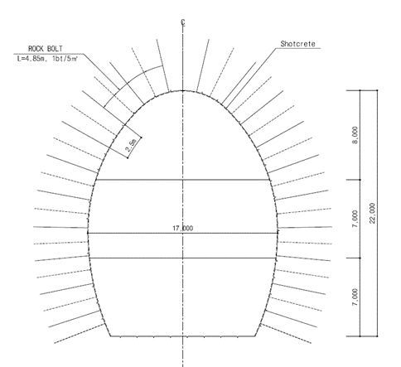
2. Numerical Simulation of the Cai Mep LPG Cavern Project
Figure 3. The shape and size of the caverns (Hyosung VINA Chemicals Co., Ltd, 2019).
The excavation of the cavern cross-section is divided into three parts stages. The top portion of the cavern tunnel is known as the heading and the two bottom portions are as a bench. The first excavation stage of the cavern is the heading with an excavated height of 8.0 m, followed by the excavation of the first part of the bench with a height of 7.0 m, and the last excavation stage at the bottom is 7.0 m in height as seen in Figure 4.
Table 3. Support Pattern of caverns.

Division | Support Pattern |  | I (>40) | II (40~10) | II (10~4) | IV (4~1) | V (1~0.1)
Cavern (17x22) m | Shotcrete [cm] | Thickness | 5.0 (S) | 5.0 (Sfr) | 6.0 (Sfr) | 12.0 (Sfr) | 20.0 (Sfr)
Cavern (17x22) m | Rock bolting | Spacing | Spot bolting | 1bt/5.0 m² | 1bt/4.0 m² | 1bt/2.0 m² | 1bt/1.0 m²
Cavern (17x22) m | Rock bolting | Length | 4.85 m
Table 4. Physical Properties of Reinforcement Materials.

Division |  | Modulus of elasticity (MPa) | Internal Friction Angle (degress) | Cohesion (MPa) | Unit Weight (kN/m²) | Poisson’s Ratio
Shotcrete | Soft | 5000 | -- | - | 24.0 | 0.2
Shotcrete | Hard | 18000 | - | - | 24.0 | 0.2
Rockbolt |  | 350000 | - | - | 18.3 | 0.3
Table 5. Applied Allowable Stress of shotcrete.

Division | Criteria | Characteristic Strength (MPa) | Allowable Stress (MPa)
Allowable Compressive Stress | $$0.4f_{ck}$$ | $$f_{ck}=26$$ | $$10.40$$
Allowable Tensile Stress | $$0.13\sqrt{f_{ck}}$$ | $$f_{ck}=26$$ | $$0.66$$
Flexural Bending Strength | $$f_{bk}$$ | - | $$4.50$$
Table 6. Applied Allowable Stress of Rock bolt.

Division | Specification | Ultimate Strength, (MPa) | Area, (m²⁾ | Allowable Axial Force, (kN/EA)
Allowable Axial Force | GRFP | $$1,000$$ | $$0.000491$$ | $$165.00$$

a) b) c)
Figure 4. Phases of caverns excavation.
a) Excavation heading; b) Excavation the bench 1; c) Excavation the bench 2.

For evaluation and conclusion of the load-bearing capacity of construction structures, the numerical analysis method is applied to the analysis. The numerical analysis method has been introduced to geotechnical engineering and has contributed to the analysis of creep features, plastic (yielding) conditions, and non-linearity of stress-strain relations of the ground (Gu, S., 2018; Yu, Y. and Xuebao, G., 2008; Yu, Y. and Xuebao, G., 2012; Ren, Q., 2019). Evaluating the maximum displacement of rock mass around tunnels and load-bearing capacity of construction structures performed based on FEM by Rocscience -RS2- Phase2 software (Rocscience Inc, 1998-2001). This software allowed to analyze the sequence of tunnel face excavation and install the rock support. The software is also given maximum stress and strength of rock support. At the time of modeling, the analysis area is considered to be 8.0 of the tunnel diameter in the horizontal and downward direction, such that the influence of the artificial constraint conditions at the boundary on the result of the analysis should be within the allowable range in terms of engineering.
The stratum boundary is considered when creating the mesh. Then the surrounding of the excavation face where the stress changes are subdivided due to excavation to acquire more precise analysis results. For the tunnel support, frame element for shotcrete, and truss element for rock bolt are applied. For shotcrete, to compensate the modulus of elasticity according to change of time, the cross-section, the elastic modulus, and the geometrical moment of inertia, with the physical properties at different time points shotcrete work is inputted. In this study, analysis model is used the elastoplastic model of Mohr-Coulomb. Since excavation of a tunnel generates the transverse arch effect on the ground and the longitudinal arch effect on the tunnel face, it is not possible to strictly apply 2-dimensional plane strain conditions. Considering the longitudinal arch effect and the shotcrete curing time under the plane strain conditions, the total load caused by excavation is distributed to each stage of excavation, soft shotcrete and hard shotcrete, which is called the load distribution ratio (Chang S. B., 1998):
Load Distribution Ratio at Excavation:
α (%) =3.34*L+3.778*E
Load Distribution Ratio of Soft Shotcrete:
β (%) =100-(α+γ)
Load Distribution Ratio of Hard Shotcrete:
γ (%) =-3.126*L+3.391*D
Where L- advance, D- equivalent diameter, E- modulus of elasticity of rock mass;
Boundary condition: the left, right and bottom boundary of the model is fixed (vertical and horizontal movement is equal to zero). The boundary at the surface of the model is free, allowing vertical and horizontal displacement as shown in Figure 5b.
The stratigraphic pressure acts on the surface of the model equal to the weight of the upper soil layers of bedrock:
P=H_{d}×P_{d}=54.6×18.0 =0.9828MN/m,
Where H_{d} - thickness above soil layers (m); P_{d}=18kN/m² - earth pressure acting on 1 m^{2.}
The sequence of tunnel face excavation and installation of the rock support of caverns is presented in Table 7.

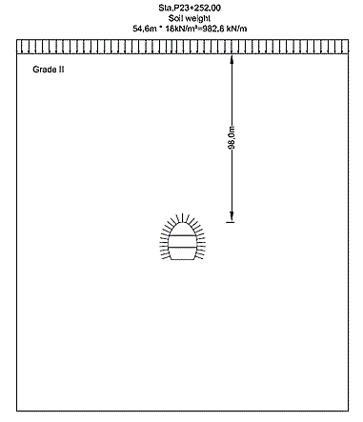
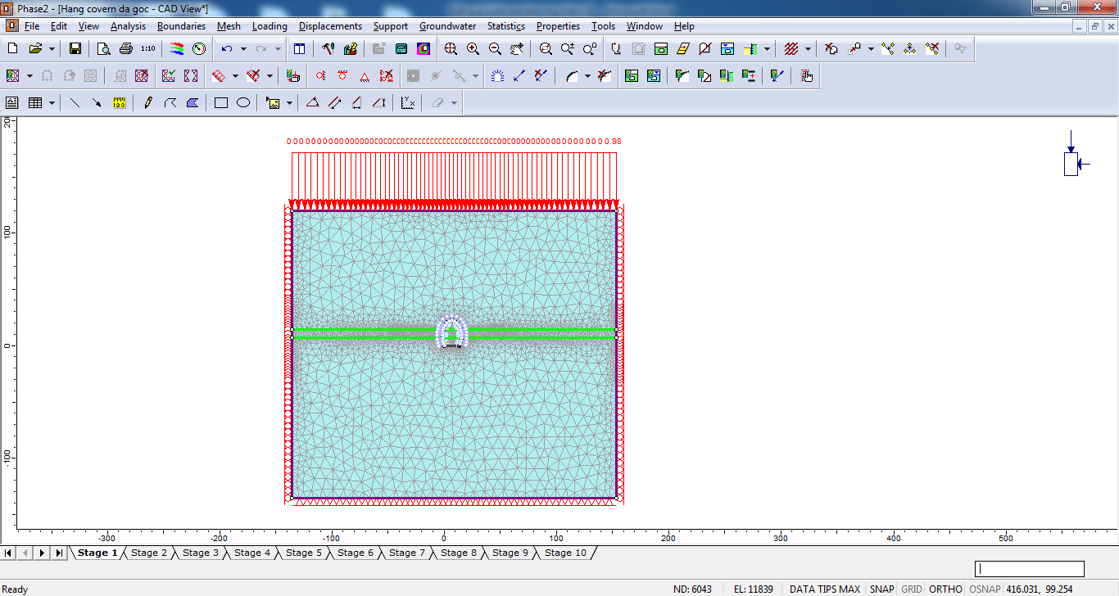
Table 7. Analysis Sequence.
Figure 5. Dimension, mesh, and boundary condition of the model.
(a) Dimension of the model, m; (b) Mesh and boundary condition of the model

Phase | Description
Step 1 | Initial Stress
Step 2 | Initialize displacement of heading
Step 3 | Installed supports (Rock bolt & Shotcrete) of heading
Step 3 | Hardened shotcrete
Step 4 | Initialize displacement of bench 1
Step 5 | Installed supports (Rock bolt & Shotcrete) of bench 1
Step 5 | Hardened shotcrete of bench 1
Step 6 | Initialize displacement of bench 2
Step 7 | Installed supports (Rock bolt & Shotcrete) of bench 2
Step 7 | Hardened shotcrete of bench 2

3. Evaluates the stability of the cavern in the Cai Mep project
The step of analysis sequence numerical simulations is described in Figures 6, 7, 8. Table 8 and Table 9 are presented the maximum displacement values of rock mass around tunnels and the load-bearing capacity of construction structures. The displacement value of rock mass around the tunnel is presented in Figure 9. The result of shotcrete bending stress and rock bolt axial force obtained by FEM is presented in Figure 10.

4. Conclusions
In this study, a numerical analysis using finite element software has been conducted to investigate the stability of rock mass surrounds the underground cavern. Some interesting conclusions arising from numerical simulations are given:
- Based on the technical design with the temporary rock support of bolt pattern and shotcrete liner, the output conditions of the design model, the stability of surrounding rock of underground has been conducted by Rocscience-RS2-Phase2.
- The maximum displacement of rock mass around caverns is performed based on rock property in the site investigation report. It is smaller than allowable values. However, it is required to check the displacement by observing during tunnels excavation time.
- Maximum compression stress and tensile stress in shotcrete, the maximum axial force of rock bolt in tunnel obtained by Rocscience -RS2- Phase2 software is also than allowable values. So, rock support of tunnels is stable. However, it is required to check the above stress values by observing during tunnels excavation time.

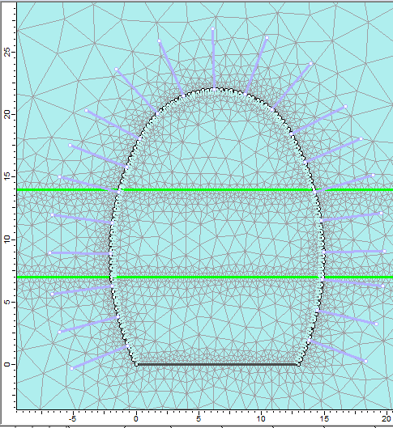 | 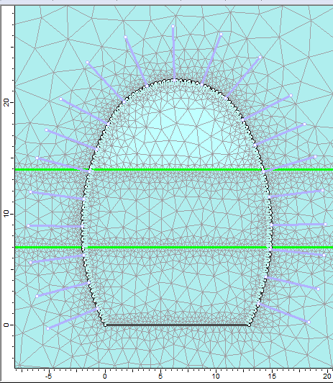 |  | 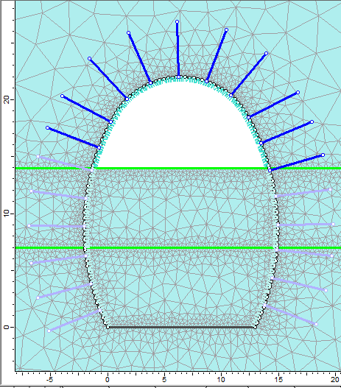
a) Initial Stress (Step 1). | b) Initialize displacement of heading (Step 2). |  | c) Install supports (Rock bolt & Shotcrete) of heading (Step 3).
Figure 6. Phases of excavation the heading.
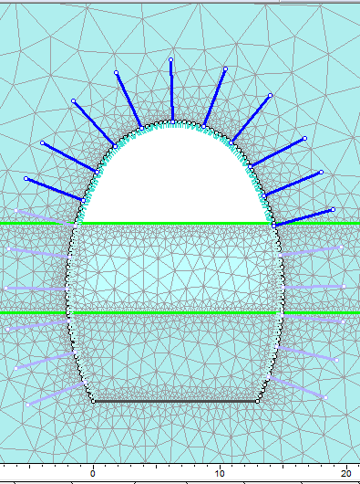 |  | 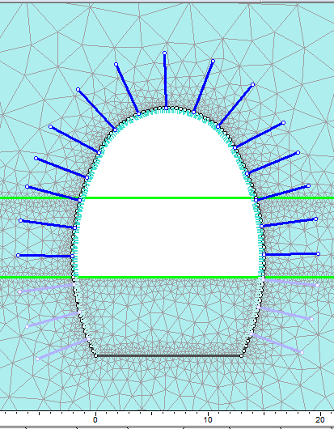
a) Step 4. |  | b) Step 5.
Figure 7. Phases of bench 1.
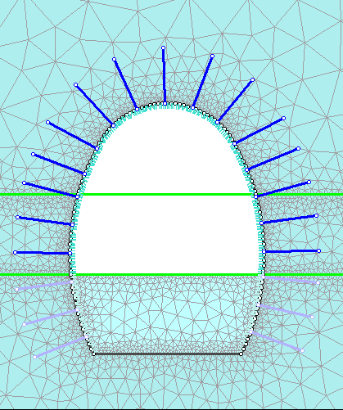 |  | 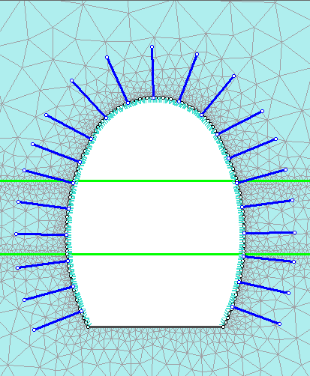
a) Step 6 |  | b) Step 7
Figure 8. Phases of bench 2.

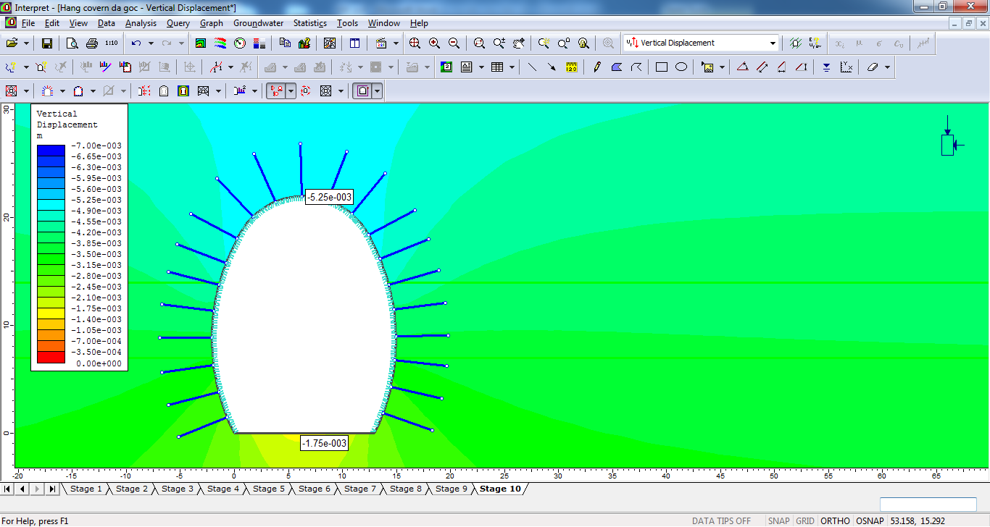 | 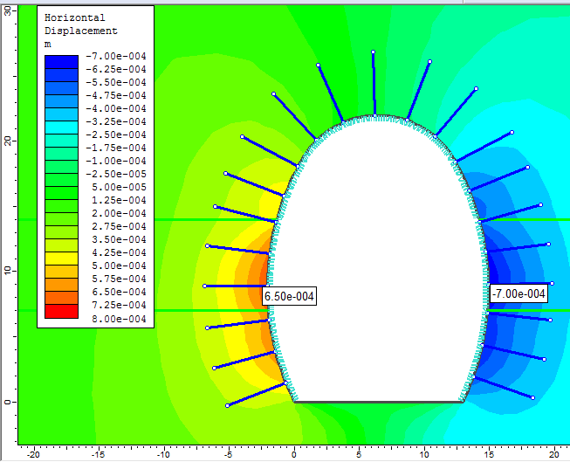
a) Vertical displacement . | b) Horisontal displacement .
Figure 9. The displacement value of rock mass around tunnel.
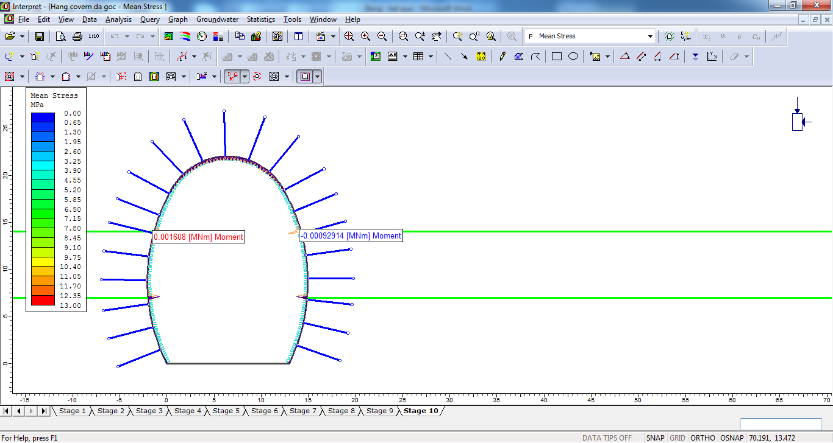 | 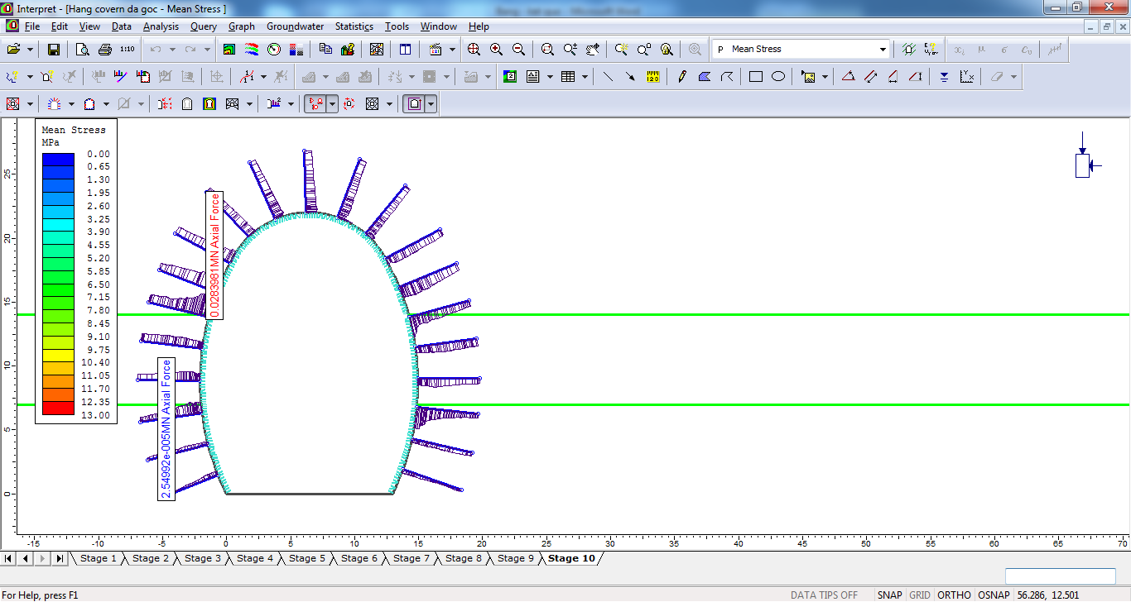
a) Moment bending in shotcrete. | b) Rock bolt axial force.
Figure 10. Result of moment bending in shotcrete and Rock bolt axial force obtained by FEM.
Table 8. The value of maximum displacement of rock mass around tunnels.

Caverns | Displacement of rock mass around tunnels |  | Remark
Caverns | Horisontal displacement (mm) | Vertical displacement (mm) | Remark
Caverns | 0.7 | 5.25 | OK
Table 9. Stress/Force of rock support.

Caverns | Shotcrete |  | Max.Rockbolt Axial Force (kN) | Remark
Caverns | Max. Compressive Stress (MPa) | Max. Tensile Stress (MPa) | Max.Rockbolt Axial Force (kN) | Remark
Caverns | 3.84 [10.40]* | 2.23[4.50]* | 28.3[165]* | 0K
* Allowable Value

- The above results are only considered during the construction phase, to calculate and analyze the stability of rock support in the tunnel using time, it is necessary to have more output data such as the largest and smallest air pressure on tunnel lining; the temperature of the gas in the vault during operating, etc. It allows the calculation of tunnels and caverns according to different load combinations to ensure the highest safety of underground above construction systems.

Author Contributions
Kien Van Dang: collecting documents and writing the manuscript, Running numerical models; Anh Ngoc Do: collecting documents, checking manuscripts, checking the result of numerical models; Thai Ngoc Do: Running numerical models.

References
Chang S. B., Moon H. K., (1998). A Study on the Quantitative Evaluation of the Load Distribution Factors Considering the Design Conditions of Tunnel Especially for the Ring-cut Excavation Method. Geotechnical Engineering Vol.14 No.5, pages 5-15, Korean Geotechnical Society.
Gu, S., Zhou, P., Sun, W., Hu, C., Li, C., Wang, C., (2018). Study on the Stability of Surrounding Rock of Underground Circular Cavern Based on the Anchor Reinforcement Effect. Advances in Civil Engineering. Volume 2018, Article ID 4185070, 18 pages. https://doi.org/10.1155/2018/4185070.
Hoek, E., Diederichs, M.S. (2006). Empirical estimation of rock mass modulus. International Journal of Rock Mechanics and Mining Sciences, 43: 203-215.
Hyosung VINA Chemicals Co.,Ltd., (2019). Report on technical design of underground storage Cai Mep-LPG-CV-GR-U-0002. Vung Tau.
Palmstrom A., Broch E., (2006). Use and misuse of Rock mass classification systems with particular reference to the Q-system. Tunnels and Underground Space Technology, 575-593.
Ren, Q., Xu, L., Zhu, A., Shan, M., Zhang, L., Gu, J., Shen, L., (2019) Comprehensive safety evaluation method of surrounding rock during underground cavern construction, Underground Space, 6(1): 46-61. https://doi.org/10.1016/j.undsp.2019.10.003Rocscience Inc., User’s Guide, 1998-2001, 2D finite element program for stresses and estimating support around underground excavations. Rocscience Inc.
Yu, Y. and Xuebao, G., (2008). Stability study of large underground caverns under high geostress September. Chinese Journal of Rock Mechanics and Engineering 27:3768-3777.
Yu, Y. and Xuebao, G., (2012). Study of stability and supporting measures of chamber arch crown for large span underground caverns. September. Chinese Journal of Rock Mechanics and Engineering 31:3643-3649.
Vo, T. H., Phung, M. D., (2005). Rock mechanics applying in the underground construction and mining. Publishing House for Science and Engineering, Hanoi, Viet Nam. 460 pages.

