

An experimental study on the use of fly ash for making concrete lagging of SVP steel arches in underground coal mines in Quang Ninh area
Kien Van Dang^{1,*}, Hung Trong Vo¹, Hao Doan Ngo¹, Huy Xuan Tran²
¹ Faculty of Civil Engineering, Hanoi University of Mining and Geology, Vietnam
² Oil, Gas, Coal department, Viet Nam Ministry of Industry and Trade, Vietnam

ARTICLE INFO |  | ABSTRACT
Article history:  Received 08th Aug. 2021  Accepted 28th Nov. 2021  Available online 31st July 2022 |  | In 2020, Vietnam has 25 thermal power plants in operation, emitting a total amount of fly ash and coal bottom ash of about 13 million tons/year. It makes increasing the costs of landfill space, and negatively affect the environment. The main objective of this research is to propose an optimized proportion of the ﬂy ash of thermal power plants used in concrete mixture on making concrete lagging in SVP steel arches of the underground mine in Quang Ninh coal area. In this study, fly ash is used 30% replacement of cement in fresh concrete in making concrete lagging of underground mining to reduce the cost of drift supporting and to increase the effectiveness of the environment protection. This study also shows the new trend study in using new materials to make rock/soil support in the underground mines in VietNam. Fly ash utilization in concrete as a partial replacement for cement is gaining importance day by day. The comparison of strength properties of concrete laggings by experimental study at the Laboratory of underground construction between two concrete lagging types at Hanoi University of Mining and Geology (HUMG) will be shown the benefits in terms of the strength of concrete lagging using fly ash. The paper also presents the results of an experimental study on using fly ash for making concrete lagging at the Laboratory. The result of the drift support passport comparison using concrete laggings in SVP steel arches made by fly ash and conventional support of underground mining will be shown the advantages of using fly ash. From the result of this study, it can be concluded that cement replacement by fly ash is useful in lower grades of concrete such as M200.  Copyright © 2022 Hanoi University of Mining and Geology. All rights reserved.
Keywords:
Concrete lagging,
Experimental study,
Fly ash,
Mine drift,
SVP steel arches.

_____________________
*Corresponding author
E - mail: dangvankien@humg.edu.vn
DOI: 10.46326/JMES.2022.63(3a).02

1. Introduction
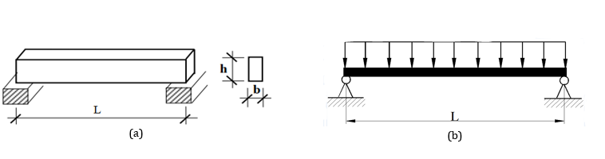
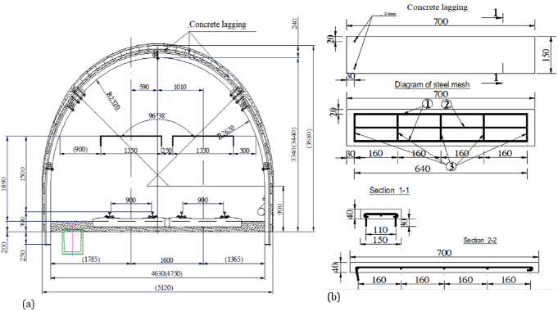
In Viet Nam, Fly Ash was used as roller compacted concrete for Son La hydroelectricity, rural road concrete, and unburnt bricks (Nguyen, Q. C.,, 2011). However, they still have not been used in the rock/soil support of underground coal mines. Now, in underground mining of Viet Nam national coal - mineral industries holding corporation limited (Vinacomin) concrete lagging with steel arches (SVP steel arches, I arches, U - shaped steel arches, etc.) are the biggest proportion of the type of current structural support (about 70÷80%). Concrete lagging is one part of rock/soil support of SVP steel arches in underground mines (Dang et al., 2019). They are responsible for closing the gap between the SVP steel arches in
drift and the dug evenly distributing the pressure of rock and soil on SVP steel arches, preventing roof landslides and sidewalls. Selecting concrete lagging with a dimension of section: b.h = 150 × 50 (mm) with the length equal to the distance of SVP steel arches: L = 0.7 m; L = 0.9 m; L = 1.0 m depending on the characteristic of mine pressure where the drift thought rock mass (Dang, V. K.,2019) (Dang, V. K., 2020). The calculation of the dimension of the cross-section of the concrete lagging is made by treating the as a beam on two supports in which the distance between two supports equals the distance of SVP steel arches. The SVP steel arches are located in the middle of the roof, subject to the uniformly distributed load of arches destroyed (see Figure 1) (Pham, T. A., 2020). The typical structure of the concrete lagging is shown in Figure 2.
Figure 1. The calculation diagram of the concrete lagging in SVP steel arches.
(a)The calculation model of concrete lagging in SVP steel arches; (b) Load diagram.

Figure 2. Structure of concrete lagging with length L = 0.7 m in Ha Lam coal mine, Quang Ninh.
(a) The concrete lagging in SVP steel arches at a drift; (b) The structure of concrete lagging.

2. Methodology

2.1. Material
The test was carried out in the Construction Laboratory of Ha Noi University of Mining and Geology (HUMG) by Advantest 9 (Control- Italy) system (see Figure 3). Materials used in experiments are as under:
Cement: Ordinary Portland cement (PCB 40 Nghi Son) was used having specific gravity: 3.10, 31.5% Consistency, and compressive strength of 40 MPa.
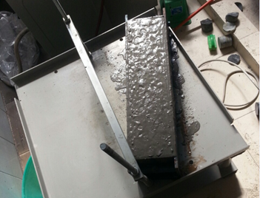
Fly ash: From the combustion of pulverized coal and transported by the flue gases of boilers by pulverized coal, Fly Ash is produced. It was obtained from Pha Lai, Quang Ninh, Vietnam thermal power station, dried, and subsequently used.
Figure 3. Specimen prepared for flexural strength value tests.
Fine Aggregate: Natural sand with a maximum size of 4.75 mm was used with a specific gravity of 2.55 and fineness modulus of 2.61 (by standard TCVN 7572-2006).
Coarse Aggregate: Natural aggregates with a maximum size of 20 mm at Hoa Thach - Quoc Oai - Ha Noi rock mine were used with a specific gravity of 2.68 and fine modulus of 7.5;
Water: Drinking water from HUMG was used for the preparation of concrete. The quality was uniform and the water samples were potable.
The concrete mix was designed for M200 grade and the mix design was done (TCVN 10302:2014): Activity admixture - Fly ash for concrete, mortar, and cement (IS 3812-2003).

2.2. Mix Design
The preferred characteristic strength of 30 N/mm² at 28 days was used in this study.
The concrete mix was designed for M200 grade and the mix design was done as per TCVN 10302:2014. A total of 45 cubes and 30 beams were prepared for this study in 5 sets. All sets were prepared in a control mix of the water-cement ratio of 0.42. Three samples from each set of the mix were tested at the age of 7, 14, and 28 days for compressive strength and 7 and 28 days for flexural strength (Tipraj, B., 2019; Rajamane, N. P., 2001; Dwivedi, A.,, 2014; Tiwari, M. K., 2016; Patil, J. V., 2017, Thomas, M., 2007, Senapati, M. R., 2011).
Preparation of Specimen: All concrete mixes were prepared using a motorized mixer of mix design proportion, 1:1.27:2.83 with a constant water-cement ratio of 0.42 (TCVN 3118: 1993). Cube specimens are prepared of size 150x150x150 mm and beam specimens of 100x100x500 mm (see Figures 3 and 4). The specimens were cured in a curing room at 30ºC temperature and 90% relative humidity. Fly Ash mix concretes were tested at 28 days of age to get compressive strength for 28 days for flexural strength values. Details of specimens prepared for the test are described in Table 2.

Test results of compressive strength and Flexural strength are described in Table 3 and Table 4. The results in Figure 6 show that the workability of concrete decreases with the increase in fly ash, the particles of fly ash reduce the amount of water required to produce a given slump. The circular shape of the fly ash particles and their dispersive ability provide water-reducing characteristics. The compressive strength test of concrete mix with different percentages of fly ash is shown in Figure 7. The result in Figures 7 and 8 also shows that the compressive strength and flexural strength increases with the increase of fly ash in concrete up to 30% replacement with cement in the conventional mix, however, the percentage increase of compressive strength more than compared to the percentage increase of flexural strength about 2,8% at 30% replacement with cement (see Figure 9). Mixing of fly ash in the concrete conventional mix has resulted in considerable variation in the properties of fresh

Table 1. Compare mixtures of M200 concrete in making concrete lagging of SVP steel arches in underground mines between two methods.
Materials | Conventional concrete mix | Concrete mix using fly ash to make concrete lagging
Cement PCB 40 (kg) | 312.0 | 193.83
Coarse aggregate (kg) | 1251.0 | 1216.0
Fine aggregate (kg) | 540.0 | 568.7
Water (liter) | 195.0 | 195.0
Fly ash (kg) | 0.0 | 83.07
Plasticizer additives (kg) | 0.0 | 3.87
Total: Cement + Coarse aggregate + Fine aggregate + Fly ash; (kg) | 2298.0 | 2260.47
Saving in cement 312-193.83 = 118.17 kg/m³ and the weight is lighter 37.3 kg/m³;
Table 2. Details of specimens prepared for the test at the construction laboratory of HUMG.
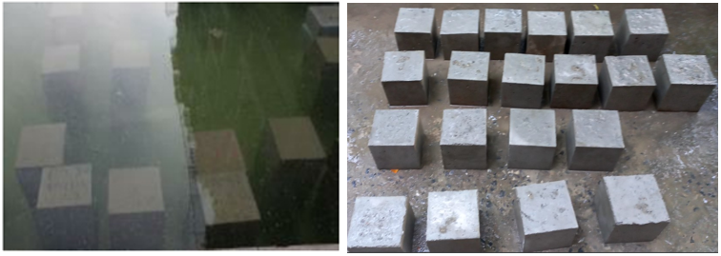
Figure 4. Curing of concrete cube.
No | Details of Cube Specimen |  |  | Details of Beam Specimen |  |  | Slump Value (%)
No | Name of Cube Sample | Fly Ash (%) | Weight of Fly Ash in Mix (gam) | Name of Beam Sample | Fly Ash (%) | Weight of Fly Ash in Mix (gam) | Slump Value (%)
1 | C 0 | 0 | 0 | B 0 | 0 | 0 | 40
2 | C 10 | 10 | 156 | B 10 | 10 | 235 | 38
3 | C 20 | 20 | 312 | B 20 | 20 | 470 | 35
4 | C 30 | 30 | 468 | B 30 | 30 | 705 | 32
5 | C 40 | 40 | 624 | B 40 | 40 | 940 | 30
Table 3. Test results of compressive strength.

Nº | Cube Sample Name | Fly Ash (%) | 28 Days Strength, N/mm² (Average of three samples)
1 | B 0 | 0 | 40.15
2 | B 10 | 10 | 39.60
3 | B 20 | 20 | 41.15
4 | B 30 | 30 | 43.19
5 | B 40 | 40 | 40.28
Table 4. Test results of flexural strength.

N⁰ | Beam Sample Name | Fly Ash (%) | 28 days Strength, N/mm² (Average of three samples)
1 | B 0 | 0 | 6.17
2 | B 10 | 10 | 6.20
3 | B 20 | 20 | 6.33
4 | B 30 | 30 | 6.42
5 | B 40 | 40 | 6.16
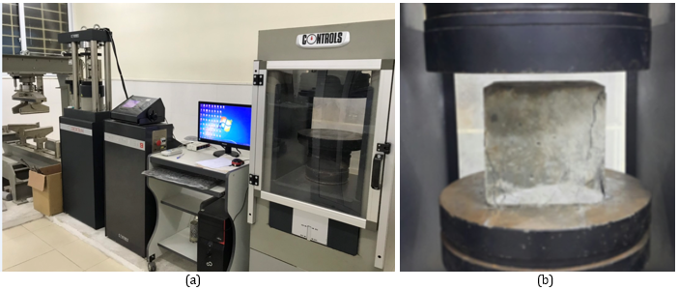
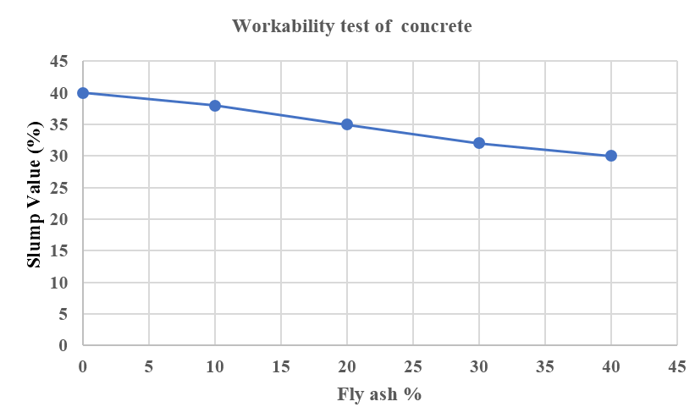
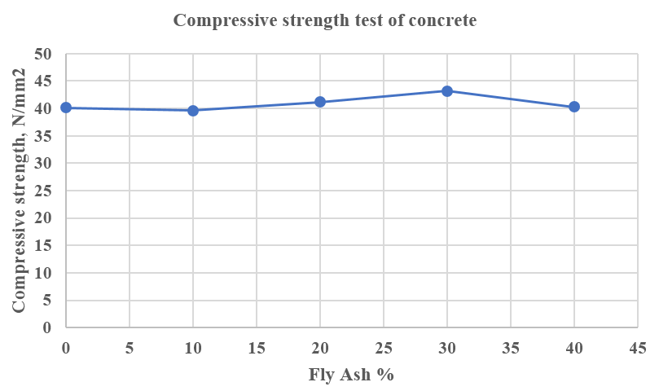
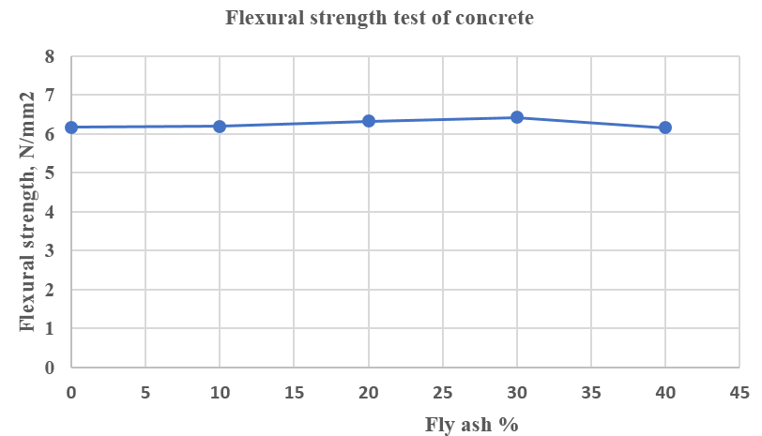
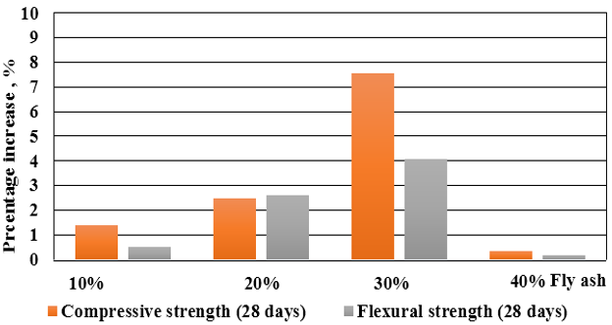
Figure 5. Compressive strength test on the cube sample by Advantest 9 (Control- Italy) system at HUMG.

Figure 6. Workability test of concrete mix with different percentages of Fly Ash.
Figure 7. Compressive strength test of concrete mix with different percentages of Fly Ash.
Figure 8. Flexural strength test of concrete mix with different percentages of Fly Ash.
Figure 9. 28 days percentage increase of strength with different percentages of Fly Ash.

concrete. Integration of fly ash in concrete increased the cohesiveness of the mix, prohibited segregation, and resulted in reduced bleeding. Higher percentages of fly ash can cause a change in the color of the mix. The incorporation of fly ash in concrete can save the coal and thermal industry disposal costs and produce green concrete for underground construction. The result in Figure 8 and Figure 9 shows that the compressive strength of the concrete cubes had been tested at the interval of 28 days. It seems that the strength goes on the increase with the increase in fly ash but after the replacement of 30% Fly Ash with cement the strength decrease. The flexural strength of concrete is tested at the interval of 28 days and it seems that flexural strength goes on increase up to 30% replacement. The strength variation is more compressive as compared to flexural strength

3. Experimental study on concrete lagging
According to the above research results, the determine the aggregate content for 1m³ of concrete M200 used for manufacturing concrete lagging (see Table 1). When calculating mortar concrete mix for M200 concrete lagging using fly ash instead of a part of cement in concrete gradation the research team has compared the results of two alternatives. Thus, from the total weight between the two methods of concrete mix, we can realize that the use of fly ash to replace a part of cement will be saved in cement 312-193.83 = 118.17 kg/m³ and 37.3 kg lighter than normal concrete grade (see on Table 1). In this section, a concrete lagging plate is carried out an experimental study of the load capacity, and expansion cracks, etc. by Advantest 9 (Control- Italy) in construction labor (HUMG). Control concrete lagging is marked in dimension b x h = 150 x 50 mm. The fly ash concrete lagging is made in dimension b x h = 150x40 mm (see Table 5).
The result of finished fly ash concrete lagging is lighter than the control concrete lagging about 2 kg in the same M200 (see Figures 10 to 12). It makes sense to transport a large amount of concrete lagging into great depth in underground mines in Quang Ninh. The expansion cracks of concrete lagging versus maximum load are present in Figure 13, Figure 14, and Figure 15. The expansion cracks of fly ash concrete lagging are higher than that of regular concrete lagging with the same M200 grade in 5÷7 days. The crack expansion of fly ash concrete increased in the range of 5÷7 days but decreased from 7÷28 days. After 14 days, the expansion cracks in the fly ash concrete lagging decreased compared to the control concrete lagging while this value of concrete lagging increased as a rule. The result of displacement of concrete lagging versus time is present in Figure 16.
The displacement of fly ash concrete lagging is higher than that of regular concrete lagging with the same M200 in 5÷7 days. The displacement of fly ash concrete is lightly increased in the range of 5÷7 days but decreased from 7÷28 days. After 14 days, the displacement in the fly ash concrete lagging decreased strongly compared to the control concrete lagging while this value of concrete lagging increased as a rule.

Table 5. Summing of main material for a concrete lagging with L= 0.7 m, bxh = 150x40 mm.
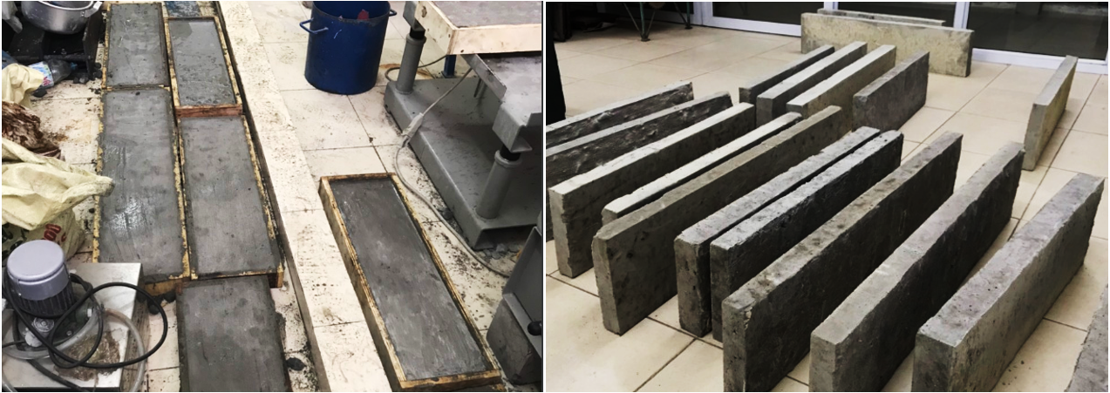
Figure 10. Concrete lagging.
No | Details of Cube Specimen |  |  | Details of Beam Specimen |  |  | Slump Value (%)
No | Name of Cube Sample | Fly Ash (%) | Weight of Fly Ash in Mix (gam) | Name of Beam Sample | Fly Ash (%) | Weight of Fly Ash in Mix (gam) | Slump Value (%)
1 | C 0 | 0 | 0 | B 0 | 0 | 0 | 40
2 | C 20 | 20 | 312 | B 20 | 20 | 470 | 35
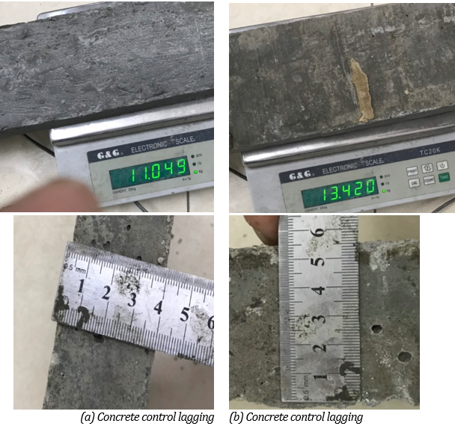
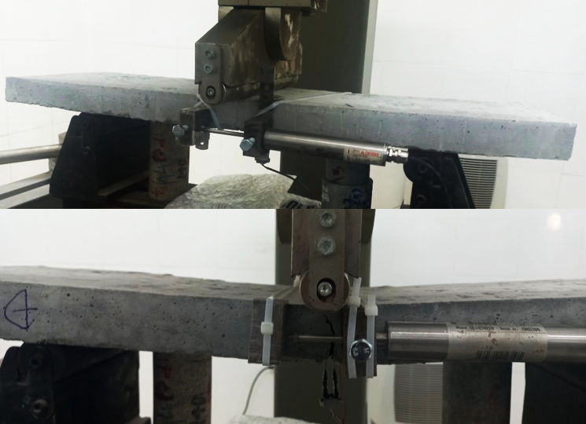
Figure 11. Dimension of concrete lagging.
Figure 12.Test concrete lagging.
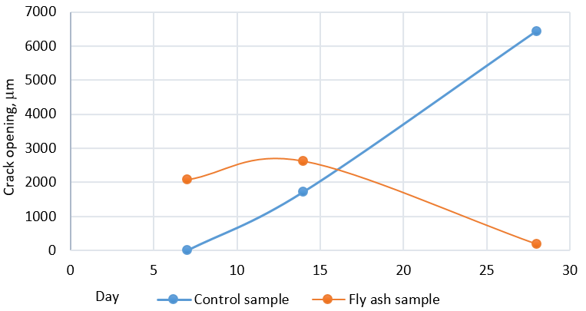
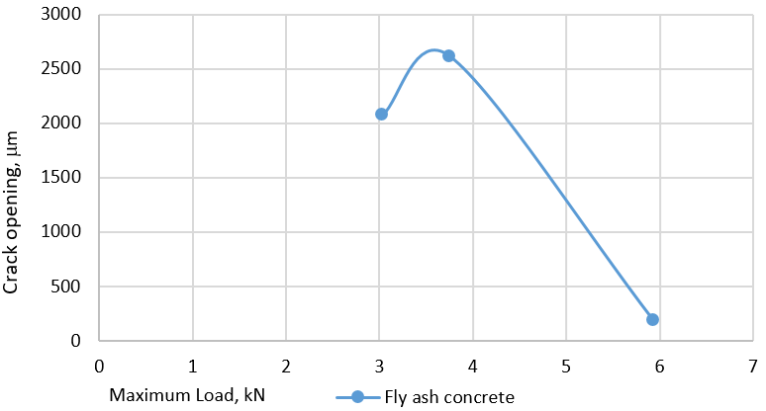
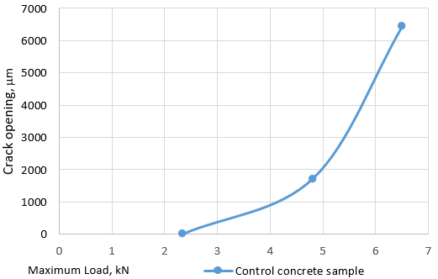
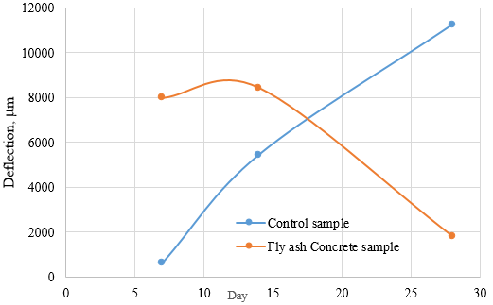
Figure 13. Expansion cracks of concrete lagging versus time.
Figure 14. The expansion cracks of concrete lagging versus maximum load in control samples.
Figure 15. The expansion cracks of concrete lagging versus maximum load in Fly ash concrete.
Figure 16. Displacement of concrete lagging versus time.

The above results can be explained by the fact that fly ash concrete has a lower cement content, so the early workability is worse than that of normal concrete of the same strength. It also makes to the extent that the expansion cracks are higher and the deformation capacity is greater. It is quite consistent with the characteristic of increasing the load of stability drifts located at great depth in Quang Ninh

4. Conclusions
In this study, an experimental study on concrete lagging at Construction Laboratory (HUMG) is carried out. Some interesting conclusions arising from the experimental study are given in the following points:
- The compressive strength and flexural strength increase with the increase of fly ash in concrete up to 30% replacement with cement unconventional mix.
- We can realize that the use of fly ash to replace a part of cement will be 37.78 kg lighter than normal concrete grade and save 118.17 kg of cement in 1 m³ of concrete for making concrete lagging of SVP steel arches in underground mines.
- The concrete lagging is lighter than the control concrete lagging in the same grade. It really makes sense to transport a large amount of concrete lagging into great depth in underground mines in Quang Ninh.
- The expansion cracks and displacement of fly ash concrete lagging are higher than that of regular concrete lagging with the same M200 grade during 7÷14 first days but it is decreased from 7÷28 days. The above results can be explained by the fact that fly ash concrete has a lower cement content, so the early workability is worse than that of normal concrete of the same strength.
- The research can be conducted further on higher grades of concrete or integration of such waste material by which more impact can be created improvement of strength.

Acknowledgments
The authors would like to thank the Construction Laboratory of Hanoi University of Mining and Geology (HUMG) for the provision of laboratory space.

Author Contributions
Kien Van Dang: collecting documents and writing the manuscript, experimental study; Hung Trong Vo: collecting documents, editing manuscript; Hao Doan Ngo: collecting documents; Huy Xuan Tran: collecting documents and writing the manuscript.

References
Dang, V. K.,, Vo, T. H., Do. N. A., Pham, T. A., (2019). Research and manufacture reinforced concrete furnace insert plates from ash slag of thermal power plants in underground mines in Vietnam. National Mining Science and Technical Conference. Industry and Trade Publishing House. ISBN: 978-604-931-849-8 (in Vietnamese).
Dang, V. K., Truong V. H. and Pham T. A., (2020). Experimental study on use fly ash in underground construction concrete. Journal of Mining and Earth Sciences 60 (3). 60 - 67.
Dwivedi, A., and Jain, M. K., (2014). Fly ash - waste management and overview: A Review. Recent Res. Sci. Technol vol. 6. 30-35.
IS 3812-2003. Pulverized Fuel Ash specification. part 1 for use as pozzolana in cement. cement mortar and concrete.
Nguyen, Q. C., (2011). Fly ash: the origin of use and the environment. Journal of Transport. No. 7-2011 (in Vietnamese).
Patil, J. V., (2017). Partial Replacement of Cement by Fly ash in Concrete Mix Design. International Research Journal of Engineering and Technology (IRJET) e-ISSN: 2395-0056. Vol. 04 Issue 11.
Pham, T. A., Dang, V. K., (2020). Research and manufacture reinforced concrete insert plates from ash slag of thermal power plants. Report of TKV – level research project (in Vietnamese).
Rajamane, N. P., Neelamegam, M., Peter, J. A. and Dattatreya, J. K., (2001). Effect of partial replacement of cement with fly ash on the strength and durability of HPC. Gopalakrishna. S. The Indian Concrete Journal. 335-341.
Senapati, M. R., (2011). Fly ash from thermal power plants-waste management an overview Curr. Sci. 100 1791-1794.
TCVN 10302:2014. Activity admixture - Fly ash for concrete, mortar and cement (in Vietnamese).
TCVN 3118: 1993. Heavyweight concrete - Method for determination of compressive strength (in Vietnamese).
Thomas, M., (2007). Optimizing the Use of Fly Ash in Concrete Microstructural approach in damage. The 2nd international conference on dynamics and control. Norfolk. Japan. 377-387.
Tiwari, M. K., (2016). Fly Ash Utilization A Brief Review in Indian Context Fly Ash Utilization : A Brief Review in Indian Context. Journal of Engineering Technology. 949-956.
Tipraj, B., (2019). Strength characteristics of Concrete with Partial Replacement of Cement by Fly Ash and Activated Fly Ash. International Journal of Recent Technology and Engineering (IJRTE) ISSN: 2277-3878. Vol. 8 Issue 4.

