Development of a data acquisition system for Geography accident warning, Environment monitoring and Agroforestry decision-making assistant purpose
Thanh Loan Pham ^{1, *}, Quang Duy Do Nguyen²
¹ Hanoi University of Mining and Geology (HUMG), Vietnam, thanhloanbkhn@gmail.com;
² Hanoi University of Industry, Vietnam, Duycommand@gmail.com

ARTICLE INFO |  | ABSTRACT
Process:  Received 15/02/2021  Accepted 16/3/2021  Published 29/6/2021 |  | Data on rainfall, soil moisture, temperature, and humidity play an important role in Agro-forestry activities, transportation, and residents’ life in the North Mountain area of Vietnam. The data can be used to study about landslide disaster, climate change, weather monitoring, decision-making assistant and to give risk warnings. In this paper, a low-cost IoT data acquisition system developing for those purposes is depicted. The acquisition system includes sensor stations (SSs) and central station (CS). In which, the SSs were designed to collect data from specific sensors (rain fall, soil moisture, temperature, and humidity). The CS is used to gather data from the SSs through designed Lora WAN communication system. The CS then sends gathered data to a cloud server for monitoring, warning, and decision assistant system by a 3G module. Hardware and software with the suitable solutions for the purpose area are represented. System experiments and tests were implemented in Ban Lang Ward (in the Northwest of Vietnam) to check design targets. Results have proved the measuring and data transmitting abilities of the system.  © 2021 Hanoi University of Mining and Geology.
Key words:
Data acquisition; Geography accident; Environment monitoring; IoT; Lora WAN

1. Introduction
In recent years, climate change, due to natural and human-induced factors, has caused many harms to residents' lives [1] [2]. Climate change causes geological disasters such as landslides; flood; drought; saltwater intrusion... These disasters have many negative impacts on the life of the community. They affect traffic activities, agroforestry activities, destroy private houses, public buildings, and lives of residents. In the last year 2020, many very unusual and extreme natural disasters were recorded in Vietnam. There were 16 types of natural disasters; including 13 storms; 264 thunderstorms, tornadoes and heavy rains hit 49 provinces and cities. Especially, the heavy rain from October 6th to 22nd caused great damage flood and landslide in the Vietnam central region [3].
To reduce the impacts of a natural disaster on communities Early Warning System (EWS) is an effective solution. Operational EWSs aim at reducing the loss of life probability by inviting people to act properly at specific times when an intolerable level of nature hazard occurs[4]. As mentioned in [5], the EWSs can be divided into 4 main modules of components: setting module, modelling module, warning module, and response module. The setting module includes all the preliminary actions and choices required for EWSs, such as: warning areas; type of disasters; monitoring instruments; data transfer systems… In which, EWSs’ data transfer systems have been developed with many wireless communication techniques. However, invented since 2009, LoRa technique has some advances on the other techniques in monitoring system also in EWSs. LoRa is a long-range and low power consumption network. Due to the gap between cellular networks, like GSM, UMTS, and LTE (up to 100km), and short range networks, like Wi-Fi, Bluetooth and ZigBee (0-1000m), LoRa network is used in Low Power Wide Area Network (LPWAN) technologies to fill this gap and to achieve the requirements of the IoT devices and applications [6]. With various advanced techniques, design and implementation of LoRa are proposed in many applications and scenarios, such as: smart city; environmental monitoring; smart heath care; smart farming [7]... And the research to improve LoRa network architecture for other applications have been implementing. LoRa network has also been researched to implement in EWSs. In [8][9], LoRa network is proposed for flood early warning system and landslide early warning system. Though, the research concentrated on low-cost sensor and small area network aspects.
In this paper, a LoRa network architecture was proposed for a data acquisition system. The system was designed as an aim of CT2019.01 project to collect data in the Vietnam’s North Mountain region for: Forecasting and warning of risks of natural disasters; Environment monitoring; Climate changing study and Agro-forestry decision assisting. Following the aim of the project, the proposed system needs to have distance of several kilometers between sensor nodes and receiving node and effective-cost. In the next sections, the suitable solutions will be shown in sequent and the results of practical implement in field of Ban Lang Ward, Phong Tho District, Lai Chau Province of Vietnam.
2. Proposed system
  - System structure
Nowadays, EWSs use Wireless sensor network (WSN) as the most efficient solution for data acquisition system [10]. The EWSs can be classified into two main groups: Local EWSs (Lo-EWSs) or Territory EWSs (Te-EWSs). The difference between Lo-EWSs and Te-EWSs is the area supervised by their used WSN. For instance, the landslide early warning systems (LEWSs) can be defined as following. Systems addressing single landslides at slope scale are herein referred to as local LEWSs (Lo-LEWSs), and systems dealing with the possible occurrence of multiple landslides at regional scale are named territorial systems (Te-LEWSs). The Te-LEWSs provide a more general name for all the LEWSs employed over a wide area, e.g. a nation, a region, a municipal territory, a river catchment [5].
With the approach of the classification above, the desired data acquisition in our project must operate like a Te-EWS, with the distance of several kilometers between sensor node and receiving node. It means, the communication should be implemented by mobile network signal (GSM) as conventional system. The problems of using GSM communication are: The telecommunication costs reduce system cost-effective; And there are many no GSM signal places in the North Mountain area of Vietnam. To solve the problem, a proposed system structure is shown in Fig. 1.a. In the structure, each Sensor Station (SS), acts as a sensor node, is arranged in a monitoring place. A Center Station (CS) acts as a receiving node is installed in a place, where must has GSM signals, to collect data from around SSs. With the benefit of LoRa communication between stations, each CS can collect data of region up to 20km in diameter (can be extend with some type of network protocol). The collected data is sent to server by CS through GSM (GPRS/3G or 4G) signal. To archive target of the project, many monitoring regions need to be installed as show in Fig. 1
Fig. 1. Proposed system structure.
  - Stations’ hardware
With the proposed system structure, the CS and SSs are designed to meet the technical requirements of Te-EWS and cost-effective system. Therefore, communication between the SSs and CS is performed by the Lora modules. These stations have been designed and assembled with components easily found in the Vietnamese market.
The SSs are designed as sensor nodes with actual structure shown in Fig. 2. In which, Pic16F886s from Microchip are used as the central controller of the stations. The sensors in each station are soil moisture sensor, Air humidity sensor, Air temperature sensor and Rainfall sensor. There are also two ADC inputs; 04 digital inputs; 04 digital outputs; 01 PWM output, which are reserved for the future additional sensors. Communication of the SS is performed via the Lora E32 433T30D module. This 1W module allows connection range of 10km in theoretically that ensuring communication range for a Te-EWS. The stations use power from a 12V battery and a solar panel. Based on the structure above, circuit board of SS is designed and manufactured as in Fig. 2.b.

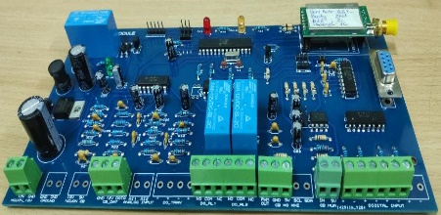
Fig. 2. Sensor station block diagram and realistic
circuit board
The CS performs the function of a base node in the WSN system mentioned above. Station structure and manufactured circuit board is depicted in Fig. 3. The central controller of CS is a Raspberry Pi board. CS communicates to SSs via Lora E32 433T30D module, while data server communication is done through GSM 3G sim module. The station is also powered by a 12V storage power source and a solar cell source.

By using designs with components from local market, manufacturing costs of CS and SS are about 300 and 200 USD in sequential order. The costs are acceptable in compare with some type of importing stations for weather or air quality monitoring.
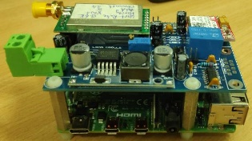
- Practical implementation and communication solution

Fig. 3. Center station block diagram and realistic circuit board
  - Field installation

With the aim to collect data in the Northern mountainous provinces, the selected site for the system testing is Ban Lang Ward, Phong Tho District, Lai Chau Province of Vietnam. The testing system includes 01 CS and 05 SSs which are arranged at marked point in Fig. 4.
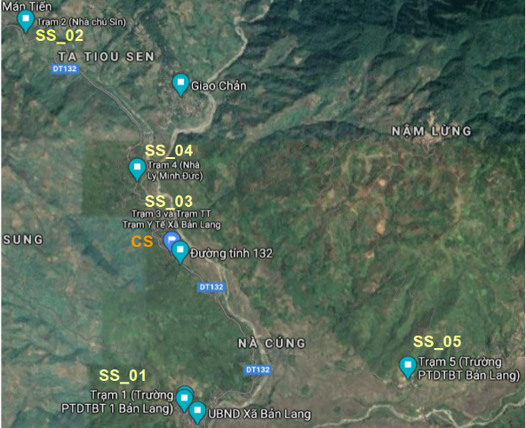

Fig. 4. Station positions in Ban Lang Ward
At first, the stations were connected according to Star Topology (Single-Hop). The CS acts as a Base Station and the SSs act as Sensor Nodes sending data to the CS. The distances between the stations are determined directly on the Google map shown in Table 1. Although the distance between the SSs to CS is within the transmission range of the selected Lora module (maximum 7.94km), the connections between CS and SSs are frequently interrupted by weak signals. Therefore, a signal transmission algorithm and Mesh Topology structure were deployed.
Table 1. Stations real distances (km)
S | CS | SS01 | SS02 | SS03 | SS04 | SS05
CS | 0.00 | 2.10 | 4.29 | 0.15 | 1.29 | 4.10
SS01 | 2.10 | 0.00 | 3.45 | 2.40 | 3.63 | 6.35
SS02 | 4.29 | 3.45 | 0.00 | 4.11 | 2.87 | 7.94
SS03 | 0.15 | 2.40 | 4.11 | 0.00 | 1.34 | 4.29
SS04 | 1.29 | 3.63 | 2.87 | 1.34 | 0.00 | 5.16
SS05 | 4.10 | 6.35 | 7.94 | 4.29 | 5.16 | 0.00
  - Routing Algorithm
Normally, the signal strength from one node on other depends on the distance between them Fig. 5a. In which, the received signal strength will be attenuated with distance as in:
(1)
Where: L(fs) = Free space loss in dB; D = Distance between SSs and CS in km; f = Carrier frequency in MHz
In WSN's literature, Optimal Routing is usually done according to the shortest distance between stations. However, the actual signal strength is also affected by obstacles, weather condition according to the Huygens Fresnel Fig. 5b [14]. Therefore, with complicated terrain of mountainous areas, it is not appropriate to optimize routing path by distance. Optimization of routing path here is done by converting the Received Signal Strength Indication (RSSI) to equivalent distance according to Eq.2.
(2)
Where: RSSI = Loss in dB; Rssi = RSSI register value in the LoRa module.
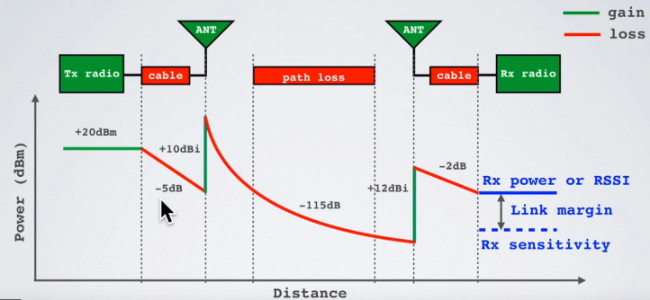
- Signal vs. Distance
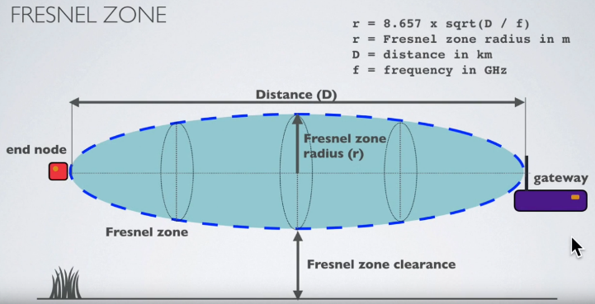
- Fresnel zone
Fig. 5. Huygens Fresnel principle [11]
From Eq.1 and Eq.2 deduce the equivalent distance between stations based on the received signal will be:
(3)
The experiments were executed at node positions by a computer program and a LoRa module to calculate equivalent distances. At each position, the testing computer tried to communicate to the other nodes and recorded RSSI register values. The actual test results of the signal strengths are shown in the Table 2. From RSSI register values, equivalent distances were calculated as in Eq.3, second value in each cell of Table 2. The equivalent distances are then mapped to Fig. 6a. and used for communication routing path optimization.
Table 2. RSSI value/Equivalent distance (km)
S | CS | SS01 | SS02 | SS03 | SS04 | SS05
CS | # | 0/inf | 61/7.78 | 100/0.08 | 66/4.37 | 59/9.79
SS01 | 0/inf | # | 0/inf | 0/inf | 0/inf | 60/8.72
SS02 | 61/7.7 | 0/inf | # | 64/5.50 | 67/3.89 | 59/9.79
SS03 | 100/0.08 | 0/inf | 64/5.50 | # | 70/2.76 | 61/7.78
SS04 | 66/4.3 | 0/inf | 67/3.89 | 70/2.76 | # | 58/10.99
SS05 | 59/9.7 | 60/8.72 | 59/9.79 | 61/7.78 | 58/10.99 | #
The optimization was implemented with an improved Dijkstra algorithm on equivalent distances.
(1) Initialization: num=0, dist=+∞, v[i] =0, (i=0, 1…n);
(2) If cost[s][i] ≤l, then set v[i]=1, (i=0, 1…n);
(3) If v[r] =1, then dist=cost[s][r], go to step (8); else go to step (4);
(4) ∀ i ∈ {v[i]=1}, u[num]=1, set v[j]=1 when j∈{cost[u[num]][j] ≤l}, (j=0,1,…n);
(5) If v[r] ≠ 1, then num++, repeat step (4); else record the path that fulfills v[r]=1, and (6) num=num+1, repeat steps (4) and (5) until all the paths, that fulfill v[r]=1, are obtained;
(7) Set dist=min{dist[i], i=0, 1,…,num}
(8) Output the corresponding path.
Where: n: Number of network nodes; s: Sending node; r: Receiving node; l: Limited transmission radius; u[num]: Relay node [num] of a routing path; v[i]: Visit mark (if not visited, set v[i]=0; else set v[i]=1); cost[i][j]: Distance between node i and node j; dist: Distance corresponding to the optimal path from s to r.
Implemented the above algorithm, simulations of a network and optimize routing paths are given in Fig. 6b.
Fig. 6. Communication optimal routing path

Fig. 7. Temperature & Humidity
  - Results
Using the proposed system structure, network topology and routing algorithm, the experimental data acquisition system has been implemented and testing in Ban Lang Ward. Data has been collected in every 30 minutes. In Fig. 7 is the result of temperature and air humidity data of the 5 experimental sensor stations from 0:00 8th February to 0:00 10th February. The result graphs show that the system can collect data without interrupt (there is no suddenly changing value) in the two days. The experimental results show that the proposed system can meet the technique requirement of the CT2019.01 project. The system with hardware and software can work and collect data from sensor stations with the furthest distance of 7.94km.
- Conclusions
The paper described the implementation of a data collection system for monitoring, Territorial warning of geography disasters and supporting decision making. The proposed hardware and LoRa network topology are presented and implemented in Ban Lang Ward. The practical problem of weak signal making loss connection was depicted and solved with suitable topology and optimal routing path. Test results show the efficient of suggested topology and optimal routing path which is based on equivalent distance. That give the system ability to collect data and transmit stably to the center of the system. In further research, the optimal routing path should be implemented online with the network mapping signal strength measuring continuously.
References
[1] Z. Tao, H. Zhang, C. Zhu, Z. Hao, X. Zhang, and X. Hu, “Design and operation of App-based intelligent landslide monitoring system: the case of Three Gorges Reservoir Region,” Geomatics, Nat. Hazards Risk, vol. 10, no. 1, pp. 1209–1226, 2019, doi: 10.1080/19475705.2019.1568312.
[2] F. Huang, X. Luo, and W. Liu, “Stability Analysis of Hydrodynamic Pressure Landslides with Different Permeability Coefficients Affected by Reservoir Water Level Fluctuations and Rainstorms,” Water, vol. 9, no. 7. 2017, doi: 10.3390/w9070450.
[3] T. Ngọc, “Thiên tai cực đoan, dị thường,” Nhân dân điện tử, 2020. https://nhandan.com.vn/tin-tuc-xa-hoi/thien-tai-cuc-doan-di-thuong-628407/.
[4] M. Calvello, “Early warning strategies to cope with landslide risk,” Riv. Ital. di Geotec., vol. 51, no. 2, pp. 63–91, 2017, doi: 10.19199/2017.2.0557-1405.063.
[5] L. Piciullo, M. Calvello, and J. M. Cepeda, “Territorial early warning systems for rainfall-induced landslides,” Earth-Science Rev., vol. 179, no. April 2017, pp. 228–247, 2018, doi: 10.1016/j.earscirev.2018.02.013.
[6] D. M. Ibrahim, “Internet of Things Technology based on LoRaWAN Revolution,” 2019 10th Int. Conf. Inf. Commun. Syst., no. September, pp. 234–237, 2019, doi: 10.1109/IACS.2019.8809176.
[7] Q. Zhou, K. A. N. Zheng, S. Member, L. U. Hou, J. Xing, and R. Xu, “Design and Implementation of Open LoRa for IoT,” IEEE Access, vol. PP, p. 1, 2019, doi: 10.1109/ACCESS.2019.2930243.
[8] E. Leon, C. Alberoni, M. Wister, and J. A. Hernández-nolasco, “Flood Early Warning System by Twitter Using LoRa †,” 2018, doi: 10.3390/proceedings2191213.
[9] M. Gamperl and J. Singer, “Internet of Things Geosensor Network for Cost-Effective Landslide Early Warning Systems,” pp. 1–23, 2021.
[10] V. Van Khoa and S. Takayama, “Wireless sensor network in landslide monitoring system with remote data management,” Meas. J. Int. Meas. Confed., vol. 118, no. January, pp. 214–229, 2018, doi: 10.1016/j.measurement.2018.01.002.
[11] G. Quoc-Anh, N. Dinh-Chinh, T. Duc-Nghia, T. Duc-Tan, K. T. Nguyen, and K. Sandrasegaran, “Wireless technology for monitoring site-specific landslide in Vietnam,” Int. J. Electr. Comput. Eng., vol. 8, no. 6, pp. 4448–4455, 2018, doi: 10.11591/ijece.v8i6.pp4448-4455.
[12] R. Azzam, T. Fernandez-Steeger, C. Arnhardt, H. Klapperich, and K. Shou, “Monitoring of landslides and infrastructures with wireless sensor networks in an earthquake environment,” Memorias la Conf. 5th Int. Conf. Earthq. Geotech. Eng., no. May 2014, pp. 10–13, 2011.
[13] L. Varandas, J. Faria, P. D. Gaspar, and M. L. Aguiar, “Low-cost IoT remote sensor mesh for large-scale orchard monitorization,” J. Sens. Actuator Networks, vol. 9, no. 3, 2020, doi: 10.3390/JSAN9030044.
[14] “LoRa,” 2018. https://lora.readthedocs.io/en/latest/#range-vs-power.

