Vietnam coal price analysis
Nguyen Thi Bich Ngoc
Ha Noi University of Mining and Geology
Corresponding author: nguyenthibichngoc@humg.edu.vn

Abstract: The prices of commodities in general and Vietnam coal prices often fluctuate due to the impact of many factors, some of which belong to the coal market, and some to the Government's policy. Therefore, analyzing Vietnam's coal price in relation to influencing factors is a necessary and regular work of managers, especially those making price policy in the Vietnam coal industry. The paper analyzes price data of Vietnam coal price from 1995 to 2020. The analysis results show that: Vietnam's coal price fluctuates steadily over time and is closely related to other factors (supply, demand, coal consumption price...). In particular, the analysis of average coal price (including domestic price and export price) in relation to the unit cost of consumed product and quantity of coal export shows the regulation of the coal industry with the goal: to ensure that coal production and trading enterprises do not suffer losses but still in the general context: The price of coal supplied for thermal power is not too high to disrupt the general price level of the economy.
Keywords: Data analysis; Price; Unit cost of the consumed product; Factors; Microsoft Excel

1. Introduction
Coal price analysis in the market is one of policymakers' necessary and regular tasks in the Vietnamese coal industry. Operated in a mixed socialist-oriented market economy, the Vietnam coal price is affected by both market and Government management factors. Based on market factors, Vietnam's coal price is affected by the supply-demand relationship in both the Vietnam domestic coal market and the world energy market in general and the world coal market in particular. On the other hand, the world energy market is also affected by world energy supply and demand factors and foreign government policies. Based on the state management factor, the Vietnam coal price is regulated by macroeconomic policies like price stability policy and energy security policy. Therefore, the analysis of coal price is not only evaluating the fluctuations over time but also considering many aspects with influencing factors. The research analyzes Vietnam coal price from 1995 to 2020 to identify the trend of changes in Vietnam coal price and answer the following questions, such as: How is the Vietnam coal price compared to the world coal price?; Does the Vietnam coal price follow market rules?; What factors affect the Vietnam coal price and the level of affection of each factor? Answering these questions, the research aims to show how the Vietnam coal price fluctuates over time and how the influencing factors affect the Vietnam coal price. At the same time, the research results also indicate the level of affection of each factor on the Vietnam coal price fluctuation. The research results provide useful information for Vietnam policymakers to make effective decisions for the production and business activities of coal industry, especially under the implementation of the "Vietnamese coal market developing project, linking coal production and trading guide by market mechanism and ensuring national energy security".
The fluctuation of Vietnam’s coal prices is affected by many factors. In the research, the author focuses on analyzing:
+ Change of Vietnam’s coal prices over time
+ Correlation between Vietnam’s coal prices with some outstanding factors such as coal consumption cost; between the average selling price with the selling price higher than domestic and the output higher than export; world natural gas prices.

2. Research Method
The research process was carried out through the following steps:
Step 1: Research the theoretical basis of the market, about the price of goods on the market, thereby pointing out the basis and factors affecting the price in theory. Research results are described through the model of factors affecting Vietnam coal prices (see figure Fig.1).
Step 2. Select analysis criteria:
- To study the fluctuation of Vietnam coal prices, the author analyzes the change of the Vietnam coal price itself over time.
- Theoretical model: There are many factors affecting Vietnam coal prices. However, in this research, to study the fluctuation of Vietnam coal prices in relation to the influence of factors, the author selects the following relationships:
+ On the supply side, the criterion chosen for analysis is the correlation between average Vietnam coal price and unit cost of consumed coal (representing coal production cost)
+ On the demand side, the selected criterion for analysis is the correlation between average Vietnam coal price and the domestic coal price and quantity of export coal; between the average Vietnam coal price and the world natural gas price; the average Vietnam coal price and the total amount of consumed coal.

Demand for Vietnam coal
Supply for Vietnam coal

Customer factors

Economic growth (GDP growth rate)
coal production and consumption costs
Vietnam Government policies
Vietnam coal price
Prices of substitutes for coal
Capacity of coal production enterprises
Vietnam Government policies
World energy market
Other environment factors
Natural resources
- Model of factors affecting Vietnam coal price

Step 3. Using descriptive statistics method with Microsoft Excel tool to analyze the above criteria.
- Time series data are described qualitatively using data visualization - a technique for presenting data and information graphically, usually as charts, graphs, or in the form of dashboard reports. The author will choose line and combo chart types to visualize data combined with trends to show the trend of coal price fluctuations over time and the relationship between the coal selling price and influencing factors.
- The quantitative analysis is performed using regression and correlation analysis tools and the functions that determine the correlation coefficient, slope, and intercept of the regression function.
Step 4. Collecting data, handling with “poor quality” data, which may distort the nature of the research phenomenon.
Step 5. According to research objectives, choosing a type of data visualization or analytical criteria calculation.
Step 6. Appropriately presenting the analysis results, discussing the calculation results, explaining, and making conclusions.

3. Research Data
Data of Vietnam coal price collected from published reports is shown in Table 1.

Table 1. Statistics on price data over the period 1995-2020
Unit: * - Thousand VND per ton; **- Thousand tons
Year | Domestic coal price,* | Average coal price, * | Export coal price, * | Unit cost of the consumed product,* | World natural gas price, USD/ mil.BTU | Quantity of produced coal, ** | Quantity of domestic consumed coal, ** | Quantity of coal export, ** | Total quantity of consumed coal, **
1995 | 203.30 | 254.63 | 343.35 | 250.5 | 3.46 | 8,350 | 4,809.0 | 2,782.0 | 7,591.0
1996 | 217.70 | 265.31 | 344.21 | 260.9 | 3.66 | 9,823 | 6,075.0 | 3,666.0 | 9,741.0
1997 | 224.70 | 273.98 | 375.39 | 263.5 | 3.91 | 11,388 | 7,254.0 | 3,525.0 | 10,779.0
1998 | 218.20 | 275.43 | 429.72 | 268.0 | 3.05 | 11,672 | 7,821.0 | 2,901.0 | 10,722.0
1999 | 224.20 | 286.96 | 417.54 | 268.3 | 3.14 | 9,629 | 6,731.0 | 3,235.0 | 9,966.0
2000 | 225.20 | 272.99 | 403.08 | 269.4 | 4.72 | 11,609 | 8,425.0 | 3,095.0 | 11,520.0
2001 | 267.00 | 305.44 | 386.48 | 292.0 | 4.64 | 13,379 | 8,849.0 | 4,197.0 | 13,046.0
2002 | 284.80 | 323.14 | 387.52 | 302.5 | 4.27 | 16,409 | 9,297.0 | 5,536.0 | 14,833.0
2003 | 301.00 | 333.12 | 394.50 | 313.0 | 4.77 | 19,314 | 12,357.0 | 6,468.0 | 18,825.0
2004 | 329.42 | 377.62 | 443.96 | 343.9 | 5.18 | 27,439 | 14,474.0 | 10,516.0 | 24,990.0
2005 | 380.80 | 508.20 | 641.71 | 406.3 | 6.05 | 34,093 | 15,447.0 | 14,741.0 | 30,188.0
2006 | 399.50 | 490.21 | 557.93 | 429.5 | 7.14 | 38,778 | 16,058.0 | 21,511.0 | 37,569.0
2007 | 501.22 | 552.51 | 589.65 | 471.5 | 7.73 | 42,483 | 17,494.0 | 24,158.0 | 41,652.0
2008 | 663.60 | 960.51 | 1,273.06 | 696.2 | 12.55 | 39,777 | 18,173.0 | 17,264.0 | 35,437.0
2009 | 681.80 | 822.18 | 938.78 | 722.5 | 9.06 | 44,078 | 20,186.0 | 24,303.0 | 44,489.0
2010 | 924.90 | 1,172.05 | 1,495.44 | 939.2 | 10.91 | 44,835 | 24,421.2 | 18,664.6 | 43,085.8
2011 | 1,178.60 | 1,459.49 | 1,922.12 | 1,116.6 | 14.73 | 46,611 | 27,821.2 | 16,892.0 | 44,713.2
2012 | 1,320.30 | 1,431.82 | 1,623.16 | 1,233.5 | 16.75 | 42,083 | 24,765.3 | 14,433.2 | 39,198.5
2013 | 1,416.00 | 1,430.26 | 1,461.94 | 1,300.2 | 16.17 | 41,064 | 26,672.5 | 12,008.3 | 38,680.8
2014 | 1,549.90 | 1,558.92 | 1,609.15 | 1,416.6 | 16.33 | 41,086 | 33,071.2 | 5,936.7 | 39,007.9
2015 | 1,557.50 | 1,579.44 | 2,244.48 | 1,436.9 | 10.31 | 41,664 | 38,875.5 | 1,282.3 | 40,157.8
2016 | 1,314.60 | 1,334.82 | 2,328.67 | 1,436.0 | 6.94 | 38,735 | 40,297.3 | 819.7 | 41,117.0
2017 | 1,472.50 | 1,516.58 | 2,650.54 | 1,493.3 | 8.10 | 38,409 | 39,645.9 | 1,541.2 | 41,187.1
2018 | 1,475.20 | 1,530.43 | 2,983.49 | 1,521.5 | 10.05 | 42,384 | 50,209.7 | 1,908.5 | 52,118.2
2019 | 1,591.81 | 1,620.82 | 3,204.57 | 1,579.6 | 9.94 | 47,158 | 59,820.2 | 1,095.8 | 60,916.0
2020 | 1,703.27 | 1,723.42 | 2,871.63 | 1,638.0 | 7.81 | 48,378 | 51,849.0 | 909.6 | 52,758.6
- Source: Data gathered from references [ 1 , 3 , 4 , 5 , 6 ];

4. RESEARCH RESULTS AND DISCUSSION
According to the order of research steps mentioned above, the research results are as follows:
* The fluctuation of the Vietnam coal price itself over time reflects the total influence of all factors. The results of analysis of the Vietnam coal price fluctuation trend in the period 1995-2020 by data visualization and regression function over time are shown in figures Fig.2 and Fig.3.

Fig. 2. Visualize the Vietnam coal prices
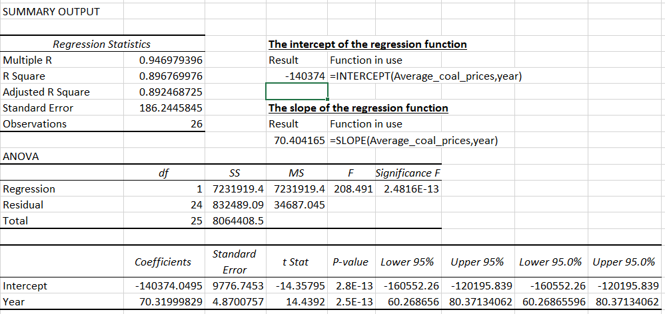
Fig. 3. Results of regression analysis of average Vietnam coal price

Visual images and test parameters of the regression function (such as: sum of squares of deviations, standard deviations, R squared, reliability) all show the annual volatility of coal prices around the regression curve is not significant. The regression function of Vietnam coal price over time is as follows:
Average coal price= -140465 + 70,404*Year(s)
As all conditions remained unchanged, the average Vietnam coal price increased by 70,404 thousand VND/ton per year. Therefore, the regression analysis results make it possible to predict the future Vietnam coal price, given all conditions remain constant.
* The correlation between the Vietnam coal price in relation to the influencing factors:
+ Average Vietnam coal price is calculated according to domestic price and export price. In which, the Vietnam coal export price depends on the world energy market in general and the world coal market in particular. But the domestic coal price is partially independent from the domestic coal market and depends largely on the control policy of the Vietnam government.
The correlation between the domestic coal price and the unit cost of the consumed product is visualized in Figure 4. The correlation coefficient between the domestic coal price and the unit cost of consumed product calculated, R = 0.99538 (see Fig.5) proved a very close relationship between domestic coal price and the unit cost of consumed product. It seems that, in order to achieve the macroeconomic regulation goal, the coal price should not be too high, only slightly above the unit cost of consumed product. This price only ensures minimum profits for coal-producing enterprises. The reason is that coal is an important input for many national economic sectors, especially thermal power. Even in some years, the domestic coal price is lower than the unit cost of the consumed product, and the coal industry has taken export revenue to compensate, ensuring profitable production and business. Thus, the close relationship between the domestic coal price and the unit cost of the consumed product is not a coincidence but is the result of Vietnam's macroeconomic regulation policy.

Fig.4. Visualize the domestic coal price with the unit cost of consumed product
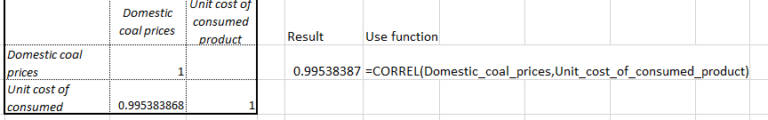
Fig.5. Correlation coefficient between domestic coal price and unit cost of consumed product

- Further analysis of the correlation between the domestic coal price and the unit cost of consumed product using the regression model (see Fig.6) also gives similar results. Therefore, it can be asserted that the domestic price will increase by 1,05682 VND when the unit cost of the consumed product increases by 1 VND. The profit from each ton of domestic consumed coal is tiny, and the rest is thanks to the price of export coal. That will be further clarified in the following analysis.
+ The government controls the domestic coal price to ensure that coal producers are profitable while stabilizing the economy's general price level. Therefore, the domestic coal price is slightly above the unit cost of the consumed product. Even, in some years, the domestic coal price is lower than the unit cost of consumed product. In order to increase income and ensure profitability, Vietnam's coal industry relies on coal export output. However, the national energy security policy also influences coal export output. Therefore, the quantity of coal export is only enough to raise the average coal price and ensure the profit of Vietnam's coal industry. The above statements are reflected in the relationship between average coal price and domestic coal price, coal export price, and quantity of coal export over time as visualized Fig.7.
The visualization of average coal price, domestic coal price, unit cost of consumed product and quantity of export coal in Fig.7 shows us:

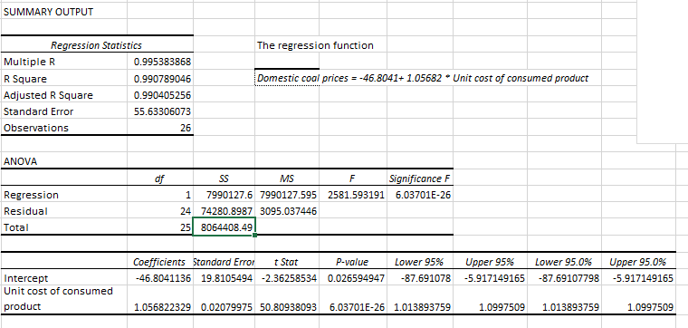
Fig.6. Regression analysis results between selling price and unit cost of consumed product

- The domestic coal price is not much different from the unit cost of consumed product.
- The average coal price depends heavily on the price and quantity of coal export. In the years with low quantity of coal export, as export revenue could not bring down the average coal price, the average price was approximately the unit cost of consumed product. In years with high quantity of coal export, coal export revenue helps to pull the average selling price (offsetting part of the domestic coal price) to ensure the coal industry is profitable in production and business.

Fig.7. Visualize average coal selling price with influencing factors

+ The correlation between the average Vietnam coal price and the world natural gas price is depicted in Fig.8.
According to market laws, when the natural gas price (a substitute for coal) increases, the price of coal increases (as other factors remain unchanged). However, the analysis shows that, after 2014, Vietnam coal price was not much affected by the price of substitutes for coal. This implies the influence of other factors, especially the management policy of the Government as well as Vietnam's energy security strategy, which have a more substantial impact on the Vietnam coal price.
+ Similar to the correlation between the Vietnam coal price and the natural gas price, according to the law of demand, the relationship between price and quantity demanded is inverse. But with the collected data on the average Vietnam coal price (after excluding the effect of inflation) and total quantity of consumed coal, Fig.9 shows that the average Vietnam coal price and the quantity of consumed coal do not obey the law of demand in a free market.

Fig.8. Correlation between Vietnam coal price and world natural gas price

Fig.9. Correlation between the Vietnam coal price and the total quantity of consumed coal

So, both visualization and regression analysis showed that:
- The average Vietnam coal price always tends to increase over time. Although the growth rate is unequal, the variation of the actual data around the regression function is relatively small.
- The average Vietnam coal price depends on the domestic coal price and the export coal price. The domestic coal price has a strong correlation with the unit cost of consumed product. It implies the Vietnam government regulation in the coal market. The Vietnam government always ensures that there is no significant disturbance in the commodities market in general and Vietnam's energy market in particular. Exporting coal can be considered a "solution" to raise the average Vietnam coal price. In the years with high coal export volume, the average Vietnam coal price was "pulled" up, far exceeding the domestic coal price (in 2011) and vice versa (in 2016, 2020).
- The average Vietnam coal price depends on both the factors of the free market and the factors under the macroeconomic management policy of the Vietnam Government. The analysis results of the correlation between the average Vietnam coal price and the world natural gas price (the price of substitute goods), the unit cost of the consumed product shows that the relationship between them does not entirely follow the free market law. It seems that, among the factors affecting the Vietnam coal price, the factor belongs to the Vietnam Government policies (such as price stabilization policy, national energy security policy, etc.) have a more substantial influence than the factors belonging to the free market.
Besides, in the Vietnam coal market, the Vietnam coal price is also affected by many other factors, such as the world energy market in general and the world coal market in particular; Vietnam's energy security policy and policies of other countries around the world. Therefore, the Vietnam coal price can be further analyzed in relation to the world coal price, coal substitute prices, such as gas price, crude oil price, or energy trends and strategies (green, sustainable, etc.) of other countries and Vietnam. These issues can also be addressed in further studies.

5. CONCLUSIONS
The analysis results from actual data show two basic conclusions:
- The selling price of Vietnamese coal fluctuates steadily over time.
The Vietnam coal price is affected both by the coal supply-demand relationship according to the law of the free market and the management policies of the Vietnam Government. In particular, the impact of the Vietnam Government management policies seems stronger than the impact of the free-market factors. The Vietnam Government strictly controlled the coal price policy. That's because the Vietnam economy is a mixed socialist-oriented market economy. The Vietnam Government also aims at the following goal: regulating coal prices to ensure profitable coal production and business enterprises, ensuring the overall price stability of the economy, and enforcing policies on Vietnam's energy security.
Coal is a non-renewable resource and plays a vital role in the economy. Therefore, it is inevitable that the coal market in general and Vietnam coal price, in particular, are under the management of the Vietnam Government. However, towards the trend of globalization, when joining the world energy market in general or the world coal market in particular, Vietnam coal price needs to be gradually formed according to the market mechanism, gradually reducing the intervention of the Vietnam Government. To do so, Vietnam needs a coal price strategy and an apparent decentralization in constructing a coal price framework between the state and the Vietnam Coal - Mineral lndustries Holding Corporation Limited.
A specific economic expenditure in general and Vietnam coal price, in particular, can be further analyzed in other aspects. However, within the paper's framework, the authors only introduce the basic contents of the analysis, which can be developed in further studies.

REFERENCES
- Dong Thi Bich, (2021), Research on factors affecting the domestic coal selling price of Vietnam, Research project at grassroots level, University of Mining and Geology, Code T21-38
- Nguyen Thi Bich Ngoc (2010), Textbook of Enterprise Economic Statistics, Hanoi University of Mining and Geology.
- Research Vietnam coal market, linking coal production and trading according to the market mechanism and ensuring national energy security, Report on scientific research project number KC.06 /16-20, Vietnam Coal - Mineral lndustries Holding Corporation Limited.
- Nguyen Cong Tan et al (2020), Research and develop a coal price framework and propose a mechanism to manage and control coal prices in Vietnam, report on a scientific research topic numbered KC.06.D34-19/12-20, Vietnam Coal - Mineral lndustries Holding Corporation Limited.
- The project of developing Vietnam's coal market, linking coal production and trading according to the market mechanism and ensuring national energy security, implemented by Mining and Industry Investment Consulting Joint Stock Company, Vietnam Coal - Mineral lndustries Holding Corporation Limited chaired, managed by the Ministry of Industry and Trade.
- Project on Developing a competitive energy market to 2030, with a vision to 2045, according to Decision No. 2233/QD-TTg dated December 28, 2020
- Hector Guerrero (2019), Excel Data Analysis, (2nd edition), Springer Nature Switzerland AG (eBook)
- Vietnam Inflation Rate 1996-2022 | MacroTrends (World Bank)

