NATURAL DISASTER RISK EXPOSURE MAPPING BY USING GIS – A CASE STUDY IN THE CORE CITY OF CAN THO
Tran Thi Mai Anh¹, Duong Anh Quan²*, Le Thi Nga³, Nguyen Thanh Binh⁴, Truong Xuan Quang⁵, Truong Van Anh⁵, Hoàng Văn Hưởng⁶.
¹ Faculty of Natural resource management, Thai Nguyen University of Agriculture and Forestry;
^{2*} Faculty of Geomatics and Land administration, Hanoi University of Mining and Geology. E-mail: duonganhquan@humg.edu.vn
3. Thanh Hoa Institute of Planning – Architecture
4. Institute of Geography, Vietnam Academy of Science and Technology
5. Hanoi University of Natural Resources and Environment
6. SAMCOM, Minsitry of Defence
Abstract: In Mekong Delta, residents have occasionally suffered the negative impacts of storms and floods in some particular ways. To mitigate the problem, the overall disaster risk assessment is crucially followed by a framework of three dimensions: hazard, vulnerability, and exposure. In this study, the GIS tool and Analytic Hierarchy Process (AHP) successfully determine the exposure risk assessment index weights based on the climate data, land management data, and socio-economic data of the core city of Can Tho. The result shows that the highly developed parts of the city are suffering more damages from flooding due to the larger population and the higher level of economic development than the other parts of the city.
Keyword: GIS, exposure, risk assessment, land use, AHP,Can Tho.
1. Introduction
The latest Special Report on the Ocean and Cryosphere from the United Nation’s Intergovernmental Panel on Climate Change [1](IPCC 2019) indicates that among the number of challenges we may face caused by climate change, flooding is one of the most devastating natural disasters as a consequence of storm surges and extreme rain. In Viet Nam, floods and storms are two kinds of disasters strongly impact the living life of the community and society. From 1990-2010, 74 times of storms were recorded in the South of Vietnam, causing extreme damages. In 1997, the Linda storm caused 3.000 death and missing, destroyed 100.000 houses and more than 300.000 ha of grain in the South of Viet Nam (Records from National flooding management[2]). In 2006, another storm lead to 76 death and missing, 532 injured, and economic losses of about 677 million USD in the Center of Viet Nam [3](Kreft et al., 2015). On the global scale, statistics revealed that flood accounts for 34% and 40% of all global natural disasters in quantity and losses, respectively [4](IPCC, 2019). Therefore, it is needed to study to mitigate the influence of storms and floods.
In recent years, a growing number of studies on risk assessment and analysis have been implemented in different regions and cities. However, these studies stood out of Can Tho.
In the mentioned methods, the index-based methods with intelligence techniques are more appropriate to consider the uncertainties of natural disasters, where AHP is one of the approaches widely employed. AHP can subdivide exposure level into particular factors suitable for zones with various characteristics, which imposes noticeable effects on practicability enhancement.
This paper applies the GIS spatial statistics technique in the exposure index analysis through the GIS spatial statistics technique and AHP.
2. Data and methodology
2.1. Study area and Data
Can Tho city is located in the center of the Cuu Long River basin (105⁰13’ 38’’ – 105⁰50’ 35’’ and 9⁰55’08’’ – 10⁰19’ 38’’). With an estimated 2009 population of 1.188.435 distributed over about 1.401 sq.m, Can Tho is the center of Can Tho province. The tropical climate is the typical characteristic of the city. The season has two distinguished rainfall and dry seasons. The rainfall season is from May to November. The dry season is from December to the next April. The average temperature is about 27⁰. The average rainfall amount is in the range of 1.500-1.800 mm. The total hours are 2.300-2.500 hours. The humidity is about 83%.(“Địa Lý Cần Thơ” n.d.) The location of Can Tho and the core city is shown in the following figure (Fig.1)
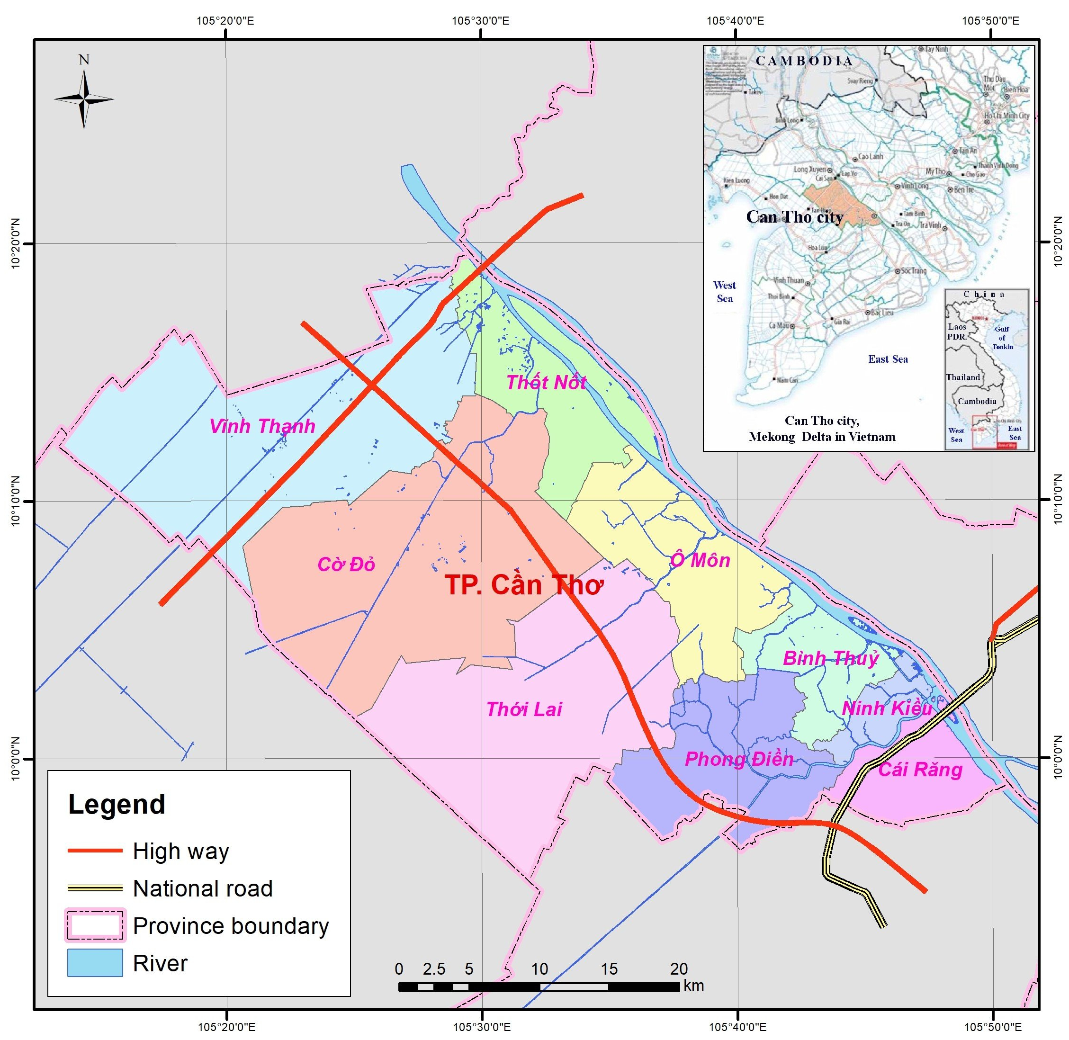 | Figure 1. The CanTho city

The core urban area of Can Tho spread in Ninh Kieu and Binh Thuy districts. In the research, those two districts are selected to assess the exposure level in natural disaster risk.
Table 1. Data sources
Data name | Data type | Source
Administration boundary | SHP | Ministry of Natural resources and Environment (MONRE)
Hydrological system | SHP | MONRE
Transportation | SHP | MONRE
Socio-economic data | the population, GDP, economic sections, hospital condition, education system | Department of Statistics, Can Tho
2.2. The methodology
2.2.1. Analytical Hierarchy Process (AHP)
The AHP model for calculating the exposure index of Can Tho core city contains three categories: Economic, Human and Social. The first and second groups are able to quantify, tangible but the last group is non-tangible. Therefore, this research applies both quantitative and qualitative approaches.
Based on those exposures categories, this research defined the AHP tree as following figure (Fig. 2)

Figure 2. AHP tree of exposure indexes
Based on the hierarchy tree, those indexes are assessed and mapping.
2.2.2. Assessment index
The risk is defined as the combination of hazard, exposure, and vulnerability, according to the fifth appraisal report of the Intergovernmental Panel on Climate Change (IPCC). Thus, an exposure assessment model was established based on the principle of AHP, consisting of an object layer, an index layer, and a sub-index layer. There are diverse factors in each layer, weights of which were calculated using AHP, and then processed in GIS.
2.2.2.1. Exposure index
AHP model is built to measure the first index level. Simultaneously, the GIS tool using spatial data and non-spatial data to assess the second index level. They are afterward converted to get the index by formula 1, then be assessed overall, and finally create maps.
Ej= E₁xW₁ + E₂xW₂ + E₃xW₃ + E₄xW₄+E₅x W₅ (Eq.1)
In there: Ej is the index by AHP (population, society, Economy); E₁ to E₅ are the index the second level (by GIS: Storms, flooding, drought, extremely high temperature, salinity); W₁ to W₅ are the index after converted and assessed.
These indexes afterward standardize to the range of 0-1 to input into the model by the formula 2.
$Yi=\frac{(Xi-Xmin)}{(Xmax-Xmin)}$ (Eq.2)
In there, Xi is the value that will be standardized, Yi is the standardized value, Xmax is the highest value, and Xmin is the lowest value.
Finally, the exposure index will be calculated by the formula:
E = E_{j1}xW_{j1} + E_{j2}xW_{j2} +E_{j3}xW_{j3} (E.q.3)
Where E is the exposure index, E_{j1}, E_{j2}, E_{j3} are the index of population, economy, and society. Wj is the index of the first level.
The model and formula create the index map divide into 2 levels:
Ei= ei*Ki (Eq.4)
Ei is the value of criteria, ei is the index, and Ki is the influence index.
Among there, the economic ei is measured based on the land use map. The index is calculated by the loss every year and converted into the value. The social ei is based on the importance of living life by UNDP (2010). The human ei is measure by the equation:
ei = D*P (Eq.5)
2.2.2.2 AHP weight calibration
AHP is calculated by PriEst 2.1 using a simple Pairwise comparison method. The Consistency index is less than 10%. The procedure is based on the Saaty(Saaty 1987) Pairwise comparison approach.
3. Results and discussion
3.1. The AHP weight index
The results from running the software PriEst:
Table 1. AHP weight index
Factor | The 1st level | Contribution factors | The 2nd level
Social | 0.238 | Storm | 0.568
Social | 0.238 | Flooding | 0.219
Social | 0.238 | Drought | 0.104
Social | 0.238 | Extreme temperature | 0.069
Social | 0.238 | Salinity | 0.04
Economic | 0.136 | Storm | 0.509
Economic | 0.136 | Flooding | 0.252
Economic | 0.136 | Drought | 0.121
Economic | 0.136 | Extreme temperature | 0.079
Economic | 0.136 | Salinity | 0.039
Human | 0.625 | Storm | 0.423
Human | 0.625 | Flooding | 0.307
Human | 0.625 | Drought | 0.174
Human | 0.625 | Extreme temperature | 0.039
Human | 0.625 | Salinity | 0.057

3.2. The exposure risk results
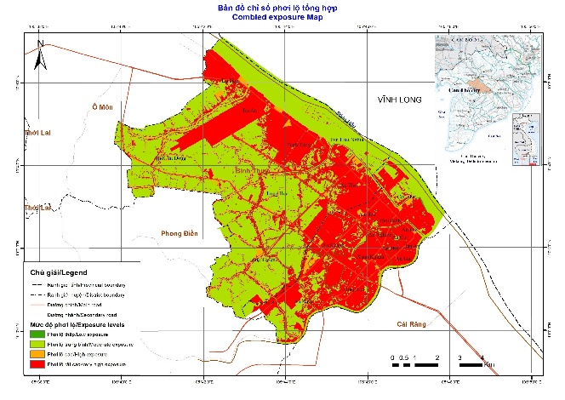 | 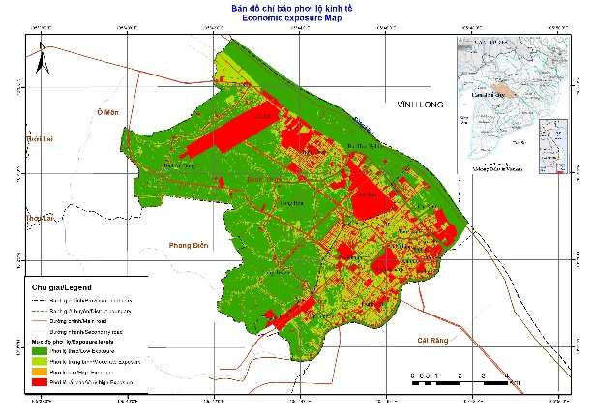
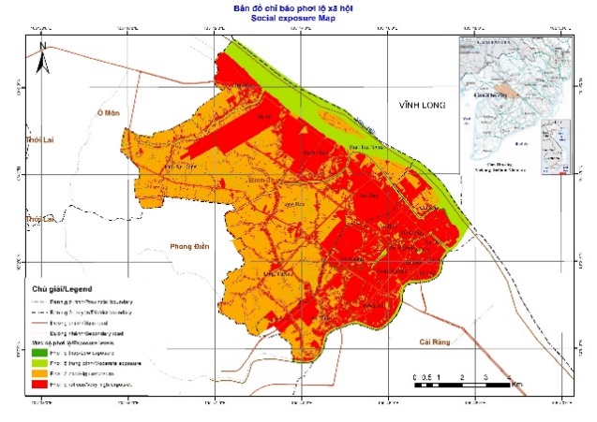 | 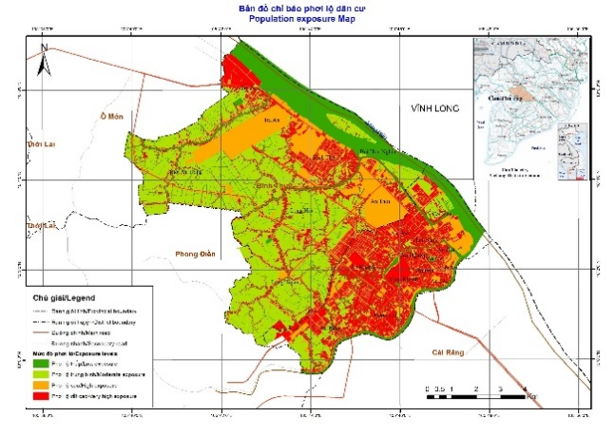
Figure 1 a) Combined exposure map, b) Economic, c) Social, and d) Population Exposure maps of Can Tho city
The exposure indexes maps show the concentration of economic assets, population, and social value in the core city, especially in the urban area of Ninh Kieu District. The Southeast area is lower exposure mainly consist rural residents and agriculture areas. The results show that the highest exposure area is in the East and the South of the city as the social and population exposure indexes are high value. This area involves various districts, Tra An, Binh Thuy, An Thoi, An Hoa, Thoi Binh, An Hoi, An Nghiep, An Cu, An Phu, An Lac, Hung Loi, An Binh, and An Khanh. Among them, the economic exposure risk index gets the highest value in Tra An and An Thoi. In Xuan Khanh, An Khanh, and An Hoi, the exposure risk indexes have a lower value but remain much higher than the area in the West of the city.
In other parts of the city, the low density of population and the lack of factories making less exposure. It means the development of society needs to consider all of the factors, especially the contribution of infrastructure and transportation.
4. Conclusion
Based on the result of the research, we can have some conclusions as:
The Exposure index of the study area is driven mainly by the concentration of humans and assets in the hazard zone. In the core urban area of Can Tho, the higher urbanization, the higher the exposure index.
The GIS and AHP are beneficial when combining to assess complex indicators, including tangible and non-tangible values. The GIS procedure can be reusable with updating data for forecasting the exposure index in the future.

References
1.“Địa Lý Cần Thơ.” n.d. Accessed July 22, 2021. http://cantho.edu.vn/gioi-thieu/dia-ly-can-tho.
2. IPCC. 2019. “Summary for Policymakers, IPCC Special Report on the Ocean and Cryosphere in a Changing Climate.” Hamish Pritchard.
3. Kreft, S, D Eckstein, L Junghans, C Kerestan, and U Hagen. n.d. THINK TANK & RESEARCH GLOBAL CLIMATE RISK INDEX 2015 Who Suffers Most From Extreme Weather Events? Weather-Related Loss Events in 2013 and 1994 to 2013. www.germanwatch.org.
4. Pörtner, Hans-Otto, and Debra C Roberts. 2019. “Technical Summary - IPCC Special Report on the Ocean and Cryosphere in a Changing Climate.” Anjal Prakash.
5. Saaty, R.W. 1987. “The Analytic Hierarchy Process—What It Is and How It Is Used.” Mathematical Modelling 9 (3–5): 161–76. https://doi.org/10.1016/0270-0255(87)90473-8.
6. Thắng, Nguyễn Văn, Mai Văn Khiêm, Nguyễn Trọng Hiệu, Vũ Văn Thăng, Nguyễn Đăng Mậu, and Lã Thị Tuyết. 2016. “Ảnh Hưởng Của Bão ở Việt Nam Thời Kỳ 1961-2014 Nguyễn,” 210–16.

ABSTRACT
Natural disaster risk exposure mapping by using GIS – a case study in the core city of Can Tho
Tran Thi Mai Anh¹, Duong Anh Quan²*, Le Thi Nga³, Nguyen Thanh Binh⁴, Truong Xuan Quang⁵, Truong Van Anh⁵, Hoàng Văn Hưởng⁶.
¹ Faculty of Natural resource management, Thai Nguyen University of Agriculture and Forestry;
^{2*} Faculty of Geomatics and Land administration, Hanoi University of Mining and Geology. E-mail: duonganhquan@humg.edu.vn
3. Thanh Hoa Institute of Planning – Architecture
4. Institute of Geography, Vietnam Academy of Science and Technology
5. Hanoi University of Natural Resources and Environment
6. SAMCOM, Minsitry of Defence
Abstract: In Mekong Delta, residents have occasionally suffered the negative impacts of storms and floods in some particular ways. To mitigate the problem, the overall disaster risk assessment is crucially followed by a framework of three dimensions: hazard, vulnerability, and exposure. In this study, the GIS tool and Analytic Hierarchy Process (AHP) successfully determine the exposure risk assessment index weights based on the climate data, land management data, and socio-economic data of the core city of Can Tho. The result shows that the highly developed parts of the city are suffering more damages from flooding due to the larger population and the higher level of economic development than the other parts of the city.
Keywords: GIS, exposure, risk assessment, land use, AHP,Can Tho

