Ag⁺ ion adsorption on hydroxyapatite powder and Ag metal recovery by electrochemical method

Le Thi Duyen¹, Vo Thi Hanh¹, Le Thi Phuong Thao¹, Dinh Thi Mai Thanh²
¹ Hanoi University of Mining and Geology
² University of Science and Technology of Hanoi

ABSTRACT
Hydroxyapatite (HAp) powder was synthesized by chemical precipitation method from 0.5 M Ca(NO₃)₂ and 0.3 M (NH₄)₂HPO₄ solution at pH 10 by using 28 % NH₃ solution. The adsorption of Ag⁺ onto the HAp powder (formation HAp-Ag) was carried out in aqueous solution. The adsorption capacity and efficiency of HAp powder adsorbent for Ag⁺ under suitable conditions were found to be 9.11 mg/g and 56.46 % respectively. The desorption of Ag⁺ out of HAp-Ag and recovery of Ag metal by electrochemical method were studied in aqueous (H₂SO₄ and Na₂SO₄ solution) and deep eutectic solvent (DES) medium (reline solvent). The results indicated that Ag⁺ can be desorbed out of HAp-Ag in H₂SO₄ solution and reline solvent was better than one in Na₂SO₄ solution. However, HAp and HAp-Ag was dissolved in H₂SO₄ solution, different from ones in reline solvent. The obtained result will open a potential application direction for the recovery of Ag⁺ ions in wastewater using HAp powder adsorbent and Ag metal recovery by electrochemical deposition in reline solvent.

Keywords: Adsorption of Ag⁺; hydroxyapatite; desorption of Ag⁺; electrochemical deposition;
- Introduction
Calcium hydroxyapatite (Ca₁₀(PO₄)₆(OH)₂, noted as HAp) has shown a remarkable adsorption efficiency, has been versatile material, has extensively studied and applied. Synthetic HAp has chemical composition and biological activity similar to the natural bone [1]. HAp is non toxic, non allergic to human and has antibacterial properties. Therefore, HAp and HAp doped some elements are prepared in different forms, including powder, membrane, composite and ceramic by physical, chemical, electrochemical methods and were applied in biomedical field [2-5]. Out of the biomedical field, HAp and HAp doped some elements have been applied in environment treatment. They can remove several contaminated agents such as Cu²⁺, Pb²⁺, Zn²⁺, Cd²⁺, Co²⁺, Ni²⁺, ... [6-9] and NO₃⁻, PO₄³⁻, F⁻, phenol, nitrobenzene, congo red from aqueous solution [10-15].
General, the studied results show that HAp can remove heavy metals in the water with high efficiency, is similar to or better than normal adsorbents such as activated carbons, aluminium oxide, silica gel, etc. However, there have been no reports to study for the adsorption of Au³⁺, Ag⁺ on HAp. But there were some reports on preparation silver doped HAp by immersion HAp powder/membrane in AgNO₃ solution to proceed ion-exchange process between Ag⁺ and Ca²⁺ [16-19]. Therefore, it can be proceeded to adsorb Ag⁺ on HAp from the water solution and form HAp-Ag. After that , it is important to desorb Ag⁺ out of HAp-Ag and recovery of Ag metal.
Many years ago, silver deposition on electrodes was investigated in aqueous solutions such as inorganic acid [20], neutral [20; 21], alkaline [22], organic acid as citric, tartaric acid [23; 24] media and some other media [25]. Especially the presence of cyanide has featured prominently as a selective reagent by high efficiency and relatively low cost [25-28]. However, cyanide media is toxic electrolyte as the traditional bath for the electrochemical deposition of silver on nickel/copper electrode. For these reasons, many cyanide-free bath formulations have been previously proposed such as thiosulphate, NH₃,…[28; 29].
Recently, room temperature ionic liquids (RTILs) have attracted considerable attention especially in the fields of catalysis, material chemistry, and more recently for the pre-treatment of biomass. RTILs have received increasing attention as potential electrolytes to overcome the limitations encountered in traditional aqueous media with electrochemical applications, such as metal electrodepositions [20; 30-33]. RTILs were formed by mixing together two salts. Although both salts have very high melting points, their proper mixing leads to the formation of a liquid phase, the so-called eutectic mixture.
To overcome the high price and toxicity of ILs, a new generation of solvent, named Deep Eutectic Solvents (DES). DES has emerged at the beginning of this century. Formation of these DESs can be obtained by simply mixing together two safe components (cheap, renewable and biodegradable) which are capable of forming a eutectic mixture. One of the most widespread components used for the formation of these DESs is choline chloride (ChCl). There were a lot of publications about deposition silver from DES which were formed from ChCl [32-36].
- Experimental
- Preparation of HAp powder
HAp powder is prepared by a wet chemical precipitation method from Ca(NO₃)₂.4H₂O and (NH₄)₂HPO₄ salts in water following reaction (2.1) [37]. Accordingly, the aqueous solution of 0.3 M (NH₄)₂HPO₄ is slowly added dropwise into a 0.5 M solution of Ca(NO₃)₂ at a rate of 1 mL.min⁻¹. During the process, the pH value of the solution is adjusted to about 10 using the concentrated NH₃ solution. The reaction is carried out at 25 ºC with continuous stirring (800 rpm). The obtained precipitate is aged for 15 h and then repeatedly centrifuge-washed with distilled water until neutral pH, then dried at 80 ºC in 24 h. The obtained HAp powder is white with a size less than 100 nm [37].
10Ca(NO₃)₂ + 6(NH₄)₂HPO₄ + 8NH₃ + 2H₂O → Ca₁₀(PO₄)₆(OH)₂ + 20NH₄NO₃ (2.1)
- Preparation of deep eutectic solvent (DES)
The DES were obtained by mixing choline chloride (ChCl) (Alfa Aesar, 98+ %) and urea (U) (VWR Chemicals, NORMAPUR). Choline chloride was recrystallized from absolute ethanol (VWR Chemicals, NORMAPUR), filtered and dried under vacuum. Choline chloride and urea were mixed in a 1:2 molar ratio in a closed container under constant stirring for 3 hours at 60ºC until a homogeneous colourless liquid was formed and formation the ChCl-U (Reline) DES.
- Adsorption of Ag⁺ on the HAp
The adsorption experiments were carried out in mixing m gram of HAp powder with 50 ml of C₀ mg/L Ag⁺ ion solution, contact time was t minutes, initial pH of solution was natural pH (5.5). All experiments were performed at room temperature and kept for stirring with speed of 800 rpm. Thereafter the mixture was filtered to separate the solid and final Ag⁺ ion concentrations were determined by Atomic Absorption Spectrophotometer.
Adsorption capacity and efficiency were calculated by equations (2.2) and (2.3), respectively:
Q = (C₀ – C).V/m (2.2)
H = (C₀ – C).100/C₀ (2.3)
where Q is the amount of metal ion adsorbed on adsorbent at equilibrium (mg/g), C₀ and C are the initial and equilibrium concentration (mg/L) of metal ion in solution respectively, V is the volume of solution (L) and m is the mass of adsorbent (g).
- Electrochemical experiments
- Cyclic voltammograms (CVs) in aqueous and DES medium
The CVs experiments were carried out using a three electrode system connected to an Autolab PGSTAT20 (Metrohm) potentiostat. The working electrode (WE) was Au (geometric area = 0.0201 cm²), reference electrode (RE) was Hg,Hg₂SO₄|SO₄²⁻ for aqueous medium and Ag,AgCl|Cl⁻ for DES medium and the counter electrode (CE) was a platinum grid of large area. Sample volume of 5 mL, scan potential range: 0.4 V ÷ - 0.4 V, scan rate of 50 mV.S⁻¹ at room temperature (30 ºC) for aqueous medium and 60 ºC for DES medium.
The working electrode was polished with a alumina-water slurry on a smooth polishing cloth, then twice sonicated for 3 minutes and rinsed with Milli-Q water to remove any trace of alumina, and finally dried under nitrogen. The platinum counter electrode was cleaned by flaming to red glow. Before each experiment, the aqueous or DES medium was purged with nitrogen for at least 20 min, and kept during all measurements under nitrogen atmosphere.
- Deposition of Ag metal on the surface of electrode
The deposition Ag metal was carried out in a three electrode electrochemical cell: the WE was gold plate (geometric area = 1 cm²), the RE was Ag,AgCl|Cl⁻ and the CE was a platinum grid of large area. The deposition potential of – 0.4 V applied for 3 hours, T = 60 ºC. DES medium was purged with nitrogen for at least 20 min, and kept during electrolysis under nitrogen atmosphere.
- Results and discussion
- Effect of the experimental factors on Ag⁺ adsorption by HAp powder
- Effect of contact time

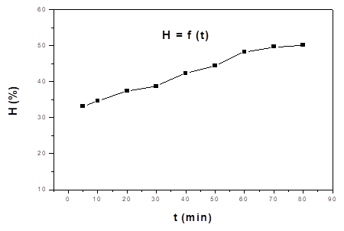
Figure 1. The variation of Ag⁺ adsorption efficiency according to contact time, m_{HAp} = 0.1 g; C₀ = 50 ppm; pH₀ 5.5; T = 30 ºC.
Figure 1 shows the variation of the adsorption efficiency of the HAp powder for Ag⁺ ions as a function of the contact time. The adsorption efficiency (H, %) increase rapidly during the first 60 min, then increase slowly and reach steady state after 60 min due to the adsorption process has tended to reach equilibrium. To obtain high adsorption efficiency, rapidly adsorption process, a contact time of 60 min is chosen for subsequent studies.
- Effect of initial Ag⁺ concentration
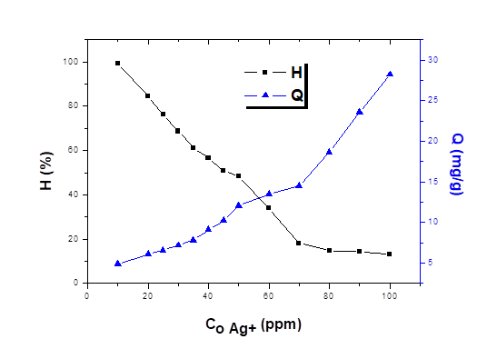
Figure 2: The effect of initial Ag⁺concentration on the adsorption capacity and efficiency of Ag ⁺, m_{HAp} = 0.1 g; pH₀ 5.5; t_{contact} = 60 min; T = 30 ºC.
The initial concentration of Ag⁺ has a significant effect on the adsorption capacity and the removal efficiency. When increasing the concentration of Ag⁺ concentration, the adsorption capacity increases while the adsorption efficiency decreases (Figure 2). To obtain a high combined adsorption capacity and efficiency, suitable Ag⁺ concentration can be used in the range of 40 ÷ 50 ppm. The maximum adsorption efficiency of 56.46 % has been obtained for the initial Ag⁺concentration of 40 ppm.
General, suitable conditions to adsorb Ag⁺ on HAp powder: mixing 0.1g of HAp powder with 50 ml of 40 ppm Ag⁺ ion solution, contact time was 60 minutes, initial pH of solution was natural pH (5.5), room temperature (30 ºC) and kept for stirring with speed of 800 rpm. Thereafter the mixture was filtered to separation the solid. The solid was Ag⁺ adsorbed HAp (noted HAp-Ag) to use for the studies further.
- Desorption of Ag⁺ out of HAp-Ag and recovery of Ag metal by electrochemical method
To find the deposition potential of Ag on the surface of electrode, CVs scan was studied in aqueous (H₂SO₄, Na₂SO₄ solution) and in DES medium.
- Desorption of Ag⁺ out of HAp-Ag in aqueous medium
a. CVs scan of AgNO₃ and HAp-Ag in H₂SO₄ solution

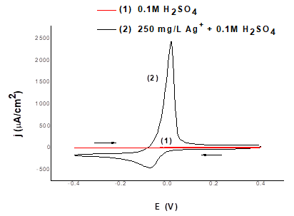 | 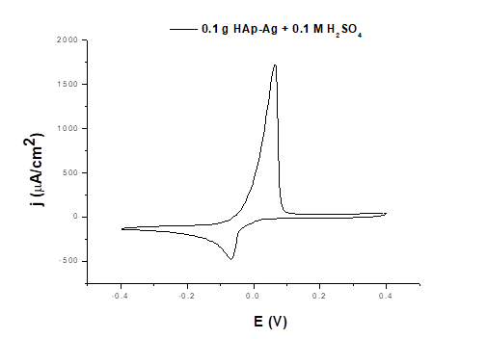
Figure 3a. CV of 0.1M H₂SO₄ (1) and 250 mg/L AgNO₃ in 0.1M H₂SO₄ (2). Scan rate: 50 mV.S⁻¹, T = 30 ºC. | Figure 3b. CV of (0.1 g HAp-Ag + 0.1M H₂SO₄). Scan rate: 50 mV.S⁻¹, T = 30 ºC.
The Figure 3a shows that the peak of reduction wave is near - 0.08 V. It means that the deposition Ag on the surface of Au electrode can be proceeded at the potential of -0.08V. The results on the Figure 3b indicated that Ag⁺ can be desorbed out of HAp-Ag in H₂SO₄ acid. The peak of reduction wave is near - 0.08 V, similar to AgNO₃ in 0.1M H₂SO₄ solution. Therefore, the presence of HAp component in the mixture will not change deposition potential of Ag on the surface of electrode. The processes happen following:
Step 1: The desorption of Ag⁺ out of HAp-Ag and then the reduction Ag⁺ to Ag on the surface of Au electrode: Ag⁺ + 1e → Ag
Step 2: The oxidation (stripping) Ag to Ag⁺: Ag - 1e → Ag⁺
b. CVs scan of AgNO₃ and HAp-Ag in Na₂SO₄ solution
 | 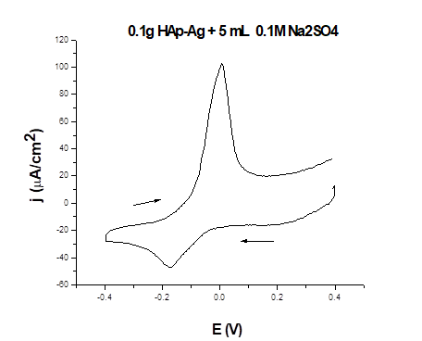
Figure 4a. CV of 0.1M Na₂SO₄ (1) and 250 mg/L Ag⁺ in 0.1M Na₂SO₄ (2). Scan rate: 50 mV.S⁻¹, T = 30 ºC. | Figure 4b. CV of (0.1 g HAp-Ag + 0.1M Na₂SO₄). Scan rate: 50 mV.S⁻¹, T = 30 ºC.
Figure 4a shows that the peak of reduction wave is near - 0.1 V. It is different a little from one in acid solution (about -0.08 V). The processes happen similar to acid solution. The figure 4b shows that both reduction and oxidation waves are small and the peak of reduction wave is near - 0.18 V. This is different from 0.1M H₂SO₄ solution (-0.08 V).
The comparison CV of HAp-Ag (m = 0.1 g) in H₂SO₄ solution to the obtained result in Na₂SO₄ solution is showed on figure 5.
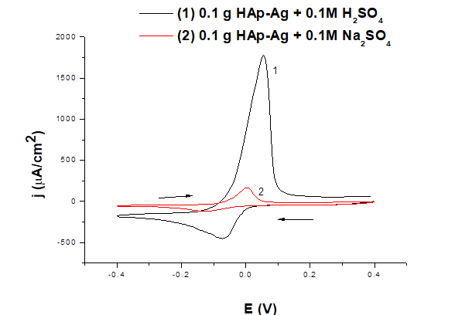
Figure 5. CV of 0.1 g HAp-Ag in 0.1M H₂SO₄ (1) and in 0.1M Na₂SO₄ (2). Scan rate: 50 mV.S⁻¹, T = 30 ºC.
It can show that Ag⁺ desorption out of HAp-Ag in H₂SO₄ is better than one in Na₂SO₄ solution. This result is explained as follow: HAp and HAp-Ag dissolve in H₂SO₄ more than Na₂SO₄ solution. The fact that dissolution 0.5g HAp or 0.5g HAp-Ag in 5mL 0.1M H₂SO₄, after 30 minutes with stirring, the mixture was not changed clearly but after a few hours it was concentrated. There was reaction in this case. Beside that it was not observed when experiment with 0.1M Na₂SO₄ solution. Addition, taking 0.5 g HAp-Ag push 5 mL 0.1M Na₂SO₄ solution with 30 minutes stirring, and then filtering and taking the solution to CV scan. The result is expressed at Figure 6.
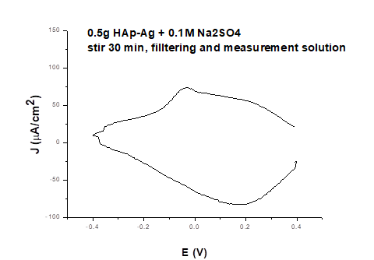
Figue 6. CV of filtering solution. Scan rate: 50 mV.S⁻¹, T = 30 ºC.
On the figure 6, there are neither oxidation peak nor reduction peak, it means that desorption of Ag⁺ out of HAp-Ag by 0.1M Na₂SO₄ solution is not successful. However, if the experiment is proceeded under electrochemical reaction, Ag can be desorbed a small part (Figue 4b).
- Desorption of Ag⁺ out of HAp-Ag in DES medium
a. Trying dissolution ability of HAp and HAp-Ag in the reline solvent
Add 0.1 g HAp powder or 0.1 gram HAp-Ag powder in 10 mL reline and then stir at 60 ºC in 30 minutes. The results show that HAp and HAp-Ag were not soluble (may be Ag⁺ ions go into reline and HAp was not soluble).
b. CV scan of reline solvent and HAp-Ag in the reline solvent
The result on the Figure 7 indicated that Ag⁺ can be desorbed out of HAp-Ag in reline solvent. The peak of reduction wave near - 0.03 V, this agrees with the CV of Ag⁺ in reline reported in the literate [34] and different from one in 0.1M H₂SO₄ solution (-0.08 V) and in 0.1 M Na₂SO₄ solution (-0.18 V). The processes happen following:
Step 1: The complex between Ag⁺ of HAp-Ag with Cl⁻ of reline was formed (AgCl_{n}^{1-n}, n = 2 - 4). After this, the reduction Ag⁺ (of AgCl_{n}^{1-n}) to Ag on the surface of electrode: AgCl_{n}^{(1-n)} + 1e → Ag + nCl⁻
Step 2: The stripping Ag to Ag⁺: Ag - 1e → Ag⁺
General, Ag⁺ can be desorbed out of HAp-Ag in the reline and adsorbent (HAp) may be recovered.
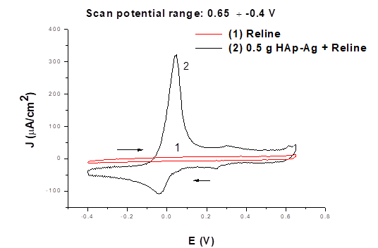
Figure 7. CV of the reline (1) and HAp-Ag in the reline (2). Scan rate: 50 mV.S⁻¹, T = 60 ºC.
3.2.3. Recovery of Ag metal
The result of CVs of HAp-Ag in H₂SO₄, Na₂SO₄ solution and reline solvent indicated that Ag⁺ can be desorbed out of HAp-Ag in H₂SO₄ solution and reline solvent was better than one in Na₂SO₄ solution. However, HAp and HAp-Ag was dissolved in H₂SO₄ solution therefor HAp adsorbent will be not recovered. To recover Ag metal and HAp adsorbent can be recovered, HAp-Ag was electrolysed in reline solvent.
The Figure 7 shows that deposition Ag metal on the surface of Au electrode can be caried out at the potential ≤ - 0.03 V. The result of electrolysis of mixture HAp-Ag in reline indecated on the Figure 8a. After electrolysis 3h, HAp-Ag powder was filted out of mixture then cleaning, drying and then CV scan (Figure 8b).

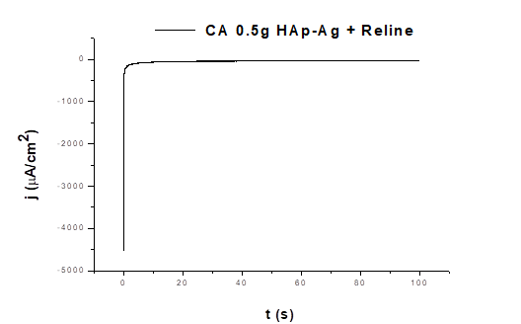 | 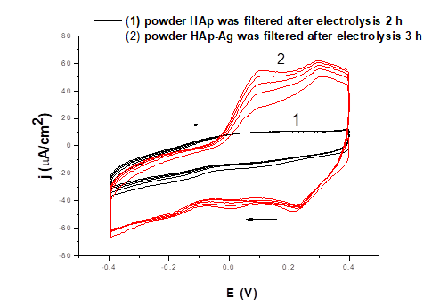
Figure 8a. Electrolysis of 0.5 g HAp-Ag in reline at – 0.4 V; T = 60 ºC; | Figure 8b. CV of HAp and HAp-Ag power after electrolysis 3h. Scan rate 50 mV.S⁻¹, T = 60 ºC.
The result (observation) showed that Ag deposition visible on the Au plate electrode and there was only small amount of Ag⁺ present in the HAp powder after electrolysis (Figure 8b). It was found that Ag⁺ was desorbed out of HAp-Ag and Ag metal was deposited on the surface of Au plate electrode.
- Conclusions
HAp powder is prepared by a wet chemical precipitation method from Ca(NO₃)₂.4H₂O and NH₄)₂HPO₄ salts in water with a size less than 100 nm and used as an adsorbent to removal Ag⁺ in aqueous solution. The adsorption process depends on some the physicochemical parameters such as the contact time, the initial Ag⁺ concentration, .... Under the conditions studied, the adsorption of Ag⁺ on HAp powder occurs rather rapidly and reaches equilibrium after 60 min. The desorption of Ag⁺ out of HAp-Ag and recovery of Ag metal in reline DES media will be more advantage due to Ag metal can be recovered and HAp adsorbent may be recovered.
References
- Sumathi Shanmugam Buvaneswari Gopal, 2014. Copper substituted hydroxyapatite and fluorapatite: Synthesis, characterization and antimicrobial properties. Ceramics International 40(10, Part A), pp. 15655-15662.
- Michiyo Honda, Yusuke Kawanobe, Ken Ishii, Toshiisa Konishi, Minori Mizumoto, Nobuyuki Kanzawa, Morio Matsumoto, Mamoru Aizawa, 2013. In vitro and in vivo antimicrobial properties of silver-containing hydroxyapatite prepared via ultrasonic spray pyrolysis route. Materials Science and Engineering: C, 33(8): p. 5008-5018.
- Flávio Augusto Cavadas Andrade, Luci Cristina de Oliveira Vercik, Fernando Jorge Monteiro, Eliana Cristina da Silva Rigo, 2016. Preparation, characterization and antibacterial properties of silver nanoparticles–hydroxyapatite composites by a simple and eco-friendly method. Ceramics International 42, pp. 2271–2280.
- Thi Hanh Vo, Thi Duyen Le, Thi Nam Pham, Thi Thom Nguyen, Thu Phuong Nguyen and Thi Mai Thanh Dinh, 2018. Electrodeposition and characterization of hydroxyapatite coatings dopedby Sr²⁺, Mg²⁺, Na⁺ and F⁻ on 316L stainless steel. Advances in Natural Sciences: Nanoscience and Nanotechnology, 9, 045001 (11pp), https://doi.org/10.1088/2043- 6254/aae984.
- Janis Locs, Vita Zalite, Liga Berzina-Cimdina, Marina Sokolova, 2013. Ammonium hydrogen carbonate provided viscous slurry foaming-A novel technology for the preparation of porous ceramics. Journal of the European Ceramic Society 33, pp. 3437–3443.
- Alessia Corami, Silvano Mignardi, Vincenzo Ferrini, 2008. Cadmium removal from single- and multi-metal (Cd+Pb+Zn+Cu) solutions by sorption on hydroxyapatite. Journal of Colloid and Interface Science, Vol. 317(2), pp. 402-408.
- Neha G., Atul K., Chattopadhyaya M.C., 2012. Adsorptive removal of Pb²⁺, Co²⁺ and Ni²⁺ by hydroxyapatite/chitosan composite from aqueous solution. Journal of the Taiwan Institute of Chemical Engineers 43(1), pp. 125-131.
- Duyen Thi Le, Thao Phuong Thi Le, Hai Thi Do, Hanh Thi Vo, Nam Thi Pham, Thom Thi Nguyen, Hong Thi Cao, Phuong Thu Nguyen, Thanh Mai Thi Dinh, Hai Viet Le, and Dai Lam Tran, 2019. Fabrication of Porous Hydroxyapatite Granules as an Effective Adsorbent for the Removal of Aqueous Pb(II) Ions. Journal of Chemistry, Volume 2019, Article ID 8620181, doi.org/10.1155/2019/8620181, 2019, 10 pages.
- Nirav P. Raval, Prapti U. Shah, Nisha K. Shah, 2016. Adsorptive removal of nickel(II) ions from aqueous environment: A review. Journal of Environmental Management 179, pp. 1-20.
- Deyi Zhang, Heming Luo, Liwen Zheng, Kunjie Wanga, Hongxia Li, Yi Wanga, Huixia Feng, 2012. Utilization of waste phosphogypsum to prepare hydroxyapatite nanoparticles and its application towards removal of fluoride from aqueous solution. Journal of Hazardous Materials 241-242, pp. 418-426.
- A. Bahdod, S. El Asri, A. Saoiabi, T. Coradin, A. Laghzizil, 2009. Adsorption of phenol from an aqueous solution by selected apatite adsorbents: Kinetic process and impact of the surface properties. Water research 43, pp. 313-318.
- Huijuan Hou, Ronghui Zhou, Peng Wu, Lan Wu, 2012. Removal of Congo red dye from aqueous solution with hydroxyapatite/chitosan composite, Chemical Engineering Journal 211-212, pp. 336-342.
- Sanna Hokkanen, Eveliina Repo, Lena Johansson Westholm, Song Lou, Tuomo Sainio, Mika Sillanpää, 2014. Adsorption of Ni²⁺, Cd²⁺, PO₄³⁻ and NO₃⁻ from aqueous solutions by nanostructured microfibrillated cellulose modified with carbonated hydroxyapatite, Chemical Engineering Journal 252, pp. 64-74.
- Wei Wei, Rong Sun, Jing Cui, Zhenggui Wei, 2010. Removal of nitrobenzene from aqueous solution by adsorption on nanocrystalline hydroxyapatite. Desalination, Vol. 263(1-3), pp. 89-96.
- Chilukoti Srilakshmi, Rohit Saraf, 2016. Ag-doped hydroxyapatite as efficient adsorbent for removal of Congo red dye from aqueous solution: Synthesis, kinetic and equilibrium adsorption isotherm analysis. Microporous and Mesoporous Materials 219, 134-144.
- F. Bir, H. Khireddine, A. Touati, D. Sidane, S. Yala, H. Oudadesse, 2012. Electrochemical depositions of fluorohydroxyapatite doped by Cu²⁺, Zn²⁺, Ag⁺ on stainless steel substrates. Applied Surface Science 258, 7021– 7030.
- Bo Tian, WeiChen, Degang Yu, Yong Lei, Qinfei Ke, Yaping Guo, Zhenan Zhu, 2016. Fabrication of silver nanoparticle-doped hydroxyapatite coatings with oriented block arrays for enhancing bactericidal effect and osteoinductivity. Journal of the mechanical behavior of biomedical materials 61, 345-359.
- Flávio Augusto Cavadas Andrade, Luci Cristinade OliveiraVercik, Fernando Jorge Monteiro, Eliana Cristina da SilvaRigo, 2016. Preparation, characterization and anti bacterial properties of silver nanoparticles–hydroxyapatite composites by a simple and eco-friendly method. Ceramics International 42, 2271–2280.
- Cong Fu, Xuefei Zhang, Keith Savino, Paul Gabrys, Yun Gao,Wanaruk Chaimayo, Benjamin L. Miller, Matthew Z. Yates, 2016. Antimicrobial silver-hydroxyapatite composite coatings through two-stage electrochemical synthesis. Surface & Coatings Technology 301, 13-19.
- Dongya Liu, Denise Krulic, Henri Groult, Nicolas Fatouros, 2016. Silver ion deposition on gold and silver disc electrodes from aqueous solutions and from dry or wet [EMIM][NTf2] room-temperature ionic liquid, Journal of Electroanalytical Chemistry 775, 91-104.
- P. Sebastián, E. Vallés, E. Gómez, 2013. First stages of silver electrodeposition in a deep eutectic solvent. Comparative behavior in aqueous medium. Electrochimica Acta 112, 149-158.
- Innocenzo G. Casella, Mariagiovanna Ritorti, 2010. Electrodeposition of silver particles from alkaline aqueous solutions and their electrocatalytic activity for the reduction of nitrate, bromate and chlorite ions. Electrochimica Acta 55, 6462–6468.
- O. Aaboubi, A. Housni, 2012. Thermoelectrochemical study of silver electrodeposition from nitric and tartaric solutions. Journal of Electroanalytical Chemistry 677-680, 63-68.
- G.M. Zarkadas, A. Stergiou, G. Papanastasiou, 2005. Influence of citric acid on the silver electrodeposition from aqueous AgNO3 solutions. Electrochimica Acta 50, 5022–5031.
- S. Syed, 2016. Silver recovery aqueous techniques from diverse sources: Hydrometallurgy in recycling. Waste Management 50, 234–256.
- B.M. Luce, G. Foulke, in: F.A. Lowenheim (Ed.), 1974. Modern Electroplating, third ed., J. Wiley & Sons, NY, p. 358.
- X. Dai, P.L. Breuer, 2013. Leaching and electrochemistry of gold, silver and gold–silver alloys in cyanide solutions: Effect of oxidant and lead(II) ions. Hydrometallurgy 133, 139-148.
- I. Krastev, A. Zielonka, S. Nakabayashi, K. Inokuma, 2001. J. Appl. Electrochem. 31, 1041.
- Feng-zhang REN, Li-tao YIN, Shan-shan WANG, A. A. VOLINSKY, Bao-hong TIAN, 2013. Cyanide-free silver electroplating process in thiosulfate bath and icrostructure analysis of Ag coatings, Trans. Nonferrous Met. Soc. China 23, 3822-3828.
- Gulnaz R. Nasretdinova, Rezeda R. Fazleeva, Rezeda K. Mukhitova, Irek R. Nizameev, Marsil K. Kadirov, Albina Y. Ziganshina, Vitaliy V. Yanilkin, 2015. Electrochemical synthesis of silver nanoparticles in solution. Electrochemistry Communications 50, 69-72.
- Roberta Bomparola, Stefano Caporali, Alessandro Lavacchi, Ugo Bardi, 2007. Silver electrodeposition from air and water-stable ionic liquid: An environmentally friendly alternative to cyanide baths, Surface & Coatings Technology 201, 9485-9490.
- Andrey Shishov, Andrey Bulatov, Marcello Locatelli, Simone Carradori, Vasil Andruch, 2017. Application of deep eutectic solvents in analytical chemistry. A review. Microchemical Journal 135, 33-38.
- Emma L. Smith, Andrew P. Abbott, and Karl S. Ryder, Deep Eutectic Solvents (DESs) and Their Applications, pubs.acs.org/CR.
- Quentin Rayée, Thomas Doneux, Claudine Buess-Herman, 2017. Underpotential deposition of silver on gold from deep eutectic electrolytes. Electrochimica Acta 237, 127-132.
- Stella Postlethwaite, Karl S. Ryder, Emma L. Smith, 2008. Sustained electroless deposition of metallic silver from a choline chloride-based ionic liquid. Surface & Coatings Technology 202, 2033-2039.
- Qinghua Zhang, Karine De Oliveira Vigier, Se´bastien Royer and Franc¸ ois Je´roˆme, Deep eutectic solvents: syntheses, properties and applications, Chem Soc Rev, DOI: 10.1039/c2cs35178a, Received 11th May 2012.
- P. T. T. Trang, N. T. Phuong, P. T. Nam, V. T. Phuong, T. D. Lam, T. Hoang, D. T. M. Thanh, 2013. Impact of physical and chemical parameters on the hydroxyapatite nanopowder synthesized by chemical precipitation method. Advances in Natural Sciences: Nanoscience and Nanotechnology, vol. 4, pp. 035014.

Hấp phụ ion Ag⁺ dùng bột hydroxyapatit và thu hồi kim loại Ag bằng phương pháp điện hóa

Lê Thị Duyên¹, Võ Thị Hạnh¹, Lê Thị Phương Thảo¹, Đinh Thị Mai Thanh²
¹ Trường Đại học Mỏ - Địa chất
² Trường Đại học Khoa học và Công nghệ

Tóm tắt

Bột hydroxyapatit (HAp) được tổng hợp bằng phương pháp kết tủa hóa học từ dung dịch Ca(NO₃)₂ 0,5M và dung dịch (NH₄)₂HPO₄ 0,3M ở pH 10 được điều chỉnh bằng dung dịch NH₃ 28 %. Quá trình hấp phụ Ag⁺ lên bột HAp (tạo thành hợp chất HAp-Ag) được tiến hành trong môi trường nước. Ở điều kiện thích hợp, dung lượng và hiệu suất hấp phụ Ag⁺ thu được lần lượt là 9,11 mg/g và 56,46 %. Quá trình giải hấp phụ Ag⁺ ra khỏi HAp-Ag và thu hồi kim loại Ag bằng phương pháp điện hóa được nghiên cứu trong môi trường nước (trong dung dịch H₂SO₄ và dung dịch Na₂SO₄) và trong dung môi relin có điểm eutecti sâu (DES). Kết quả nghiên cứu cho thấy, Ag⁺ có thể được giải hấp phụ ra khỏi HAp-Ag trong dung dịch H₂SO₄ và trong dung môi relin tốt hơn trong dung dịch Na₂SO₄. Tuy nhiên, trong dung dịch H₂SO₄, HAp và HAp-Ag đều tan còn trong dung môi relin không tan. Kết quả thu được mở ra định hướng ứng dụng thu hồi Ag⁺ trong nước thải bằng bột HAp và thu hồi Ag kim loại bằng phương pháp kết tủa hóa học từ dung môi relin.

