
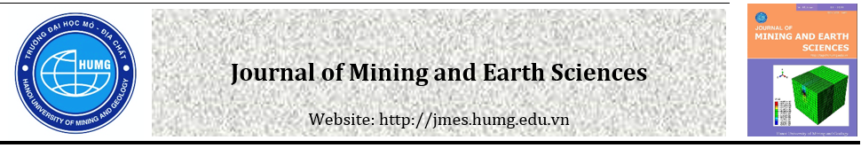
Studying the biochar modified by AgNO₃ from coffee grounds to handle organic pollutants and microorganism in the seafood-processing wastewater
Huong Thu Thi Tran ^{1*}, Tong Xuan Nguyen², Toan Ngoc Vu³, Nga Thanh Pham⁴, Cuong Manh Nguyen¹, Thanh Van Doan¹, Manh Cuong Tran¹, Duc Hieu Tran¹, Quoc Huan Nguyen⁷
^{1:} Faculty of Environment, Hanoi University of Mining and Geology, 18 Vien street, Duc Thang Ward, Bac Tư Liem District, Ha noi city
^{2:} Institute of Environmental Science, Engineering and Management, Industrial University of Ho Chi Minh City, 12 Nguyen Van Bao, Go Vap District, Ho Chi Minh city
^{3:} Institute of Chemistry - Material, Institute of Military Science and Technology, 17 Hoang Sam, Cau Giay District, Ha Noi city
^{4:} Faculty of Chemistry, Hanoi National University of Education, 136 Xuan Thuy street, Cau Giay District, Ha Noi city
⁵ Faculty of Environmental Sciences, VNU University of Science, 334 Nguyen Trai Street, Thanh Xuan District, Hanoi City, Vietnam

ARTICLE INFO |  | ABSTRACT
Article history:  Received .....April 2021  Accepted .......  Available online ....... |  | The aim of this study is using four types of biochar modified AgNO₃ from coffee grounds including CF5 (600°C/1.5h), CF6 (600°C/3h), CF7 (700°C/1.5h), and CF8 (700°C/3h) for the treatment of organic contaminants and microorganism in the seafood-processing wastewater. The results showed that the materials had the porous structure, the diameter of the pores corresponded to the crystal plane. The carbon content in the four samples reached over 90%. In addition, four samples were observed the presence of Ag with the weight percent varying from 0.06 to 0.09%. The adsorption capacities for pollutants by the four materials at different times were different. After the adsorption time, the COD value was still higher from 1.6 to 5.2 times than the limited value of the Vietnamese Standard QCVN 11:2015/MONRE - National technical regulation on the effluent of aquatic products processing industry. The three remaining parameters: TSS, ammonium (NH₄⁺), and microorganism met the standard limit value requirement of QCVN 11:2015. The TSS contents decreased with the lowest adsorption efficiency in CF5 sample (68.87%) and the highest value in CF8 sample (99.21%); NH₄⁺ content decreased respectively from 385.14 mg/L to 19.97; 15.55; 21.5 and 19.16 mg/L (CF5-CF8) with the efficiency over 94% after 2 h adsorption. The removal capacity of coliform in CF7 sample is the highest value of 640 MPN/100 mL with the efficiency of 98.61% while the lowest one obtained in CF5 sample with 4.300 MPN/100 mL and the efficiency of 90.65%.  Copyright © 2020 Hanoi University of Mining and Geology. All rights reserved.
Keywords:
ammonium, COD, coliform, adsorption capacity, TSS.
_____________________
*Tác giả liên hệ
E - mail: huonghumg@gmail.com
DOI: ......

1. Introduction

In recent years, Vietnam's seafood has made great progress, the domestic production and exports continuously increasing leading to Vietnam joining top three leading seafood producing and exporting countries in the world (Food and Agriculture United Nations, 2009). However, the seafood processing industry also discharges a large amount of wastewater into the environment, causing serious pollution of the water source. This wastewater contains high concentration of organic compounds (mainly protein and lipids) derived from sea creatures. The water-quality parameters of untreated seafood processing wastewater are often reported many times higher than the National Technical Regulation on seafood processing wastewater - QCVN 11: 2015/MONRE. Therefore, seafood processing wastewater needs to be treated effectively to reduce levels of pollutants content before releasing into the environment (VASEP, 2016). Therein, biochar is an effective material meeting this requirement.

Biochar is a carbon-rich compound produced by pyrolysis under anaerobic conditions using plant-based raw materials or various organic residuals, especially agricultural products (rice husks, corn cobs, fruit bark, poultry manure…) (Chen et al., 2011; Lehmann, 2007; Pan et al., 2013). Biochar is considered as a potential adsorbent for removing pollutants from wastewater due to its high porosity, large pore size and surface area (500 to 2.500 m²/g) (Chen et al., 2011; Lehmann, 2007; Pan et al., 2013). Biochar exhibited great adsorption ability and ion exchange capacity leading to storing significant amount of pollutants (Chen et al., 2011; Lehmann, 2007; Pan et al., 2013). In particular, biochar synthesized from coffee grounds has many advantages in terms of the source of initiral raw materials and material characteristics.

In Vietnam, researches on applying biochar to remove organic pollution or pathogenic microorganisms in aquaculture wastewater have not received much attention since most studies focus on soil improvement in agriculture (Doan et al., 2015; Mohammadi et al., 2017; Ngo et al., 2013), remove ammonium (Vu Thi Mai et al., 2016), or remove propoxur insecticide (Nguyen Khoi Nghia et al., 2015) ... Vietnamese coffee ranked second in the world in terms of producing and exporting volume; the total coffee volume for Vietnam’s domestic consumption reached 60,000 tons/year (Truong Hong, 2018), so that the annual amount of coffee grounds in Vietnam is very large, however they are often discarded as wasting carbon-based potential materials. Morever, to make biochar more effective, modified biochar has been studied. According to Cui et al (2015), AgNO₃ considered as a strong antibacterial factor that plays a main role in the treatment of microbial contamination. Therefore, the main aim of this study is to utilize coffee grounds (a kind of agriculture by-products) to synthesize biochar modified by AgNO₃ in the slow pyrolysis condition. Finally, the modified biochar will be evaluated the ability to remove organic pollution (COD, TSS, ammonium) and pathogens microorganisms from the seafood-processing wastewater.

2. Materials and methods

2.1. Preparation the biochar material

Material using in this study include the coffee grounds were collected from a company in Dak Lak province, drying in sunlight for 3 days, move to laboratory as the raw material. The seafood-processing wastewater sample was collected at the fish powder production factory in Hai Phong, stored at 4°C and transported to the laboratory.

Silver modified biochar material was synthesized according to the procedure reported by (Cui et al., 2015). Coffee grounds were crushed and passed through the 0.5 mm sieve and then heated at different temperatures and time duration: 600°C/1.5h (CF5); 600°C/3h (CF6); 700°C/1.5h (CF7) and 700°C/3h (CF8). Next step, 01 mg of each material of the CF5-CF8 synthesized biochars added into a flask containing 100 mL of deionized water and ultrasonic for 30 minutes in order to form a homogeneous suspension before 3 g of Polyvinylpyrrolidone (PVP) dissolved the solution. Afterwards, 01 mL of AgNO₃ solution (0.1N) was added and stired into the solution vigorously at 65°C/6 h in the dark condition. Samples were collected by centrifuging with deionized water 3 times and drying at 60°C for 3 h. All chemicals in this study were sourced from Merck supplies.

2.2. Methods for characterization of biochar material

The biochar samples were determined structural characteristics by a scanning electron microscope (SEM), transmission electron microscopy (TEM), scanning electron microscope (BET), Fourier-transform infrared spectroscopy (FTIR) and Energy Dispersive X-Ray (EDX) at Institute for Tropical Technology, Vietnam Academy of Science and Technology.

2.3. Methods of determining the adsorption capacity of the biochar

The original wastewater will be analyzed four parameters as COD, TSS, NH₄⁺-N and Coliform bacteria. Four types of biochar materials modified by AgNO₃ were evaluated for their adsorption capacity of pollutants according to the procedure reported by (Trinh Thi Thu Huong et al., 2015). 4 g of biochar was added in a the erlenmeyer flask containing 400 mL of seafood processing wastewater, and then stirred with the speed of 150 rpm for 2 h. All the samples were filtered through a filter paper and analyzed following parameters such as COD, TSS, NH₄⁺-N and coliform.

The adsorption capacity of qe (mg/g) at equilibrium was determined by the equation suggested by (Abdelkreem, 2013):

q_{e} = (Co-Ce).V/m

Here: Co - initial concentration (mg/L); Ce - equilibrium concentration (mg/L); V: volume of the dye solution (l); m - mass of the sorbent added (g).

The treatment efficiency (H%) at equilibrium was determined by the equation suggested by (Figueiredo et al., 2017):

H = (Co-Ce)/Co.100 (%)

2.4. Statistical data

The collected data in this study were statistic and processed by following softwares such as GraphPad 6, Origin lab 9 and Excel 2010 with statistical significance of ρ <0.05.

3. Results and discussion

3.1. Structural characterization of synthesized biochar materials

Physical and chemical characteristics of 4 types of AgNO₃ modified biochar (CF5-CF8) are given in the Table 1. It was shown that the samples produced quite high ash content (> 25%), however the BET surface area of the samples was quite low, ranging from 0.7831 to 1,2807 m²/g. All four samples recorded the presence of Ag element from 0.06 to 0.09% by weight.

Surface morphology and content of elements of different biochar samples were also determined by SEM and EDX. The results illustrated in Figures 1, 2 and 3 have shown that the surface of the control sample and the experimental sample indicated significant differences. The surface structure of four materials (CF5-CF8) noted similarity with the published biochar studies (Cui et al., 2015; Liu et al., 2015). The biochar samples all were observed rough surface, clearly fibrous structures, and the pores space corresponded to the lattice plane (Figure 2) which was different from that in Figure 1A (CF0, un-ashed coffee grounds). It had a solid surface with unknown cellulose fibers. Rough and patterned surfaces may be present during pyrolysis process or are a part of the properties of the initial raw material (Liu et al., 2015. These properties strongly influence their adsorption properties (Cui et al., 2015; Liu et al., 2015). The results shows that the ashesized coffee grounds have better adsorption capacity than the original raw material.

Table 1. Physical and chemical characteristics of four types of AgNO₃ modified biochar.
Samples | Temperature and Time | Ash Content (%) | BET surface area (m2/g) | Elemental composition of biochar surface
 |  |  |  | C (%) | O (%) | N (%) | Ag (%)
CF0 | - | - | - | 74.15 | 18.48 | 7.30 | 0.00
CF5 | 600°C/1,5 h | 27.57 | 0.8670 | 90.78 | 5.32 | 3.27 | 0.06
CF6 | 600°C/3 h | 27.00 | 0.7831 | 92.32 | 4.25 | 3.06 | 0.06
CF7 | 700°C/1,5 h | 26.41 | 1.1602 | 91.99 | 4.83 | 2.42 | 0.09
CF8 | 700°C/3 h | 25.51 | 1.2807 | 93.67 | 4.15 | 1.69 | 0.07

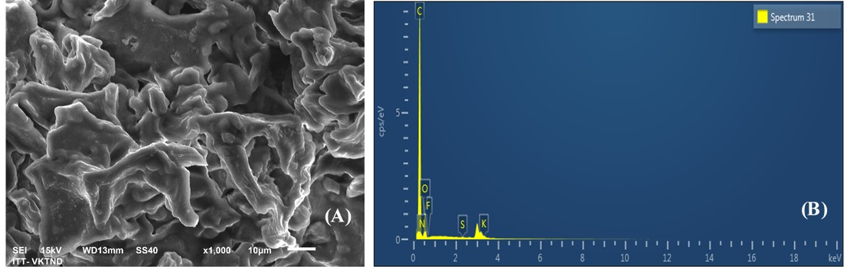

Figure 1. The SEM (A) and EDX (B) images of the control biochar CF0.

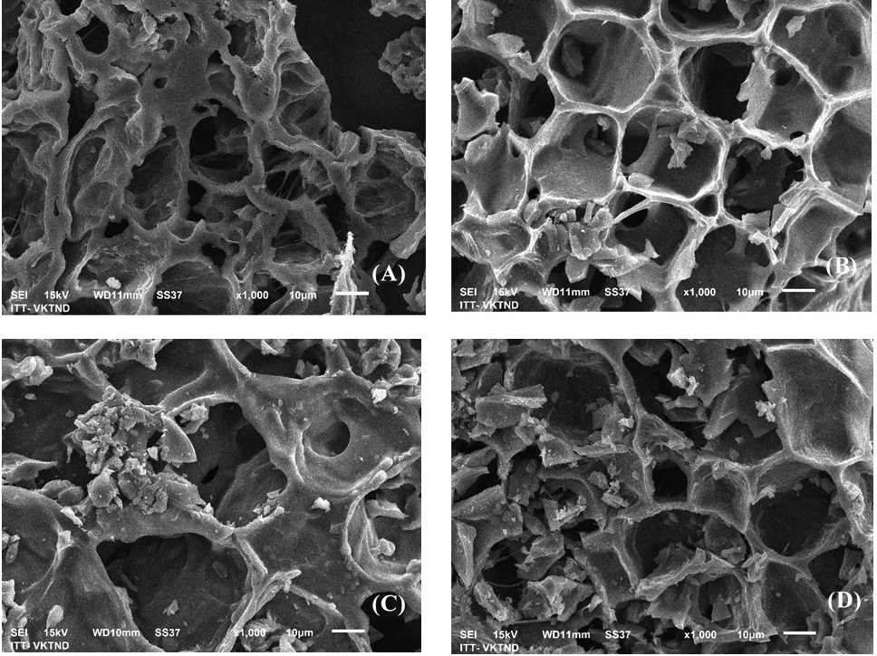
Figure 2. The SEM images of synthesized biochar materials: (A) CF5-600°C/1.5h; (B) CF6-600°C/3h; (C) CF7-700°C/1.5h and (D) CF8-700°C/3h.

EDX analysis is shown in Figures 1 and 3. It is obvious that the C content in both the raw and ashesized biochar samples was slighly high. However, the biochar samples contained much higher C content, ranging from 90.78% (CF5), 92.32% (CF6), 91.99% (CF7) and 93.67% (CF8), respectively, compared with the original raw material sample with only 74.15% of C. All samples recorded the presence of metallic Ag element with the weight percent range from 0.06 to 0.09%. The Ag element has a great influence on the material's ability to remove coliforms due to its strong antibacterial properties (Cui et al., 2015). The adsorption efficiency of pollutants depends on the polar groups on the surface of the carbonate material. The chemical groups such as hydroxyl, carboxyl groups and functional bonding groups like -OH, CH, C = O affect strongly to the ionic adsorption capacity (Hirata et al., 2002). Therefore, the C content of over 90% after ashing has been demonstrated that biochar samples obtained from coffee grounds material indicate the ability to adsorb pollutants.

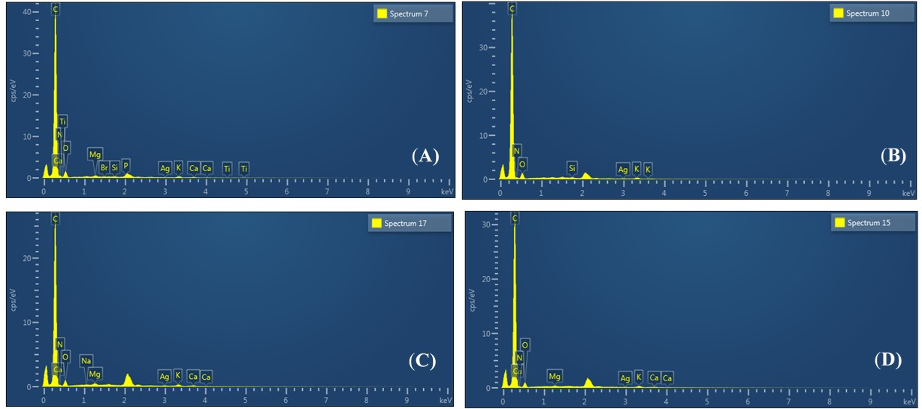
Figure 3. EDX analysis of four synthesized biochars: (A) CF5-600°C/1.5h; (B) CF6-600°C/3h; (C) CF7-700°C/1.5h and (D) CF8-700°C/3h.
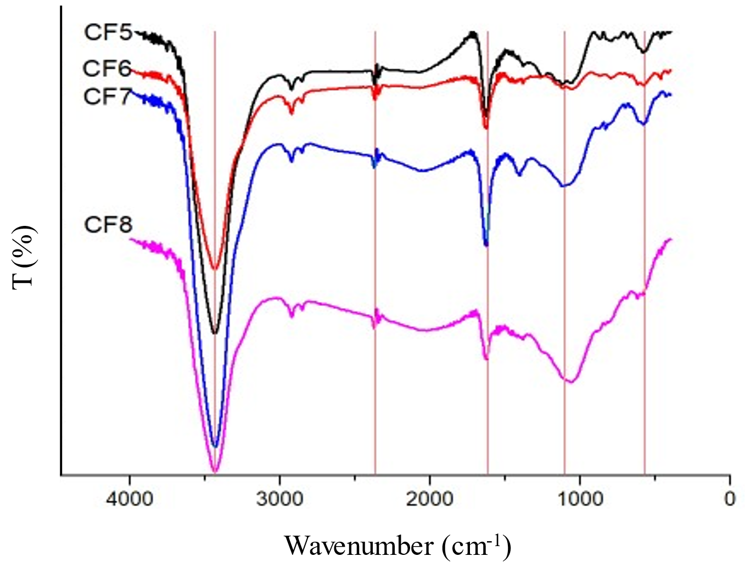
Figue 4. FTIR spectrum of four synthesized biochars: (A) CF5-600°C/1.5h; (B) CF6-600°C/3h; (C) CF7-700°C/1.5h and (D) CF8-700°C/3h.

The bonding characteristics (functional groups and bonds) on the surface of four biochar materials were determined by the FTIR spectrum. The results shown in Figure 4 reported that the adsorption spectrum of four biochar samples ranged from 500 ÷ 4.000 cm⁻¹. All samples have found associated groups such as N-H, C-O, C-H, C≡C, OH. The normal biochar materials showed an increase in intensity of oxygen-containing functional groups, especially C-O and O-H groups, and the position of C-O functional groups had changed significantly. These results proved the strong interactions of biochar materials with functional groups. In addition, no new peaks were observed in the FTIR spectrum, indicating that no new bonds were formed between the biochar materials and functional groups in aqueous solution. These results also demonstrated that the pyrolysis time significantly affected the material properties.

3.2. Evaluation of adsorption capacity of the biochar to organic pollutant and microbiological
To evaluate the removal capacity of organic pollutant and microbiological, the four water quality parameters of the initial seafood wastewater sample were analyzed, including COD, TSS, NH₄⁺-N and coliform. The analytical results (Table 2) are shown that all four parameters exceed the permitted Vietnamese standards QCVN 11: 2015/MONRE many times.

Table 2. The result analysis of pollutant parameters in the initial seafood wastewater sample
Parameters | Unit | Results | QCVN 11:2015/MONRE | Exceedance factor
COD | mg/L | 14,400 | 150 | 96
TSS | mg/L | 151 | 100 | 1.51
NH₄⁺ | mg/L | 385.14 | 20 | 19.26
Coliform | MPN/100 mL | 46,000 | 5,000 | 9.2

3.2.1. COD removal capacity of the biochar
In this study, the COD removal capacity in wastewater sample were investigated at different intervals of time: at 0h (COD0); 1 h (COD1) and 2 h (COD2). The COD analysis results in Figure 5 showed that, the COD value in the wastewater sample after adsorption by the biochar material significantly reduced comparing to the initial sample. CF7 material achieved the highest removal capacity and recorded COD value of 240 mg/L comparing to the initial sample with the COD value of 14.400 mg/L.
The COD removal efficiency of four different biochar materials was different and at different adsorption times was also different (Table 3). The study reported that the highest efficiency of CF7 material sample was 98.3% after reaction time 2 h and the lowest value of CF8 material sample was 94.58% after 1 h, respectively. The organic treatment efficiency of all CF5-CF8 biochar materials was quite high, however, the COD value after the treatment had not yet met the output requirements according to the Vietnam standard QCVN 11: 2015/MONRE and the COD values were higher from 1.6 to 5.2 times than the standard limit values.
Table 3. The COD removal efficiency of four biochar materials after 1 h and 2 h

Time (Hour) | COD (%)
Time (Hour) | CF5 | CF6 | CF7 | CF8
1 h | 96.67 | 96.67 | 97.08 | 94.58
2 h | 97.08 | 97.92 | 98.3 | 96.25

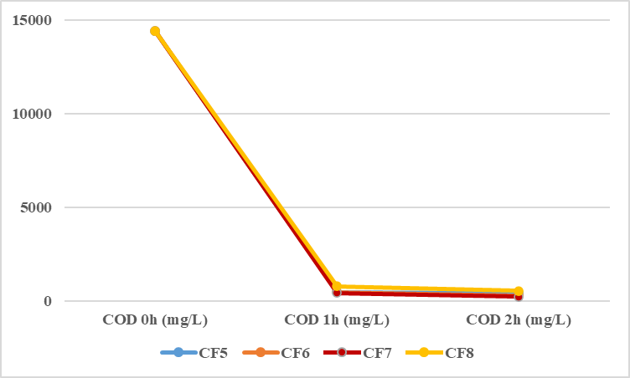

Figure 5. The COD removal capacity of four biochar materials after 1 h and 2 h (mg/L).
3.2.2. TSS removal capacity
Similarly, the four biochar materials were evaluated for their adsorption capacity with total suspended solids (TSS) after reaction time of 0, 1 and 2 h. The results are illustrated in Figure 6 and Table 4. The analysis results (Fig. 6) indicated that the TSS content significant decreased comparing to the initial wastewater sample. In which, CF8 material had achieved the highest adsorption capacity with TSS value of 1.2 mg/L after reaction time 2 h compared to the initial wastewater sample with 151 mg/L.
The treatment efficiency (Table 4) recorded the highest value of 99.21% for CF8 sample after 2 h and the lowest of 45.30% for CF6 sample after 1 h. This result proved that the reaction time played an important role to the treatment efficiency of the biochar materials. After the reaction time of 1-2 hours, all four absorbents (CF5-CF8) reported the removal capacity of TSS the output requirements according to the Vietnam standard QCVN 11: 2015/MONRE.
Table 4. The TSS treatment efficiency of four biochar materials after 1 h and 2 h
Time (hour) | TSS (%)
Time (hour) | CF5 | CF6 | CF7 | CF8
1 h | 61.19 | 45.30 | 52.32 | 82.25
2 h | 68.87 | 88.45 | 80.40 | 99.21

Figure 6. The TSS adsorption capacity of four biochar materials after 1 h and 2 h (mg/L).
3.2.3. NH₄⁺ removal capacity
NH₄⁺ content after the adsorption by the biochar materials changed according to the reaction time and is presented in Figure 7 and Table 5. After 2 h reaction time, NH₄⁺ content in all four samples (CF5-CF8) decreased from 385.14 mg/L to 19.97; 15.55; 21.50 and 19.16 mg/L, respectively. Their NH₄⁺ removal efficiency was quite similar together with the value above 94%. Our experimental results indicated that the NH₄⁺ adsorption process not only depended on the pyrolyris time and temperature, but also depended on the reaction time of the biochar materials (1 and 2 h). The highest treatment efficiency of NH₄⁺ was observed after 2h with the adsorption efficiency of up to 95% after 1 and 2 hours recorded in CF6 sample, respectively.
Table 5. The NH₄⁺-N treatment efficiency of four biochar materials after 1 h and 2 h
Time (hours) | H% (amoni)
Time (hours) | CF5 | CF6 | CF7 | CF8
1h | 94,17 | 95,45 | 92,7 | 94,51
2h | 94,82 | 95,96 | 94,42 | 95,03

Figure 7. The NH₄⁺-N adsorption capacity of four biochar materials after 1 h and 2 h (mg/L).
3.2.4. The microorganism removal capacity
The analysis result of microbiological parameter is illustreated in Figure 8 and Table 6. It is shown that the coliform density significantly decreased compared to the untreated wastewater sample and met the output requirements according to the Vietnam standard QCVN 11: 2015/MONRE. Among the four materials, CF7 had obtained the highest coliform removal capacity of 98.61% with only 640 MPN/100 mL after reaction time 2 h and the lowest value for CF5 sample after 1 h was of 4.300 MPN/100 mL with the treatment efficiency of 90.65% comparing to the initial wastewater sample.
Table 6. The microorganism treatment efficiency of four biochar materials after 1 h and 2 h
Time (hours) | H% (Coliform)
Time (hours) | CF5 | CF6 | CF7 | CF8
1h | 90.65 | 96.74 | 97.78 | 92.17
2h | 96.74 | 97.61 | 98.61 | 98.37

Figure 8. The microorganism adsorption capacity of four biochar materials after 1 h and 2 h (MPN/100 mL).

Our results are similar to the previous research published by (Vu Thi Mai et al., 2016) when using synthezed biochar material obtained from coffee grounds to treat dyes and organic pollutant in textile wastewater; the FTIR measurement results were found similar wavelengths and peaks. The removal capacity with dyes and organic matter (COD parameter) had reached the treatment efficiency of up to 96.5%; or the study reported by (Trinh Thi Thu Huong et al., 2015) who used biochar material modified corn cob H₃PO₄ and NaOH to treat organic pollution in wasterwater. The study also showed that the adsorption process occurred well at pH ≥7 and after reaction time of 60 minutes, the adsorption equilibrium had reached the highest value. In fact, the previous studies mainly used biochar to absorb dye pollution (Hirata et al., 2002; Gehan et al., 2015), pesticides (Liu et al., 2015) or remove pathogenic bacteria (Cui et al., 2015). The seafood processing wastewater with a high content of organic pollutant leads to the difficulty of treatment and not much studies investigated this issue have been reported. Biochar is a material characterized by a high specific surface area and the high the microporous density due to having layers of graphene stacked, and aromatic structure alternating with graphene layer. This special structure of the material enhances physical adsorption capacity leading to increase treatment efficiency. For these characteristics, the biochar material has been proposed as the potential material source for treating organic pollution (Rebeca et al., 2012; Deng at el., 2017).
The removal capacity of NH₄⁺ by the biochar material has been reported in many previous studies (Trinh Thi Thu Huong et al., 2015; Haider et al., 2014). The NH₄⁺ treatment efficiency was quickly achieved with the results recorded of 77% by biochar material from the cob after reaction time of 1 h (Trinh Thi Thu Huong et al., 2015), or ranged from 20.04-94.3 % when using biochar modified organic acid (Haider et al., 2014). It can be seen that with the same modified biochar for ammonium removal, the different studies have noted different treatment results. According to (Zhu et al., 2012), the ammonium content was adsorbed with certain efficiency base on chemical ion exchange mechanism on the biochar material surface from rice husk. Although the ammonium content had not full completely removed, but NH₄⁺-N adsorption biochar can be used as a preservative fertilizer due to the concentration of NH₄⁺-N removed from the wastewater solution may increase in the samples [20]. Similarly, the removal capacity of microbiological parameter showed that the number of coliform bacteria significantly decreased comparing to the initial wastewater sample.
According to (Cui et al., 2015), the biochar from rice husk modified with nano silver showed that inhibiting effect for pathogenic bacteria much higher than the biochar without nanosilver. In the biochar samples without nanosilver, this inhibition was not as high as that of materials loading silver nanoparticle, but the effect on bacterial growth was recorded. It was indicated that Ag⁺ ions play a major role in inhibiting bacterial growth, damaging the cell membrane and killing bacterial cells (Cui et al., 2015). Afrooz et al., (2016) reported that the microorganism removal process by biochar absorption depends on several factors such as surface area, hydrophilic and hydrophobic properties of the absorbent since these properties play the important role for attaching microorganism on the material surface. The porous structure can be a good habitat for bacteria (Afrooz, et al., 2016; Gorovtsov et al., 2020). It is also noted that their physical and chemical properties (like surface area, particle size, hydrophobicity, polarity ...) are very different depending on the type of raw material used and method of biochar synthesis.
4. Conclusion
This study used four biochar samples modified AgNO₃ from coffee grounds including CF5 (600°C/1.5h), CF6 (600°C/3h), CF7 (700°C/1.5h), and CF8 (700°C/3h) for treatment of the organic contaminants and microorganism in the seafood-processing wastewater. The results found that the CF7 biochar material sample acheived the highest organic pollutant removal capacity (COD) with the adsorption efficiency of 98.30% after reaction time of 2 h and the lowest value was the CF8 sample with 94.58% after 1 h. However, the COD value after the treatment of all four material had not yet met the output requirements according to the Vietnam standard QCVN 11: 2015/MONRE and the COD values were higher from 1.6 to 5.2 times than the standard limit values.
The three parameters (TSS, ammonium and microorganism) met the standard limit value requirement. After reaction time of 2 h, the TSS content decreased the lowest in CF5 sample (68.87%) and highest in CF8 sample (99.21%); NH₄⁺ content of four absorbents (CF5-CF8) decreased from 385.14 mg/L to 19.97; 15.55; 21.50 and 19.16 mg/L, respectively, with the adsorption efficiency over of 94%. The coliform removal capacity of CF7 sample had the highest efficiency of 98.61% with the value of 640 MPN/100 mL and the lowest efficiency (90.65%) was observed in the sample CF5 with the decrease value of 4.300 MPN/100 mL. These results showed that the biochar modified by AgNO₃ is the potential material for removing pollution contamination in wastewater.

References
A.J. Haider, M.R. Mohammed, E.A.J. Al-Mulla, D.S. Ahmed (2014), “Synthesis of silver nanoparticle decorated carbon nanotubes and its antimicrobial activity against growth of bacteria”, Rend. Lincei, 25, pp.403-407.
A.R.M.N. Afrooz, A.B. Boehm (2016), “Escherichia coli removal in biochar-modified, biofilters: effects of biofilm”, PLOS ONE, 11(12), DOI: 10.1371/journal.pone.0167489.
Andrey V. Gorovtsov, Tatiana M. Minkina, Saglara S. Mandzhieva, Leonid V. Perelomov, Gerhard Soja, Inna V. Zamulina, Vishnu D. Rajput, Svetlana N. Sushkova, Dinesh Mohan & Jun Yao. The mechanisms of biochar interactions with microorganisms in soil.
B. Chen, Z. Chen, L. Shaofang (2011), “A novel magnetic biochar efficiently sorbs organic pollutants and phosphate”, Bioresource Technology, 102(2), pp.716-723.
Cui, Y. Yang, Y. Hu, F. Li (2015), “Rice husk based porous carbon loaded with silver nanoparticles by a simple and cost-effective approach and their antibacterial activity”, Journal of Colloid and Interface Science, 455, pp.117-124.
Gehan M.K. Tolba, Nasser A.M. Barakat, A.M. Bastaweesy, E.A. Ashour, Wael Abdelmoez, Mohamed H. El-Newehy, Salem S. Al-Deyab, and Hak Yong Kim (2015), “Effective and highly recyclable nanosilica produced from the rice husk for effective removal of organic dyes”, Journal of Industrial and Engineering Chemistry, 29, pp.134-145.
Hirata, M., Kawasaki, N., Nakamura, T., Matsumoto, K., Kabayama, M., Tamura, T., Tanada, S (2002), “Adsorption of dyes onto carbonaceous materials produced from coffee grounds by microwave treatment”, Journal of Colloid and Interface Science, 254(1), pp.17-22.
J. Lehmann (2007), “A handful of carbon”, Nature, 447, pp.143-144.
J. Pan, J. Jiang, R. Xu (2013), “Adsorption of Cr (III) from acidic solutions by crop straw derived biochars”, Journal of Environmental Sciences, 25(10), pp.1957-1965.
K. Zhu, H. Fu, J. Zhang, X. Lv, J. Tang, X. Xu (2012), “Studies on removal of NH4+-N from aqueous solution by using the activated carbons derived from husk”, Biomass and Bioenergy, 43, pp.18-25.
M. Abdelkreem (2013), “Adsorption of phenol from industrial wastewater using olive mill waste”, APCBEE Procedia, 5, pp.349-357.
M.K.K. Figueiredo, K.N.C. Caldas, B.P. Nascimento, P. Schroeder, G.A. Romeiro (2017), “Use of biochar obtained from coffee grounds as adsorbent of dyes and solid biofuel”, Revista Eletrônica em Gestão, Educação e Tecnologia Ambiental Santa Maria, 21, pp.92-103.
Mai, V.T., Tuyen, T.V.: Research on ammoniumremovalfrom aqueous solution usingmodified corncob-biochar by H3PO4 and NaOH. VNU J. Sci. 32, 274–281 (2016)
Mohammadi, A., Cowie, A.L., Anh Mai, T.L., Brandão, M., Anaya de la Rosa, R., Kristiansen, P., Joseph, S (2017), “Climate-change and health effects of using rice husk for biochar-compost: comparing three pyrolysis systems”, J. Clean. Prod., 162 pp.260-272.
N. Liu, A.B. Charrua, C.H. Weng, X. Yuan, F. Ding (2015), “Characterization of biochars derived from agriculture wastes and their adsorptive removal of atrazine from aqueous solution: a comparative study”, Bioresource Technology, 198, pp.55-62.
Nghia, N.K., Oanh, N.T.K., Sang, D.H., Lang, L.T.: Immobilization capacity of biochar for the pesticide Propoxur degrading bacteria, Paracoccus sp. P23-7. Sci. J. Can Tho Univ. (Vietnam) 38, 88–94 (2015)
Ngo, P.T., Rumpel, C., Ngo, Q.A., Alexis, M., Vargas, G.V., Mora Gil, M.d.l.L. (2013), “Biological and chemical reactivity and phosphorus forms of buffalo manure compost, vermicompost and their mixture with biochar”, Bioresour. Technol. 148, tr.401-407.
Rebeca Cruz, Maria M. Cardoso, Luana Fernandes, Marta Oliveira, Eulália Mendes, Paula Baptista, Simone Morais, and Susana Casal (2012), “Espresso coffee residues: a valuable source of unextracted compounds”, Journal of Agricultural and Food Chemistry, 60(32), pp.7777-7784.
T.T. Doan, T. Henry-Des-Tureaux, C. Rumpel, J.L. Janeau, P. Jouquet (2015), “Impact of compost, vermicompost and biochar on soil fertility, maize yield and soil erosion in Northern Vietnam: a threeyear mesocosm experiment”, Sci. Total Environ., 514, pp.147-154.
Trinh Thi Thu Huong, Vu Duc Thao (2015), “Research on using biochar from coffee grounds to treat color and organic matter in textile wastewater", Journal of Chemical Analysis, Physics and Biology, 20 (2): 76-82.
Truong Hong, (2018). Report of ‘Area and Output of Coffee in the World, Western Highlands Agriculture and Forestry Science Institute, 2018.
VASEP Report, 2016.
Y. Deng, Z. Tao, W. Qiming (2017), “Biochar adsorption treatment for typical pollutants removal in livestock wastewater: a review”, Engineering Applications of Biochar, 5, DOI: 10.5772/intechopen.68253.

