Effect of annealing temperature on Cu₂O thin films prepared by thermal oxidation method.
Tran Thi Ha^{1,2}, Nguyen Thi Huyen Trang², Bach Thanh Cong²,
Nguyen Thi Dieu Thu¹, Nguyen Thanh Binh², Pham Nguyen Hai^{2#}, NguyenViet Tuyen^{2,*}
¹Department of Physics, Faculty of Basic Science, University of Mining and Geology, Duc Thang, Tu Liem, Hanoi
²Faculty of Physics, Vietnam National University- University of Science, 334 Nguyen Trai, Thanh Xuan, Hanoi
Email: #phamnguyenhai@hus.edu.vn; *nguyenviettuyen@hus.edu.vn;
Abstract: We report a facile process to fabricate cuprous thin film by thermal oxidation of copper substrate. Structure and phase identification were studied by Xray diffraction measurement and Raman spectroscopy. Scanning electron microscopy was utilized to study surface morphology of the as-fabricated thin films and optical properties of the sample was investigated with diffused reflectance spectroscopy. The study shows that cuprous thin films could be obtained by controlling annealing temperature in region of 200-300 ºC.
Keywords: copper oxide; thin films; thermal oxidation; Raman
- Introduction:
Cuprous oxide (Cu₂O) is a semiconductor with bandgap of around 1-2 eV [1], which finds many applications in fields of sensor, photocatalyst and especially photovotaics [2–8] thanks to their interesting properties such as: earth abundant composition, environment friendly, high absorption coefficient in visible region, p type conduction. Even though the efficiencies of solar cell based on copper oxide is often quite low of around 1-2%, the ratio of efficiency to cost of Cu₂O is still very competitive to other materials. Hence, preparation of Cu₂O thin film is an interesting topic for study from both fundament and application point of view.
Various techniques were developed to fabricate Cu₂O thin films for example: electro-deposition, chemical oxidation, reactive sputtering, reactive chemical deposition [4,9–14]… However, to realize such applications, a cost effective fabrication process is very important. In this paper, we report a one-step process to fabricate high quality cuprous thin films by thermal oxidation and investigate the influence of annealing temperature on the structure and some properties of the materials.
- Experiment
Cuprous oxide thin films were prepared on high purity copper substrates. Diluted HCl acid (10%) solution was first used to remove native oxide layer on copper substrate. The substrates were then rinsed thoroughly with distilled water. Thermal oxidation of copper substrate was performed in an electrical furnace XD-1600MT. The annealing time was set at various temperatures in range of 200-300 ºC. Surface morphologies of the as-produced thin films were studied by using Nova Nano SEM 450. Raman spectra of samples were acquired on Labram 800 from Horiba. The samples were excited with 632.8 nm line of He-Ne laser. All spectra were taken at room temperature with acquisition time of 30s and low power at surface sample of 0.5 mW. Structure and phase identification of the samples were investigated by Xray diffractometer Bruker D500, using monochromatic wavelength (1.54056 Å) of Cu K_{α} radiation. Energy dispersive Xray spectroscopy integrated on SEM system was used to verify elemental composition of the sample. Optical properties of the samples were characterized with diffuse reflectance spectroscopy.
- Results and discussion:
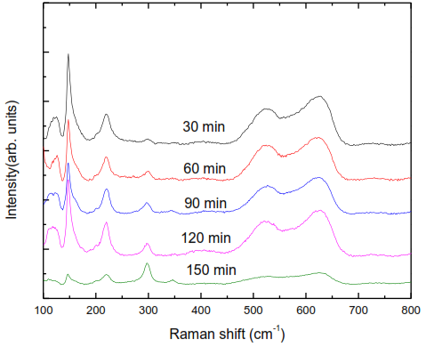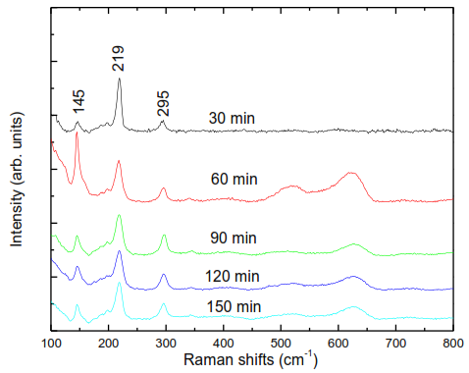
(a) (b)
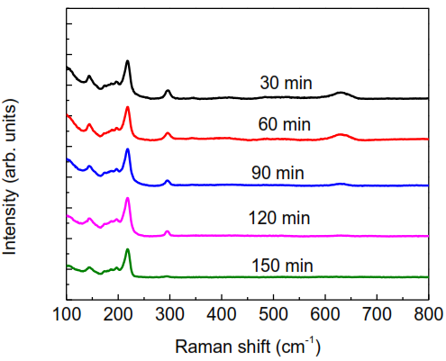
(c)
Figure 1. Raman spectra of copper oxide thin films prepared at 200 ºC (a); 250 ºC (b) and 300 ºC in different times.
Figure 1 shows Raman spectra of copper oxide thin films prepared at different temperatures and times. Several Raman features were observed in the region from 100 to 600 cm⁻¹. Three characteristic peaks of CuO appeared at 288 cm⁻¹, 330 and 621 cm⁻¹, which can be assigned to the A_{g}, B_{1g} and B _{2g} modes, respectively [15,16]. Other Raman peaks in region 100-300 cm⁻¹ belong to Cu₂O as reported [17–19]. It should also be noted that according to group theory, cuprous oxide has one Raman active mode at 600 cm⁻¹. However this Raman mode was not observed in the spectra of these samples. Some other Raman features were observed at around 200 cm⁻¹. These Raman modes are believed to related to defects in this Cu₂O materials, which are reponsible for p type conduction in Cu₂O [19,20].
As can be seen from Raman spectra in Figure 1, after 30 min of annealing, both CuO and Cu₂O were formed. As increasing annealing time to 60 min, the intensity of the peaks of Cu₂O increased notably and became dominant in the spectra. At longer annealing time and higher temperature, the peaks of CuO became weaker and weaker. At annealing time of 150 min, the most intense peak of CuO at 290 cm⁻¹ almost disappeared for samples annealed at 300 ºC. We understand that 300 ºC the crystal growth rate of Cu₂O is higher than that of CuO and even though the obtained thin films are composed of both Cu₂O and CuO, Cu₂O becomes dominant at the latter stage of the growth and might form a layer of Cu₂O on top of the films.
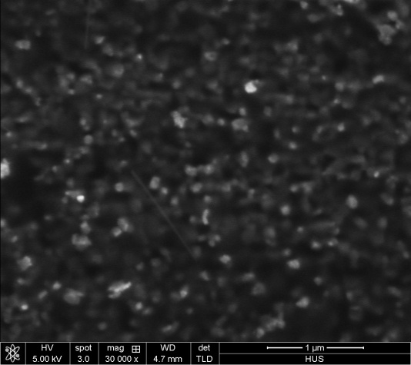
Figure 2. SEM image of copper oxide thin film prepared at 300 ºC in 150 min
Figure 3. Energy dispersive spectrum of copper oxide thin film prepared at 300 ºC in 150 min
SEM image of copper oxide thin film annealed in 150 min is shown in Figure 2. It can be seen that the obtained film contains no crack or holes. The top view image demonstrates that the film is composed of nanocrystals. The purity of the sample was verified by the fact that only oxygen and copper peaks appear in the EDS spectrum.
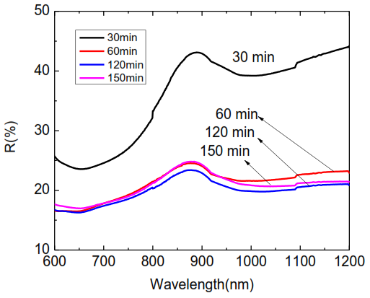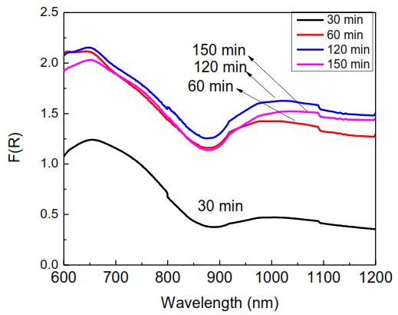
(a) (b)
Figure 4. Diffuse reflectance spectra (a) and F(R) vs wavelength plot (b) of thin films prepared at 300 ºC in different times.
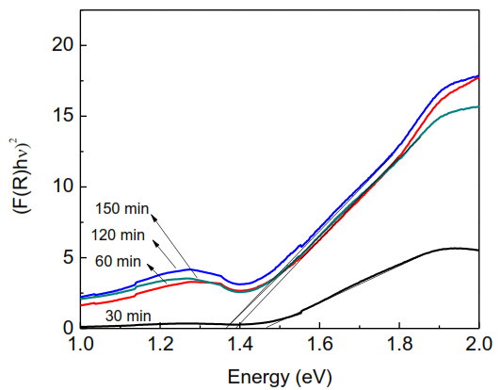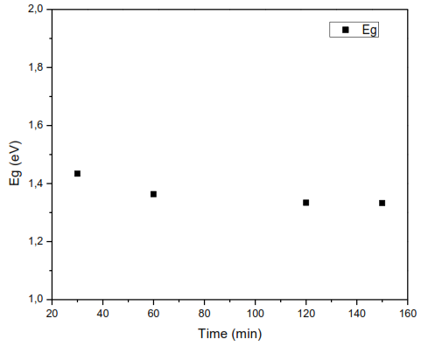
(a) (b)
Figure 5. Plot of (F(R).hv)² vs hv (a) and bandgap values (b) of the samples annealed at 300 ºC in different times.
Figure 4 shows diffuse reflectance spectra and the plot of absorption coefficient F(R) calculated from reflectance data by using Mubelka Munk function. From the absorption coefficient, the plot of (F(R)hv)² vs. hv was built to estimate the bandgap of the as-prepared films. Band gap values are extrapolated from intersection between the linear fit of the graphs with the energy axis.
The results show that band gap gradually reduces as heating time decreases. Bandgap of the films tends to remain unchanged at heating greater than 120 min. The results can be understood that at long annealing time, Cu₂O is the dominant phase in the sample as shown by Raman data. The bandgap value of the films is closed to the optimal value for solar absorber layer for solar cell.
- Conclusion:
High quality thin films of cuprous oxide were successfully fabricated on copper substrate by thermal oxidation method. The results showed that annealing temperature and annealing time are critical parameters to get thin films of pure phase. The as-prepared copper oxide thin films has band gap of around 1.4 eV, which is optimum for solar absorbing materials and hence are very promising in electronic and photovoltaics applications.
Acknowledgement:
This research is funded by Vietnam National Foundation for Science and Technology Development (NAFOSTED) under grant number 103.02-2017.351
References:
[1] Y. Wang, S. Lany, J. Ghanbaja, Y. Fagot-Revurat, Y.P. Chen, F. Soldera, D. Horwat, F. Mücklich, J.F. Pierson, Electronic structures of Cu₂O, Cu₄O₃, and CuO: A joint experimental and theoretical study, Phys. Rev. B. 94 (2016) 1–10. doi:10.1103/PhysRevB.94.245418.
[2] K. Mikami, Y. Kido, Y. Akaishi, A. Quitain, T. Kida, Synthesis of Cu₂O/CuO nanocrystals and their application to H₂S sensing, Sensors (Switzerland). 19 (2019) 1–14. doi:10.3390/s19010211.
[3] M. Hara, Cu2O as a photocatalyst for overall water splitting under visible light irradiation, Chem. Commun. 2 (1998) 357–358. doi:10.1039/a707440i.
[4] N. Dasineh Khiavi, R. Katal, S. Kholghi Eshkalak, S. Masudy-Panah, S. Ramakrishna, H. Jiangyong, Visible Light Driven Heterojunction Photocatalyst of CuO–Cu₂O Thin Films for Photocatalytic Degradation of Organic Pollutants, Nanomaterials. 9 (2019) 1011(1)-1011(12). doi:10.3390/nano9071011.
[5] H.M. Wei, H.B. Gong, L. Chen, M. Zi, B.Q. Cao, Photovoltaic Efficiency Enhancement of Cu₂O Solar Cells Achieved by Controlling Homojunction Orientation and Surface Microstructure, J. Phys. Chem. C. 116 (2012) 10510–10515.
[6] Y. Ievskaya, R.L.Z. Hoye, A. Sadhanala, K.P. Musselman, J.L. MacManus-Driscoll, Improved Heterojunction Quality in Cu₂O-based Solar Cells Through the Optimization of Atmospheric Pressure Spatial Atomic Layer Deposited Zn_{1-x}Mg_{x}O, J. Vis. Exp. (2016) 1–7. doi:10.3791/53501.
[7] N. Winkler, S. Edinger, J. Kaur, R.A. Wibowo, W. Kautek, T. Dimopoulos, Solution-processed all-oxide solar cell based on electrodeposited Cu₂O and ZnMgO by spray pyrolysis, J. Mater. Sci. 53 (2018) 12231–12243. doi:10.1007/s10853-018-2482-2.
[8] T.H. Tran, V.T. Nguyen, Copper Oxide Nanomaterials Prepared by Solution Methods, Some Properties, and Potential Applications: A Brief Review, Int. Sch. Res. Not. 2014 (2014) 1–14. doi:10.1155/2014/856592.
[9] T.H. Tran, V.T. Nguyen, Phase transition of Cu₂O to CuO nanocrystals by selective laser heating, Mater. Sci. Semicond. Process. 46 (2016) 6–9. doi:10.1016/j.mssp.2016.01.021.
[10] T.T. Ha, N. Thi, H. Trang, N.M. Hong, N.V. Tuyen, Fabrication of thin cuprous oxide layer on copper substrate by thermal oxidation method, Proc. IWNA 2017, 08-11 Novemb. 2017, Phan Thiet, Vietnam. (2017) 391–393.
[11] I.S. Brandt, M.A. Tumelero, S. Pelegrini, G. Zangari, A.A. Pasa, Electrodeposition of Cu₂O: growth, properties, and applications, J. Solid State Electrochem. 21 (2017) 1999–2020. doi:10.1007/s10008-017-3660-x.
[12] D.S. Zimbovskii, B.R. Churagulov, Cu₂O and CuO Films Produced by Chemical and Anodic Oxidation on the Surface of Copper Foil, Inorg. Mater. 54 (2018) 660–666. doi:10.1134/S0020168518070208.
[13] S. Dolai, S. Das, S. Hussain, R. Bhar, A.K. Pal, Cuprous oxide (Cu₂O) thin films prepared by reactive d.c. sputtering technique, Vacuum. 141 (2017) 296–306. doi:10.1016/j.vacuum.2017.04.033.
[14] M.D. Susman, Y. Feldman, A. Vaskevich, I. Rubinstein, Chemical deposition of Cu2O nanocrystals with precise morphology control, ACS Nano. 8 (2014) 162–174. doi:10.1021/nn405891g.
[15] T.H. Tran, V.T. Nguyen, Phase transition of Cu2O to CuO nanocrystals by selective laser heating, Mater. Sci. Semicond. Process. 46 (2016) 6–9. doi:10.1016/j.mssp.2016.01.021.
[16] T.T. Ha, B.T. Huyen, N.V. Tuyen, Preparation of Well-aligned CuO Nanorods by Thermal Oxidation Method, 32 (2016) 40–44.
[17] D.T.M. Huong, N.H. Nam, L. Van Vu, N.N. Long, Preparation and optical characterization of Eu₃₊ doped CaTiO₃perovskite powders, J. Alloys Compd. 537 (2012) 54–59. doi:10.1016/j.jallcom.2012.05.087.
[18] H. Solache-Carranco, G. Juarez-Diaz, M. Galvan-Arellano, J. Martinez-Juarez, G. Romero-Paredes R., R. Pena-Sierra, Raman scattering and photoluminescence studies on Cu₂O, in: 2008 5th Int. Conf. Electr. Eng. Comput. Sci. Autom. Control. CCE 2008, 2008: pp. 421–424. doi:10.1109/ICEEE.2008.4723375.
[19] T. Sander, C.T. Reindl, P.J. Klar, Breaking of Raman selection rules in Cu₂O by intrinsic point defects, Mater. Res. Soc. Symp. Proc. 1633 (2014) 81–86. doi:10.1557/opl.2014.47.
[20] T. Sander, C.T. Reindl, M. Giar, B. Eifert, M. Heinemann, C. Heiliger, P.J. Klar, Correlation of intrinsic point defects and the Raman modes of cuprous oxide, Phys. Rev. B - Condens. Matter Mater. Phys. 90 (2014) 1–8. doi:10.1103/PhysRevB.90.045203.

