Preparation of ZnO nanoflowers for surface enhance Raman scattering applications
Tran Thi Ha¹, Nguyen Manh Hong², Pham Van Thanh², Mai Hong Hanh², Sai Cong Doanh²,Nguyen Thi Dieu Thu¹,Nguyen Thanh Binh², Nguyen Trong Tam³, Ho Khac Hieu⁴,Pham Nguyen Hai²,Nguyen Viet Tuyen^{2*}
¹Department of Physics, Faculty of Basic Science, University of Mining and Geology, Duc Thang, Tu Liem, Hanoi
²Faculty of Physics, Vietnam National University- University of Science, 334 Nguyen Trai, Thanh Xuan, Hanoi
³Department of Physics, Faculty of Basic –Fundamental Sciences, Vietnam Maritime University, 484 Lach Tray – Le Chan - Hai Phong
⁴Duy Tan University, 03 Quang Trung, Danang, Vietnam
*Corresponding author: nguyenviettuyen@hus.edu.vn

Abstract: Thanks to unique Raman spectra of chemical substances, a growing number of applications in environmental and biomedical fields based on Raman scattering has been developed. However, the low probability of Raman scattering hindered its potential development and thus, many different techniques were developed to enhance Raman signal. A key step of surface-enhanced Raman scattering technique is to prepare active SERS substrate from noble metals. The main enhancement mechanism is electromagnetic enhancement resulted from surface plasmon resonance. The disadvantages of nanoparticles based SERS substrates include high randomness due to self - assembly process of nanoparticles. Recently, a new kind of SERS substrates with order nanostructures of semiconductors combining with noble metals can serve as active SERS substrates, which are expected to possess high enhancement of Raman signals. In this study, ordered ZnO nanorods were first prepared by galvanic hydrothermal method and gold was sputtered on the as prepared ZnO nanomaterials to enhance Raman. Our SERS substrates exhibit promising high enhancement factors, and can detect chemical substances at concentration in nano molar range.
Keywords: ZnO, nanorods, Raman scattering, hydrothermal, galvanic effect.

- Introduction:
Raman spectroscopy is well known as a useful tool to characterize materials with many advantages such as: non-destructive, time saving and ability to provide finger-print spectra of materials. However, the main limitation of this method is low Raman intensity due to small probability of inelastic scattering. Surface enhanced Raman scattering is believed to be a perfect solution to overcome this bottleneck. The key problem is to fabricate SERS substrate of high uniformity and high enhancement factor. Among available noble metals for SERS, gold has several advantages compared with other including: chemical stability, biocompatibility[1]. Although SERS substrates based on colloidal particles were reported to provide good results in regards tohigh enhancement factor. Difficulties in controlling size, shape and the distance between nanoparticles lead to limited repeatability Raman results. Another approach is to distribute noble metal nanoparticles on 1D semiconductor nanostructures[2–4]. This approach is hoped to provide reproducibility and consistent analysis results. Moreover, enhancement factor of these structures is believed to be higher than that of noble metal nanoparticles due to charge transfer between metallic nanoparticles and semiconductor nanomaterials[4].
ZnO is a potential candidate because it is convenient to fabricate, environmental friendly, economical, diversity in size and shape of available nanostructures[5–9]. In this research, ZnO nanoflowers were fabricated by a simple hydrothermal process assisted with galvanic effect. Effect of hydrothermal time on the morphology of the nanoproduct was investigated. Gold was then deposited on the as prepared ZnO nanorods by sputtering method.
2. Experiment
ZnO nanoproducts were prepared by hydrothermal method assisted with galvanic effect[8,10]. First, the print circuit boards served as substrates were polished by fine sand paper to remove oxide and any surface cover on top of copper layer. The substrates were then cleaned in sequence with acetone, ethanol and double distilled water. Aluminum foil was used to cover the edge of substrates. The center area (5×5 mm) were left blank for the growth of ZnO nanomaterials.
Equal volumes of 90 mM Zn(NO₃)₂ and hexamethylence tetra-amine (HMTA) solutions were mixed well. The as prepared substrates were then immersed into the above mixture solution. The substrates were held upside down horizontally in the solution. The temperature of the system was raised to 90 ºC and maintained in 3h. Then, the samples were rinsed with double distilled water and dried in air at 90 ºC in 30 min. For surface enhance Raman scattering applications, ZnO nanoproducts were then sputtered with gold in 15 s with a current of 30 mA. The samples were characterized with Raman spectroscopy Horiba Jobin Yvon, HR 800, Scanning electron microscopy (Nova NanoSem), energy dispersive spectrum integrated in SEM system. The photoluminescence spectra of the samples were measured on FL3-22 spectrometer.
Surface enhanced Raman scattering was investigated with methylene blue (MB) as probe agent. 10⁻⁷ M MB solution was dropped on ZnO/Au nanomaterials. The sample was dried naturally before Raman measurement. The excitation wavelength was 632.8 nm from He-Ne laser. The spectra were taken at room temperature with low laser power of 0.5 mW at the surface sample to avoid burning of MB.

3. Results and discussion
Figure 1 shows morphology of ZnO sample observed by scanning electron microscopy. SEM image reveals that the as-prepared nanostructures are grown densely and have multi-pod structure. These nanorods were grown from one common centre in radial directions and formed flower structures as observed. The formation of the multi-pod structures might result from a small poly-crystal which plays the role of seed for the growth of small nanorods. The small nanorods have hexagonal cross-section with length of several micrometers. The rods have tapered tips with the average diameter at the tips and bottom of the rods are in the range of 70 and 300 nm, respectively. The reduction of precursor solution at the latter stage of the synthesis might be responsible for tapered tip configuration of the nanorods.
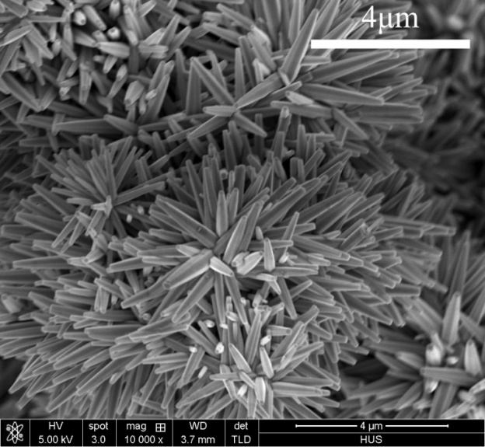 | 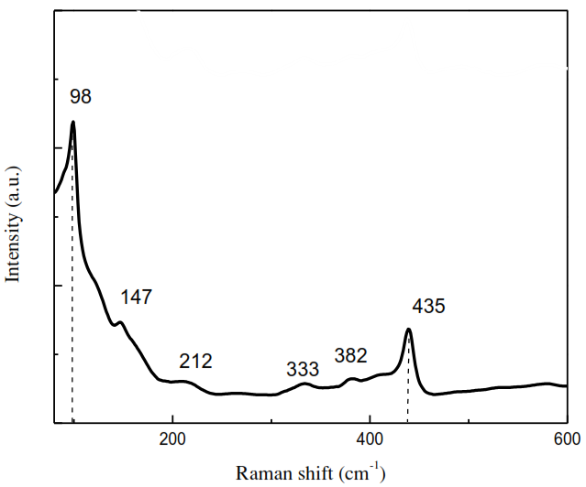
Figure 1. SEM images of ZnO nanoflowers prepared in different hydrothermal time: 3 h. | Figure 2. Raman spectrum of ZnO nanoflowers

Raman spectrum of the prepared ZnO nanoflowers is shown in Figure 2. Two clear peaks can be seen in the spectrum at 98 and 435 cm⁻¹, corresponding to E₂^{low} and E₂^{high} Raman modes of ZnO. These modes are resulted from the lattice vibrations of zinc and oxygen, respectively. High intensities of these two peaks along with observation of 2E₂^{low} at 212 cm⁻¹ demonstrate high crystal quality of the samples. Some other peaks of low intensity can be observed at 333 and 382 cm⁻¹. These peaks correspond to 3E₂^{high}-E₂^{low}, A₁(TO) modes of ZnO[11–13].Another peak, observed at 147 cm⁻¹, was believed to be related to the intrinsic host lattice defects in ZnO[14].
Photoluminescence spectrum of the as-prepared ZnO nanoflowers is shown in Figure 3. A sharp band to band transition was observed at 380 nm. A broadgreen band at around 540 nm is attributed to transition from intrinsic defects of ZnO, i.e. zinc interstitial, oxygen vacancies or complex defects of these two. This result is in agreement with the Raman data discussed above. Relative intensities between defect and band to band transitions are usually considered as an indicator of crystal quality of ZnO. The much lower intensity of green emissioncompared with that of near band edge transition reconfirms the high quality of ZnO crystal of our sample.
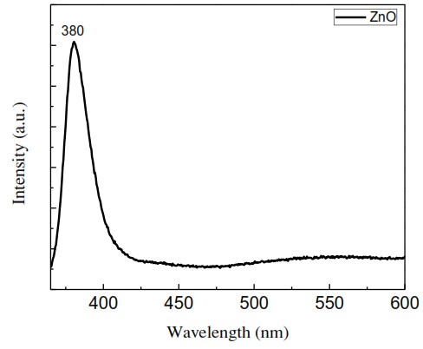 | 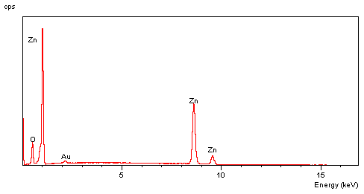
Figure 3. Photoluminescence spectrum of ZnO nanoflowers prepared by hydrothermal method. | Figure 4.. EDS spectrum of ZnO/Au nanoflowers

Recently some researchers proposed new SERS platforms based on 1D nanostructures of semiconductor and noble metals. Such new type of SERS substrates are expected to possess higher repeatability and high enhancement factor. To demonstrate the potential of applying ZnO nanoflowers in the field of SERS, the ZnO nanoflower sample was then coated with gold by sputtering methods.Figure 4 shows EDS spectrum of ZnO/Au nanoflowers. EDS measurement shows that ZnO/Au nanoflowers are pure and clean without any residue or contaminants.
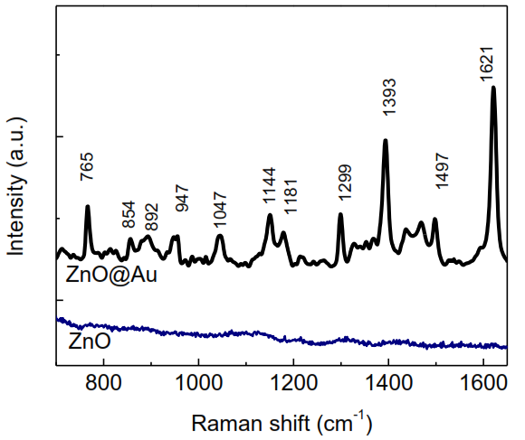
Figure 5. SERS spectra of Methylence Blue measured on ZnO@Au nanorods and bare ZnO nanorods.

Figure 5 shows the Raman spectra of 10⁻⁷ Mb measured on ZnO/Au nanorods and bare ZnO nanorods. As can be seen in the spectra, without gold layer, only a background noise was recorded. In contrast, clear Raman peaks of MB were observed when measured on ZnO/Au nanoflowers substrate.
Characteristic peaks of MB can be detected clearly at 765, 1144, 1299, 1393, 1497, 1621 cm⁻¹. The corresponding vibration modes were summarised in Table 1. The peak position shows good agreement with previous reports[15–17]. The advanced properties of ZnO/Au nanoflowers as SERS substrate are resulted from several simultaneous phenomena. First, charge transfer between metal layers and semiconductor nanomaterials further enhanced electromagnetic field at the surface of metallic nanomaterials. Second, the density of hot spots distributed on the surface of semiconductor nanomaterial might increase greatly thanks to high surface area of nanomaterials.Estimated enhancement factor of the ZnO/Au substrates was 10⁷, which demonstrates the potential of using ZnO/Au nanoflowers as SERS substrate.

Table 1. Raman peak position and the corresponding vibration mode
Observed Raman peak | Raman vibration mode [15,16]
765 | (C-N)AMG; (C-N-C) ring
854 | (C-C-C) ring; (C-N-C) ring;
947 | (CH2); (CH)
1144 | (CH)
1181 | (CH3); (CH)
1299 | (CH); (C-N) ring
1393 | (C9-N10); (C3-N2); (C-N) ring; (CH)
1497 | (CH2)twist ; (CH)
1621 | (C-C)/(C-N)

Conclusion
ZnO nanoflowers were successfully prepared by hydrothermal method assisted with galvanic effect. The as-prepared nanoflowers are made of hexagonal ZnO nanorods of uniform in size and shape grown from one common poly-crystal seed. The nanoproducts are of good quality as demonstrated by Raman spectroscopy, photoluminescence. ZnO/Au is a potential SERS substrate with high enhancement factor. The results suggested that ZnO/Au could be a useful tool to measure toxic substances at low concentration and hence can be applied in the field of environment monitoring. Further optimization of the ZnO nanoproducts and thickness of gold layer is under investigation; hopefully the results can be developed as a novel, high sensitivity surface enhanced Raman scattering substrates for chemical detection at trace level.

Acknowledgement
This research was funded by the Vietnam Ministry of Education and Training under grant number B2018-MDA-01-CtrVL
References:
[1] B.B. Karakoçak, R. Raliya, J.T. Davis, S. Chavalmane, W.N. Wang, N. Ravi, P. Biswas, Biocompatibility of gold nanoparticles in retinal pigment epithelial cell line, Toxicol. Vitr. 37 (2016) 61–69. doi:10.1016/j.tiv.2016.08.013.
[2] H. Gebavi, D. Ristić, N. Baran, L. Mikac, V. Mohaček-Grošev, M. Gotić, M. Šikić, M. Ivanda, Horizontal silicon nanowires for surface-enhanced Raman spectroscopy, Mater. Res. Express. 5 (2018) 015015(1)-015015(8). doi:10.1088/2053-1591/aaa152.
[3] B.S. Lee, D.Z. Lin, T.J. Yen, A low-cost, highly-stable surface enhanced raman scattering substrate by si nanowire arrays decorated with au nanoparticles and Au backplate, Sci. Rep. 7 (2017) 1–7. doi:10.1038/s41598-017-04062-4.
[4] X. Zhao, W. Zhang, C. Peng, Y. Liang, W. Wang, Sensitive surface-enhanced Raman scattering of TiO2/Ag nanowires induced by photogenerated charge transfer, J. Colloid Interface Sci. 507 (2017) 370–377. doi:10.1016/j.jcis.2017.08.023.
[5] N.V. Tuyen, T.D. Canh, N.N. Long, N.X. Nghia, B.N.Q. Trinh, Z. Shen, Synthesis of undoped and M-doped ZnO (M Co, Mn) nanopowder in water using microwave irradiation, J. Phys. Conf. Ser. 187 (2009) 1–7. doi:10.1088/1742-6596/187/1/012020.
[6] T.D. Canh, N.V. Tuyen, N.N. Long, Influence of solvents on the growth of zinc oxide nanoparticles fabricated by microwave irradiation, 25 (2009) 71–76.
[7] N.T. Huong, N.V. Tuyen, N.H. Hong, Structural properties of P-doped ZnO, Mater. Chem. Phys. 126 (2011) 54–57. doi:10.1016/j.matchemphys.2010.12.012.
[8] P. Van Thanh, L.T.Q. Nhu, H.H. Mai, N.V. Tuyen, S.C. Doanh, N.C. Viet, D.T. Kien, Zinc Oxide Nanorods Grown on Printed Circuit Board for Extended-Gate Field-Effect Transistor pH Sensor, J. Electron. Mater. 46 (2017) 3732–3737. doi:10.1007/s11664-017-5369-0.
[9] N.V. Tuyen, N.N. Long, T.T.Q. Hoa, N.X. Nghia, D.H. Chi, K. Higashimine, T. Mitani, T.D. Canh, Indium-doped zinc oxide nanometre thick disks synthesised by a vapour-phase transport process, J. Exp. Nanosci. 4 (2009) 243–252. doi:10.1080/17458080802627482.
[10] H.H. Mai, V.T. Pham, V.T. Nguyen, C.D. Sai, C.H. Hoang, T.B. Nguyen, Non-enzymatic Fluorescent Biosensor for Glucose Sensing Based on ZnO Nanorods, J. Electron. Mater. 46 (2017) 3714–3719. doi:10.1007/s11664-017-5300-8.
[11] R. Sánchez Zeferino, M. Barboza Flores, U. Pal, Photoluminescence and raman scattering in ag-doped zno nanoparticles, J. Appl. Phys. 109 (2011). doi:10.1063/1.3530631.
[12] L.N. Wang, L.Z. Hu, H.Q. Zhang, Y. Qiu, Y. Lang, G.Q. Liu, J.Y. Ji, J.X. Ma, Z.W. Zhao, Studying the Raman spectra of Ag doped ZnO films grown by PLD, Mater. Sci. Semicond. Process. 14 (2011) 274–277. doi:10.1016/j.mssp.2011.05.004.
[13] L.N. Dem’yanets, R.M. Zakalyukin, B.N. Mavrin, Growth and Raman spectra of doped ZnO single crystals, Inorg. Mater. 47 (2011) 649–653. doi:10.1134/s0020168511060070.
[14] T.M.K. Thandavan, S.M.A. Gani, C.S. Wong, R.M. Nor, Enhanced photoluminescence and Raman properties of Al-doped ZnO nanostructures prepared using thermal chemical vapor deposition of methanol assisted with heated brass, PLoS One. 10 (2015) 1–18. doi:10.1371/journal.pone.0121756.
[15] G.N. Xiao, S.Q. Man, Surface-enhanced Raman scattering of methylene blue adsorbed on cap-shaped silver nanoparticles, Chem. Phys. Lett. 447 (2007) 305–309. doi:10.1016/j.cplett.2007.09.045.
[16] S. Dutta Roy, M. Ghosh, J. Chowdhury, Adsorptive parameters and influence of hot geometries on the SER(R) S spectra of methylene blue molecules adsorbed on gold nanocolloidal particles, J. Raman Spectrosc. 46 (2015) 451–461. doi:10.1002/jrs.4675.
[17] S.H.A. Nicolai, J.C. Rubim, Surface-enhanced resonance Raman (SERR) spectra of methylene blue adsorbed on a silver electrode, Langmuir. 19 (2003) 4291–4294. doi:10.1021/la034076v.

