Recovery of clean coal from the contaminated waste of Quang Ninh province - viet nam

Kim Dung Nhu Thi¹*, Chinh Vu Thi¹
¹ HUMG Hanoi University of Mining and Geology, Faculty of Mining, Hanoi, Vietnam
Abstract. The contaminated waste is a by-product generated during coal mining process. This type of products may contain more or less 20% of clean coal, thus their ash content may vary in a wide range of 60 to 80%. This waste normally is stockpiled separately at “temporary disposal dumps” as they would not be regarded as waste in the full meaning, however, it is very sensitive for the miners who attempt to process such a waste. Based on the results of the coal characteristics survey at some surface coal mines of Vietnam, the studying authors have collected a large quantity of representative samples, such as Ha Tu, Nui Beo, Tay Khe Sim, Ha Rang mines and have carried out a number of experiments using low cost and highly efficient separating equipments. These are semi-industrial movable screen jig, fluidization separator, some samples of -0.5 mm size using flotation method. Products of processing include clean coal, which has ash content obtain quality standard of Viet Nam (clean coal is consumed easily) and tailings have ash content over 80%, which can waste. The study results showed that the application of the new machines could allow significant recovery of clean coal from the contaminated waste. This may significantly contributes in reduction of environmental pollution while ensuring the production viability and economic efficiency for the miners.
1 Introduction
The contaminated waste, also known as low-quality coal, is a relative definition of a mixture of waste rocks contaminated with coals at such a ratio that rock volume is much more than coal’s. In general cases, it is a special by-product generated in the coal mining process, and in some particular cases, it may be a reject from coal screening plants, which prepare run of mine coals at mines and it is known as "coal screening reject". Characteristics of the contaminated waste include high ash content of 60% to 75% for small sized fractions while it may reach over 80% for coarser sizes. This waste is normally stockpiled separately at "temporary disposal dumps" as this product can not be regarded as waste, currently however, it is not economical viable and efficient if miners wish to process such contaminated waste by traditional methods.
According to the data of Vietnam National Coal - Mineral Industries Holding Corporation Limited on December, 2012, the amount of low-quality coal of 14 mining companies of the Corporation has reached 8.6 Mt, from which the Coc Sau coal company contributes 2.6 Mt and Cao Son coal company has 1.9 Mt [1]. The contaminated waste quality of each stockpile at mines also varies significantly, however, there is some common characteristic of these coals as they have high ash content exceeding 60%. Selected survey data of temporary disposal dumps in Ha Tu coal mine, as shown in the table 1 [2], clearly indicate this. According to the table 1, the majority of coal size fractions 0-6 mm in the disposal dump have ash content over 40%, only few of this size may have have ash content under 40%.
Table 1. Particle size composition and ash content temporary disposal dumps in the Ha Tu Coal Company [2]
Particle size, mm | Pile 2B |  | Pile CB3 |  | West Pillar - Mass I
Particle size, mm | Yield, % | Ash content, % | Yield, % | Ash content, % | Yield, % | Ash content, %
+ 35 | 25.24 | 81.67 | 23.72 | 82.25 | 26.24 | 83.6
15- 35 | 18.71 | 81.81 | 21.3 | 82.65 | 22.22 | 81.56
6 - 15 | 21 | 60.94 | 17.87 | 61.58 | 20.74 | 64.91
0 - 6 | 35.05 | 49.9 | 37.11 | 48.86 | 30.8 | 59.8
Sum | 100.00 | 66.21 | 100.00 | 66.25 | 100.00 | 71.94
Table 1 (continue)
Particle size, mm | West Pillar - Mass II |  | Pile 7A |  | BT 20 Pillar
Particle size, mm | Yield, % | Ash content, % | Yield, % | Ash content, % | Yield, % | Ash content, %
+ 35 | 26.99 | 83.57 | 24.18 | 82.07 | 26.9 | 83.45
15- 35 | 22.27 | 82.26 | 19.77 | 81.04 | 19.45 | 81.11
6 - 15 | 22.69 | 67.62 | 25.9 | 60.21 | 24.9 | 61.92
0 - 6 | 28.05 | 61.40 | 30.15 | 48.9 | 28.75 | 52.20
Sum | 100.00 | 73.44 | 100.00 | 66.20 | 100.00 | 68.65
2. Characteristics of some of the contaminated waste samples
The research group have collected contaminated waste samples from the coal mines: Ha Tu, Nui Beo and Khe Sim coal mines. Results of the particle size and ash content analysis of the studied samples are presented in table 2; 3 and 4.

Table 2. Dry sieve analysis result of sample of Ha Tu coal mine [2]
Particle size, mm | Yield, % | Ash content, %
> 35 | 8.5 | 87.1
15 - 35 | 18.84 | 79.65
6 - 15 | 17.65 | 68.08
3 - 6 | 17.91 | 59.49
1 - 3 | 12.79 | 47.17
0.5 - 1 | 9.02 | 44.88
0 - 0.5 | 15.29 | 34.12
Sum | 100 | 60.38
Table 3. Dry sieve analysis result of sample of Nui Beo coal mine [3]
Particle size, mm | Yield, % | Ash content, %
> 35 | 16.40 | 84.80
15 - 35 | 12.97 | 81.74
6 - 15 | 13.15 | 66.60
3 - 6 | 12.90 | 58.93
1- 3 | 14.49 | 51.28
0.5 - 1 | 9.26 | 45.00
0 - 0.5 | 2083 | 37.81
Sum | 100.00 | 60.34
Table .: Dry sieve analysis result of sample of Khe Sim coal mine [3]
Particle size, mm | Yield, % | Ash content, %
> 50 | 22.58 | 80.19
35 - 50 | 6.55 | 78.34
15 - 35 | 15.15 | 73.38
6 - 15 | 16.03 | 70.78
3 - 6 | 10.36 | 65.68
1 - 3 | 11.34 | 56.82
0.5 - 1 | 2.74 | 41.51
0 - 0.5 | 15.25 | 63.59
Sum | 100 | 69.78

Comments:
- The size fraction +15 mm of the Ha Tu coal mine sample, the size fraction +35 mm of the Nui Beo coal mine sample and the fraction +50 mm of the Khe Sim coal mine samples have ash content over 80%, thus these size fractions can be separated and disposed directly otherwise additional clean coal from these sizes can be recovered by using hand sorting method;
- The size fractions 0-3 mm in the coal mines of Nui Beo and Ha Tu have ash content less than 45% that is equivalent to the ash content of the traded fine coal 6B thus they can be commercialized, but the value of the trade is low. Particle size fractions 0-3 mm in the Khe Sim coal mine have ash content over 58%, thus they cannot be used for trading;
- Fine coals of 0-0.5 mm of the two coal mines of Nui Beo and Ha Tu have ash content less than 40%, thus they can be traded, however, their ash content in practice would be significantly increased due to the contamination of the broken fines from the coarse sizes;
- Particle size fractions +3 mm of the mines were sink-and-float analyzed for the assessment of the gravity washability. The assessment of the gravity washability is based on the amount of middlings fraction yields (the yield of S.G. fractions from 1.5 to 1.8). The results indicated that these particles size fractions of the three mines were of easy to average gravity washability.
3. Experimental tests
3.1. Tests on the moving screen jig
Moving screen jig (ROM jig) is a equipment developed at the end of the 20th century for the treatment of run of mine coals. To the present time, this equipment is widely accepted in many countries of the world such as China, the Federal Republic of Germany, South Africa and Australia. The advantages of this machine type are: low energy costs, low cost of the process water, suitability to high-ash content coal. This is why a semi-industrial moving screen jig was chosen to process coal samples of the previously mentioned three mines.
Particle size fractions used for tests include: fraction 3 - 35 mm of Nui Beo and Ha Tu coal mines; size fraction 15-50 mm and 3-15 mm of Khe Sim coal mine.
Table 5. Results of coal processing of particle size of 3-35 mm, Nui Beo coal sample
Products | Yield, % | Ash content, % | Combustible matter recovery, %
Clean coal | 18.26 | 35.63 | 39.90
Fines - 3 mm | 6.04 | 50.83 | 10.08
Sum of clean coal | 24.3 | 39.41 | 49.98
Reject | 75.7 | 80.54 | 50.02
Primary coal | 100.00 | 70.54 | 100.00
The procedure for the conditional experiments on the semi-industry moving screen jig is as the follows: adjust the setting of one operating parameter while keeping others fixed, thus optimal operating parameters can be selected. Experiment results of the particle size fractions washing of the three mines in optimal operating conditions are presented in table 5; 6; 7 and 8.
Table 6. Results of coal processing of particle size of 3-35 mm, Ha Tu coal sample
Products | Yield, % | Ash content, % | Combustible matter recovery, %
Clean coal | 26.64 | 36.08 | 49.12
Fines – 3 mm | 18.15 | 59.29 | 21.31
Sum of clean coal | 44.79 | 45.49 | 70.43
Reject | 55.21 | 81.43 | 29,57
Primary coal | 100.00 | 65.33 | 100.00
Table 7. Results of coal processing of particle size of 15-50 mm, Khe Sim sample
Products | Yield, % | Ash content, % | Combustible matter recovery, %
Clean coal | 7.07 | 29.04 | 18.88
Fines - 3 mm | 28.20 | 64.75 | 37.40
Sum of clean coal | 35.27 | 57.59 | 56.28
Reject | 64.73 | 82.05 | 43.72
Primary coal | 100.00 | 73.42 | 100.00
Table 8: Results of coal processing of particle size of 3-15 mm, Khe Sim coal sample
Products | Yield, % | Ash content, % | Combustible matter recovery, %
Clean coal | 21.34 | 22.94 | 40.07
Fines - 3 mm | 23.17 | 55.19 | 25.30
Sum of clean coal | 44.51 | 39.73 | 65.37
Reject | 55.49 | 74.39 | 34.63
Primary coal | 100.00 | 58.96 | 100.00
Comments:
- Treatment of broader size fractions up to 35, 50 mm can produce a reject with the ash content over 80%, but processing the coal particle size fractions of 3-15 mm can give a reject with the ash content only of approximately 75%;
- By jigging, one can recover clean coal with the ash content below 40%, that is equivalent to the traded 6B fines, which is currently traded by the local thermal power plants;
- Including of more fines in jigging would increase the ash content of clean coal (for sample of Ha Tu coal mine and coal particle size 15 -50 mm of Khe Sim coal mine) over 45% that is difficult to be regarded as a clean coal product for trading.
3.2. Tests on the fluidized bed separator
Fluidized bed machine HSBS has a inclined plate structure. The equipment was invented by the late 20th and early 21st century for processing of fine coals. This device has also been already implemented in full industrial scale. Fluidized bed machine is a well suited equipment for processing of coal particle sizes of 0.5-3 mm. Compared to other processing equipment of coal particle size fraction -3 mm, fluidized bed machine has higher capacity and requires little construction area etc.
The research group have tested the coal particle size 0.5-3 mm of Nui Beo coal mine sample on the laboratory scale fluidized bed machine at the optimumal operating parameters as defined by the conditional experiments. The resulted coal recovery are shown in the table 9.
Table 9. Coal processing result of particle size 0.5-3 mm, coal sample of Nui Beo mine
Products | Yield, % | Ash content, % | Combustible matter recovery, %
Clean coal | 51.39 | 10.7 | 82.61
Reject | 48.61 | 80.13 | 17.39
Primary coal | 100 | 44.45 | 100.00
Comment:
- For particle size of 0.5-3 mm, the obtained clean coal has ash content less than 13% (maximum limits of the traded coal fine 3A), combustible matter recovery of clean coal over 82% and this product is suitable for both export and for domestic uses;
- The reject has ash content over 80% that is regarded as suitable for disposal.
3.3. Flotation tests
The research group have performed experiments on floatation machines (on the froth flotation Lab 1 l) for fine coals (particle size of 0-0.5 mm) of Nui Beo sample. The coal slurry was collected from the contaminated waste processing line of the moving screen jig at Ha Tu coal mine. The research has found the optimal froth flotation operating conditions. Froth flotation results of the optimumal conditional experiments of the two coal samples are presented in tables 10 and 11.
Table 10. Coal processing result of particle size 0-0.5 mm, coal sample of Nui Beo mine
Products | Yield, % | Ash content, % | Combustible matter recovery, %
Clean coal | 59.93 | 12.26 | 92.34
Reject | 40.07 | 80.8 | 12.76
Primary coal | 100.00 | 39.72 | 100.00
Comments:
- Froth flotation clean coals of the two samples have ash content of less than 13% that is equivalent to the coal fines 3A and the combustible matter recovery is over 88%;
- The reject has ash content over 80% and can be disposed.
Table 11: Coal processing result of particle size 0-0.5 mm, coal sample of Ha Tu mine [4]
Products | Yield, % | Ash content, % | Combustible matter recovery, %
Clean coal | 58,38 | 11,78 | 88,89
Reject | 41,62 | 84,54 | 11,11
Primary coal | 100,00 | 42,06 | 100,00
4. Conclusions and recommendations
4.1. Conclusions
- Coarse size fractions 35 (50) mm in contaminated wastes have ash content over 80% thus they can be scalped and disposed in permanent waste dumps or can be hand sorted for additional recovery of clean coal;
- Moving screen jigging of particle size 3-35 (50) mm in contaminated waste implemented tests have produced clean coal equivalent to coal fines 5A to 6A with yield from 6 to 26% depending on the quality of the raw coal coal size fractions + 3 mm;
- The amount of fines after jigging could be used in whole or in part depending on the quality of fines and the clean coal quality after jigging;
-When ash content of the raw coal size 0.5-3 mm is higher 40% then it is required to be washed by the fluidized bed machine to produce clean coal with quality equivalent to 3A fine coals. Clean coal of fluidized bed machine can be mixed with coal fines of jigging together with fines coals -0.5 mm of the raw coal to produce fine coal 6A;
- The contaminated waste fines -0.5 mm can be cleaned by froth flotation to recover additional clean fine coals.
- From contaminated waste with ash content of 60-70%, one can recover more 30-50 % clean coals that are of equivalent quality to in 6A fine coals, depending on the quality of the contaminated waste.
4.2. Recommendations
On the data basis of the study of the three samples of contaminated waste, it allows to develop two technological flowsheets as follows:
- Flowsheet of Figure 1, applied when fines particles - 3 mm have ash content under 40%
- Flowsheet of Figure 2, applied when fines particles - 3 mm and ash content over 40%
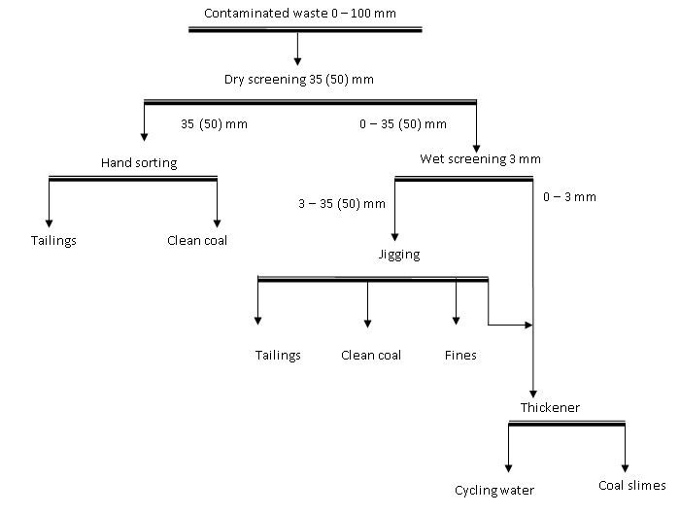
Fig 1. Washing flowsheet for contaminated waste containing size fraction 0 - 3 mm with the ash content below 40 %
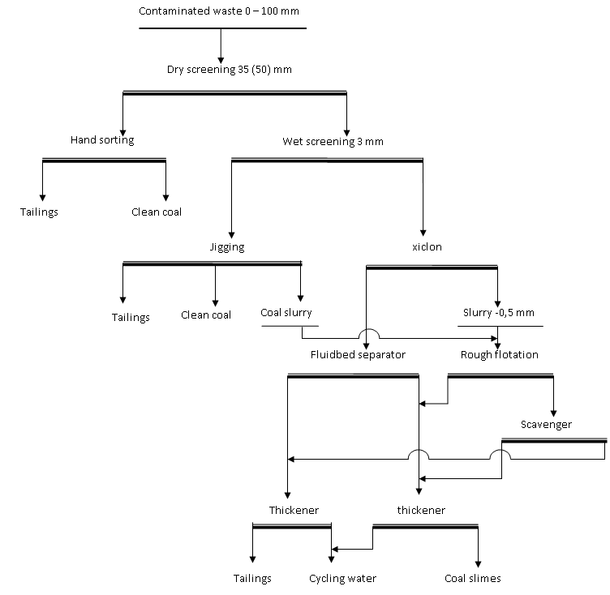
Fig 2. Washing flowsheet for contaminated waste containing size fraction 0 - 3 mm with the ash content over 40%.
References
- Source of the Quacontrol-Vinacomin (2013).
- Pham Huu Giang, investment-construction project: System of processing by moving screen jig Ha Tu coal company -Vinacomin (2009).
- Nhu Thi Kim Dung - Research projects funded by the Ministry of Education and Training level: Study on recovery of clean coal from waste rocks contaminated with coal at some coal mines of Quang Ninh Area, (2017).
- Nguyen Thi Mai - master's thesis: Study of froth flotation of high ash content fines of Ha Tu Coal Mine, (2010).

* Corresponding author: nhuthikimdung@humg.edu.vn

