Weakly-informed Audio Source Separation based on Nonnegative Matrix Factorization
Tran Thanh Huan¹, Duong Thi Hien Thanh^{2,}, Nguyen Thu Hang²
¹ Hanoi University of Industry
² Hanoi University of Mining and Geology
ABSTRACT
This paper focuses on using weakly-informed strategy to target the real-world single-channel audio source separation challenge. We use a very abstract semantic information just about the types of audio sources existing in the mixture to find and collect some source examples for training the Generic Source Spectral Model (GSSM). Then, our algorithm exploits the GSSM, which represents the spectral characteristics of audio sources, to guide the separation process based on Nonnegative Matrix Factorization (NMF) model. In order to compare fairly the obtained separation results with other existing methods, we use the well-designed benchmark dataset is from the Signal Separation Evaluation Campaign (SiSEC) for the speech and real-world background noise separation task. Especially, we target to participate the SiSEC challenge so as to bring our developed algorithm to the international research community.
And allowing for high-quality interactive-rate sep aration without explicit training data
Keywords: source separation; generic source spectral model; NMF; sparsity constraint.
- Introduction
Audio source separation aims at providing machine listeners with a similar function to the human ears by separating and extracting the signals of individual sources from a given mixture. This technique is known as an effective solution for cocktail party problem in audio signal processing community (Benesty, Makino, and Chen 2005; Makino, Lee, and Sawada 2007). Depending on specific application, some source separation approaches focus on speech separation, in which the speech signal is extracted from the mixture containing multiple background noise and other unwanted sounds. Other methods deal with music separation, in which the singing voice and certain instruments are recovered from the mixture or song containing multiple musical instruments. The separated source signals may be either listened to or further processed, giving rise to many potential applications. Speech separation is mainly used for speech enhancement in hearing aids, hands-free phones, or automatic speech recognition (ASR) in adverse conditions (Sunohara, Haruta, and Ono 2017; Revit and Schulein 2013; Sainath et al. 2017). While music separation has many interesting applications, including editing/remixing music post-production, music information retrieval, rendering of stereo recordings, and karaoke (Ewert et al. 2014; Parekh et al. 2017).
State-of-the-art audio source separation algorithms perform quite well in instantaneous or noiseless anechoic conditions, but still far from perfect by the amount of reverberation. Moreover, when the desired sound is corrupted by high-level background noise, the separation performance is even lower (Ono et al. 2015, 2013). That shows addressing the separation of reverberant mixtures, a common case in the real-world recording applications, remains one of the key scientific challenges in the source separation community. Also current studies have shown that the fully blind techniques do not provide sufficient results. Some existing informed source separation techniques using specific guide information, such as music score (Ewert et al. 2014; Emmanuel Vincent et al. 2014)., speech transcript (Le Magoarou, Ozerov, and Duong 2015), motion associated with audio-visual objects in a video (Parekh et al. 2017), get outperform results. But such specific information may not be available in different settings. In this context, weakly-informed strategy approach is an effective way to improve separation efficiency and eliminate difficult problems that are lacking in training data. We use a very abstract semantic information just about the types of sources existing in the mixture to find training examples. Such training data includes only a few short audio files (e.g. three or five recording, each has a duration of about 5 seconds) of the same type as the sources in the mixture. They are used to learn the General Source Spectral Model (GSSM), then this GSSM is explored in order to guide the separation process.
The structure of the rest of the paper is as follows. We introduce the problem formulation and modeling in Section 2. We then present the proposed weakly-inform source separatin algorithm with the details of parameter estimation in Section 3. The effectiveness of the proposed approach are validated in Section 4. Finally we conclude in Section 5.
- NMF-based audio source separation
- Problem formulation
Let us formulate the single mixture signal, where $J$ sources are observed by a microphone, with indexes $s\left(t\right),j∈\{1,..,J\}$ to indicate specific source $j$. This mixture signal is denoted by
$x\left(t\right)=\sum_{j=1}^{J}{s_{j}(t)}.$ (1)
The mixture and source are time-domain digital signals indexed by $t∈\{0,.., T-1\}$, where $T$ is the length of the signal. Switched to the time-frequency (T-F) domain by applying a short-time Fourier transform (STFT), equation (1) can be written as
$x\left(n,f\right)=\sum_{j=1}^{J}{s_{j}(n,f)},$ (2)
where $x\left(n,f\right)∈C$ and $s_{j}\left(n,f\right)∈C$ denote the T-F representations computed from $x\left(t\right)$and $s_{j}\left(t\right),$ respectively. $n∈\{1,..,N\}$ is the time frame index and $f∈\{1,..,F\}$ presents the frequency bin index.
Audio source separation consists in recovering either the $J$ original source signals $s_{j}(t)$ given the single-channel mixture signal $x\left(t\right)$.
- Audio spectra decomposition
NMF has been widely used for supervised source separation in the literature. Accordingly, a short-time Fourier transform (STFT), is applied to the original signal $x\left(t\right)$. Then the power spectrogram of the STFT coefficients is computed resulting in a nonnegative matrix $V∈C^{F×N}$. NMF aims at finding two nonnegative matrices $W∈C^{F×K}$ and $H∈C^{K×N}$such that (Lee and Seung 2001)
$V≈WH,$ (3)
where $K, F$ and $N$ denote the number of spectral basis, the number of frequency bins, and the number of time frames, respectively (Lee and Seung 2001). The columns of $W$ represent the spectral basis and their corresponding rows in $H$ represent the time gain of these spectral basis.
For decomposing a matrix $V$ into matrices $W$ and $H$, we want to get as close an approximation for equation (3) as possible. This can be achieved by optimizing the cost function (Lee and Seung 2001)
$\min_{W≥0, H≥0}{D\left(V\left\|WH\right.\right)}$. (4)
Denoting $\hat{V}=WH$, the cost function (4) is defined by $D\left(V\left\|\hat{V}\right.\right)=\sum_{f=1}^{F}{\sum_{n=1}^{N}{d_{IS}\left(V_{fm}\left\|{\hat{V}}_{fm}\right.\right)}}$, where $d_{IS}\left(x\left\|y\right.\right)=\frac{x}{y}-\log{\frac{x}{y}-1}$ is Itakura-Saito divergence, the most popular divergence for audio signal processing (Févotte, Bertin, and Durrieu 2009; Févotte, Vincent, and Ozerov 2018).
To solve the minimization problem in (4), two parameters W and H are usually initialized with random non-negative values and are iteratively updated via the well-known multiplicative update (MU) rules (Lee and Seung 2001).
- Proposed weakly-informed audio source separation algorithm
We assume that the types of sources in the mixture are known and some recorded examples of such sounds are available. This is actually feasible in practice. For instance, in the speech separation from noisy mixture, one target source is speech and another is noise and one can easily find speech and noise recordings. We need several examples for each type of source because one recording is usually not fully representative of the others and a source like “noise” is poorly defined. However, the amount of training data we need is very small, e.g., three speech files and three noise files, duration of each file is from 5 to 15 seconds. From this assuming, we proposed a weakly-informed single-channel audio source separation method based on NMF, exploiting only few training examples available to guide the separation process. The general pipeline works in the T-F domain after the STFT transform and consists in two phases as shown in Fig. 1: (1) learning GSSM from some training examples by NMF, and (2) decomposing the observed mixture with the guide of the pre-learned models.
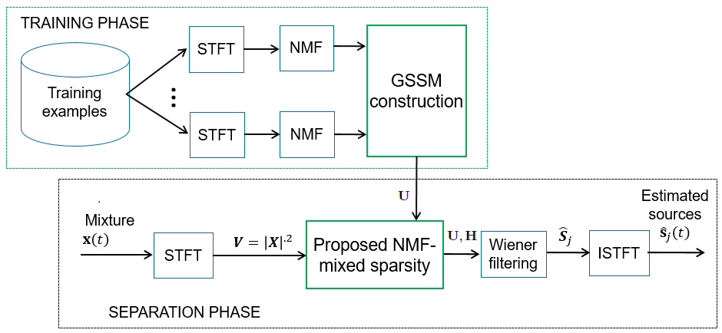
Figure 1. Proposed weakly-informed single-channel source separation algorithm.
Training examples are some audio files of the same type as the sources. Let us denote by $s_{j}^{l}(t)$ an $l$-th single-channel learning example of $j$-th source. First, $s_{j}^{l}(t)$ is used to learn the corresponding NMF spectral dictionary, denoted by $W_{j}^{l}$, as described in Section 2.2. Then, the GSSM for the $j$-th source is constructed by ${U_{j}=[W}_{j}^{1},…, W_{j}^{L_{j}}]$. Finally, the GSSM for all sources can be written as $U=[U_{1},…, U_{J}]$.
The GSSMs $U_{j}$ become large matrices when the number of examples increases, and they are actually redundant matrices since different examples may share similar spectral patterns. Thus, in the model fitting for the mixture spectrogram, sparsity constraint is naturally needed so as to fit only a subset of the large matrix $U$ to the targeted source. The mixture spectrogram is decomposed by solving the following optimization problem
$\min_{W≥0, H≥0}{D\left(V\left\|WH\right.\right)}+ λΩ(H)$ (5)

where $Ω(H)$ denotes a penalty function imposing sparsity on the matrix $H$, and $λ$ is a trade-off parameter determining the contribution of the penalty. In our recent work, we proposed a general form for the penalty function, called mixed sparsity as (Duong et al. 2015, 2018)
$Ω\left(H\right)=γ\sum_{g=1}^{G}{log⁡(ϵ+{\left\|H_{(g)}\right\|}_{1})}+\left(1-γ\right)\sum_{k=1}^{K}{log⁡(ϵ+{\left\|h_{k}\right\|}_{1})}$ (6)
where $γ∈[0, 1]$ weights the contribution of each term in mixed group sparsity constraint.
In proposed weakly-informed audio source separation approach, the cost function (5) and the penalty function (6) are used in the model fitting for the mixture spectrogram to guide the source separation phase.
- Experiment
4.1. Dataset and parameter settings
To validate the performance of the proposed approach, we created two training sets for training the GSSM. Speech training set contains three different speeches from two female voices and one male voice with 10 seconds duration each. Noise training set includes three types of environmental noise: kitchen sound, metro, and field sound with duration varying from 5 to 15 seconds. They are selected from the Diverse Environments Multichannel Acoustic Noise Database (DEMAND).
We used the benchmark dataset of the “Two-channel mixtures of speech and real-world background noise" (BGN) task within the International Signal Separation and Evaluation Campaign (SiSEC) perform the test. This dataset, called SiSEC-BGN, contains 29 stereo mixtures of 10-second duration and 16 kHz sampling rate. They were the mixture of male/female speeches and real-world noises recorded from different public environments: cafeteria (Ca), square (Sq), and subway (Su). Note that the dataset mentioned was carefully designed by researchers in the audio source separation community and widely used. These recording environments had different reverberation level, in which the mixtures in cafeteria and subway were higher than the mixtures at the square in reverberation level. The signal-to-noise ratio was drawn randomly between -17 and +12 dB by the dataset creators. Overall there were 29 mixtures divided into two sets: the devset includes 9 mixtures, and the testset contains 20 mixtures.
The parameters were set as follows. The STFT was calculated using a sliding window with a frame length of 1024, 50% overlap. The number of NMF components were set to 32 and 16 for speech and noise, respectively. The number of iterations for MU updates was 100 for the training step and was tested with values from 1 to 100 in the testing in order to investigate the convergence of the algorithm. To consider the sensitivity of the proposed algorithm to the trade-off parameter $λ$ determining the contribution of the sparsity-inducing penalty and the contribution weighting of each penalty term $γ$, we varied the values of these parameters, $λ=\{1, 10, 25, 50, 100, 200, 500\}$, $γ=\left\{0, 0.2, 0.4, 0.6, 0.8, 1\right\}.$
4.2. Evaluation method
Separated speech results were evaluated using the source-to-distortion ratio (SDR) measuring overall distortion as well as the source-to-interference ratio (SIR) and the source-to-artifacts ratio (SAR). They were measured in dB and averaged over all sources where the higher is the better. These criteria, known as BSS-EVAL metrics, have been mostly used in the source separation community (E. Vincent, Gribonval, and Fevotte 2006).
The results obtained by proposed algorithm over the SiSEC-BGN dataset was submitted to SiSEC 2016 campaign. Our results were compared to the results of several state-of-the-art algorithms, which also participated in the SiSEC campaign over different years since 2013 as following:
- Martinez-Munoz's algorithm (in SiSEC 2013): this algorithm exploits source-filter model for the speech source and the noise source is modeled as a combination of pseudo-stationary broadband noise, impulsive noise, and pitched interferences. The parameter estimation is based on the MU rules employed in NMF (Ono et al. 2013).
- Bryan's algorithm (in SiSEC 2013): this interactive approach exploits human annotation on the mixture spectrogram to guide and refine the source separation process. The modeling is based on the probabilistic latent component analysis (PLCA), which is equivalent to NMF (Bryan and Mysore 2013).
- López's algorithm (in SiSEC 2015) : uses spectral subtraction, they designs the demixing matrix and the post-ﬁlters based on a single-channel source separation method (Ramirez Lopez et al. 2015).
- Liu's method (in SiSEC 2016): performs Time Difference of Arrival (TDOA) clustering based on Generalized Cross Correlation Phase Transform (GCC-PHAT) (Liutkus et al. 2017).
Table 1. Speech separation performance obtained on the SiSEC-BGN. _ indicates submissions by the authors and “-” indicates missing information.
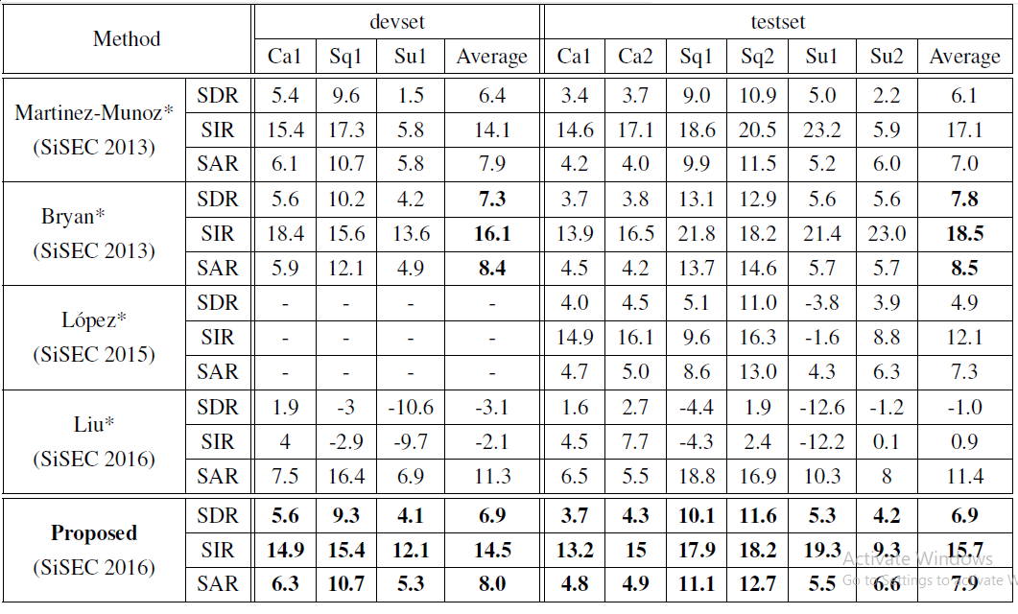
4.3. Results and discussion
Table 1 shows the speech separation performance obtained by the proposed algorithm over the SiSEC-BGN dataset compared to the results of the state of the art methods which participated in the SiSEC campaign over different years since 2013. Note that these measures were calculated by the SiSEC organization committee and published in (Liutkus et al. 2017; Ono et al. 2015, 2013). It can be seen that:
Comparing to the results of Liu's method in the SiSEC 2016 campaign, our method clearly outperformed Liu's method in all noisy environments in terms of SDR and SIR but worse for the SAR. However, with the better performance in terms of two criteria, especially the superiority (greater than 10 dB and 7.9 dB for devset and testset, respectively) in terms of the most important criterion SDR, our method was better judged than Liu's method by the SiSEC 2016 organizing committee (Liutkus et al. 2017).
Taking into account the results of results of the state of the art methods submitted to the SiSEC campaign over different years since 2013, our method outperforms all other methods, except Bryan's method, in terms of the energy-based criterion SDR, SIR and SAR. This confirms the effectiveness of the proposed approach where the GSSM is successfully exploited by NMF with mixed group sparsity constraint in the case that the training data are not available. It should be noted that Bryan's method (Ewert et al. 2014) uses human annotation on the mixture spectrogram to guide and refine the source separation process, so it is a supervised approach and not applicable without an audio expert.
- Conclusion
Real-world sound scenes are usually very complicated as they are mixtures of many different sound sources. Thus, the creation of machine listening algorithms that can automatically separate sound sources in the real-world recording conditions has remained very challenging.
We have proposed a novel single-channel audio source separation algorithm weakly guided by some source examples. This algorithm exploits the GSSM, which represents the spectral characteristics of audio sources, to guide the separation process based on NMF. With that, a new sparsity-inducing penalty for the cost function has also been proposed. We have validated the speech performance of the proposed algorithm in different settings with the SiSEC-BGN dataset, which was carefully designed by researchers in the audio source separation community and widely used. Future work can extend the proposed approach to the multichannel case where the source spatial model is incorporated with the proposed spectral NMF model and combine the proposed algorithm with other microphone array techniques (e.g. source localization, dereverberation, post-filtering) to complete the source separation pipeline.
References
Benesty, Jacob, S Makino, and J Chen. 2005. Speech Enhancement. Springer.
Bryan, Nicholas J., and Gautham J. Mysore. 2013. ‘An Efficient Posterior Regularized Latent Variable Model for Interactive Sound Source Separation’. In Proceedings of the 30th International Conference on Machine Learning, Jun. 2013, Atlanta, GA, JMLR.org. 208–216.
Duong, Hien-Thanh T., Quoc-Cuong Nguyen, Cong-Phuong Nguyen, Thanh-Huan Tran, and Ngoc Q. K. Duong. 2015. ‘Speech Enhancement Based on Nonnegative Matrix Factorization with Mixed Group Sparsity Constraint’. In Proceedings of the Sixth International Symposium on Information and Communication Technology, Dec. 2015, Hue, Vietnam, ACM Press. 247–251.
Duong, Hien-Thanh Thi, Phuong Cong Nguyen, and Cuong Quoc Nguyen. 2018. ‘Exploiting Nonnegative Matrix Factorization with Mixed Group Sparsity Constraint to Separate Speech Signal from Single-Channel Mixture with Unknown Ambient Noise’. EAI Endorsed Transactions on Context-Aware Systems and Applications 18 (13): 1–8.
Ewert, Sebastian, Bryan Pardo, Meinard Mueller, and Mark D. Plumbley. 2014. ‘Score-Informed Source Separation for Musical Audio Recordings: An Overview’. IEEE Signal Processing Magazine 31 (3): 116–124.
Févotte, Cédric, Emmanuel Vincent, and Alexey Ozerov. 2018. ‘Single-Channel Audio Source Separation with NMF: Divergences, Constraints and Algorithms’. In Audio Source Separation. Springer International Publishing. 1–24.
Févotte, Cédric, Nancy Bertin, and Jean-Louis Durrieu. 2009. ‘Nonnegative Matrix Factorization with the Itakura-Saito Divergence: With Application to Music Analysis’. Neural Computation 21 (3): 793–830.
Le Magoarou, Luc, Alexey Ozerov, and Ngoc Q. K. Duong. 2015. ‘Text-Informed Audio Source Separation. Example-Based Approach Using Non-Negative Matrix Partial Co-Factorization’. Journal of Signal Processing Systems 79 (2): 117–131.
Lee, Daniel D., and H. Sebastian Seung. 2001. ‘Algorithms for Non-Negative Matrix Factorization’. In Advances in Neural Information Processing Systems 13, MIT Press. 556–562.
Liutkus, Antoine, Fabian-Robert Stöter, Zafar Rafii, Daichi Kitamura, Bertrand Rivet, Nobutaka Ito, Nobutaka Ono, and Julie Fontecave. 2017. ‘The 2016 Signal Separation Evaluation Campaign’. In Latent Variable Analysis and Signal Separation, Springer International Publishing. 10169:323–332.
Makino, S, Te-Won Lee, and Hiroshi Sawada. 2007. Blind Speech Separation. Springer International Publishing.
Ono, Nobutaka, Zbynek Koldovsky, Shigeki Miyabe, and Nobutaka Ito. 2013. ‘The 2013 Signal Separation Evaluation Campaign’. In Proceedings of the 2013 IEEE International Workshop on Machine Learning for Signal Processing, Sep. 2013, Southampton, UK, IEEE. 1–6.
Ono, Nobutaka, Zafar Rafii, Daichi Kitamura, Nobutaka Ito, and Antoine Liutkus. 2015. ‘The 2015 Signal Separation Evaluation Campaign’. In Latent Variable Analysis and Signal Separation, Springer International Publishing. 9237:387–395.
Parekh, Sanjeel, Slim Essid, Alexey Ozerov, Ngoc Q. K. Duong, Patrick Perez, and Gael Richard. 2017. ‘Motion Informed Audio Source Separation’. In Proceedings of the 2017 IEEE International Conference on Acoustics, Speech and Signal Processing (ICASSP), Mar. 2017, New Orleans, IEEE. 6–10.
Ramirez Lopez, A., N. Ono, U. Remes, K. Palomaki, and M. Kurimo. 2015. ‘Designing Multichannel Source Separation Based on Single-Channel Source Separation’. In Proceedings of the 2015 IEEE International Conference on Acoustics, Speech and Signal Processing (ICASSP), Apr. 2015, South Brisbane, Queensland, IEEE. 469–473.
Revit, Lawrence J., and Robert B. Schulein. 2013. ‘Sound Reproduction Method and Apparatus for Assessing Real-world Performance of Hearing Aids’. The Journal of the Acoustical Society of America 133 (2): 1196.
Sainath, Tara N., Ron J. Weiss, Kevin W. Wilson, Bo Li, Arun Narayanan, Ehsan Variani, Michiel Bacchiani, et al. 2017. ‘Multichannel Signal Processing With Deep Neural Networks for Automatic Speech Recognition’. IEEE/ACM Transactions on Audio, Speech, and Language Processing 25 (5): 965–79.
Sunohara, Masahiro, Chiho Haruta, and Nobutaka Ono. 2017. ‘Low-Latency Real-Time Blind Source Separation for Hearing Aids Based on Time-Domain Implementation of Online Independent Vector Analysis with Truncation of Non-Causal Components’. In , 216–20. IEEE.
Vincent, E., R. Gribonval, and C. Fevotte. 2006. ‘Performance Measurement in Blind Audio Source Separation’. IEEE Transactions on Audio, Speech and Language Processing 14 (4): 1462–69.
Vincent, Emmanuel, Nancy Bertin, Remi Gribonval, and Frederic Bimbot. 2014. ‘From Blind to Guided Audio Source Separation: How Models and Side Information Can Improve the Separation of Sound’. IEEE Signal Processing Magazine 31 (3): 107–15.

TÓM TẮT
Tách nguồn âm thanh với thông tin hướng dẫn yếu sử dụng mô hình thừa số hóa ma trận không âm
Trần Thanh Huân¹, Dương Thị Hiền Thanh^{2,}, Nguyễn Thu Hằng²
¹ Trường Đại học Công nghiệp Hà Nội
² Trường Đại học Mỏ - Địa chất
Bài báo đề xuất thuật toán phân tách các nguồn âm thanh từ tín hiệu thu âm đơn kênh trong môi trường thực chứa nhiều âm thanh khác nhau theo hướng sử dụng ít thông tin hướng dẫn. Chúng tôi sử dụng thông tin về các loại âm thanh có trong hỗn hợp để tìm và thu thập một số ví dụ cho bước học ma trận phổ tổng quát GSSM. Sau đó, thuật toán khai thác ma trận GSSM để hướng dẫn quá trình tách nguồn dựa trên NMF kết hợp với ràng buộc thưa. Để so sánh các kết quả phân tách của thuật toán đề xuất với các phương pháp hiện có khác, chúng tôi đã thực hiện thí nghiệm với tập dữ liệu SiSEC, được thiết kế và sử dụng phổ biến trong cộng đồng tách nguồn âm thanh.
Từ khóa: source separation; generic source spectral model; NMF; sparsity constraint.

* Tác giả liên hệ Email: duongthihienthanh@humg.edu.vn
http://sisec.inria.fr/
http://parole.loria.fr/DEMAND/
https://sisec.inria.fr/sisec-2016/bgn-2016/
Tác giả liên hệ Email: duongthihienthanh@humg.edu.vn

